Dockerization

- Dockerfile:
FROM python:3.12-slim
WORKDIR /app
ENV PYTHONDONTWRITEBYTECODE=1 PYTHONUNBUFFERED=1
COPY requirements.txt .
RUN pip install --no-cache-dir -r requirements.txt
COPY . .
RUN useradd -m appuser && chown -R appuser:appuser /app
USER appuser
EXPOSE 5000
HEALTHCHECK --interval=30s --timeout=3s CMD python -c "import urllib.request; urllib.request.urlopen('http://localhost:5000/health')"
CMD ["gunicorn", "--bind", "0.0.0.0:5000", "--workers", "2", "run:app"]

- Docker compose yml:
services:
app:
build: .
ports:
- "5000:5000"
environment:
MONGO_URI: mongodb://mongo:27017/ecommerce
SECRET_KEY: local-dev-secret
depends_on:
mongo:
condition: service_healthy
mongo:
image: mongo:7
ports:
- "27018:27017"
volumes:
- mongo_data:/data/db
healthcheck:
test: ["CMD", "mongosh", "--quiet", "--eval", "db.adminCommand('ping').ok"]
interval: 10s
timeout: 5s
retries: 10
volumes:
mongo_data:
- Build Flask Image:
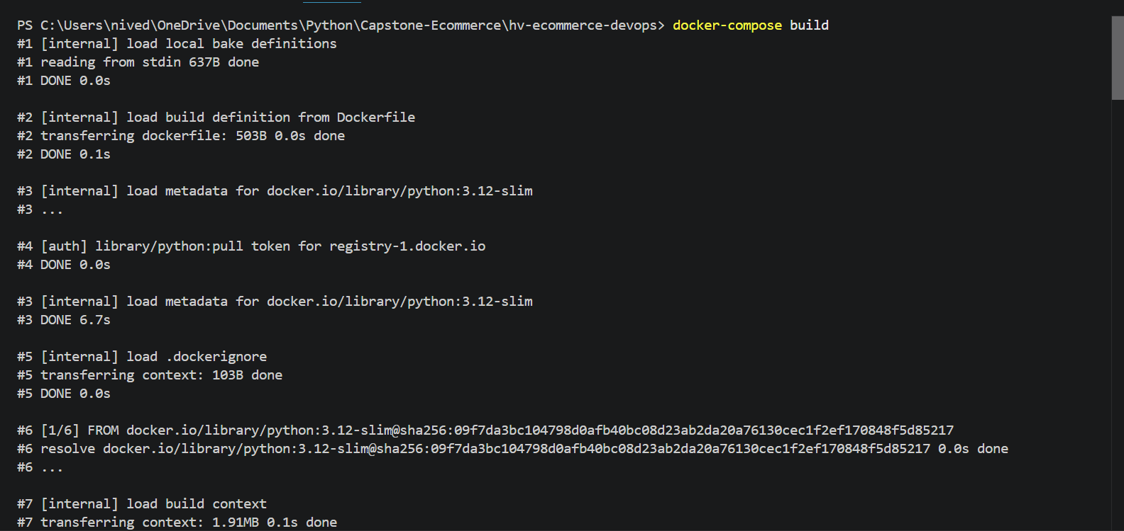
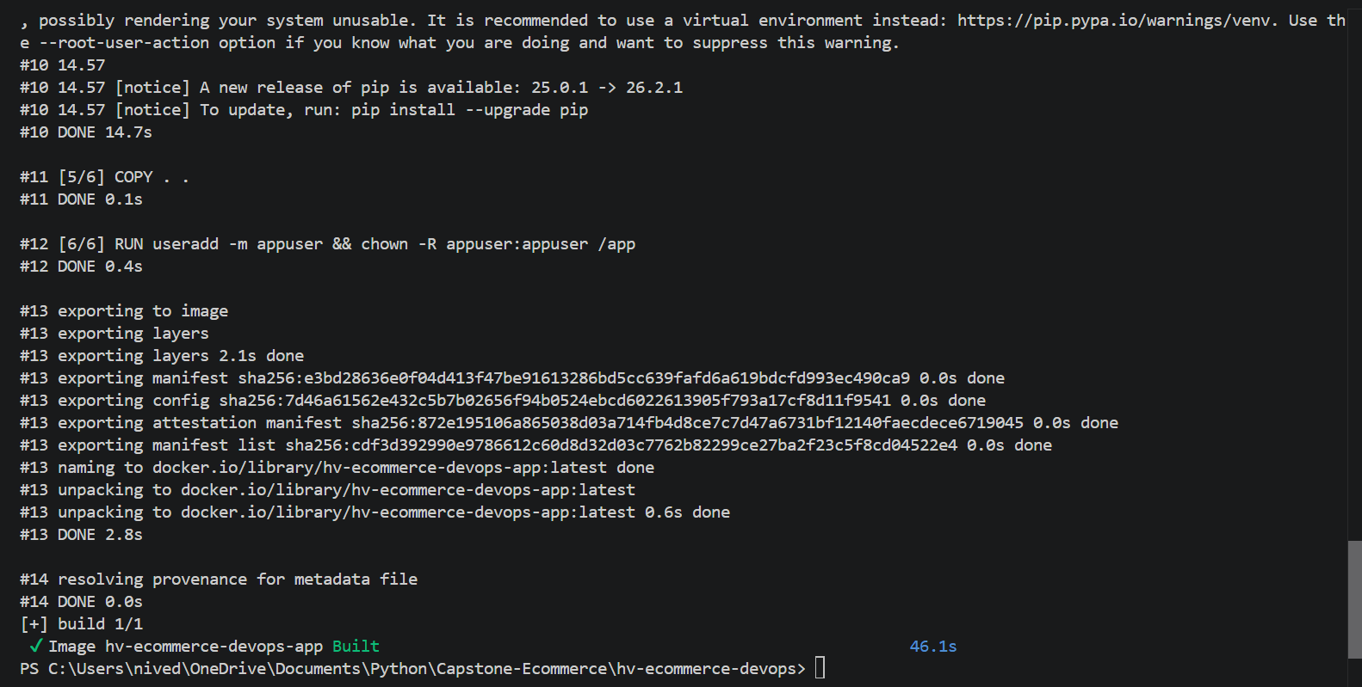
- Start Containers:
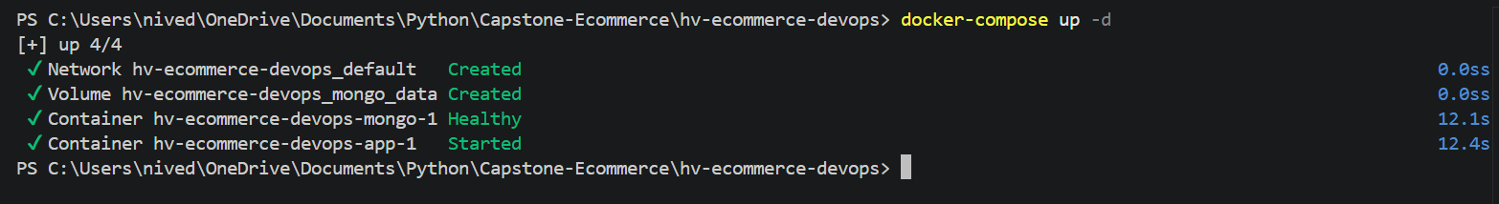
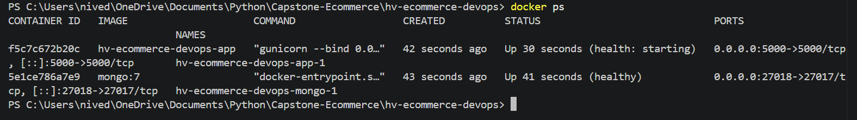
- Verify Application on localhost:5000

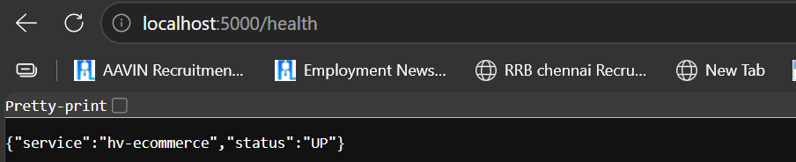
- Verify MongoDB Persistence
