Case Study 1: Hyperlocal Grid Quality Assessment Using Spatial Features from Static Map Images

1. Background
For hyperlocal market analysis, operational planning, and business expansion strategies, urban regions are divided into uniform geographical grids. Each grid represents a small locality and captures its physical, structural, and land-use characteristics.
Although grids are uniform in size, they differ significantly in commercial relevance and business potential. Some grids correspond to dense, mixed-use neighborhoods with high residential and retail activity, while others may represent open land, water bodies, industrial zones, or sparsely developed areas.
The objective of this case study is to assess and rank grid quality using spatial indicators derived from static map images, without relying on manually assigned labels such as “good” or “bad” grids. The solution must be data-driven, interpretable, and scalable across geographies.

2. Data Description

A. Grid Metadata File
- File name: delhi_grids.csv
- Coverage: Entire Delhi region
- Grid resolution: 200 × 200 meters
- Total grids: ~2000
Each grid (size 200 × 200 meters) is associated with a static map image that provides a top-down visual view of the locality.
- grid_id
Unique identifier for the grid
- latitude, longitude
Geographic coordinates of the grid centroid
- building_density
Ratio of total built-up area to the total grid area
  - Higher values indicate denser development
- building_count
Total number of buildings detected within the grid
- Yellow_building_density (footprints)
Proportion of the grid area occupied by small, low-rise, closely packed buildings
  - These structures typically represent residential houses or small retail units
  - This feature is used as a proxy for mixed-use or kirana-friendly localities, as opposed to large industrial or commercial buildings
- Yellow_building_count (footprints)
Absolute count of such small/low-rise buildings
- empty_area_percentage
Percentage of the grid area that is open or undeveloped land
- water_percentage
Percentage of the grid covered by water bodies

B. Static Map Images Folder
- A separate folder containing static map images
- One image per grid
- Image corresponds to the same grid_id present in delhi_grids.csv
Each image is a top-down map tile representing a 200 × 200 m grid, visually encoding:
- Building blocks / footprints
- Road networks
- Open or undeveloped land
- Water bodies

3. Problem Objective
Using only the above spatial features derived from static map images, design a framework to:
- Infer grid quality without any explicit labels
- Assign a continuous grid quality score

Dependent Variable (Derived Output)
- grid_score
A composite score representing the overall business relevance of a grid
- grid_segment
A categorical interpretation of the score:
  - Good (High Potential)
  - Neutral (Medium Potential)
  - Bad (Low Potential)

4. Constraints & Challenges
- Absence of ground-truth labels
- Feature correlations (e.g., building density vs building count)
- Variability in grid characteristics across different geographic regions
- Need for interpretability and consistency

5. Expected Tasks
Candidates are expected to address the following:
- Exploratory Data Analysis
  - Analyze feature distributions and skewness
  - Study correlations among spatial indicators
  - Identify anomalous grids (e.g., high building count but high empty area)
  - Compare patterns across different regions if available
- Feature Reasoning
  - Interpret how different spatial features contribute to grid quality
  - Justify the importance of residential and mixed-use indicators
- Methodology Design
  - Propose an approach such as:
    - Rule-based scoring
    - Clustering or segmentation
    - Composite index or weighted scoring
    - Computer Vision Technique
    - Or any other techniques
  - Clearly state assumptions and design choices
- Validation Strategy
  - Explain how the approach would be evaluated in the absence of labels
  - Suggest proxy checks or qualitative validation methods
- Scalability & Adaptability
  - Discuss how the solution can generalize across cities or regions
  - Explain how thresholds or scores might be recalibrated

6. Expected Output
The solution is expected to generate the following deliverables:

A. Enriched Output CSV
For each grid_id, candidates should produce an output CSV file that extends the original grid metadata with additional computed columns:
- grid_score (float)
A continuous score representing the inferred business relevance of the grid (preferably between 1-100)
- grid_segment (categorical)
A qualitative classification derived from the score, with values:
  - good
  - neutral
  - bad
Each row in the output CSV must correspond to a single grid_id from the input dataset.

B. Analysis & Results Document
In addition to the output CSV, candidates are required to submit a separate document that clearly explains:
- The exploratory data analysis performed
- The reasoning behind feature selection and weighting
- The methodology used to compute grid scores and segments
- Key assumptions and design choices
- Summary of results and observed patterns
- Validation approach and qualitative findings
C. Visualization using Dashboard
The final output of the solution should be presented not only as a data file but also as an interactive visualization dashboard that enables intuitive exploration of grid quality across the city.

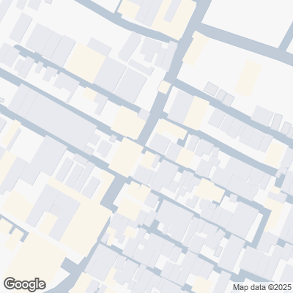
7. Examples

Good (High Potential)
- High building density
- High yellow building density
- Low empty area
- Minimal water coverage

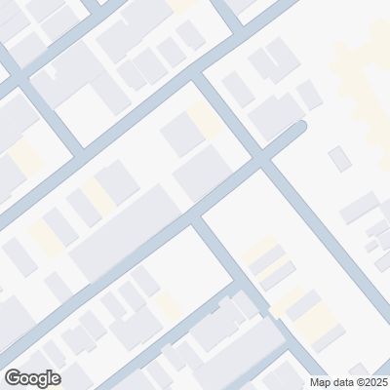

Neutral (Medium Potential)
- Moderate development
- Mixed spatial signals
- Partial open land

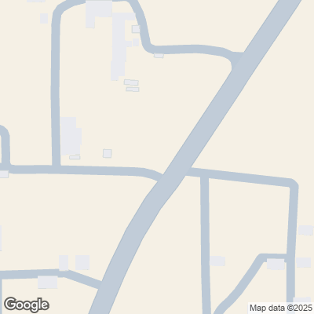

Bad (Low Potential)
- Dominated by open land or water
- Sparse buildings
- Low residential presence

8. Evaluation Criteria
Candidates will be evaluated on:
- Clarity of problem understanding
- Soundness of assumptions
- Practicality of the proposed approach
- Ability to reason with unlabeled, real-world data
- Communication and structuring of ideas

Link for Data:
https://drive.google.com/file/d/1nwnqPw798GKHiJgKB-rohnDWhr896pTF/view?usp=sharing

