IMPLEMENTATION OF TEXTILE ANTENNA WITH SAR MEASUREMENTS FOR WEARABLE COMMUNICATION IN MEDICAL APPLICATION

Sreedevi. B Assistant Professor Department of ECE
St. Joseph’s Institute of Technology OMR, Semmencherry, Chennai- 600119, Tamilnadu, sreedevistjoseph@gmail.com
Yamini. S UG Scholar
Department of ECE
St. Joseph’s Institute of Technology OMR, Semmencherry, Chennai- 600119
Tamilnadu, yamsuresh07@gmail.com
Saranya. U UG Scholar
Department of ECE
St. Joseph’s Institute of Technology OMR, Semmencherry, Chennai- 600119,
Tamilnadu, vaishnavraaj2004@gmail.com
Mohan. C
Assistant Professor Department of ECE
St. Joseph’s Institute of Technology OMR, Semmencherry, Chennai- 600119 Tamilnadu,
mohanrc803@gmail.com

Abstract— This paper introduces a new triple band meander patch antenna designed for optimal performance in medical applications. The antenna structure is in meander shape to achieve multi band functionality as well as low frequency as it is used close to the human skin in order to monitor the brain function. The proposed antenna has compact dimensions of
.............. x 2 mm³. For multi band function, the antenna operates in various frequency bands, enabling us to have various application but we choose 2.2 GHZ for better functionality. This antenna is multi band, has more applications, it is compact, and it has low SAR(Specific Absorption Rate), the low the SAR values the less the health risk as it is the amount of radio frequency absorbed by human body.
Keywords--Meander patch, Bandwidth, Multi band, SAR, Flexible antenna

INTRODUCTION

SAR (Specific Absorption Rate) SAR measurement is an important step to guarantee the safety of the antenna for wearable use. SAR values are tested by using standardized phantoms that represent human tissue, along with specific equipment. Measurements are taken at various operating frequencies to assess the electromagnetic energy absorption level in the body. This ensures that safety standards are met according [1]. The accepted SAR value is 1.6 W/KG, and this is achieved by design and optimized antenna system with slots. If the SAR values exceed tolerable limits, modifications are done in the design to reduce energy absorption. The iterative process of measuring and adjusting ensures that the antenna remains safe for the user and is performed with high performance and efficiency [2].
Recent times the new development is the multi band antenna as this antenna can work in various frequencies, we can have various applications. This is cost effective rather than earlier versions of antenna [3]. A compact patch antenna has been developed for biomedical applications at the ISM band. Slots are incorporated into this design to reduce SAR and improve performance when attached on [4] the human body.
Textile antennas are designed on flexible substrate
frequent shapes for tiny UWB antennas include circular, tarniadngle, stepped rectangle, square, ring, ellipse, pentagon, hexagon. UWB antenna bandwidth can be increased by a variety of techniques that have been documented in the literature. These techniques include the use of low dielectric constant substrates, different feeding schemes, lumped element loading, numerous slots and slits geometries,
shorting
posts, and fractal geometry. It is possible to mix different UWB approaches to create a hybrid structure that operates efficiently. Nowadays, a combination of structures is employed in the development of the majority of UWB antennas [10,11].

- (b) (c)

PROPOSED DESIGN ANALYSIS

The analysis for the proposed design is given below.The proposed design is given in figure 1.


Figure 1. Detailed view of the proposed antenna.
It is possible to get a good matching throughout a broad frequency band by applying a wideband approach to the antenna and feeding that matches with impedance. The tapered ground plane of a rectangular patch monopole antenna is provided better miniaturization [12]. Research indicates the use of monopole antennas, which provide enhanced
bandwidth and an almost omnidirectional pattern. An ultrawide bandwidth is generated by combining three separate stimulated modes. The ground plane operates as a scattered matching network, and tapering it off reduces the capacitance between it and the radiator [13].
The monopole antenna's tiny size, low manufacturing cost,
straightforward construction, thin profile, and remarkably small ground plane make it appropriate for integration with compact UWB systems [14]. A UWB antenna is one such application where fractal patterns are mixed with additional DGS (Defected Ground Surface), slots, and various feeding methods. The design and implementation of multiband and ultra-wideband antennas have made great use of it [15].
This investigation shows a new circular-shaped monopole
like antenna for UWB behaviour. This antenna has a total volume of approximately 15 x 25 x 1 mm3. This antenna is suitable for incorporation with compact-sized UWB systems because of its compact dimensions, low cost, simple fabrication, low profile, and very small ground plane. The
  - Front view

To further cover the lower band of the UWB, antenna 3 has additional annular circular ring shaped slots etched into the inside of the patch. Figure 1 describes the development of the modified slotted antenna.
The last design is made of a 2 mm thickness Glass substrate and covers the whole UWB spectrum with good

compactness. A substrate of Glass material has a permittivity of 2 and a loss value of 0.042. Figure 2 shows the complete configuration of the flexible circular antenna. The length and width of the suggested antenna are only 15 and 25 mm, respectively. Furthermore, the partial ground layer measures 3 mm lengthy and 10 mm width. The proposed antenna has a feeding arrangement of 2.2 mm feed width and 7 mm feed length. To model the recommended antenna, Computer Simulation Technology (CST) software is employed. Table 1 contains a complete list of this antenna's specifications.

  - Back view
Figure 1. Different stages of the proposed circular shaped antenna. (i) Front and (ii) Back ; (a) Antenna 1, (b) Antenna 2, and (c) Antenna 3.

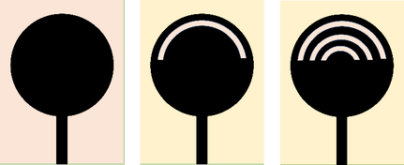

Figure 2. Total geometry and structure of the proposed Antenna.

antenna underwent significant parametric analysis. The proposed antenna's performance is outlined by its impedance bandwidth, radiation behaviour, and obtained gain.

PROPOSED ANTENNA DESIGN
With an entire ground plane and the fundamental design
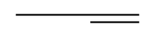
equation for a circular microstrip patch antenna is used to compute the antenna's initial str𝑐ucture [16].
4𝜋𝐷 √𝜀𝑒𝑓𝑓
𝑓𝑟=

The speed of light is denoted by 𝑐, the equivalent dielectric
constant is 𝜀𝑒𝑓𝑓, and D is the circular patch's outer diameter. The extremely narrow band at 3.1 GHz is covered by antenna
1. The antenna's basic design has been modified by etching leaf-shaped slots into a circular patch to improve performance. Antenna 2's 5.6 GHz bandwidth is provided by the structure between 5.3 and 10.9 GHz. Since the edge of the leaf-shaped slots in this design obtains the greatest amount of flow of current, more leaf-shaped slots have been created within it. This modified design provides an even
better bandwidth ( upto 9.6 GHz from 3.3 to 12.9 GHz).
TABLE 1 .APRAMETERS OF THE ROPOPSED A NTENNA

Parameter | Size (mm) | Parameter | Size (mm)
WS | 15 | LS | 25
WF | 2.2 | LF | 7
D | 11 | LG | 4.5

RESULTS & ANALYSIS

The performance of this multi band textile antenna has recognized with various frequencies and most needed low frequency of 2.2 GHZ is obtained as it lowers the health risks. It is done using CST software and certain characteristics like E-field, H-field and return loss is also monitored. This operates at frequencies 1.8GHZ and 2GHZ. The return loss values quantified by S11, are obtained at -22 dB and -40 dB for the frequencies.

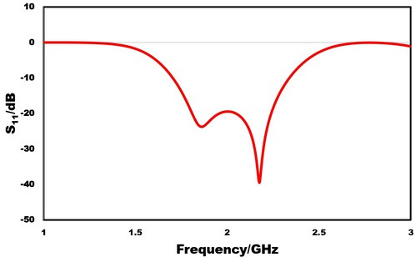
Figure 3. Scattering response of the proposed antenna.

Figure 4 depicts the current distribution for each frequency
to help with the antenna's performance analysis. As it can display the distribution of surface current at 3.2, 6.5, and 9.8 GHz, respectively. The greater gain concerning the increased electrical length of the slots is because of strong distributions over the outer edges of the circular-shaped slots and feedline, which acquire more resonances. This is believed to be the cause of the UWB characteristics. Figure 4(i) makes it clear that currents are mostly flowing through the lower part of the patch at lower frequencies. Figure 4(ii) & 4(iii) show the greatest distribution along the boundaries of the inner and outer circular patches, which is responsible for the wider bandwidth at middle and upper frequencies. The surface current distributions show that the feed line and patch's outside regions are where the majority of the current is concentrated.
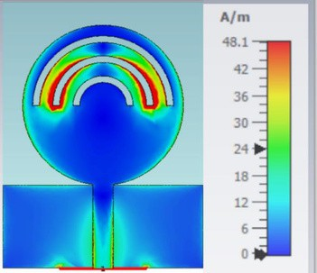
(i)
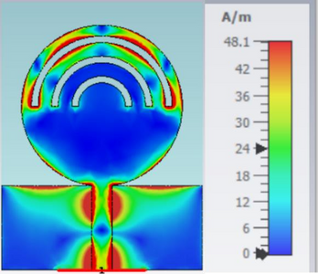
(ii)

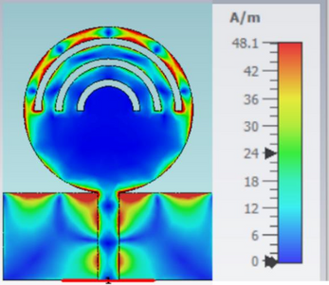
Figure 4. Current analysis of the proposed antenna. (i), 4.5 GHz, (ii), 6 GHz and (iii), 10.35 GHz.
The entire UWB band is investigated in terms of the
designed antenna's simulated radiation characteristics. The resonance frequencies in the E- and H-planes, which are selected for 3.2 GHz, 5.5 GHz, and 9.8 GHz are plotted in Figure 5. The H and E planes of the suggested antenna are plotted together in the results. Over the whole frequency range, the antenna provides, as can be seen, an approximately omnidirectional and bidirectional pattern in both planes.
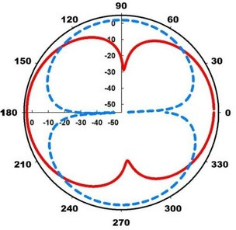

(i)
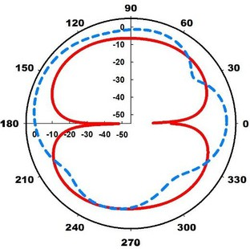
(ii)

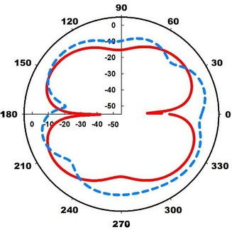
REFERENCES

(iii)
1
. 2
.3
. 4
.
56.
. .


7.
Ali U, Ullah S, Khan J, Shafi M, Kamal B, Basir A, Flint JA, Seager RD. Design and SAR Analysis of Wearable Antenna on Various Parts of Human Body Using Conventional and Artificial Ground Planes. Journal of Electrical Engineering & Technology. 2017;12(1):317-328.
Garg R, Bhartia P, Bahl I, Ittipiboon A. Microstrip Antenna Design Handbook. Norwood, MA: Artech House, 2001.
A. K. Gupta, P. Sharma, and R. P. Singh, "A novel compact multiband antenna for wireless communication systems," Proceedings of the 2019 IEEE International Conference on Communications and Signal Processing, Chennai, India, pp. 675-678, Dec. 2019.
[Y. Xiao et al.Multiband and Low-Specific-Absorption-Rate Wearable Antenna with Low Profile Based on Highly Conductive Graphene Assembled Film. IEEE Antennas and Wireless Propagation Letters, vol. 22, no. 9, pp. 2195-2199, Sept. 2023.

Figure 5. Simulated radiation patterns of the antenna. (a) 3.2 GHz (b) 5.5 GHz and (c) 9.8 GHz.
radiFaitgiounre 6 displays the planned antenna's efficiency and achieved peak gain. The drawing clearly
demonstrates the suggested antenna's 3.6 dB peak gain. The highest actualized gain at 9.6 GHz is 3.78 dB. Furthermore, the proposed antenna's highest radiation efficiency at 10.1 GHz is 78.2%.
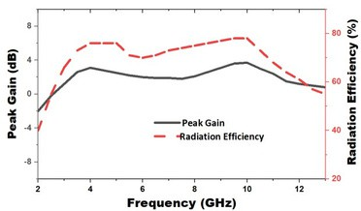
Figure 6. Gain and radiation efficiency analysis at whole UWB band.
8.

9.

10.

11.

12.

13.

14
. 15
.16.

CONCLUSION
This paper presents a new type of flexible circular-shaped monopole antenna for UWB operations. The total volume of the prototype is approximately 15 × 25 × 1 mm3. The maximum gain of this antenna is about 3.2 dB throughout the whole frequency range. The suggested monopole antenna is a great option for integration with smaller UWB systems because of its tiny size, low cost, simple fabrication, low profile, and extremely small ground plane. Additionally, the
apnrodposed antenna's acceptable radiation patterns transmission characteristics show that it is an excellent choice for incorporation into a variety of small devices for UWB operation.

