**CORE JAVA PROJECT**

PROJECT TITLE**: AIRLINE RESERVATION SYSTEM**

AIM:

* To achieve the seat reservation Process without any interruptions.

LANGUAGES:

* JAVA and SQL

SOFTWARE REQUIREMENTS**:**

* Eclipse for java.
* Mysql for sql.

SYNOPSIS:

In this AIRLINE RESERVATION SYSTEM there 5 main operations are there.

That MAIN OPERATIONS are:

1.REGISTRATION -->Passenger can perform that operation.

2.LOGIN -->Both admin and passenger can perform that operation.

3.SEAT RESERVATION -->Passenger can perform that operation.

4.SEAT CANCELLATION -->passenger can perform that operation.

5.DISPLAY -->Both the admin and passenger perform the operation.

The control is given for both the admin and also user. Admin can perform two operations one is the fetching information about the passenger who all are reserved the seat and second one is admin can able the seat how many seats are reserved. In that Passenger side there is five main operations are given. The first one is registration operation it will make permanent account creation. Second one is login whenever you need the seat reservation for that security purpose this module will help. Third one is seat reservation this will take personal information’s about that person, flight timing, trip type, seat type, fare. Forth one is display process after the reservation if passenger need to be seen the details about the reservation it will show the information about the seat reservation. Final one is seat cancellation this will also asking the security questions after that it will cancel and also it refunds the ticket fare.

INITIAL SETUP:

**(IN JAVA):**

**Mavan Project Name**: Airline Project.

**Package Name:** airline_project.

**Classes Name:** 1. AirlineMain

2.AirlineConnection

3.AirlineOperation

**(IN DATABASE):**

Creating database in sql (query)



**(DATABASE CREATION):**

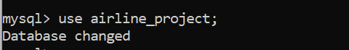

**(TABLES CREATION):**

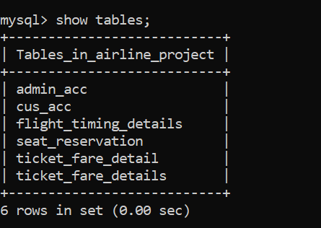

**AIRLINERESERVATIONMAIN:**

**ADMIN AND USER MAIN METHOD CODE:**

****************************CORE JAVA PROJECT********************

* CSR CAPGEMINI TRAINING PROJECT

* EDUBRIDGE INDIA PRIVATE LIMITED

* PROJECT TITLE: AIRLINE RESERVATION SYSTEM

* UNDER THE GUIDENCE OF TRAINER MRS.INDRAKA MALLI

* @DONE BY SARASWATHI L

*

* In AIRLINE RESERVATION SYSTEM:

* MAIN OPERATIONS:

* 1. REGISTRATION -->passenger can perform that operation.

* 2. LOGIN -->Both admin and passenger can perform that operation

* 3.SEAT RESERVATION -->Passenger can perform that operation.

* 4.SEAT CANCELLATION -->passenger can perform that operation.

* 5.DISPLAY -->Both the admin and passenger perform the operation.

*/

* AirlineMain class is having two major operations

*This will decide who is going to perform the operation

*1. admin

*2. user

*

Case 1:

*If it is admin and user choice mean it gives one choice for admin

*1. Admin Login-->it allows to login the admin account

*

*Case 2:

*If it is user choice means it gives one choice for user

*1. User Login-->it allows to login the user account

*/

package airline_project;

import java.sql.SQLException;

import java.util.Scanner;

public class AirlineMain {

public static void main(String[] args) throws SQLException {

Scanner sc=new Scanner (System.in);

System.out.println("****Welcome****");

System.out.println("Travel Joy Airline Reservation");

System.out.println("are you admin or user?");

while (true) {

System.out.println("1.admin");

System.out.println("2.user");

int n=sc.nextInt();

switch(n) {

case 1:

System.out.println("enter admin username");

String un=sc.next();

System.out.println("enter admin password");

String up=sc.next();

if(un.equals("admin")&&up.equals("admin@123")) {

System.out.println("Login successfull");

while (true) {

System.out.println("choose the action you want to do");

System.out.println("1.diplay single record");

System.out.println("2.display seat reserved");

int choice=sc.nextInt();

switch(choice) {

case 1:

System.out.println("Your choosen display single records process");

AirlineOperation.displayRervation();

break;

case 2:

System.out.println("Your choosen seat reserved process");

AirlineOperation.Seatreservation();

break;

default:

System.out.println("invalid input");

}//switch

System.out.println("do you want to continue y/n");

char ch=sc.next().charAt(0);

if(ch=='n'|| ch=='N')

break;

} //while(true)

}

else {

System.out.println("incorrect username or password");

}

System.out.println("you are terminated");

break;

//user process

case 2:

System.out.println("you are in user portal");

System.out.println("enter user name");

String un1=sc.next();

System.out.println("enter password");

String up1=sc.next();

if(un1.equals("saras")&&up1.equals("saras@123")) {

System.out.println("Login successfull");

while(true) {

System.out.println("choose the action you want to do");

System.out.println("1.Seat Reservation");

System.out.println("2.Seat Cancellation");

int choice2=sc.nextInt();

switch(choice2) {

case 1:

System.out.println("displaying your record");

AirlineOperation.seatReservation();

break;

case 2:

System.out.println("Seat cancelling process");

AirlineOperation.seatCancellation();

break;

default:

System.out.println("invalid input");

}

System.out.println("do you want to continue y/n");

char ch=sc.next().charAt(0);

if(ch=='n'|| ch=='N')

break;

}}

else {

System.out.println("incorrect username or password");

}

System.out.println("you are terminated");

break;

default:

System.out.println("invalid input");

}//switch

System.out.println("do you to return to home page y/n");

char ch=sc.next().charAt(0);

if(ch=='n'|| ch=='N')

break;

}

System.out.println("you are terminated");

}

}

**DATABASE CONNECTION CLASS:**

**DATA BASE CODE:**

/**

* Data base connection class-> it makes a connection between the spring tool shoot and mysql

*1. Driver->That implements the java databases connectivity (JDBC) API

*2. url->data base management system jdbc driver uses to connect to a database

*3. username-> user name of the database

*4. password->pass word for the databases

*5. Forname()-> method is loading the driver dynamically loads a java class at runtime

*6. DriverManger->Is that class making connection to database by passing arguments as a url, username and password.

*/

package airline_project;

import java.sql.Connection;

import java.sql.DriverManager;

public class AirlineConnection {private static Connection conn;

private static String driver="com.mysql.cj.jdbc.Driver";

private static String url= "jdbc:mysql://localhost:3306/airline_project";

private static String un="root";

private static String up="root";

public static Connection getConnection() {

try {

Class.forName(driver);

conn=DriverManager.getConnection(url,un,up);

if(conn==null) {

System.out.println("Connection Error");

}

}catch(Exception e) {

e.printStackTrace();

}

return conn;

}

}

**LOGIN:**

**ADMIN LOGIN CODE:**

/*

* In this admin login process the back end we created one user name and password for the admin

*

* That user name and pass word can be used to login admin login module

*

* If the login process get successful means admin can perform display operation

*

* 1. display single record -> it gives information about single seat number

*

* 2. display seat reserved-> it gives result about how many seats are reserved

*/

**//LOGIN PROCESS FOR ADMIN**

public static void main(String[] args) throws SQLException {

Scanner sc=new Scanner (System.in);

System.out.println("****Welcome****");

System.out.println("Travel Joy Airline Reservation");

System.out.println("are you admin or user?");

while (true) {

System.out.println("1.admin");

System.out.println("2.user");

int n=sc.nextInt();

switch(n) {

case 1:

System.out.println("enter admin username");

String un=sc.next();

System.out.println("enter admin password");

String up=sc.next();

if(un.equals("admin")&&up.equals("admin@123")) {

System.out.println("Login successfull");

while (true) {

System.out.println("choose the action you want to do");

System.out.println("1.diplay single record");

System.out.println("2.display seat reserved");

int choice=sc.nextInt();

switch(choice) {

case 1:

System.out.println("Your choosen display single records process");

AirlineOperation.displayRervation();

break;

case 2:

System.out.println("Your choosen seat reserved process");

AirlineOperation.Seatreservation();

break;

default:

System.out.println("invalid input");

}//switch

System.out.println("do you want to continue y/n");

char ch=sc.next().charAt(0);

if(ch=='n'|| ch=='N')

break;

} //while(true)

}

else {

System.out.println("incorrect username or password");

}

System.out.println("you are terminated");

break;

}}

**Admin Login java output:**

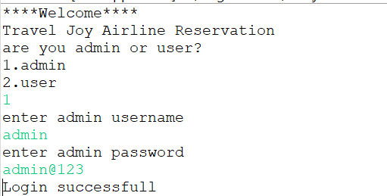

**PASSENGER LOGIN CODE:**

/*

* In this passenger login process the back end we created one user name and password for the user

*

* That user name and pass word can be used to login user login module

*

* If the login process get successful means user can perform operations

* Operation is seat reservation, display and cancellation

*

* 1. seat reservation-> this module is used to reserve the seat

*

* 2. seat cancellation-> this module is used to canceling the reserved seat

*

*/

**//LOGIN FOR PASSANGER**

public static void main(String[] args) throws SQLException {

Scanner sc=new Scanner (System.in);

System.out.println("****Welcome****");

System.out.println("Travel Joy Airline Reservation");

System.out.println("are you admin or user?");

while (true) {

System.out.println("1.admin");

System.out.println("2.user");

int n=sc.nextInt();

switch(n) {

case 1:

System.out.println("you are in user portal");

System.out.println("enter user name");

String un1=sc.next();

System.out.println("enter password");

String up1=sc.next();

if(un1.equals("saras")&&up1.equals("saras@123")) {

System.out.println("Login successfull");

while(true) {

System.out.println("choose the action you want to do");

System.out.println("1.Seat Reservation");

System.out.println("2.Seat Cancellation");

int choice2=sc.nextInt();

switch(choice2) {

case 1:

System.out.println("displaying your record");

AirlineOperation.seatReservation();

break;

case 2:

System.out.println("Seat cancelling process");

AirlineOperation.seatCancellation();

break;

default:

System.out.println("invalid input");

}

System.out.println("do you want to continue y/n");

char ch=sc.next().charAt(0);

if(ch=='n'|| ch=='N')

break;

}}

else {

System.out.println("incorrect username or password");

}

System.out.println("you are terminated");

break;

default:

System.out.println("invalid input");

}//switch

System.out.println("do you to return to home page y/n");

char ch=sc.next().charAt(0);

if(ch=='n'|| ch=='N')

break;

}

System.out.println("you are terminated");

}

}

**User Login java output:**

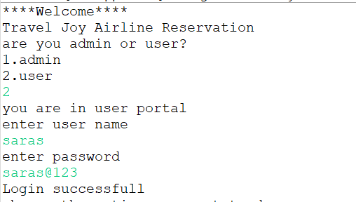

**RESERVATION PROCESS:**

**ATTRIBUTES:**

//these are the static variables

private static Connection con;

private static Scanner sc=new Scanner(System.in);

private static PreparedStatement pst;

private static ResultSet rst;

private static int seatno;

private static int ch;

private static long balance;

private static int t; private static int v;

private static String tripname;

private static long totalamount;

private static int accno;

private static int pinno;

private static String depaturetime;

private static String arrivaltime;

private static String seattype;

private static long ticketamount;

private static long inventoryfare;

private static String tickettype;

**SEAT RESERVATION CODE:**

**//FOR USER PURPOSE SEAT RESERVATION PROCESS**

/**

* In this seat reservation process there are trip choosing option, timing option, seat type, ticket type, ticket class, luggage weight, payment

* These are the key modules are working in side this method.

*

* While reservation process it also takes the personal information about the passenger.

*

* Main thing in this process choosing the seat no it shows how many seats are reserved and the seat numbers also.

*/

**//SELECTING SEAT NUMBER**

public static void seatReservation() throws SQLException {

while(true) {

System.out.println("Total number of seats"+totalNoOfSeats);

System.out.println("available seat count"+(avalseatcount-reservedseat));

System.out.println("Enter The Seat No");

seatno=sc.nextInt();

String sql1="select * from seat_reservation where seatNo=?";

pst=con.prepareStatement(sql1);

pst.setInt(1, seatno);

rst=pst.executeQuery();

String name;

String mobno;

Scanner sc=new Scanner(System.in);

System.out.println("Enter passange name");

name=sc.next();

System.out.println("Enter your phone number");

mobno=sc.next();

System.out.println("Enter your full Address");

System.out.println("Door no");

sc.nextLine();

String Doorno=sc.next();

System.out.println("enter the street name");

String street=sc.next();

System.out.println("Enter your location");

String location=sc.next();

System.out.println("enter the pincode");

String pincode=sc.next();

**//SELECTING TRIP PLAN**

/**

* Here next to personal details the airline having some different kind of trip plans

*

* This is fully depends on the passenger requirements

* what ever the choice is given from the passenger it will takes.

*

* If suppose the passenger choice is invalid means it shows invalid choice

* and it gives one more chance for the trip plan choosing process

*

*/

while(true)

{

System.out.println("Which Trip you want to Choose");

System.out.println("1.CHENNAI TO BANGALORE");

System.out.println("2.CHENNAI TO HYDRABED");

System.out.println("3.CHENNAI TO PUNE");

ch=sc.nextInt();

if(ch<4)

{

switch(ch)

{

case 1:System.out.println("Your selected Chennai to Bangalore option");

tripname="CHENNAI TO BANGALORE";

break;

case 2:System.out.println("your selected Chennai to hydrabed option");

tripname="CHENNAI TO HYDRABED";

break;

case 3:System.out.println("your selected Chennai to Pune option");

tripname="CHENNAI TO PUNE";

break;

}

break;

}

else

{

System.out.println("INVALID OPTION");

}

}

while(true) {

System.out.println("Select which Time you Want..");

System.out.println("1.DEPATURE TIME is 10.00AM and ARRIVAL TIME is 2.00PM");

System.out.println("2.DEPATURE TIME is 11.00AM and ARRIVAL TIME is 3.10PM");

System.out.println("3.DEPATURE TIME is 11.30AM and ARRIVAL TIME is 4.45PM");

t=sc.nextInt();

if(t<4)

{

switch(t)

{

case 1:System.out.println("your Depature time is 10.00AM ");

depaturetime="10:00:00 AM";

System.out.println("your Depature time is 10.00AM");

arrivaltime="02:00:00 PM";

break;

case 2:System.out.println("your DEPATURE TIME is 11.00AM and ARRIVAL TIME is 3.10PM");

depaturetime="11:00:00 AM";

arrivaltime="03:10:00 PM";

break;

case 3:System.out.println("your DEPATURE TIME is 11.30AM and ARRIVAL TIME is 4.45PM ");

depaturetime="11:30:00 AM";

arrivaltime="04:45:00 PM";

break;

}break;

}

else

{

System.out.println("invalid option...");

}

}

**//SELECTING SEAT TYPE**

/**

* Next to timing option the seat type option is given.

* Airline having two king of seats options

*

* This one also the passenger requirement if the passenger

* chosen the option it will taken for the further actions

*

* If the passenger chosen the invalid option in the sense

* it will give a chance to choose the seat type option.

*/

while(true) {

System.out.println("select which type of seat you want");

System.out.println("1.AISLE SEAT");

System.out.println("2.WINDOW SEAT");

v=sc.nextInt();

if(v<3){

switch(v){

case 1:System.out.println("your selected the type is AISLE SEAT (A and F rows)");

seattype="aisel type";

break;

case 2:System.out.println("your selected the type is WINDOW SEAT(C and D rows)");

seattype="window type";

break;}

break;

}

else

System.out.println("invalid option...");}}

**//SELECTING TICKET TYPE**

/**

* Next to seat type option the ticket type is given to the passengers.

*

* This option is also depends on the passenger needs.If the passenger chosen the option

* it will taken for the further processes.

*

* If the passenger chosen the invalid option in the sense

* it will give a chance to choose the seat type option.

*/

while(true)

{

System.out.println("1.FIRST CLASS ticket price is 9000");

System.out.println("2.NORMAL CLASS ticket price is 4000");

System.out.println("enter your choice");

int ch=sc.nextInt();

if(ch<3){

switch(ch)

{

case 1:System.out.println("your selected FIRST CLASS ticket");

tickettype="first class";

ticketamount=6000;

break;

case 2:System.out.println("your selected NORMAL CLASS ticket");

tickettype="normal class";

ticketamount=4000;

break;

}break;

}}

**//SELECTING LUGGAGE WEIGHT**

/**

* Next to ticket type option the luggage weight options are given to the passengers.

*

* This option is more important comparing to other transport types this also giving the options to the passengers.

* If the passenger chosen the option it will take for the further processes.

*

* If the passenger chosen the invalid option in the sense

* It will give a chance to choose the seat type option.

*/

while(true)

{

System.out.println("1.Inventory spare is 8kg then fare is 1000")

System.out.println("2.Inventory spare is 3kg then fare is 500");

System.out.println("enter your choice");

int fare=sc.nextInt();

if(fare<3)

{

switch(fare)

{

case 1:System.out.println("your selected 8kg");

inventoryfare=1000;

break;

case 2:System.out.println("your selected 3kg");

inventoryfare =500;

break;

}

break;}

**//PAYMENT PROCESS**

/**

* The payment process also very simple and also securely handled.

*

* It also having checking processes taking information’s from the passengers account number

* And pin it two data are correct then it do the payment process

*

* Here the account number or pin number is invalid means it gives the alert and gives one more chance.

*

* May be both are correct but the balance is insufficient means it gives that insufficient message also.

*

* If the payment is done then only it reserve that seat otherwise it not takes all the information before the payment option.

*/

while(true)

{

totalamount=ticketamount+inventoryfare;

System.out.println("GO TO PAYMENT");

System.out.println("Enter your Account Number");

accno=sc.nextInt();

System.out.println("Enter your Pin Number");

pinno=sc.nextInt();

String transacc="select Acc_No from cus_acc where Acc_No=?";

pst=con.prepareStatement(transacc);

pst.setInt(1, accno);

rst=pst.executeQuery();

if(rst.next())

{

String transpin="select PinNo from cus_acc where PinNo=?";

pst=con.prepareStatement(transpin);

pst.setInt(1, pinno);

rst=pst.executeQuery();

if(rst.next())

{

//load the driver at run time, register

con =AirlineConnection.getConnection(); //create the connection

String sm="insert into seat_reservation values(?,?,?,?,?,?,?)";

pst=con.prepareStatement(sm);

pst.setInt(1, seatno);

pst.setString(2, name);

pst.setString(3, mobno);

pst.setString(4, Doorno);

pst.setString(5, street);

pst.setString(6,location);

pst.setString(7, pincode);

int rv=pst.executeUpdate();

if(rv>0)

{

String seatch="insert into flight_timing_details values(?,?,?,?,?,?,?,?)";

pst=con.prepareStatement(seatch);

pst.setInt(1, ch);

pst.setString(2, tripname);

pst.setInt(3, t);

pst.setString(4, depaturetime);

pst.setString(5, arrivaltime);

pst.setInt(6, v);

pst.setString(7, seattype);

pst.setInt(8, seatno);

int p=pst.executeUpdate();

if(p>0)

{

String fare="insert into ticket_fare_detail values(?,?,?,?,?)";

pst=con.prepareStatement(fare);

pst.setString(1, tickettype);

pst.setLong(2, ticketamount);

pst.setLong(3, inventoryfare);

pst.setLong(4, totalamount);

pst.setInt(5, seatno);

int k=pst.executeUpdate();

if(k>0)

{

String bal="select Balance from cus_acc where (select Balance from cus_acc where Acc_No=?)>0";

pst=con.prepareStatement(bal);

pst.setLong(1,accno);

rst=pst.executeQuery();

if(rst.next())

{

String withdraw="update cus_acc set Balance=Balance-(select InventoryFare from ticket_fare_details where SeatNo=?) where Acc_No=? ";

pst=con.prepareStatement(withdraw);

pst.setLong(1,seatno);

pst.setInt(2,accno);

int t=pst.executeUpdate();

if(t>0)

{

String deposite="insert into cus_acc values(?,?)";

pst=con.prepareStatement(deposite);

pst.setLong(1, totalamount);

pst.setInt(2, seatno);

int l=pst.executeUpdate();

if(t>0)

{

String Cus="insert into admin_acc values(?,?,?)";

pst=con.prepareStatement(Cus);

pst.setInt(1, accno);

pst.setInt(2, pinno);

pst.setLong(3, balance);

int z=pst.executeUpdate();

if(z>0)

{

System.out.println("your seat is reserved");

System.out.println("Do you want to See the Whole details about your reservation yes/no");

String m=sc.next();

if(m.equalsIgnoreCase("yes"))

{

totalNoOfSeats=totalNoOfSeats-1;

break;

}

else

{

break;

}

}

break;

}}

else

{

System.out.println("Insufficient balance");

String delfare="delete from ticket_fare_details where SeatNo=?";

pst=con.prepareStatement(delfare);

pst.setInt(1, seatno);

int df=pst.executeUpdate();

if(df>0)

{

String deltime="delete from flight_timing_details where SeatNo=?";

pst=con.prepareStatement(deltime);

pst.setInt(1, seatno);

int dt=pst.executeUpdate();

if(dt>0)

{

String delseat="delete from seat_reservation where seatNo=?";

pst=con.prepareStatement(delseat);

pst.setInt(1, seatno);

int ds=pst.executeUpdate();if(ds>0)

{

System.out.println("check your balance");

break;

}

}

}}}}}

}else

{

System.out.println("invalid account number or pin number");

}

}

}else

{

System.out.println("your seat is reserved... ");

}

avalseatcount=totalNoOfSeats-1;

break;

}

}

}

}

catch (Exception e) {

e.printStackTrace();}}

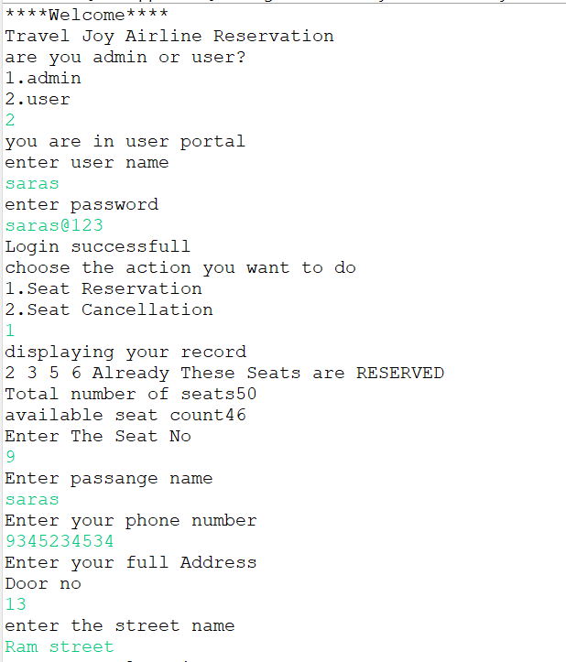

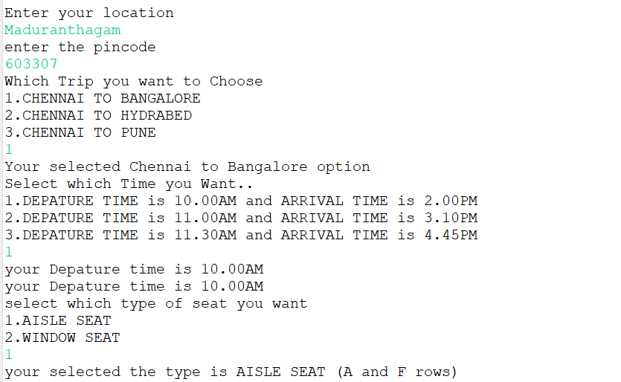

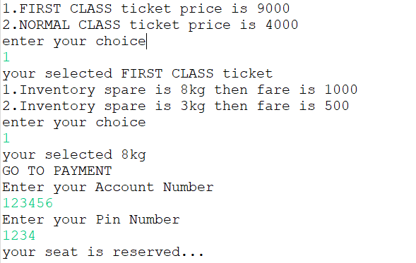

**Database records:**

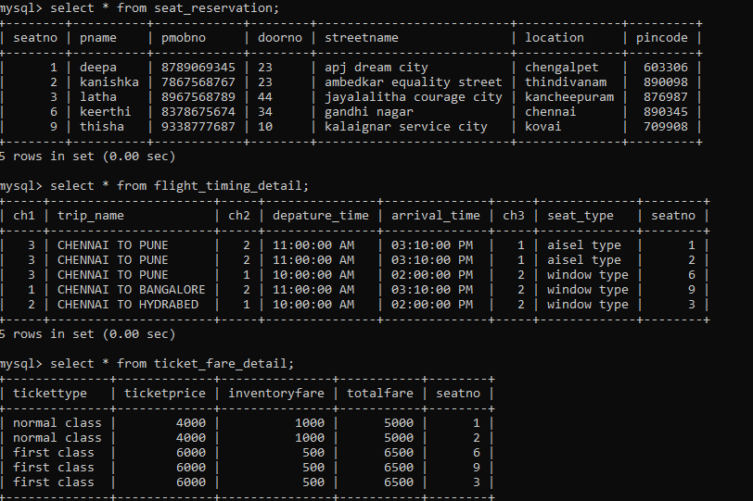

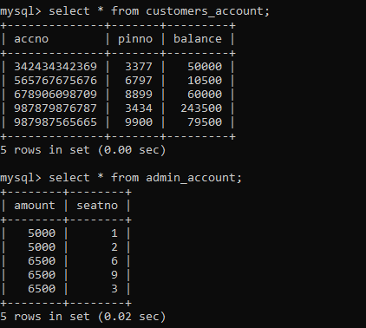

**SEAT CANCELLATION CODE:**

**//CANCELLATION PROCESS**

/**

* This cancellation process is given to the passengers convenient.

*

* If may be situation passenger not able to travel means it will gives the chance

* to canceling the seat and conditions applied amount is refund.

*

* It asking the major informations regarding that passengers email id,

* user name, password and seat number every informations are correct

* then only it will cancel the seat other wise it will not cancel.

*/

**public** **static** **void** seatCancellation() **throws** SQLException {

Scanner sc=**new** Scanner(System.***in***);

System.***out***.println("Enter seatno to cancelling your seat");

**int** seatno=sc.nextInt();

**try** {

*con* =AirlineConnection.*getConnection*();

String sel="select * from seat_reservation where seatno=?";

*pst*=*con*.prepareStatement(sel);

*pst*.setInt(1, seatno);

*rst*=*pst*.executeQuery();

**if**(*rst*.next()) {

String del="delete from seat_reservation where seatno=?";

*pst*=*con*.prepareStatement(del);

*pst*.setInt(1, seatno);

**int** rv=*pst*.executeUpdate();

**if**(rv>0) {

System.***out***.println("Your cancellation is done");

}**else** {

System.***out***.println("ERROR!!!!!");

}

}**else** {

System.***out***.println("seat no "+seatno+" not exists");

}

}**catch**(Exception e) {

e.printStackTrace();

}

}

**Cancellation java output:**

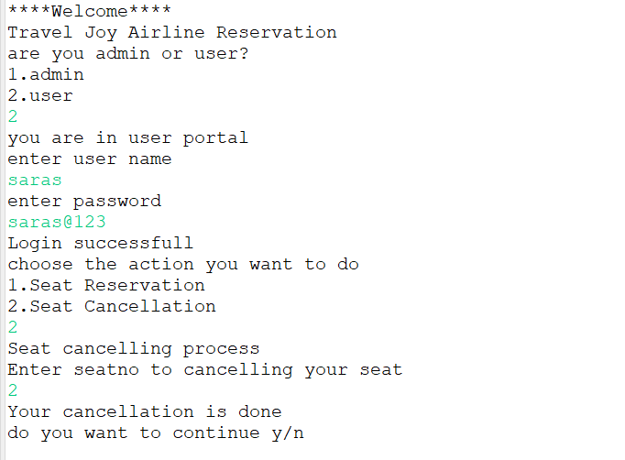

**Database records:**

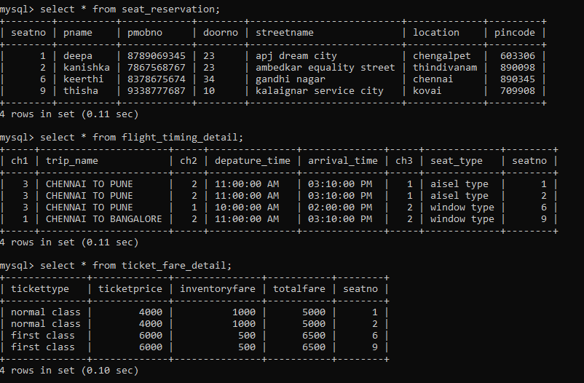

**SEAT COUNT CODE FOR ADMIN:**

**//FOR ADMIN PROCESS RESERVED SEAT COUNT**

/**

* This is for admin purpose If may be seat is not available they are not given that reservation process enable.

*

* If there is no seat is reserved means that time it gives the message no seats are reserved.

*

* And also reserved seat calculation purpose.

*/

**public** **static** **void** Seatreservation() **throws** SQLException {

**try**

{

*con*=AirlineConnection.*getConnection*();

String sel="select count(*) from seat_reservation";

*pst*=*con*.prepareStatement(sel);

*rst*=*pst*.executeQuery();

**if**(*rst*.next())

{

**int** reservedSeats=*rst*.getInt(1);

System.***out***.println("Number of Seat are Reserved "+reservedSeats);

}

**else**

{

System.***out***.println("Till now no seat are reserved ");

}

}**catch**(Exception e)

{

e.printStackTrace();

}

}

Reserved seat count java output:

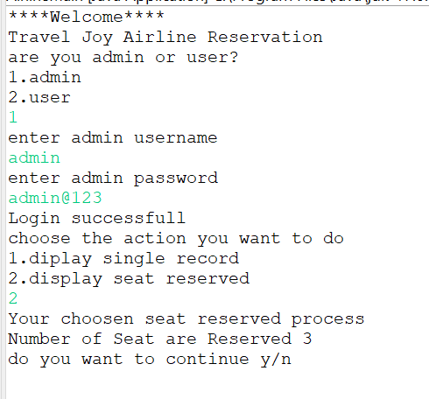

**USER DISPLAY CODE:**

**//FOR USER PROCESS-->DISPLAY RECORDS**

/**

* This module is used to display the information about the seat reservation.

*

* After the seat reservation it will ask you want to know about your seat reservation informations

* If the passenger given yes means it show all the details about the reservation.

*/

**public** **static** **void** displayRervation() **throws** SQLException {

**try**

{

*con*=AirlineConnection.*getConnection*();

System.***out***.println("Enter the seat no:");

*seatno*=*sc*.nextInt();

String de="select * from seat_reservation where seatNo=?";

*pst*=*con*.prepareStatement(de);

*pst*.setInt(1,*seatno*);

*rst*=*pst*.executeQuery();

**if**(*rst*.next())

{

System.***out***.println("--------------------PERSONAL DETAIL--S---------------");

System.***out***.println("_______________________________________________________________");

System.***out***.println("seatNo\t\tPname\t\tPmobileNo\t\tPincode");

System.***out***.println("_______________________________________________________________");

System.***out***.println(*rst*.getInt(1)+"\t\t"+*rst*.getString(2)+"\t\t"+*rst*.getString(3)+"\t"+*rst*.getInt(7));

System.***out***.println("_______________________________________________________________");

System.***out***.println( );

String seatch="select * from flight_timing_details where SeatNo=?";

*pst*=*con*.prepareStatement(seatch);

*pst*.setInt(1, *seatno*);

*rst*=*pst*.executeQuery();

**while**(*rst*.next())

{

System.***out***.println("------------------TRAVELLING DETAILS-------------");

System.***out***.println("_______________________________________________________________");

System.***out***.println("Traveling place\t\tSeattype\t");

System.***out***.println("_______________________________________________________________");

System.***out***.println(*rst*.getString(2)+"\t"+*rst*.getString(7)+"\t");

System.***out***.println("_______________________________________________________________");

System.***out***.println( );

String farech="select * from ticket_fare_detail where seatno=?";

*pst*=*con*.prepareStatement(farech);

*pst*.setInt(1, *seatno*);

*rst*=*pst*.executeQuery();

**while**(*rst*.next())

{

System.***out***.println("-----------------------FARE DETAILS-----------------------");

System.***out***.println("_______________________________________________________________");

System.***out***.println("Tickettype\tticketamount\tinventoryfare\ttotalamount");

System.***out***.println("_______________________________________________________________");

System.***out***.println(*rst*.getString(1)+"\t"+*rst*.getInt(2)+"\t\t"+*rst*.getInt(3)+"\t\t"+*rst*.getInt(4)+"\t");

System.***out***.println("_______________________________________________________________");

//System.out.println("-------------------------------------------------------------------------------------------------------------------------------------------------------");

**break**;

}

}

}

**else**

{

System.***out***.println("seat no is not exist");

}

}

**catch**(Exception e)

{

e.printStackTrace();

}

}

}

User display java output:

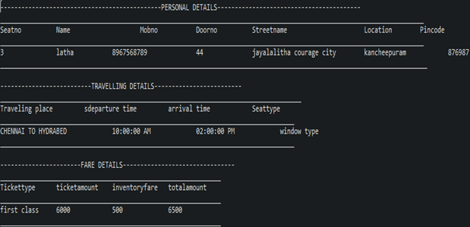

**ADMIN DISPLAY CODE:**

**//FOR ADMIN PROCESS DISPLAY RECORDS**

/**

* This module is used to display the information about the seat reservation.

*

* If the admin want the see information about the specified seat number means admin can

* able to put the seat number what ever the seat number he need and it will show the highlighted informations about the passenger.

*/

public static void displayRervation()

{

try

{

con=DbConnect.getconnection();

System.out.println("Enter the seat no:");

seatno=sc.nextInt();

String de="select * from seat_reservation where seatno=?";

pst=con.prepareStatement(de);

pst.setInt(1,seatno);

rst=pst.executeQuery();

if(rst.next())

{

System.out.println("--------------------PERSONAL DETAIL--S---------------");

System.out.println("_______________________________________________________________");

System.out.println("Seatno\t\tName\t\tMobno\t\tPincode");

System.out.println("_______________________________________________________________");

System.out.println(rst.getInt(1)+"\t\t"+rst.getString(2)+"\t\t"+rst.getString(3)+"\t"+rst.getInt(7));

System.out.println("_______________________________________________________________");

System.out.println( );

String seatch="select * from flight_timing_detail where seatno=?";

pst=con.prepareStatement(seatch);

pst.setInt(1, seatno);

rst=pst.executeQuery();

while(rst.next())

{

System.out.println("------------------TRAVELLING DETAILS-------------");

System.out.println("_______________________________________________________________");

System.out.println("Traveling place\t\tSeattype\t");

System.out.println("_______________________________________________________________");

System.out.println(rst.getString(2)+"\t"+rst.getString(7)+"\t");

System.out.println("_______________________________________________________________");

System.out.println( );

String farech="select * from ticket_fare_detail where seatno=?";

pst=con.prepareStatement(farech);

pst.setInt(1, seatno);

rst=pst.executeQuery();

while(rst.next())

{

System.out.println("-----------------------FARE DETAILS-----------------------");

System.out.println("_______________________________________________________________");

System.out.println("Tickettype\tticketamount\tinventoryfare\ttotalamount");

System.out.println("_______________________________________________________________");

System.out.println(rst.getString(1)+"\t"+rst.getInt(2)+"\t\t"+rst.getInt(3)+"\t\t"+rst.getInt(4)+"\t");

System.out.println("_______________________________________________________________");

//System.out.println("-------------------------------------------------------------------------------------------------------------------------------------------------------");

break;

}

}

}

else

{

System.out.println("seat no is not exist");

}

}

catch(Exception e)

{

e.printStackTrace();

}

}

Admin display java output:

