# Chapter 3 Design

# Introduction

Design is the development process that is processed under the specific user’s requirement. It short, it is the creation or construction of the system about how it resembles when brought in process.

We can find two different types of modeling

* Structural Modelling
* Behavior Modelling

# 3.1 Structural modelling

A system is design up of various parts as an application and a database. In order to implement different system structure, a development tool is used that is known as structure diagram. Whereas, structure design is defined as the process of designing the steps the system such as modules, architecture and components including the interfaces of those components as well as the data which pass through the system.

Here, I have created class diagram and data flow diagram.

# 3.1.1 Class diagram

In the Unified Modeling Language (UML), class diagram is a static structural diagram that demonstrate the structural representation of system by identifying system classes, attributes and operation (or methods).

Here I have created class diagram by showing relationship or dependencies between the classes. I have chosen noun as class, verbs as attributes and adjective as methods. The others reason to choose class diagram for my system are:

* Class diagram is considered as a primary diagram in the Object Oriented and software because everything is represented in the form of classes. As class is considered as back bone of OOP.
* Class diagram defines the structure of class, classifier and relationship between them.
* It shows the static view of the system that can be used for future designing.

The following table shows the notation used in Class diagram

|  |  |  |  |
| --- | --- | --- | --- |
| **No** | **Notation** | **Name** | **Explanation** |
| 1 |  | Association | It represents a binary association that can link any number of classes. |
| 2 |  | Inheritance | It indicates that one of the two related class (subclass) is considered to be a specialized form of the other (super type). |
| 3 |  | Realization/ Implementation | It is the relationship between two model elements in which one model elements executes the behavior of another element. |
| 4 |  | Dependency | It is the semantic connection between dependent and independent model element that exists between two elements. |
| 5 |  | Aggregation | It is a variant of association that represent a part whole or part of relationship that connects it to the contained class. |
| 6 |  | Composition | It shows the composition filled on the class end of the line that connect contained classes to the containing class. |

# 3.1.2 Data flow diagram

The graphical representation flow of the data in the information system that describe the process which are engaged in a system for transferring the data to perform certain functionality of business. It determines the construction of physical system that consists of various layers in which each unique to a data function or specific process.

I used Data flow diagram to due to various purpose as mentioned below

* It provides a graphical representation of how the information moves between processes in a system.
* It shows the flow of information through a system in which each process transforms input into output.
* The data flow diagram are the results of diagram that represents the system activity in a concise and clear manner.

The following table shows the notation used in Data flow diagram.

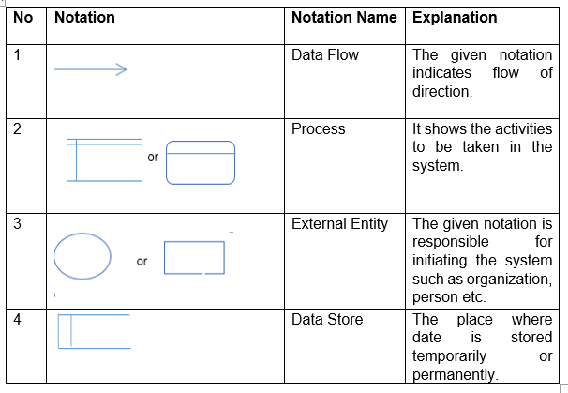

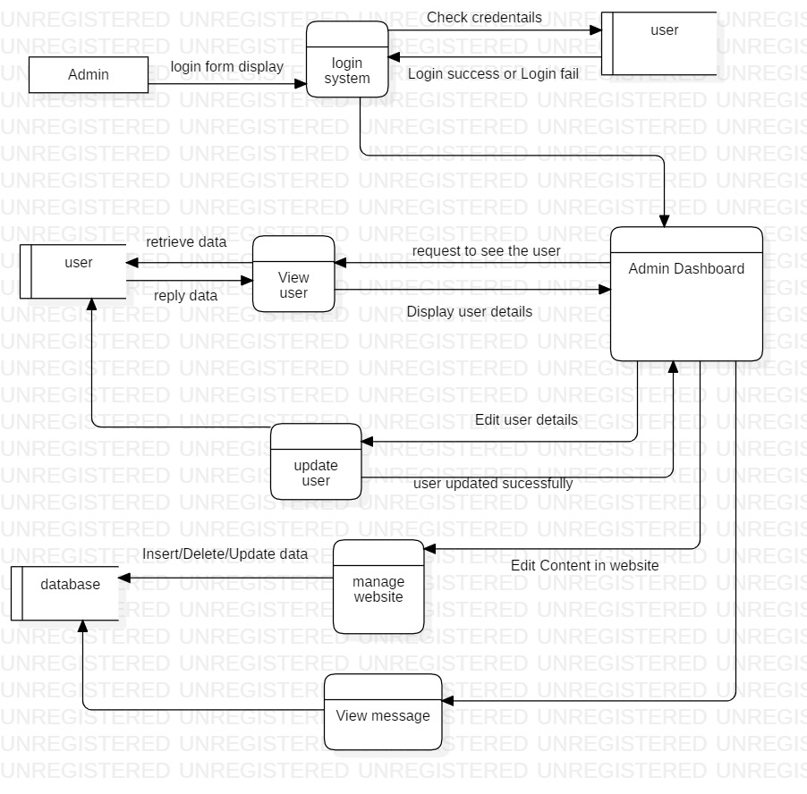

Figure 1: Flow chart of Admin

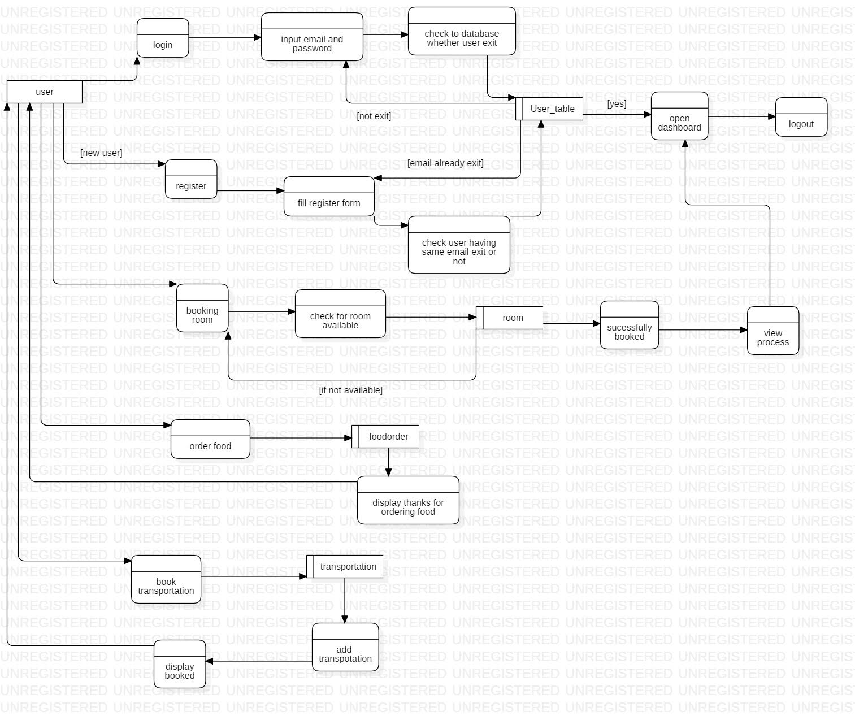

Figure : Flow chart of work flow

The above data flow diagram describes about the flow of the event. It shows that user can login and register themselves to be part of the hotel management system. Then their details are store in database.

# 3.2 Behavioral modelling

The representation that shows the dynamic behavior of the object in the system that is considered to be change over time is Behavior diagram.

# 3.2.1 Activity modelling

The process of representing the flow of activities on the system and details of operation or computations using flowcharts. It is not only used for visualizing the dynamic nature of a system but also used for constructing the executable system.

The purpose for using activity diagram are mentioned below

* It describes the coordination of activities to provide a service that can be different level of abstraction.
* It captures the business logic in a simple format of diagram representation that makes easier to interaction and communication.
* It shows the flow of task which is the way to describe a process step b step in the project.

The notation used in Activity diagram is showed below

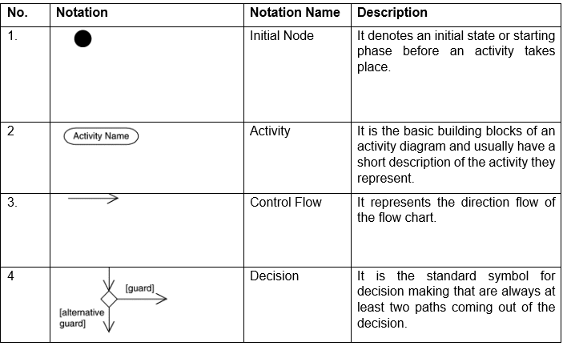

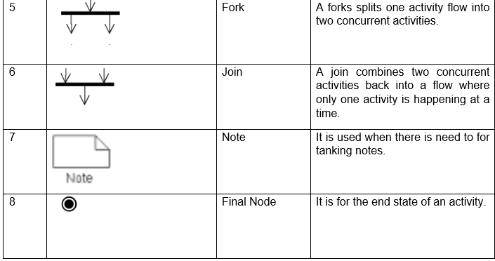

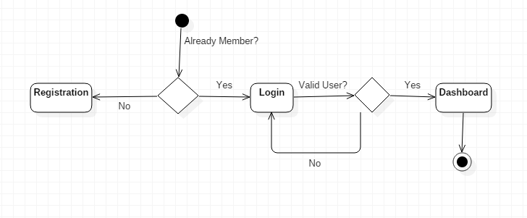

Figure 3: Sequence Diagram of Login and Registration

The activity diagram of my system is shown below

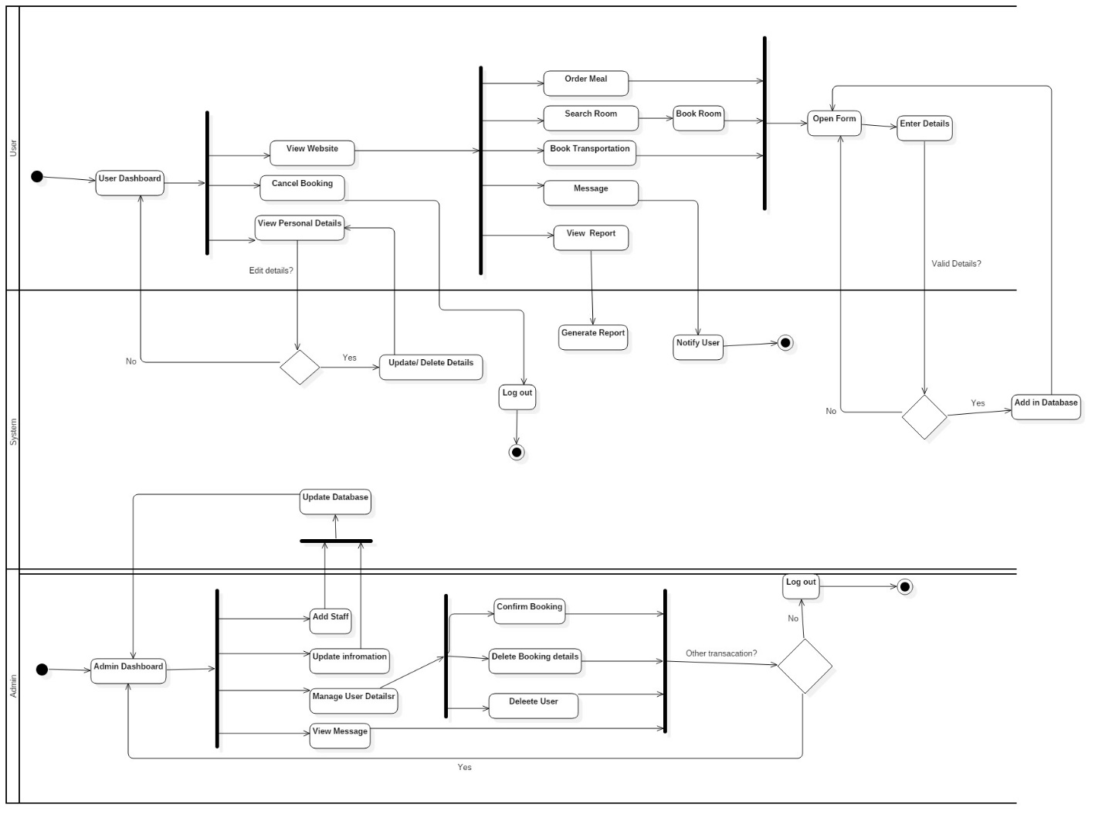

Figure 4: Sequence Diagram of user and admin

This activity diagram shows that after successfully login user can view their personal details and can update or delete their details whereas user can view the website and can search for room availability, transportation, food ordering and request for booking. After booking system checks its validity details and confirm by sending notifications. The user can cancel their booking and can logout of their account. Whereas, Admin can view user details, messages and can also update the information in the site.

# 3.2.2 Sequence modelling

A sequence diagram illustrates the interactions arranged in time sequence which depicts the object and classes involved in the scenario and message exchanged between the object that needed to be carry out the functionality. The stages for illustrating the ordering of the messages according to time.

I have chosen sequence diagram due to following reason

* In order to show the behavior of several objects within a single use case which show the collaboration among the objects.
* It presents complex fact in an understanding way by showing element interaction with each other.
* It supports the logical analysis for parts of the system that works within it.

The notation used in sequence diagram is shown below

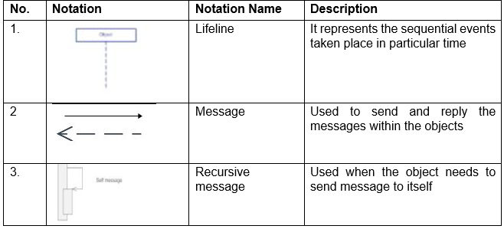

The following diagram shows the sequence interaction between user, login, system.

# signinSequence

Figure 5: sequence diagram of login and registration

The following diagram shows how the whole system is going to work.

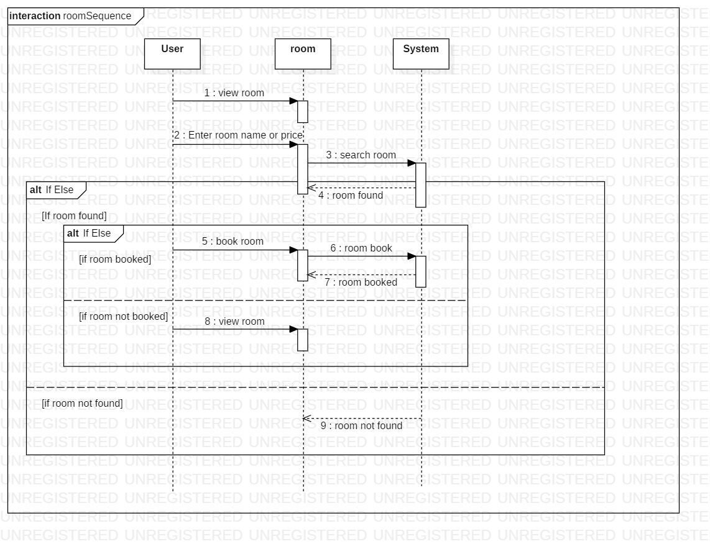

Figure 6: Sequence Diagram of work flow

# 3.3 Database modelling

A database model illustrates the logical structure including the relationship and constraints of the database that determine the how data can be stored and can be accessed. Here data model is represented by accompanying database design.

# 3.3.1 Data dictionary

The collection of the set of the information that describe the structure, format and contents of the database and their relationship between the element which is used to access control and manipulate the database which shows the standard definition of the data 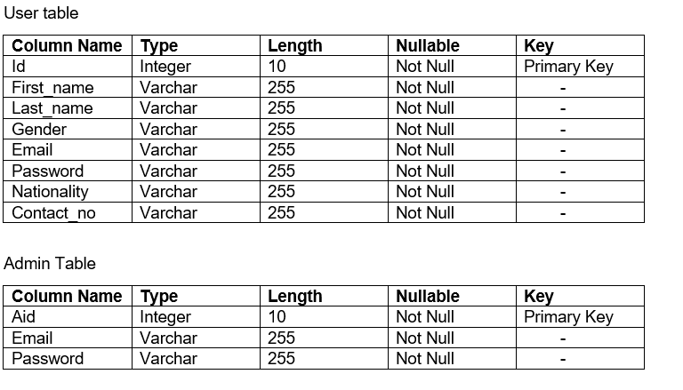

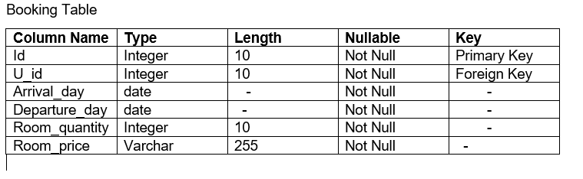

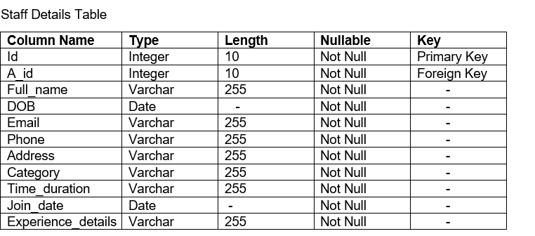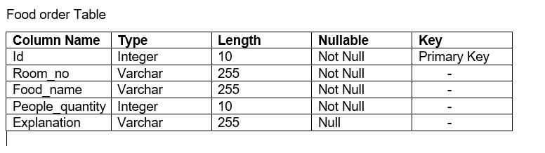

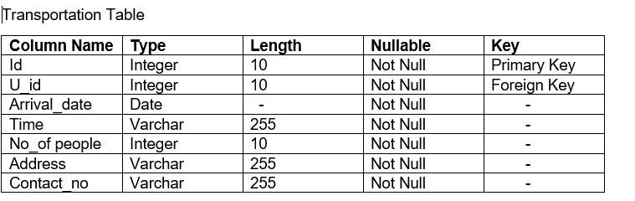

# 3.3.2 ER diagram

An entity relationship (ER) diagram is the graphical illustration of an information system that represent the relationship among people, objects, concepts, places or events within the system boundaries.

The reason behind for making ER diagram for my project is mentioned below:

* Entity can be determined.
* It helps to know about cardinality of relationship.
* Relation between entities can be known.

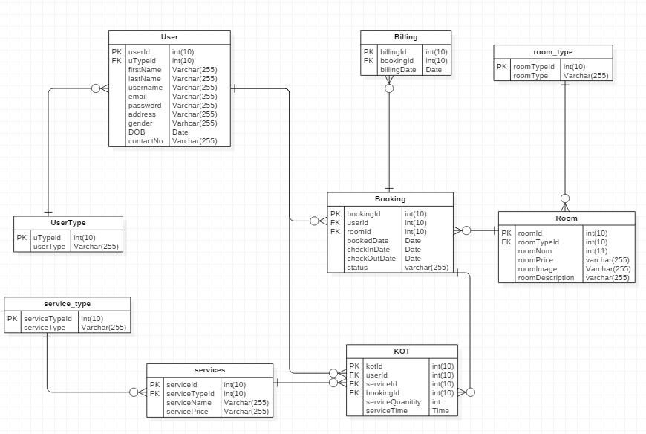

Figure 7: Er diagram

# 3.4 UI Modeling Design

The graphical interface for the software that is aim to create for user that makes easy to use and increase efficiency. It includes not only design but also control panels, voice-controlled interface.

# 3.4.1 Prototyping

Prototyping is considered as a kind of sample about how the software is going to be or how the system works in it. Here we have used balsamic for making the digital prototype.

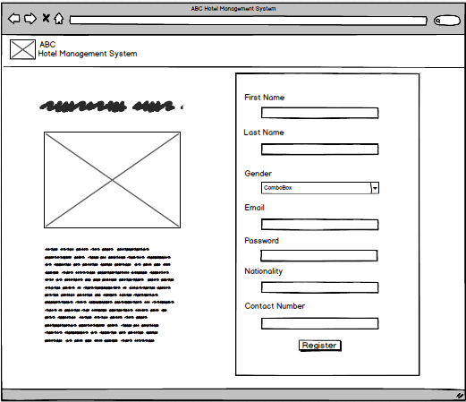

Figure 8:Registration form

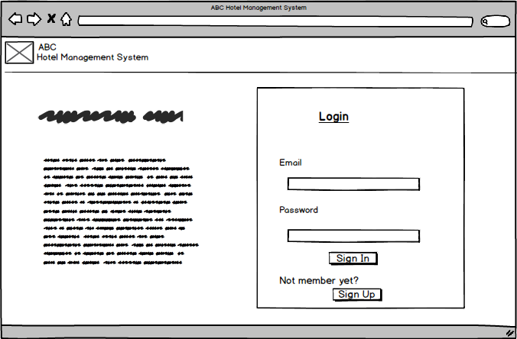

Figure 9: Login Form

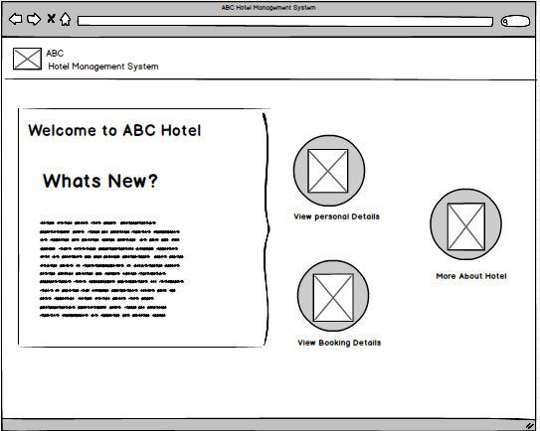

Figure 10: User Dashboard

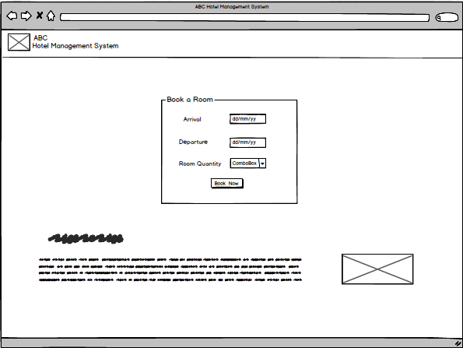

Figure 11: Booking form

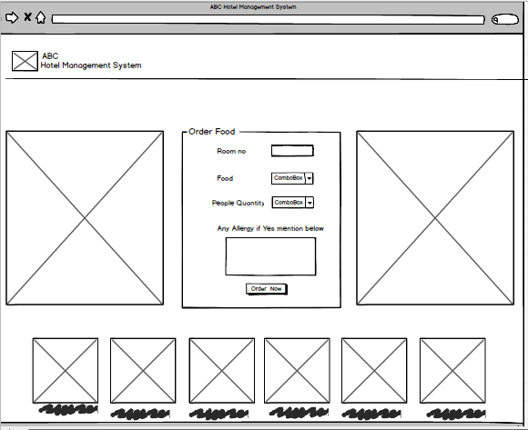

Figure 12: Food order form

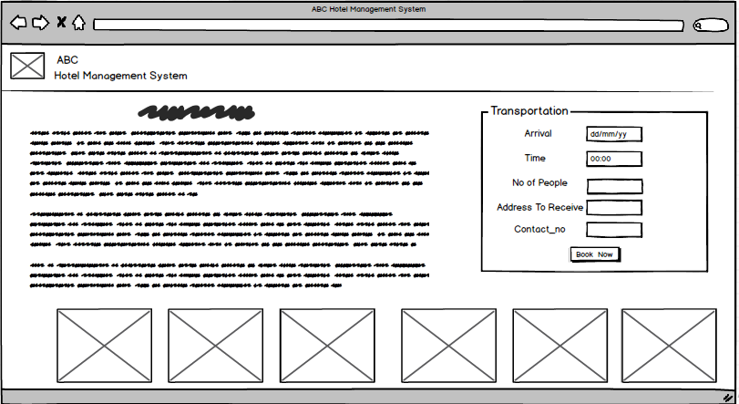

Figure 13: Transportation form

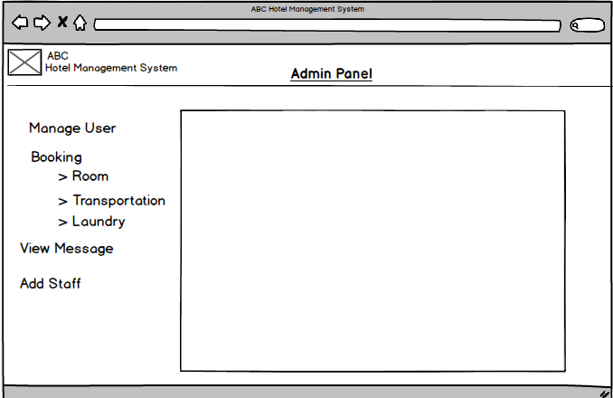 Figure 14:Admin Dashboard

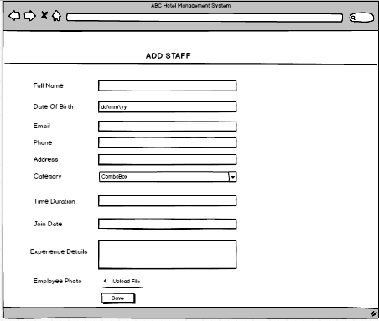

Figure 15:Staff information form