**PROPOSAL ON HOTEL MANAGEMENT SYSTEM**



**MODULE NAME: Computing Project**

**Submitted by:** **Submitted to:**

Name: Saraswoti Luitel Module leader

NCC ID: 00175884 Sudeep Lal Bajimaya

Email: Sersoti.luitel11@gmail.com

Batch: 23 ‘A’

Table of Contents

Chapter 1 4

Introduction 4

1.1 Introduction of the system 4

1.2 Background of the system 4

1.3 Justification of the project 5

1.4 Overview of the proposed system 5

Chapter 2 6

Scope 6

2.1 Aims of the project 6

2.2 Objectives of the project 6

2.3 Features of the project 6

2.4 Overview of the Scope 7

Chapter 3 8

Development Methodologies 8

3.1 Methodologies 8

3.2 Design Pattern 9

3.3 System Architecture 10

Chapter 4 11

Scheduling 11

4.1 WBS (Work Breakdown Structure) 11

4.2 Milestones 12

4.3 Scheduling / Gantt Chart 14

Chapter 5 16

Risk Management 16

Chapter 6 18

Configuration Management 18

Conclusion 20

References 21

**Table of Figures**

Figure 1: Waterfall Methodology 8

Figure 2: MVC Pattern 9

Figure 3: Three Tier Architecture 10

Figure 4: Work Break Down structure 11

Figure 5: WBS in ProjectLibre 14

Figure 6: Gantt Chart 15

Figure 7:GitHub screenshot 18

Figure 8:project local directory 19

# Chapter 1

## Introduction

### 1.1 Introduction of the system

This project will be developed for smooth running and management of hotel. This is introduced for replacing the problem faced in current manual system in the hotel. It is designed to ensure maximum efficiency of the system at the hotel. The system will indeed help the hotel management and the esteemed staff member to manage and steer the hotel’s functionality and transactions to realize its maximum potential in addition to its competence in the hotel business field.

### 1.2 Background of the system

Most of the hotel management system contains booking, data entry, information sharing about hotel in which the current manual system uses paperwork and direct verbal communication to manage the hotel system in which only few adapt the computerized system. Booking is done via phone calls or through visit to the main office. The personal details of guest such as Name, Age, Nationality, and Duration of stay and other information are input during booking. This delays information transmission in the hotel. The data entry on paper-based work is transmission through manually to data entry department from reception.

#### **Problem statement**

The current manual system is not in systematic way which creates numbers of problem in management.

1. Difficulty in location of guest files: due to the large number of guests’ files, location of guest files during checking in, updating of daily expenditures, receipt generation and checking out can be extremely difficult for the hotel employees.

2. Human and computational errors: Many errors enabled by the system due to tedious computations required during data processing.

3. Poorly generated records: Poorly generated records encourage omission of some important data by the employees which can bring conflicts in future days.

4. less secure of information: Due to poor condition of file management there is no secureness in data protection.

5. Difficulty in data analysis: The accountants usually found it difficult to analyze the guests’ data during generation of bills due to missing of some records.

### 1.3 Justification of the project

Nowadays, hotel business is increasing day by day which also increase in maintaining the data who engage in hotel business. Thus, the hotel system should be upgraded in order to increase efficiency of the work. The employee engaged in maintaining the data of the customers may sometime cause error to the work due to lack of systematic computerized system. This system will include the quality which make the work efficiency.

### 1.4 Overview of the proposed system

The employee or user whoever will be using this system, they will easily adapt the system as it is user friendly. The customer can easily book their required room online along with other many services like ironing, laundry and swimming services. Their personal information is saved in secured way so that no other unauthorized people can access the data.

This system tends to improve the way of recording the data which can be easily accessible and insertable. If there is proper inserting of records then there will be less conflicts in managing the bills system as well. This can lead to secureness in information of customers.

# 

# Chapter 2

## Scope

### 2.1 Aims of the project

The aim of the project is to increase the efficiency of the system of hotel management in which also focuses on secondary aim as:

* To make ensure the hotel would have proper management system so that user will have no problem engaging in any kind of hotel business.
* To replace the manual paper work system in hotel management industry into systematic computer-based system.

### 2.2 Objectives of the project

The main objectives for the development of project is to ensure proper management system. Some of them are mentioned below.

* To enable online booking system through internet.
* To enable reliable communication with the hotel administration through comment or contact details.
* To enable modification of user details in authorized way.
* To retrieve the hotel information details.
* Ensuring secure measures to avoid unauthorized access to customers personal details.
* To cancel the booking if needed.

### 2.3 Features of the project

The features of Hotel Management System Software are mentioned below:

* **Online Booking/ Cancellation of booking**

The user can book their rooms according to their preference and their budget allocation. The user can cancel their booking if needed.

* **Login and Registration**

The user can login and register in order to enjoy website features.

* **Feedback / Comments from customers/ visitors**

The user can keep their point of view or suggestion by commenting or messaging them.

* **Rating system**

The user can rate their experience through this.

* **CRUD Functions**

The user can add, retrieve, update or delete their entry.

* **Admin control of system**

Admin has access control to the file. Admin can review the customer query and see customers data.

### 2.4 Overview of the Scope

The system includes booking of the accommodation, meals following by side service like laundry, room services, ironing which can also be chosen beforehand while booking. The customer details are saved in the database which can be seen by the admin user only and have authority to manage it. However, one customer has no authority to see or modify other customer personal information. The visitors can also message or send query through direct message or message sect.

# Chapter 3

# Development Methodologies

### 3.1 Methodologies

The theoretical and systematical analysis of method applied to a field is methodology. The method used in this system is waterfall methodology.

The waterfall model is the earliest SDLC approach that was used for software development. It illustrates the software development process in a sequential flow which means that, we cannot overlap to another phase until previous phase is complete. (Anon, 2017)In this project I have used waterfall methodology because It is easy to use and understand as well as easy to manage and work are smaller and easy to understand the requirements.

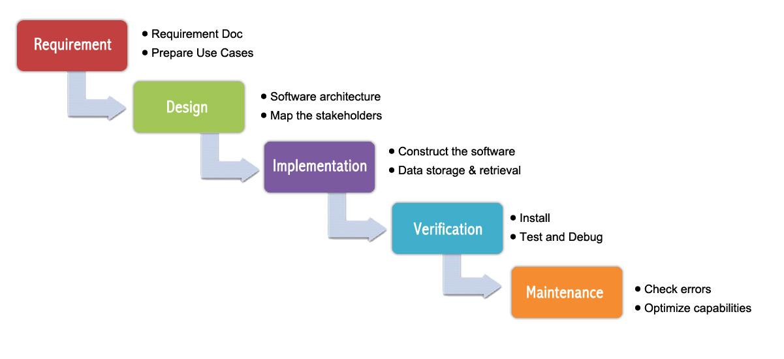

Figure : Waterfall Methodology

### 3.2 Design Pattern

We can find various type of design pattern such as flyweight design pattern, singleton design pattern, MVC pattern. In which I will be processing my application in MVC pattern. Model-View-Controller is the design pattern which is efficiently and successfully relating the user interface to underlying data model. It is useful for the reuse of object code. MVC is actually an event handler that deal with user input to data. (Kumar, 2015)

* Model: It represents the logical structure of data in the software application.
* View: It is the collection of classes that represent the content of any information about user interface that can be seen or respond by user that include CRUD function.
* Controller: It represent the connection or communication of classes between model and view.

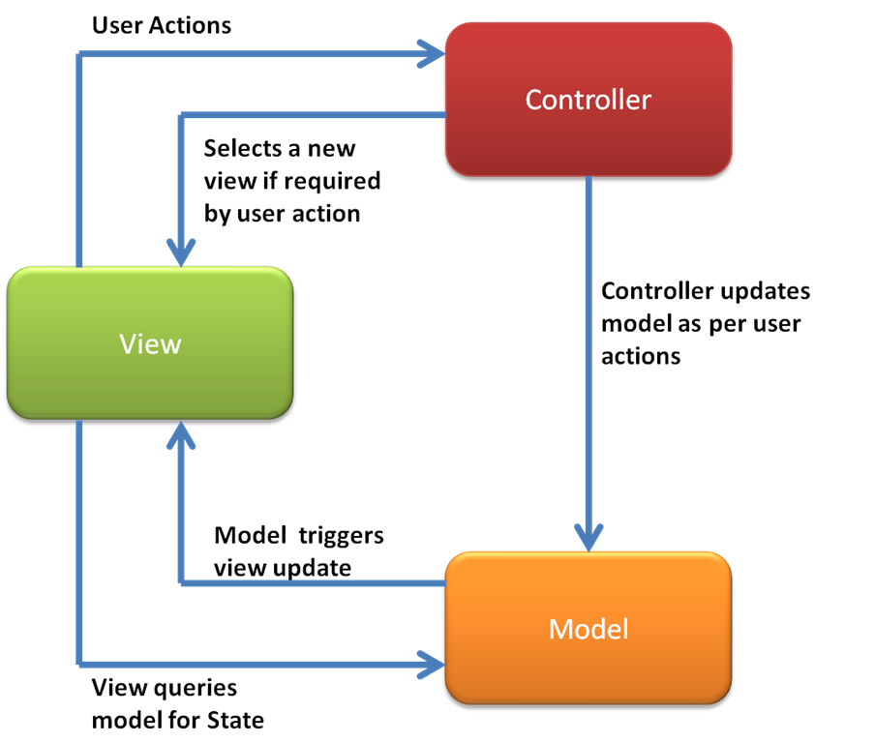

Figure : MVC Pattern

### 3.3 System Architecture

System architecture is response to the conceptual and practical difficulties of the description and the design of complex systems. It helps to describe consistently and design efficiently complex system. As a conceptual design it helps to explain a system view, behavior and its structure.

A three- tier architecture is a software design pattern and a well-established software architecture. Also known as client-server architecture. The functional process logic, data access, computer data storage and user interface are developed and maintained on separate platforms as independent modules. (Rouse, 2018)

.

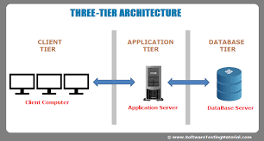

Figure : Three Tier Architecture

# Chapter 4

## Scheduling

### 4.1 WBS (Work Breakdown Structure)

Work Breakdown is carried out so that the project can be divided from complex project into simple manageable form. We can understand and decide to continue the work according to their complex level of this project as defined below.

Figure : Work Break Down structure

### 4.2 Milestones

A milestone is one of the most important aspect that need to be done in any project planning. It is also known as visible indicators of project progress towards its objectives. It also helps the developer to understand the structure of the project. (Harned, 2018) Proper creation of milestone indicates that a project is proceeding according to a plan and trigger corrective action.

|  |  |  |  |
| --- | --- | --- | --- |
| **Hotel management system** | | | |
| **WBS number** | **Milestone** | **Date (2019)** | **Days** |
| **1** | **Proposal** | **(16 June – 1 July )2019** | **16 days** |
| 1.1 | Scope and objectives | 16 June- 19 June | 4 days |
| 1.2 | WBS, Milestone and Gantt Chart | 20 June – 23 June | 4 days |
| 1.3 | Risk Management | 24 June – 26 June | 3 days |
| 1.4 | Configuration Management | 27 June – 29 June | 3 days |
| 1.5 | Submission | 30 June – 1 July | 2 days |
| **2** | **Analysis** | **(2 July- 29 July) 2019** | **28 days** |
| 2.1 | Feasibility study | 2 July- 13 July | 12 days |
| 2.2 | Specification Requirement | 14 July – 26 July | 13 days |
| 2.3 | Use Case Diagram | 27 July – 29 July | 3 days |
| **3** | **Design** | **(30 July – 29 August) 2019** | **31 days** |
| 3.1 | Structural Model  [Class Diagram] | 30 July – 6 August | 8 days |
| 3.2 | Behavior Model | 7 August – 14 August | 8 days |
| 3.3 | Database design  [ER diagram]  [Data-Dictionary] | 15 August – 22 August | 8 days |
| 3.4 | User Interface (UI) Design | 23 August - 29 August | 7 days |
| **4** | **Coding** | **(30 August – 20 September) 2019** | **22 days** |
| 4.1 | Build Database | 30 August – 7 September | 9 days |
| 4.2 | Implementation of code | 8 September – 20 September | 13 days |
| **5** | **Testing** | **(21 September – 30 September) 2019** | **10 days** |
| 5.1 | Black Box Testing | 21 September- 23 September | 3 days |
| 5.2 | Unit Testing | 24 September – 27 September | 4 days |
| 5.3 | Validation Testing | 28 September- 30 September | 3 days |
| **6** | **Documentation** | **(1 October – 12 October) 2019** | **12 days** |
| 6.1 | User Manual | 1 October – 8 October | 8 days |
| 6.2 | Final Report | 9 October - 12 October | 4 days |

### 

### 4.3 Scheduling / Gantt Chart

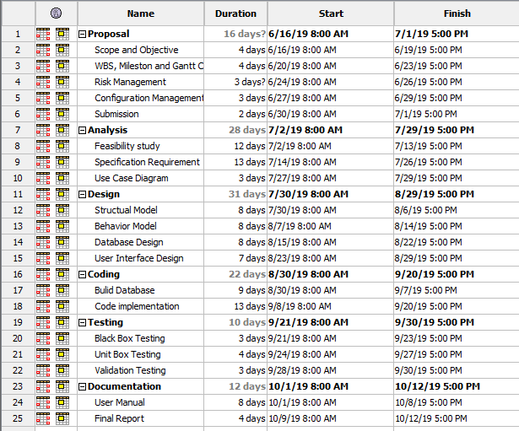

Figure : WBS in ProjectLibre

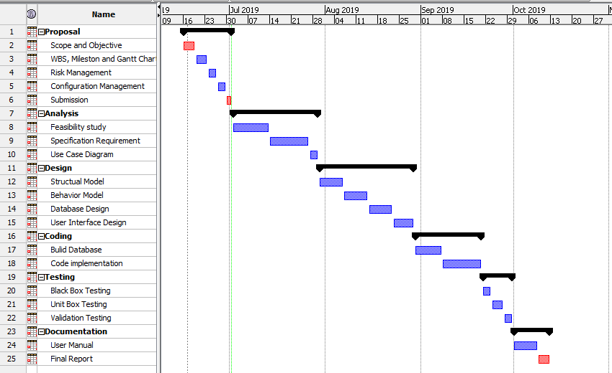

Figure : Gantt Chart

# Chapter 5

## Risk Management

Risk management is the process of identifying, assessing and controlling threats to an organization’s capital and earning which could stem from a wide variety of sources, including financial uncertainly, legal liabilities, strategic management errors, natural disaster or any kind of accidents. (Impe, 2017)

1. Identity the Risk

The risk needs to be recognized that might affect our project. So, number of techniques can be applied.

1. Analyze the risk

After risk identification, we need to understand the its potential to affect project goal and objectives with its likelihood and consequences.

1. Evaluate or Rank the Risk

After analysis to the consequences and likelihood, we need to decide its acceptance whether it is serious enough to warrant treatment.

1. Treat the Risk

In this step, we need to access our highest ranked risk and set out the plan to treat these risks and has to decide to minimize the probability of the negative risk. We create strategies, preventive plans and contingency plan in this step or risk treatment measures for the highest-ranking risk.

1. Review the Risk

This is the step where we take our risk register and use it to monitor, track and review risks.

In order to calculate the Impact on the system following formula is implemented:

**Impact = Likelihood * Consequences**

|  |  |
| --- | --- |
| **Likelihood Table** | |
| **Likelihood** | **Value** |
| Low | 1 |
| Medium | 2 |
| High | 3 |

|  |  |
| --- | --- |
| **Risk Consequences Table** | |
| **Consequence** | **Value** |
| Very low | 1 |
| Low | 2 |
| Medium | 3 |
| High | 4 |
| Very high | 5 |

**Risk Management table:**

|  |  |  |  |  |  |
| --- | --- | --- | --- | --- | --- |
| **RID** | **Risk Name** | **Likelihood** | **Consequence** | **Impact** | **Solution** |
| 1 | Virus/ Malware | 2 | 4 | 8 | Antivirus should be installed and daily scan should be done. |
| 2 | External hazards | 1 | 3 | 3 | Proper safety measures for hazards. |
| 3 | Lack of proper requirement specification | 2 | 5 | 10 | Proper user requirement analysis should be done. |
| 4 | Bug on code | 2 | 3 | 6 | Proper testing should be done before deployment. |
| 5 | Untrained developer | 1 | 5 | 5 | The developer should be given training. |
| 6 | Strategy risk | 2 | 5 | 10 | Proper planning should be done before implementation. |
| 7 | Server failure | 1 | 5 | 5 | Back up should be done time to time. |

# 

# Chapter 6

## Configuration Management

It manages the configuration of all the project key products and assets. This includes any end products that will be delivered to the customer, as well as all management products such as the project management plan and performance management baseline. It is basically process of recording and tracking updates, changes and progresses during software development process.

I will be keeping all the progress in the GitHub. I’ll also backup every change in my software development process so that I’ll have a complete backup of my configuration management and can utilize it if the original records are missed.

In order to access the file anytime from anywhere, here in GitHub, files and folders are manage in systematic way.

In order to access the project, click on following link

<https://github.com/Saraswoti1/CP>

n 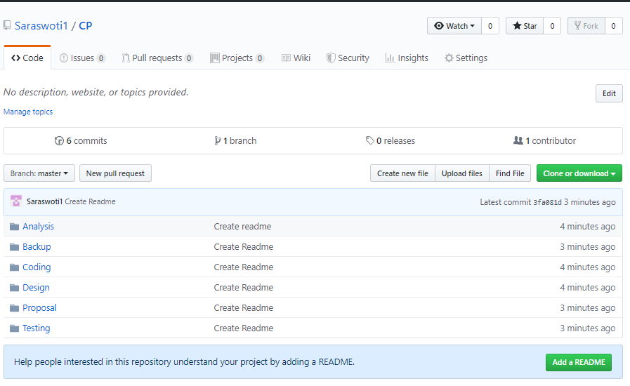

Figure :GitHub screenshot

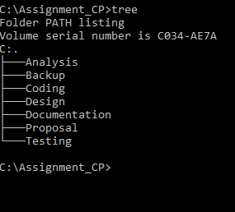

Figure :project local directory

# Conclusion

After certain information gathering, the system is readily available in the market and cheaply affordable by any kind of hotel. Hence. With the overview completion of proposal, this system helps in the field of hotel management. The features included in tis system helps in maintaining the environment secured and trustworthy.

# References

Anon, 2015. *Tutorials point.* [Online]   
Available at: https://www.tutorialspoint.com/design_pattern/mvc_pattern.htm  
[Accessed 20 04 2019].

Anon, 2017. *Tuitorialpoint.* [Online]   
Available at: https://www.tutorialspoint.com/sdlc/sdlc_waterfall_model.htm  
[Accessed 19 06 2019].

Harned, B., 2018. *Teamgantt.* [Online]   
Available at: https://www.teamgantt.com/blog/the-how-and-why-of-using-milestones-in-your-project-plan  
[Accessed 22 06 2019].

Impe, K. V., 2017. *Security Intelligence.* [Online]   
Available at: https://securityintelligence.com/simplifying-risk-management/  
[Accessed 20 06 2019].

Kumar, S., 2015. *GeeksforGeeks.* [Online]   
Available at: https://www.geeksforgeeks.org/mvc-design-pattern/  
[Accessed 18 06 2019].

Rouse, M., 2018. *TechTarget.* [Online]   
Available at: https://searchsoftwarequality.techtarget.com/definition/3-tier-application  
[Accessed 21 16 2019].