# Installation:

## Install Vue

npm install vue@next

Or

npm install -g vue@next (-g Indicates global)

## Install Vue CLI

npm install -g @vue/cli

## Install NodeJS

<https://nodejs.org/en/>

## Install yarn

npm install -g yarn

# Vue Ecosystem

## Vue Router

## Install Vue Router

npm install -g vue-router@4

# Create And Serve first VueJS application:

~~Create:~~

~~Command: vue create <<app-name>>~~

~~Ex: vue create -d hello-world~~

~~-d: Creates hello-world app with all defaults~~

*~~Note: This may create Vue 2 application~~*

Create Vue3 application:

vue create hello-world-vue3

***Note: This will prompt to select vue3 and package manager npm or***

***yarn***

Serve:

Change to hello-world-vue3 directory

Execute command:

npm run serve

Or

yarn serve

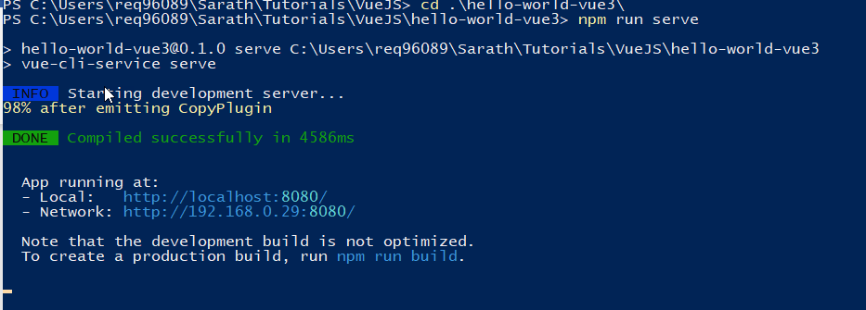

Access hello-world app:

http://localhost:8080/

