AUTOMATIC IRRIGATION SYSTEM USING MICROCONTROLLER

*Note: Sub-titles are not captured in Xplore and should not be used

# M.V.SARATH CHANDER

# 22BAI1148

# COMPUTER SCIENCE SPECIALIZATION IN (AI&ML)

*VIT CHENNAI*

# VISHNU PRASATH

# 22BAI1169

# COMPUTER SCIENCE SPECIALIZATION IN (AI&ML)

*VIT CHENNAI*

***Abstract*—** **The modern world wastes a massive amount of water every single day. It is the need of the hour to come together and make automation-inspired plans to save more water. Water given to plants should be enough to sustain and keep them healthy while also not wasting too much or taking too long to supply them. This project is about a moisture-sensing automatic plant watering system using an 8051 microcontroller. The system senses the moisture level and switches on the irrigation pump when the moisture is below the threshold limit. The system switches off the pump when the moisture rises above the set point. The moisture level threshold can be set using a trim pot on the system. The status of the pump (whether ON or OFF) and the moisture level (LOW OR HIGH) is displayed on a 16×2 LCD display . the presented moisture sensing automatic plant watering system offers an innovative solution for plant care which significantly reducing the manual efforts involved while promoting healthier plant growth by ensuring an optimized and consistent watering .**

1 )**Introduction**

**A)EXISITING SYSTEM:**

The automation of irrigation systems has several positive effects. Once installed, the water distribution on fields or small-scale gardens is easier and does not have to be permanently controlled by an operator. There are several solutions to design automated irrigation systems. Modern big-scale systems allow big areas to be managed by one operator only. Sprinkler, dripper subsurface drip irrigation systems require pumps and some high tech-components and if used for large surfaces skilled operators are also required. Extremely hightech solutions also exist using GIS and satellites to automatically measure the water needs and the content of each crop parcel and optimise the irrigation system. But automation of irrigation can sometimes also be done with simple, mechanical appliances: clay pots or porous capsule irrigation networks or bottles. Nowadays drone technology is becoming very helpful in agricultural usage. Many people across the world are using drones to water their crops which is 20% more than last year. A centralized control system processes the data obtained from sensors. It uses algorithms to determine the precise irrigation needs based on factors such as plant type, soil type, weather conditions, and time of year.

*B.* ***PROBLEM DEFINING :***

The automation of irrigation systems has several positive effects. Once installed, the water distribution on fields or small-scale gardens is easier and does not have to be permanently controlled by an operator. There are several solutions to design automated irrigation systems. Modern big-scale systems allow big areas to be managed by one operator only. Sprinkler, dripper subsurface drip irrigation systems require pumps and some high tech-components and if used for large surfaces skilled operators are also required. Extremely hightech solutions also exist using GIS and satellites to automatically measure the water needs and the content of each crop parcel and optimise the irrigation system. But automation of irrigation can sometimes also be done with simple, mechanical appliances: clay pots or porous capsule irrigation networks or bottles. Nowadays drone technology is becoming very helpful in agricultural usage. Many people across the world are using drones to water their crops which is 20% more than last year. A centralized control system processes the data obtained from sensors. It uses algorithms to determine the precise irrigation needs based on factors such as plant type, soil type, weather conditions, and time of year.

C. ***PROPOSED SYSTEM:***

We thoroughly try to understand that this is programmed in such a way that it will sense the moisture level of the plants and supply the water if required automatically This type of system is often used for general plant care, as part of caring for small and large gardens. Normally, the plants need to be watered twice daily, morning and evening. So, the microcontroller has to be coded to water the plants in the greenhouse about two times per day. People enjoy plants, their benefits and the feeling related to nurturing them. However for most people it becomes challenging to keep them healthy and alive. To solve this problem we made a project for those who cannot water the plant due to their busy schedule or when they go outside for long time. The system automation is designed to be assistive to the user. We hope that through this project people will enjoy having plants without the challenges related to absent .

**2)IRRIGATION SYSTEM USING SENSOR**

1. *Methodology:* The project is designed to develop an automatic irrigation system which switches the pump motor ON/OFF on sensing the moisture content of the soil. In the field of agriculture, the use of proper methods of irrigation is important. The advantage of using this method is to reduce human intervention and still ensure proper irrigation. The project uses an 8051 series microcontroller which is programmed to receive the input signal of varying moisture conditions of the soil through the sensing arrangement. This is achieved by using an op-amp as a comparator which acts as an interface between the sensing arrangement and the microcontroller.
2. *Design Approach:* The specific design used in this circuit is universal to all 8051 microcontroller circuits that are interfaced with a sensor or an LCD peripheral. The standard input and output connections have been used and the power supply is a normal +12V DC supply. Such components are good to use in a circuit for simpler applications like this one as they are low-cost, easily available and highly accessible in most areas and therefore this automatic system will be easily accessible as well. The comparator module and sensor should be cleaned and handled carefully as they are the main components interacting with the outside world and thus they must be protected from rusting, etc

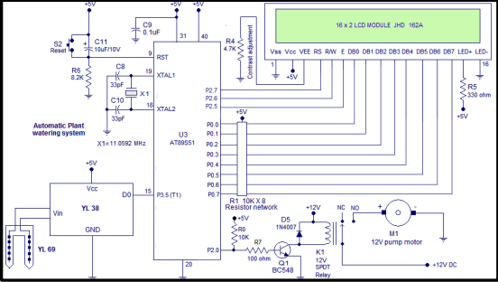

Circuit diagram

***C. Technical Specifications Components:***

i) YL 69 MOISTURE SENSOR PROBE***:***

The sensor contains a fork-shaped probe with two exposed conductors that goes into the soil or anywhere else where the water content is to be measured. As said before, it acts as a variable resistor whose resistance varies according to the soil moisture. The sensor is set up by two pieces: the electronic board (at the right), and the probe with two pads, that detects the water content (at the left).

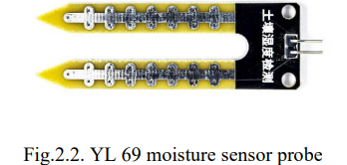

***ii) YL 38 COMPARATOR MODULE:***

The module has a built-in potentiometer for sensitivity adjustment of the digital output (DO). You can set a threshold by using a potentiometer; So that when the moisture level exceeds the threshold value, the module will output LOW otherwise HIGH. This setup is very useful when you want to trigger an action when a certain threshold is reached. So when the moisture level in the soil crosses a threshold, you can activate a relay to start pumping water***.***

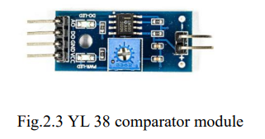

***iii) 16*2 LCD MODULE:***

An LCD is an electronic display module that uses liquid crystal to produce a visible image. The 16×2 LCD display is a very basic module commonly used in DIYs and circuits. The 16×2 translates a display of 16 characters per line in 2 such lines. In this LCD each character is displayed in a 5×7 pixel matrix

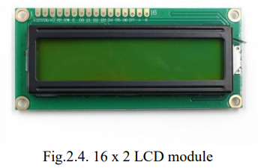

***iv)8051MICROCONTROLLER***:

The 8051 microcontroller was designed by Intel in 1981. It is an 8-bit microcontroller. It is built with 40 pins DIP (dual inline package), 4kb of ROM storage and 128 bytes of RAM storage, 2 16-bit timers. It consists of four parallel 8-bit ports, which are programmable as well as addressable as per the requirement

* + 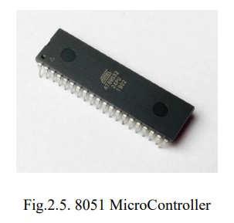
  + ***v) BC548 TRANSISTOR***:

12 BC548 is an NPN transistor so the collector and emitter will be left open (Reverse biased) when the base pin is held at the ground and will be closed (Forward biased) when a signal is provided to the base pin. BC548 has a gain value of 110 to 800, this value determines the amplification capacity of the transistor. The maximum amount of current that could flow through the Collector pin is 500mA, hence we cannot connect loads that consume more than 500mA using this transistor. To bias a transistor we have to supply current to the base pin, this current (IB) should be limited to 5mA.

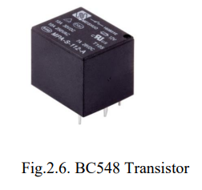

***vi) SPDT RELAY 12V***:

These are high-quality Single Pole - Double Throw (SPDT) sealed 12V Sugar Cube relays. Use them to switch high voltage (240AC), and/or high current devices(7A). This relay's coil is rated up to 14V, with a minimum switching voltage of 10V.

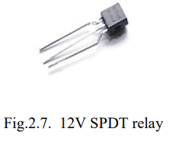

***vii) 1N4007 DIODE:***

13 1N4007 is a rectifier diode, designed specifically for circuits that need to convert alternating current to direct current. It can pass currents of up to 1 A, and have a peak inverse voltage (PIV) rating of 1,000

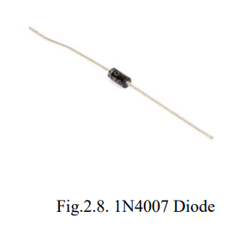

***viii) DC PUMP MOTOR:***

A DC water pump is a machine that transports liquid or pressurised liquid. When the water pump is working, the coil and commutator rotate, but the magnetic steel and carbon brushes do not rotate. The alternating current direction of the coil is changed by the commutator and brushes that rotate with the motor

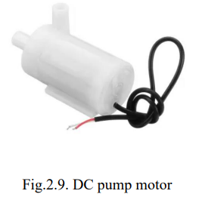

***ix) IC555:***

The 555 timer IC is an integrated circuit used in a variety of timer, delay, pulse generation, and oscillator applications. Derivatives provide two or four timing circuits in one package.

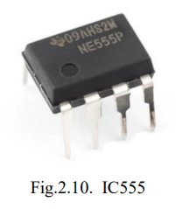

THQ

TQ

***x) RESISTORS:***

A resistor is a passive two-terminal electrical component that implements electrical resistance as a circuit element. In electronic circuits, resistors are used to reduce current flow, adjust signal levels, divide voltages etc. Here we use 8.2k,4.7k,10k, 100, and 330 ohms resistors to build the circuit.

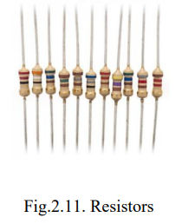

***xi) CAPACITORS:***

Ceramic capacitors are mainly used for high stability performances and wherein devices with low losses. These devices provide very accurate results and also the capacitance values of these capacitors are stable with respect to the applied voltage, frequency and temperature. Here we use 33pF,10pF, and 0.1uF capacitors to build our circuit.

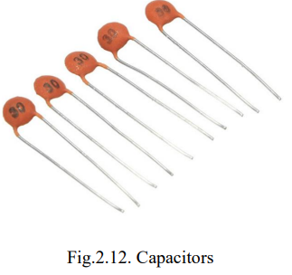

***xii) 11.0592 CRYSTAL OSCILLATOR***:

A crystal oscillator is an electronic oscillator circuit that uses the mechanical resonance of a vibrating crystal of piezoelectric material to create an electrical signal with a very precise frequency. Here we use a crystal oscillator of 11.0592 MHz.

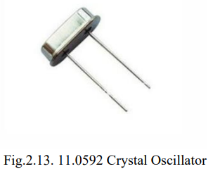

***xiii) 2-PIN SWITCH:***

A "2-pin switch" generally refers to a switch with two electrical pins or terminals. These are simple switches that can be used in various electronic circuits to control the flow of electrical current. The two pins typically represent the open and closed states of the switch.

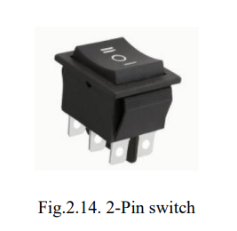

***xiv) POWER SUPPLY:***

Here we use a 5V and 12V power supply for making the circuit work.

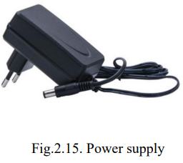

***CONCLUSION:***

This chapter sums up the details of the methodology, design approach of the circuit and the components required to build the circuit. Through the chapter, it is understood that the device can be used in an effective way to solve the problems of water management during monsoons on a farm. The device is also cost-effective and hence economical to be used by an Indian farmer for daily use.

***Future Work:***

The use of mobile phones gives an extra advantage by controlling the motor as well as fencing. The project can be extended to greenhouses where manual supervision is far and few in between. The principle can be extended to create fully automated gardens and farmlands. Combined with the principle of rainwater harvesting, it could lead to huge water savings if applied in the right manner. In agricultural lands with a severe shortage of rainfall, this model can be successfully applied to achieve great results with most types of soil.

***APPENDIX***

***8051 CODE USED IN THE PROJECT :***

***RS EQU P2.7***

***RW EQU P2.6***

***E EQU P2.5***

***ORG 00H***

***SETB P3.5***

***MOV TMOD,#00000001B***

***MAIN:ACALL DINT***

***ACALL TEXT1***

***JB P3.5, NEXT***

***ACALL LINE2***

***ACALL TEXT2***

***CLR P2.0***

***SJMP EXIT***

***NEXT:ACALL LINE2***

***ACALL TEXT3***

***SETB P2.0***

***EXIT:ACALL DELAY1***

***SJMP MAIN***

***DELAY1:MOV R0,#15D***

***BACK1: MOV TH0,#00000000B***

***MOV TL0,#00000000B***

***SETB TR0***

***HERE2: JNB TF0,HERE2***

***CLR TR0***

***CLR TF0***

***DJNZ R0,BACK1***

***RET***

***TEXT1: MOV A,#"M"***

***ACALL DISPLAY***

***MOV A,#"o"***

***ACALL DISPLAY***

***MOV A,#"i"***

***ACALL DISPLAYMOV A,#"s"***

***ACALL DISPLAY***

***MOV A,#"t"***

***ACALL DISPLAY***

***MOV A,#"u"***

***24***

***ACALL DISPLAY***

***MOV A,#"r"***

***ACALL DISPLAY***

***MOV A,#"e"***

***ACALL DISPLAY***

***MOV A,#" "***

***ACALL DISPLAY***

***MOV A,#"C"***

***ACALL DISPLAY***

***MOV A,#"o"***

***ACALL DISPLAY***

***MOV A,#"n"***

***ACALL DISPLAY***

***MOV A,#"t"***

***ACALL DISPLAY***

***MOV A,#"r"***

***ACALL DISPLAY***

***MOV A,#"o"***

***ACALL DISPLAY***

***MOV A,#"l"***

***ACALL DISPLAY*** ***RET***

***TEXT2: MOV A,#"["***

***ACALL DISPLAY***

***MOV A,#"O"***

***ACALL DISPLAY***

***MOV A,#"K"***

***ACALL DISPLAY***

***MOV A,#"]"***

***ACALL DISPLAY***

***MOV A,#" "***

***ACALL DISPLAY***

***MOV A,#"P"***

***ACALL DISPLAY***

***MOV A,#"u"***

***ACALL DISPLAY***

***MOV A,#"m"***

***ACALL DISPLAY***

***MOV A,#"p"***

***ACALL DISPLAY***

***MOV A,#" "***

***ACALL DISPLAY***

***MOV A,#"O"***

***25***

***ACALL DISPLAY***

***MOV A,#"F"***

***ACALL DISPLAY***

***MOV A,#"F"***

***ACALL DISPLAY***

***RET***

***TEXT3: MOV A,#"["***

***ACALL DISPLAY***

***MOV A,#"L"***

***ACALL DISPLAY***

***MOV A,#"o"***

***ACALL DISPLAY***

***MOV A,#"w"***

***ACALL DISPLAY***

***MOV A,#"]"***

***ACALL DISPLAY***

***MOV A,#" "***

***ACALL DISPLAY***

***MOV A,#"P"***

***ACALL DISPLAY***

***MOV A,#"u"***

***ACALL DISPLAY***

***MOV A,#"m"***

***ACALL DISPLAY***

***MOV A,#"p"***

***ACALL DISPLAY***

***MOV A,#" "***

***ACALL DISPLAY***

***MOV A,#"O"***

***ACALL DISPLAY***

***MOV A,#"N"***

***ACALL DISPLAY***

***RET***

***DINT:MOV A,#0CH***

***ACALL CMD***

***MOV A,#01H***

***ACALL CMD***

***MOV A,#06H***

***ACALL CMD***

***MOV A,#80H***

***ACALL CMD***

***MOV A,#3CH***

***ACALL CMD***

***26***

***RET***

***LINE2:MOV A,#0C0H***

***ACALL CMD***

***RET***

***CMD: MOV P0,A***

***CLR RS***

***CLR RW***

***SETB E***

***CLR E***

***ACALL DELAY***

***RET***

***DISPLAY:MOV P0,A***

***SETB RS***

|  |  |  |  |
| --- | --- | --- | --- |
| ***S.NO*** | ***link*** | ***author*** |  |
| ***1)*** |  |  |  |
|  |  |  |  |
|  |  |  |  |
|  |  |  |  |
|  |  |  |  |
|  |  |  |  |
|  |  |  |  |

***CLR RW***

***SETB E***

***CLR E***

***ACALL DELAY***

***RET***

***DELAY: CLR E***

***CLR RS***

***SETB RW***

***MOV P0,#0FFH***

***SETB E***

***MOV A,P0***

***JB ACC.7,DELAY***

***CLR E***

***CLR RW***

***RET***

***END***

***LITERATUR SURVEY:***

**REFERENCE PAPER :**

1. [LCD Interfacing with 8051 Microcontroller (89S52): Tutorial with Circuit Diagram and Code (circuitdigest.com)](https://circuitdigest.com/microcontroller-projects/lcd-interfacing-with-8051-microcontroller-89s52)
2. [8051 Dc Motor Interfacing With 8051 | 8051 (electronicwings.com)](https://www.electronicwings.com/8051/dc-motor-interfacing-with-8051)
3. [Power Supply for 8051 Microcontroller | Free Microcontroller Projects - 8051-AVR-PIC (8051projects.info)](http://www.8051projects.info/resources/power-supply-for-8051-microcontroller.61/)
4. [How do soil moisture sensors work? — GroPoint Soil Moisture Sensing](https://www.gropoint.com/new-blog/how-do-soil-moisture-sensors-work)
5. [8051 Microcontroller : Architecture, Block Diagram and Applications (watelectronics.com)](https://www.watelectronics.com/8051-microcontroller-architecture/)
6. <https://www.researchgate.net/publication/321307351_Automatic_Plant_Watering_System>
7. <https://www.researchgate.net/publication/321307351_Automatic_Plant_Watering_System>
8. [**https://www.researchgate.net/publication/343675925_Automated_Watering_and_Irrigation_System_using_Arduino_UNO**](https://www.researchgate.net/publication/343675925_Automated_Watering_and_Irrigation_System_using_Arduino_UNO)
9. <https://www.jetir.org/papers/JETIR2105138.pdf>
10. [**https://www.smec.ac.in/assets/images/research/ece/19-20/102.ARDUINO%20BASED%20AUTOMATIC%20PLANT%20WATERING%20SYSTEM.pdf**](https://www.smec.ac.in/assets/images/research/ece/19-20/102.ARDUINO%20BASED%20AUTOMATIC%20PLANT%20WATERING%20SYSTEM.pdf)
11. [**https://www.sciencedirect.com/science/article/pii/S187705092030096X**](https://www.sciencedirect.com/science/article/pii/S187705092030096X)
12. [**https://www.sciencedirect.com/science/article/pii/S187705092030096X**](https://www.sciencedirect.com/science/article/pii/S187705092030096X)
13. [**https://www.scribd.com/document/441279451/Automatic-Plant-Watering-System**](https://www.scribd.com/document/441279451/Automatic-Plant-Watering-System)
14. [**https://www.irjmets.com/uploadedfiles/paper/issue_10_october_2022/30390/final/fin_irjmets1664790240.pdf**](https://www.irjmets.com/uploadedfiles/paper/issue_10_october_2022/30390/final/fin_irjmets1664790240.pdf)
15. [**https://www.irjmets.com/uploadedfiles/paper/issue_10_october_2022/30390/final/fin_irjmets1664790240.pdf**](https://www.irjmets.com/uploadedfiles/paper/issue_10_october_2022/30390/final/fin_irjmets1664790240.pdf)
16. <https://www.ijraset.com/research-paper/automatic-plant-watering-system>
17. [**https://ijarsct.co.in/Paper2507.pdf**](https://ijarsct.co.in/Paper2507.pdf)
18. •[https://circuitdigest.com/microcontroller-projects/lcd-interfacing-with-8051- microcontroller-89s52](https://circuitdigest.com/microcontroller-projects/lcd-interfacing-with-8051-%20microcontroller-89s52)
19. <https://www.electronicwings.com/8051/dc-motor-interfacing-with-8051>
20. <http://www.8051projects.info/resources/power-supply-for-8051-microcontroller.61/>
21. <https://www.gropoint.com/new-blog/how-do-soil-moisture-sensors-work>
22. <https://www.watelectronics.com/8051-microcontroller-architecture/>
23. <https://technobyte.org/8051-interfacing-with-relays-drive-high-power-peripherals/>