**Multi Charts with QlikView**

**Student ID:** VXM180001

**Date:** 07/11/2019

1. Screenshot of ‘Youth Employment Population’ is:

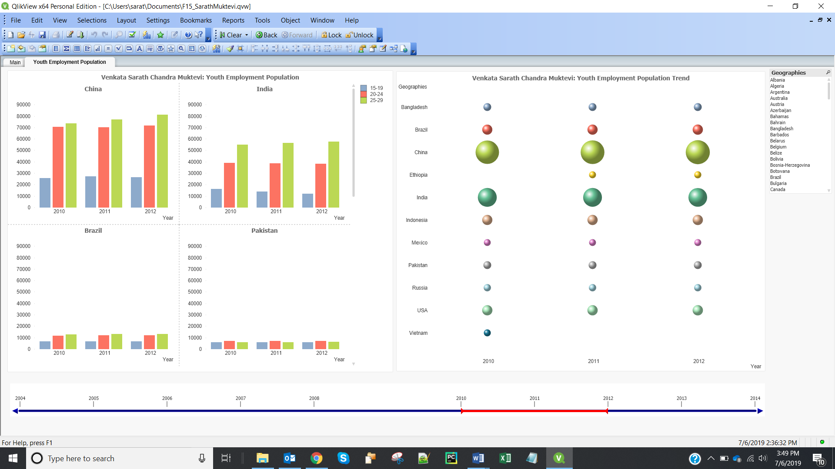

1. **China** has the highest youth employment population between 2004 through 2014. The screen shot of the Youth Employment Population in China for the above period is shown below:

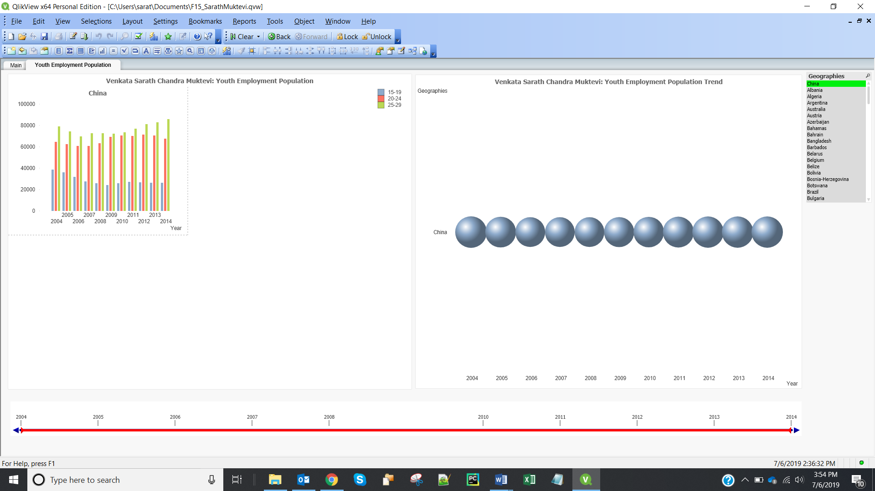

1. Youth employment population from 2005 to 2014 increased from lower to higher age groups in most countries. i.e. Employment population of age group 25-29 is higher than age group 20-24, and employment population of age group 20-24 is higher than 15-19.

Trend in Pakistan: Unlike other countries, where employment population of age group 25-29 is greater than age group 20-24, whereas in Pakistan, employment population of age group 20-24 is greater than other 2 age groups (15-19, 25-29).

1. Screenshot of ‘Youth Gross Income’ is:

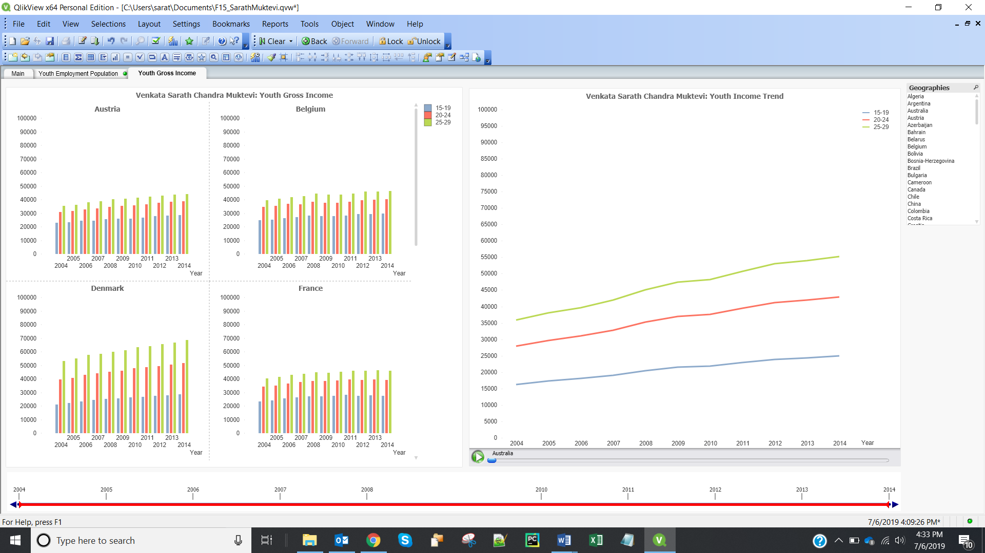

1. In **2009** year, there was a dip in the youth income in United Arab Emirates across all categories.
2. The screenshot of ‘Per Capita Youth Expenditure’ is:

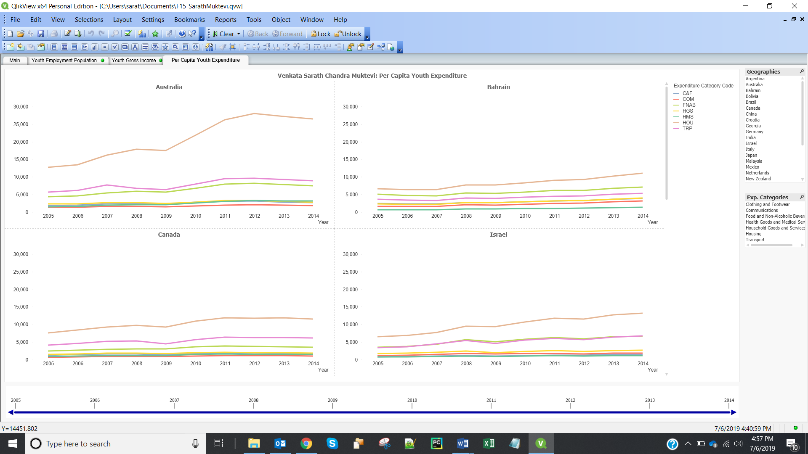

1. On **Housing** commodity, the youth spent most.
2. On **Housing** commodity, the youth in Switzerland spent the most in the year 2007.
3. The screenshot for ‘Aggregated Youth Expenditure’ is:

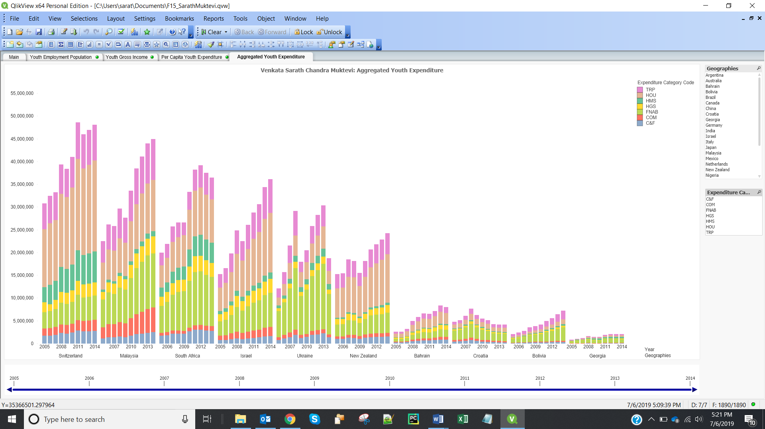

1. In year **2011**, the youth spent on housing the most in Switzerland.
2. In the years **2009** and **2014,** there is a sudden dip in the youth expenditure in Ukraine.