**Visualization using D3**

**Name:** Venkata Sarath Chandra Muktevi

**Date:** 07/25/2019

1. Screenshot of ‘HTML_Document.html’ webpage is:

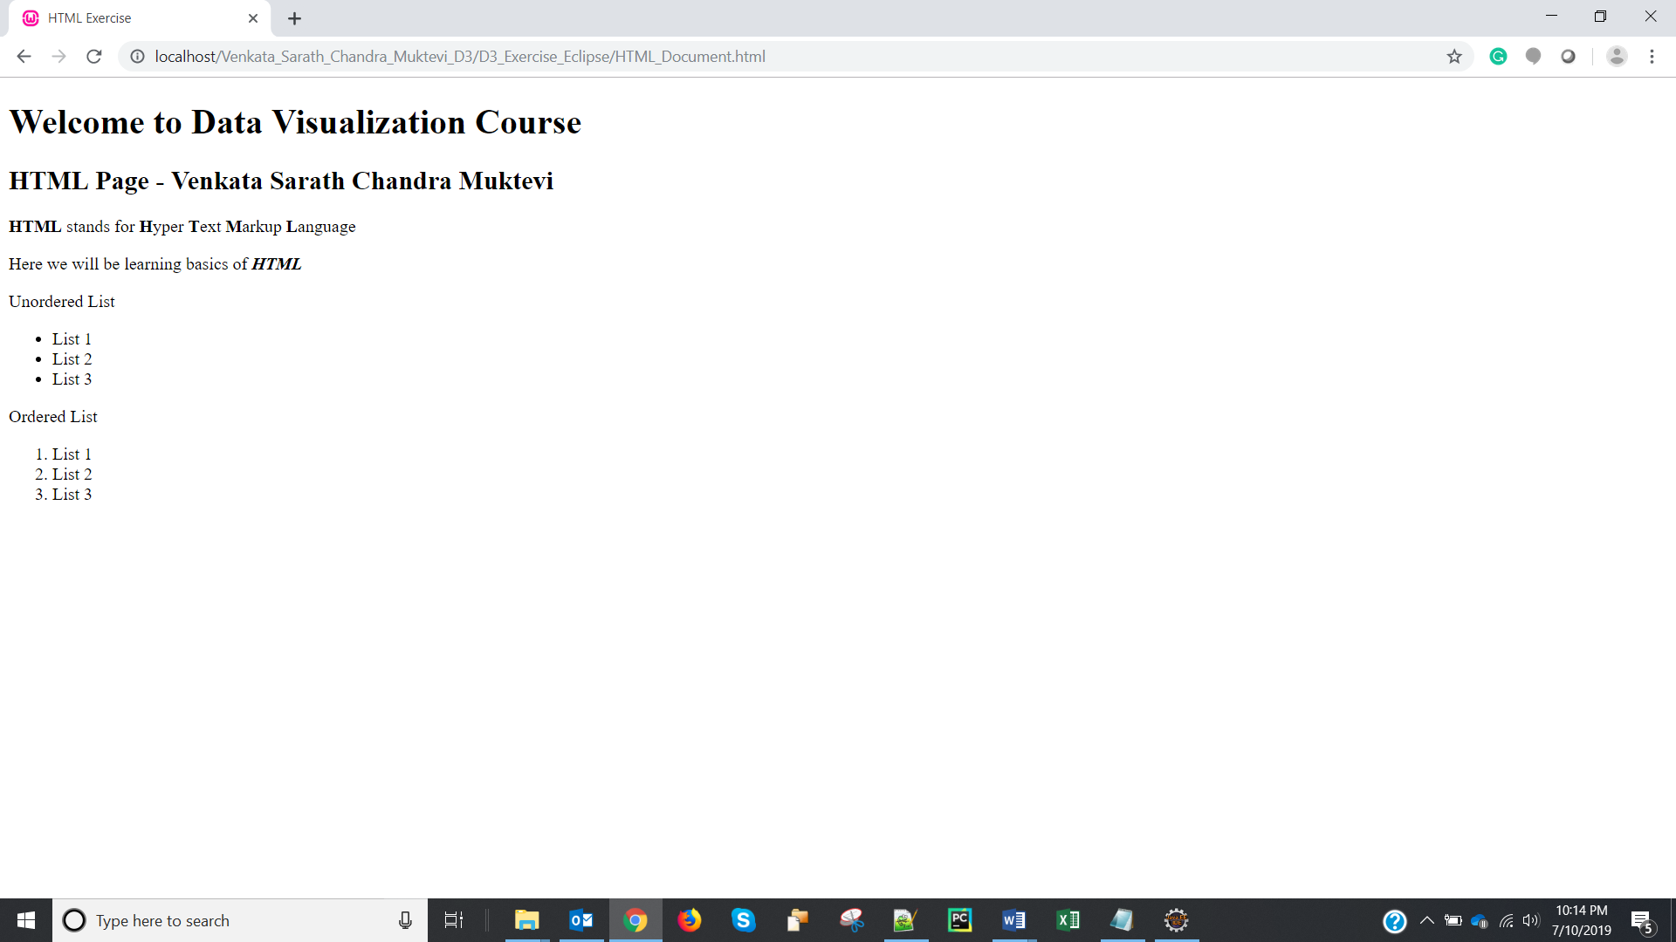

1. Screenshot of ‘HTML_CSS_Link.html’ webpage is:

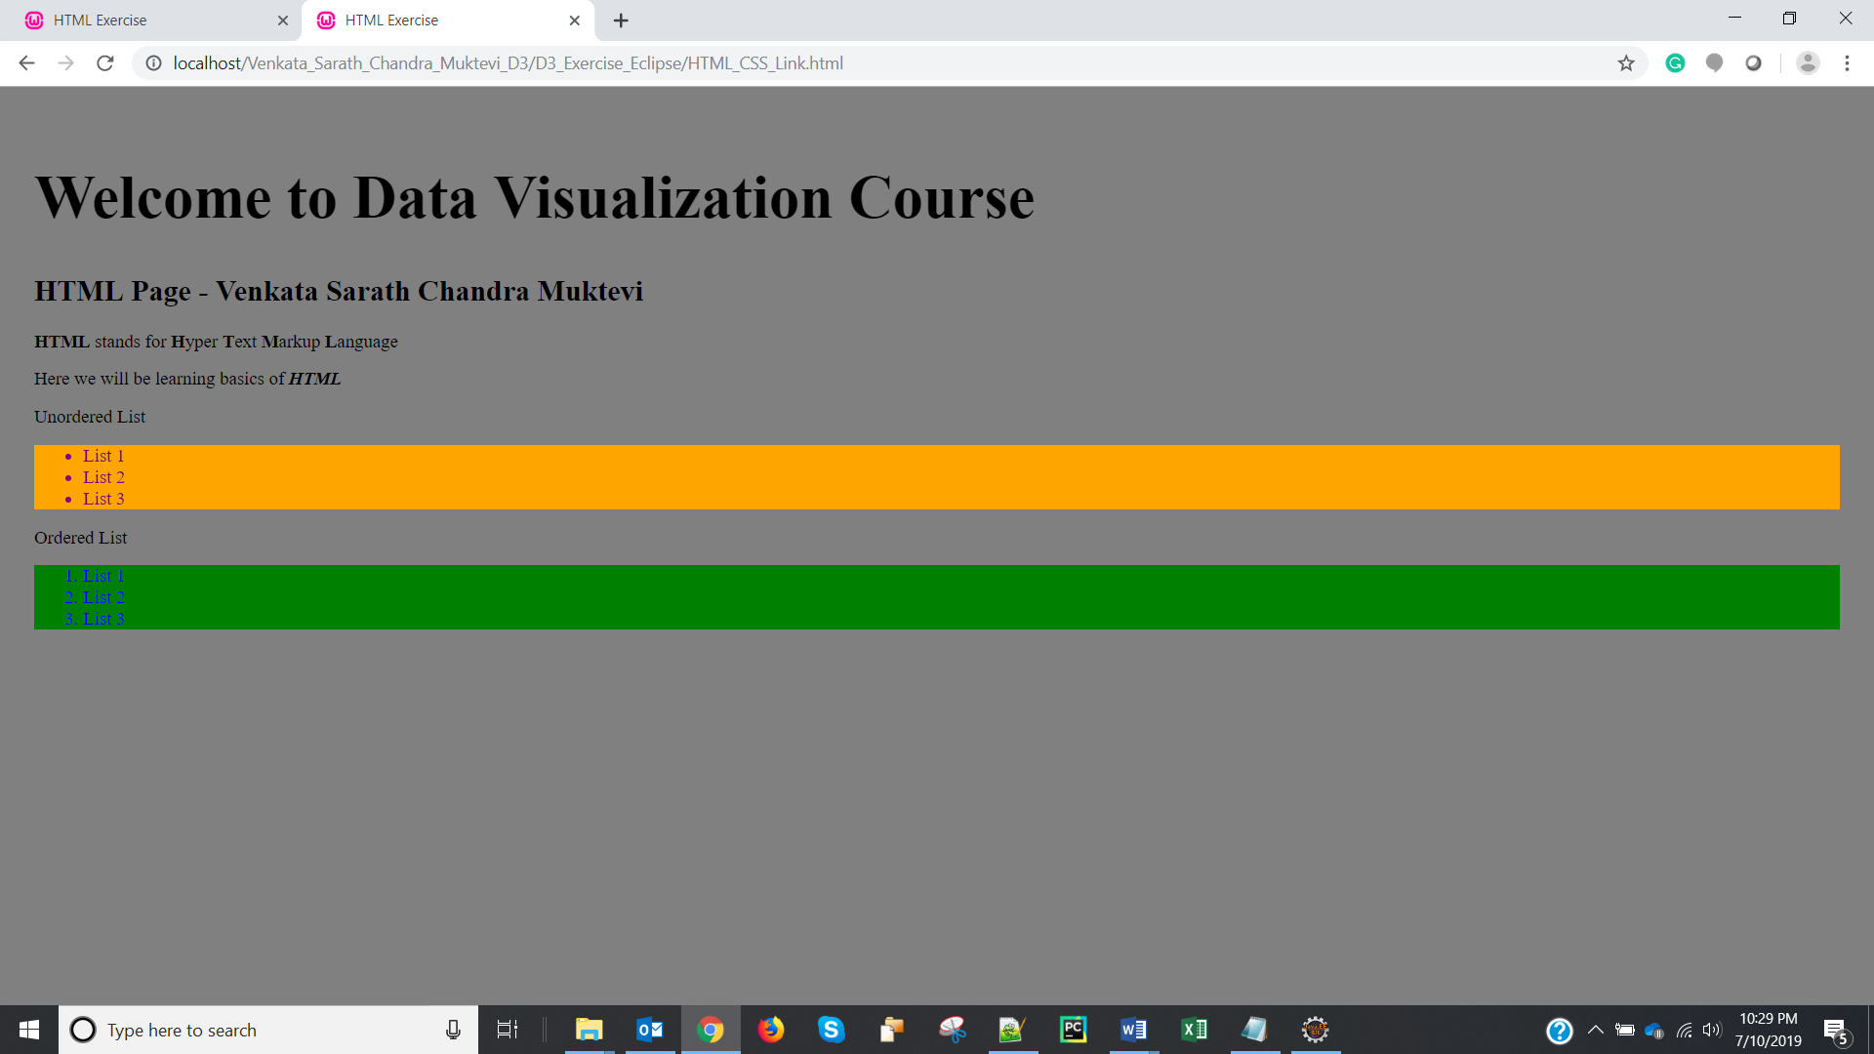

1. Screenshot of ‘HTML_SVG_Included.html’ webpage is:

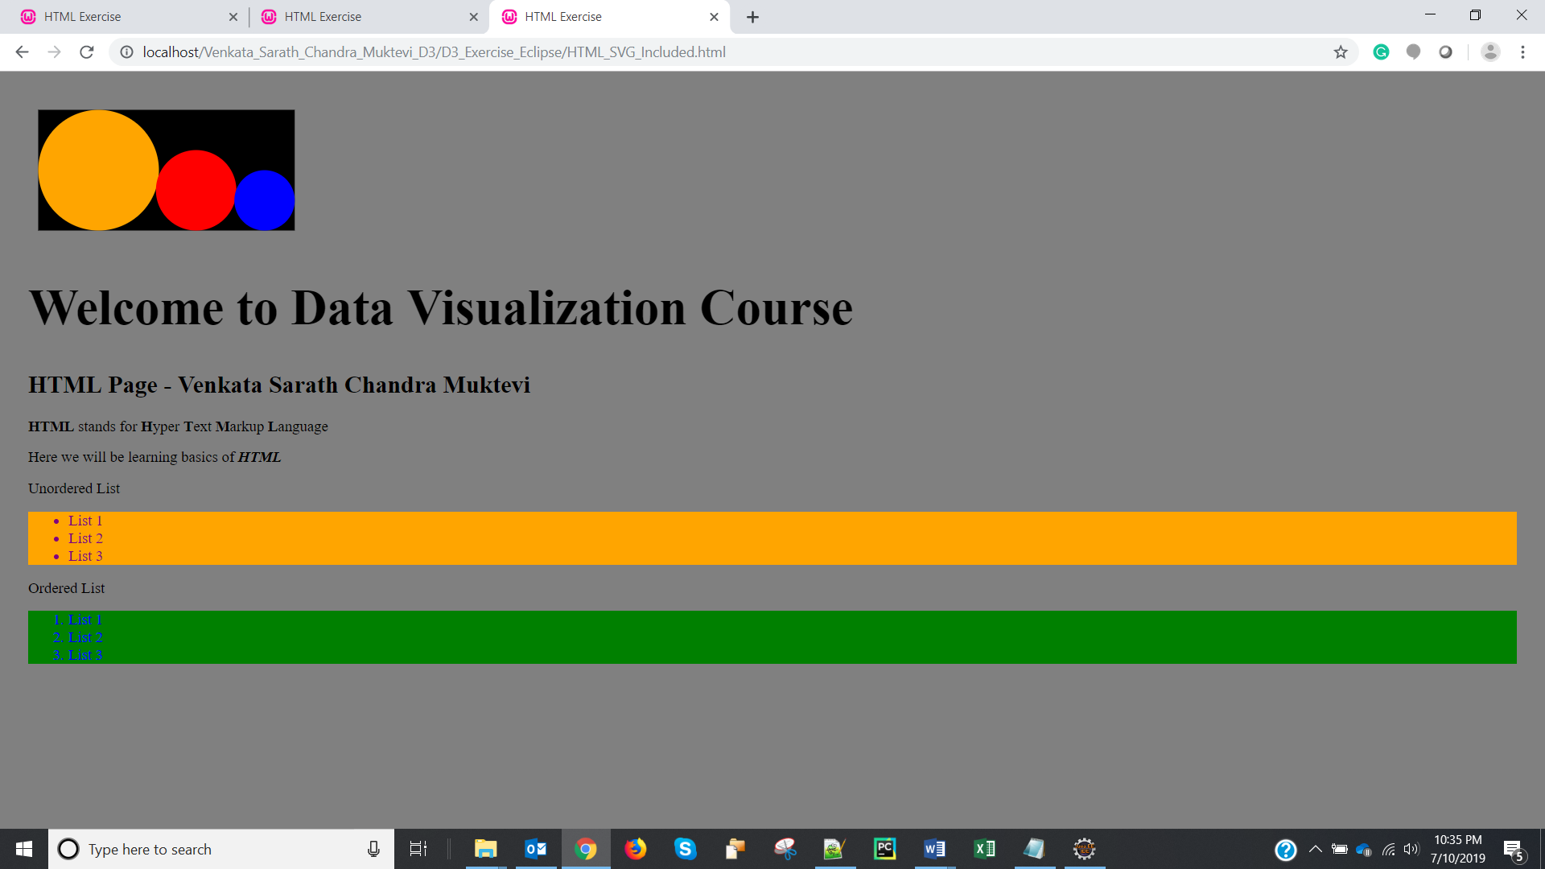

1. Screenshot of ‘Javascript.js’ document after opening it in the web browser is:

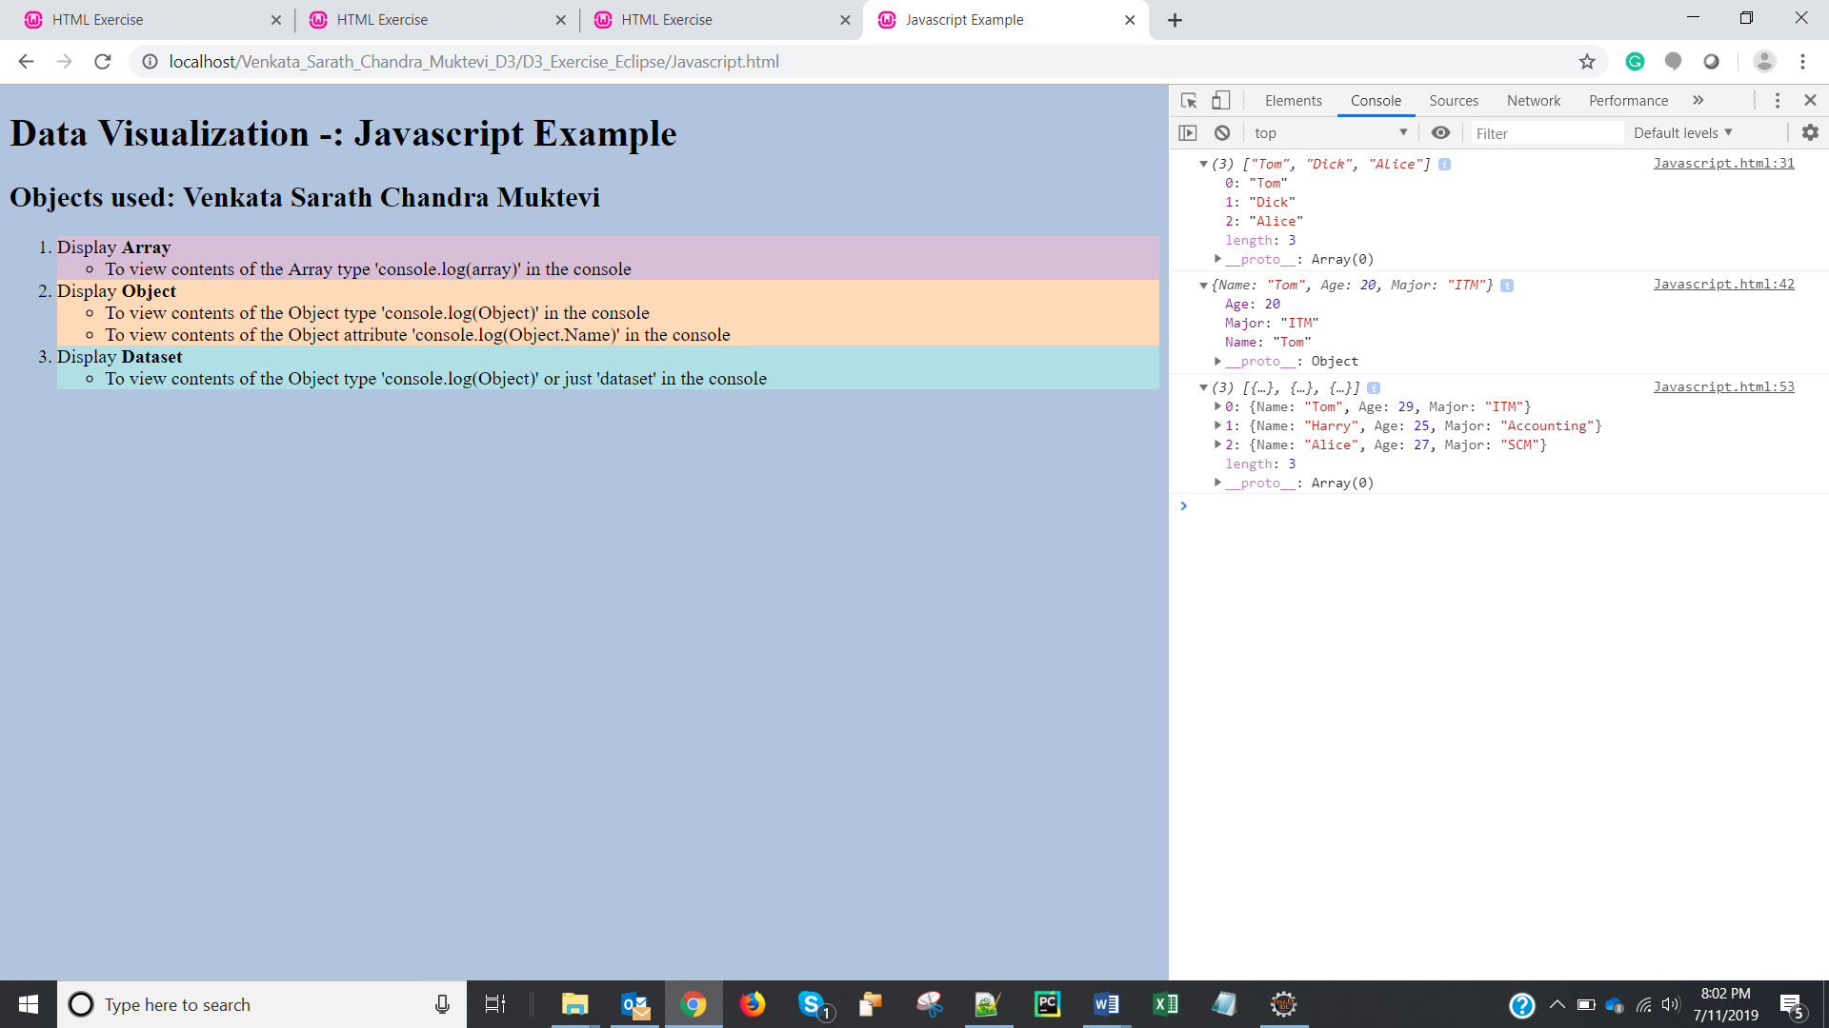

1. Screenshot of the ‘Load_CSV.html’ document after opening it on the web browser and displaying the console log with the array (expanding the array) created after loading the data is:

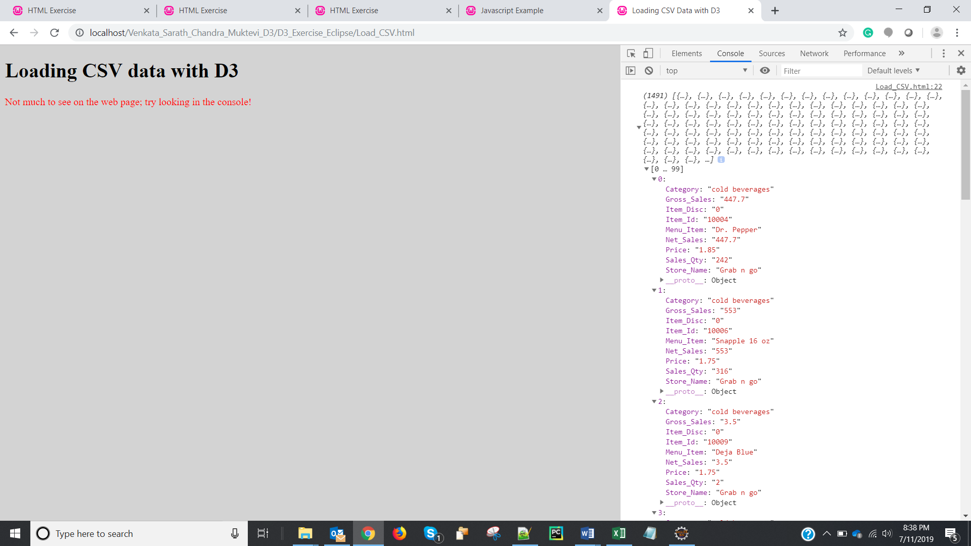

1. We have loaded the following two file types into gist.github.com:
2. **csv** (food_court.csv)
3. **html** (index.html)
4. **index.html** should be the name of the html file while uploading html file in the gist.github.com.
5. Screenshot of the browser with URL after creating a public gist is:

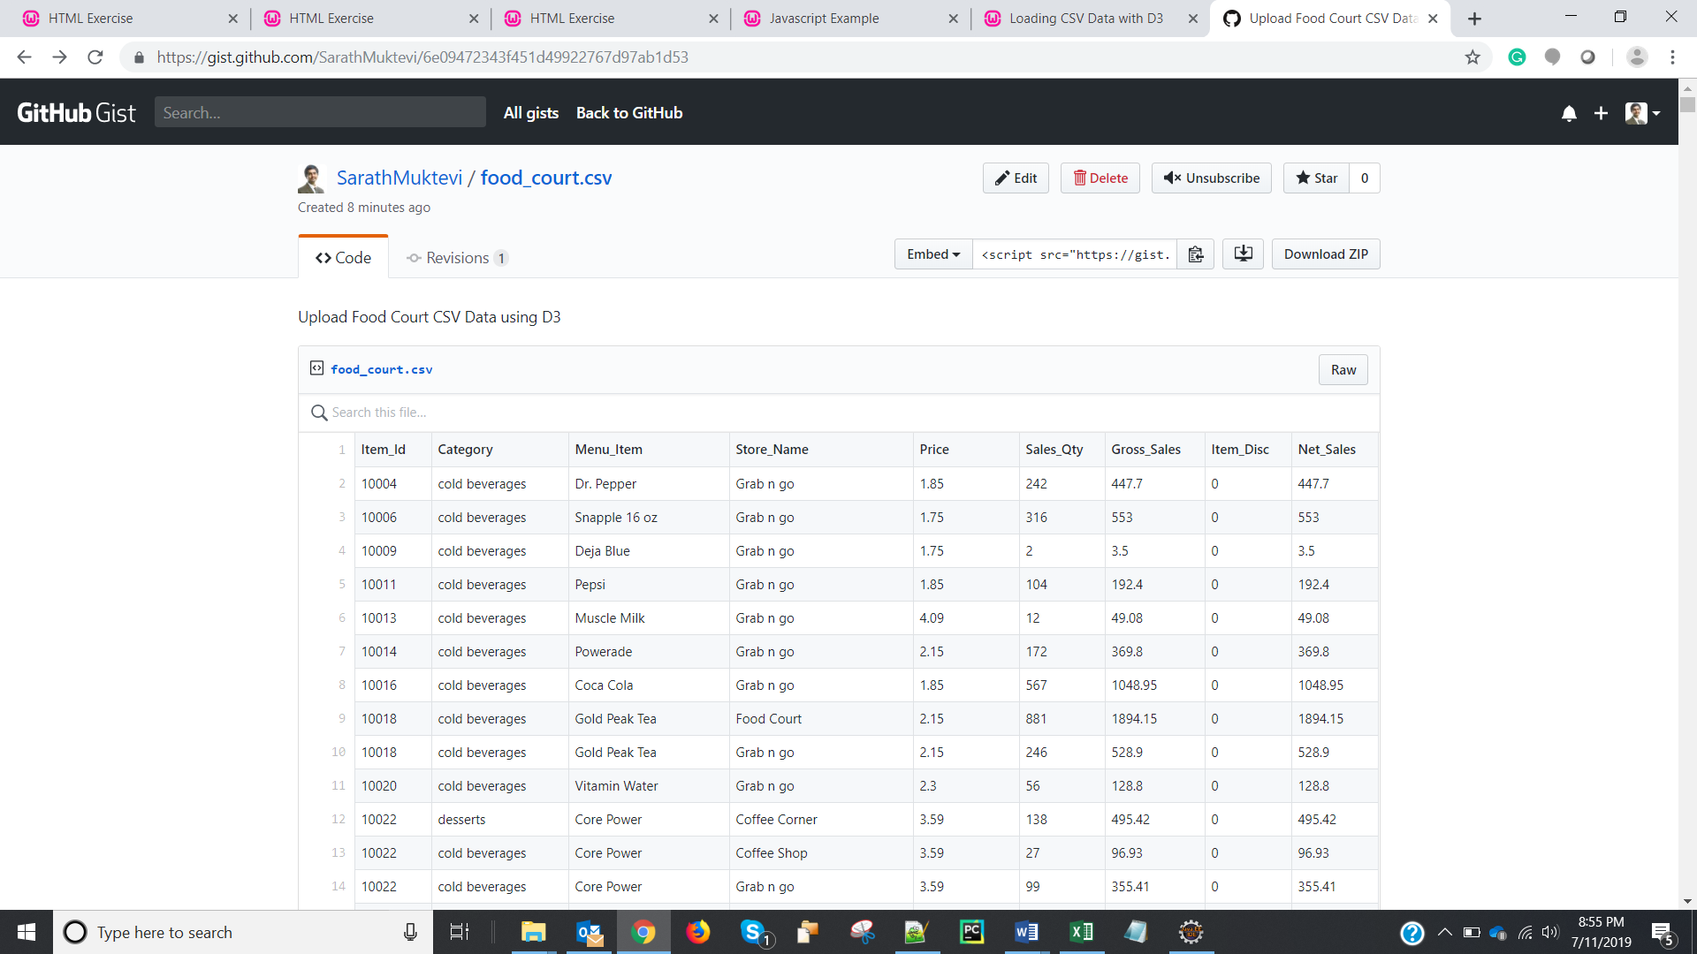

1. Screenshot of the browser after opening the webpage using in bl.ocks.org is:

