

20CYS404

Android Application Development

Lab Exam

Notes App

**Name :** E. Sarath Chandra

**Roll No :** CH.EN.U4CYS21017

# Experiment Number : Lab Exam - 03

**Aim:**

1.Create a Registration page

2.Based on dummy gmail as user name and password – Login

3.Logout

4.Then login again and the session should be maintained the Welcome back “gmail id” should be display

# Code:

**File :** MainActivity.java (Registration Page)

package com.example.registration;  
  
import android.content.ContentValues;  
import android.content.Intent;  
import android.database.sqlite.SQLiteDatabase;  
import android.os.Bundle;  
import android.widget.Button;  
import android.widget.EditText;  
import android.widget.Toast;  
  
import androidx.appcompat.app.AppCompatActivity;  
  
public class MainActivity extends AppCompatActivity {  
  
 EditText name, phone, email, password;  
 Button register, login;  
 SQLiteDatabase db;  
  
 @Override  
 protected void onCreate(Bundle savedInstanceState) {  
 super.onCreate(savedInstanceState);  
 setContentView(R.layout.*activity_main*);  
  
 name = findViewById(R.id.*editTextName*);  
 phone = findViewById(R.id.*editTextPhone*);  
 email = findViewById(R.id.*editTextEmail*);  
 password = findViewById(R.id.*editTextPassword*);  
 register = findViewById(R.id.*buttonRegister*);  
 login = findViewById(R.id.*buttonLogin*);  
  
 // Create/open database  
 db = openOrCreateDatabase("SAMPLEDB", *MODE_PRIVATE*, null);  
 db.execSQL("CREATE TABLE IF NOT EXISTS USERS(NAME VARCHAR, PHONE VARCHAR, EMAIL VARCHAR PRIMARY KEY, PASSWORD VARCHAR);");  
  
 register.setOnClickListener(v -> {  
 String userName = name.getText().toString();  
 String userPhone = phone.getText().toString();  
 String userEmail = email.getText().toString();  
 String userPassword = password.getText().toString();  
  
 if (userName.isEmpty() || userPhone.isEmpty() || userEmail.isEmpty() || userPassword.isEmpty()) {  
 Toast.*makeText*(MainActivity.this, "Please fill all fields", Toast.*LENGTH_SHORT*).show();  
 } else {  
 ContentValues contentValues = new ContentValues();  
 contentValues.put("NAME", userName);

contentValues.put("PHONE", userPhone);

contentValues.put("EMAIL", userEmail);  
 contentValues.put("PASSWORD", userPassword);  
  
 long result = db.insert("USERS", null, contentValues);  
 if (result != -1) {  
 Toast.*makeText*(MainActivity.this, "Registration Successful", Toast.*LENGTH_SHORT*).show();  
 Intent intent = new Intent(MainActivity.this, LoginActivity.class);  
 startActivity(intent);  
 finish();  
 } else {  
 Toast.*makeText*(MainActivity.this, "Registration Failed", Toast.*LENGTH_SHORT*).show();  
 }  
 }  
 });  
  
 login.setOnClickListener(v -> {  
 Intent intent = new Intent(MainActivity.this, LoginActivity.class);  
 startActivity(intent);  
 });  
 }  
}

**File :** MainActivity.xml

<?xml version="1.0" encoding="utf-8"?>  
<LinearLayout xmlns:android="http://schemas.android.com/apk/res/android"  
 xmlns:app="http://schemas.android.com/apk/res-auto"  
 xmlns:tools="http://schemas.android.com/tools"  
 android:id="@+id/main"  
 android:orientation="vertical"  
 android:layout_width="match_parent"  
 android:layout_height="match_parent"  
 tools:context=".MainActivity"  
 android:padding="16dp"  
 android:background="@drawable/background_gradient">  
  
 <TextView  
 android:layout_width="wrap_content"  
 android:layout_height="wrap_content"  
 android:text="Registration"  
 android:textColor="@color/white"  
 android:textSize="30sp"  
 android:padding="30dp"  
 android:layout_marginBottom="50dp"/>  
  
 <ImageView  
 android:id="@+id/logo"  
 android:layout_width="wrap_content"  
 android:src="@drawable/logo"  
 android:layout_height="60dp"  
 android:scaleType="fitEnd"  
 android:layout_marginTop="-40dp"  
 android:layout_alignParentTop="true"  
 android:layout_alignParentEnd="true"  
 android:layout_marginEnd="10dp"  
 android:contentDescription="Logo" />

<EditText  
 android:id="@+id/editTextName"  
 android:layout_width="match_parent"  
 android:layout_height="wrap_content"  
 android:hint="Name"  
 android:padding="15dp"  
 android:backgroundTint="@android:color/white"  
 android:textColorHint="@color/white"

android:layout_marginTop="30dp" />  
  
 <EditText  
 android:id="@+id/editTextPhone"  
 android:hint="Phone number"  
 android:inputType="phone"  
 android:padding="15dp"  
 android:textColorHint="@color/white"  
 android:backgroundTint="@android:color/white"  
 android:layout_width="match_parent"  
 android:layout_height="wrap_content"/>  
  
 <EditText  
 android:id="@+id/editTextEmail"  
 android:hint="Gmail"  
 android:padding="15dp"  
 android:textColorHint="@color/white"  
 android:backgroundTint="@android:color/white"  
 android:inputType="textEmailAddress"  
 android:layout_width="match_parent"  
 android:layout_height="wrap_content"/>  
  
 <EditText  
 android:id="@+id/editTextPassword"  
 android:hint="Password"  
 android:padding="15dp"  
 android:textColorHint="@color/white"  
 android:backgroundTint="@android:color/white"  
 android:inputType="textPassword"  
 android:layout_width="match_parent"  
 android:layout_height="wrap_content"/>  
  
 <Button  
 android:id="@+id/buttonRegister"  
 android:text="Register"  
 android:padding="15dp"  
 android:backgroundTint="#FFFFFF"  
 android:textColor="#A9573C"  
 android:layout_width="match_parent"  
 android:layout_height="wrap_content"/>  
  
 <Button  
 android:id="@+id/buttonLogin"  
 android:text="Login"  
 android:padding="15dp"  
 android:backgroundTint="@color/white"  
 android:textColor="#A9573C"  
 android:layout_width="match_parent"  
 android:layout_height="wrap_content"/>

<TextView  
 android:layout_width="wrap_content"  
 android:layout_height="wrap_content"  
 android:text="Sarath Chandra(21017)"  
 android:textColor="@color/white"  
 android:layout_marginTop="40dp"

android:layout_marginLeft="100dp" />  
  
</LinearLayout>

**File :** LoginActivity.java

package com.example.registration;  
  
import android.content.Intent;  
import android.database.Cursor;  
import android.database.sqlite.SQLiteDatabase;  
import android.os.Bundle;  
import android.widget.Button;  
import android.widget.EditText;  
import android.widget.TextView;  
import android.widget.Toast;  
import androidx.appcompat.app.AppCompatActivity;  
  
  
public class LoginActivity extends AppCompatActivity {  
  
 EditText email, password;  
 Button login;  
 TextView register;  
 SQLiteDatabase db;  
  
 @Override  
 protected void onCreate(Bundle savedInstanceState) {  
 super.onCreate(savedInstanceState);  
 setContentView(R.layout.*activity_login*);  
  
 email = findViewById(R.id.*editTextEmail*);  
 password = findViewById(R.id.*editTextPassword*);  
 login = findViewById(R.id.*buttonLogin*);  
 register = findViewById(R.id.*textViewRegister*);  
  
 // Open database  
 db = openOrCreateDatabase("SAMPLEDB", *MODE_PRIVATE*, null);  
  
 login.setOnClickListener(v -> {  
 String inputEmail = email.getText().toString();  
 String inputPassword = password.getText().toString();  
  
 if (inputEmail.isEmpty() || inputPassword.isEmpty()) {  
 Toast.*makeText*(LoginActivity.this, "Please fill all fields", Toast.*LENGTH_SHORT*).show();  
 } else {  
 // Query to check if user exists with the given email and password  
 Cursor cursor = db.rawQuery("SELECT * FROM USERS WHERE EMAIL=? AND PASSWORD=?", new String[]{inputEmail, inputPassword});  
  
 if (cursor.moveToFirst()) {  
 // Login successful  
 Intent intent = new Intent(LoginActivity.this, WelcomeActivity.class);  
 intent.putExtra("email", inputEmail);  
 startActivity(intent);  
 finish();  
 } else {  
 // Invalid credentials  
 Toast.*makeText*(LoginActivity.this, "Invalid Credentials", Toast.*LENGTH_SHORT*).show();  
 }  
 cursor.close();

}  
 });  
  
 // Handle New User? Register TextView click  
 register.setOnClickListener(v -> {  
 Intent intent = new Intent(LoginActivity.this, MainActivity.class);

startActivity(intent);  
 });  
 }  
}

**File :** activity_login.xml}

<?xml version="1.0" encoding="utf-8"?>  
<LinearLayout xmlns:android="http://schemas.android.com/apk/res/android"  
 xmlns:app="http://schemas.android.com/apk/res-auto"  
 xmlns:tools="http://schemas.android.com/tools"  
 android:id="@+id/main"  
 android:orientation="vertical"  
 android:background="@drawable/background_gradient"  
 android:layout_width="match_parent"  
 android:layout_height="match_parent"  
 android:padding="16dp"  
 tools:context=".LoginActivity">  
  
 <TextView  
 android:layout_width="wrap_content"  
 android:layout_height="wrap_content"  
 android:text="Login"  
 android:textColor="@color/white"  
 android:textSize="30sp"  
 android:padding="30dp"  
 android:layout_marginBottom="100dp"/>  
  
 <ImageView  
 android:id="@+id/logo"  
 android:layout_width="wrap_content"  
 android:src="@drawable/logo"  
 android:layout_height="60dp"  
 android:scaleType="fitEnd"  
 android:layout_marginTop="-70dp"  
 android:layout_marginBottom="50dp"  
 android:layout_alignParentTop="true"  
 android:layout_alignParentEnd="true"  
 android:layout_marginEnd="10dp"  
 android:contentDescription="Logo" />  
  
 <EditText  
 android:id="@+id/editTextEmail"  
 android:hint="Email"  
 android:padding="15dp"  
 android:textColorHint="@color/white"  
 android:backgroundTint="@android:color/white"  
 android:layout_width="match_parent"  
 android:layout_height="wrap_content" />  
  
 <EditText  
 android:id="@+id/editTextPassword"  
 android:hint="Password"  
 android:padding="15dp"  
 android:textColorHint="@color/white"  
 android:backgroundTint="@android:color/white"  
 android:inputType="textPassword"  
 android:layout_width="match_parent"  
 android:layout_height="wrap_content"/>  
  
 <Button  
 android:id="@+id/buttonLogin"  
 android:text="Login"  
 android:padding="15dp"  
 android:backgroundTint="@color/white"  
 android:textColor="#A9573C"  
 android:layout_width="match_parent"  
 android:layout_height="wrap_content"/>  
 <TextView  
 android:id="@+id/textViewRegister"  
 android:text="New User? Register"  
 android:textColor="@android:color/black"  
 android:gravity="center"  
 android:textSize="16sp"  
 android:layout_width="match_parent"  
 android:layout_height="wrap_content"  
 android:layout_marginTop="16dp"/>  
  
  
 <TextView  
 android:layout_width="wrap_content"  
 android:layout_height="wrap_content"  
 android:text="Sarath Chandra(21017)"  
 android:textColor="@color/white"  
 android:layout_marginTop="40dp"  
 android:layout_marginLeft="110dp" />  
</LinearLayout>

**File :** WelcomeActivity.java

package com.example.registration;  
  
import android.content.Intent;  
import android.content.SharedPreferences;  
import android.os.Bundle;  
import android.widget.Button;  
import android.widget.TextView;  
import androidx.appcompat.app.AppCompatActivity;  
  
public class WelcomeActivity extends AppCompatActivity {  
  
 TextView welcomeMessage;  
 Button logout;  
  
 @Override  
 protected void onCreate(Bundle savedInstanceState) {  
 super.onCreate(savedInstanceState);  
 setContentView(R.layout.*activity_welcome*);  
  
 welcomeMessage = findViewById(R.id.*textViewWelcome*);  
 logout = findViewById(R.id.*buttonLogout*);  
  
 SharedPreferences sharedPreferences = getSharedPreferences("UserInfo", *MODE_PRIVATE*);  
 String userEmail = getIntent().getStringExtra("email");  
  
 welcomeMessage.setText("Welcome back, " + userEmail);  
  
 logout.setOnClickListener(v -> {  
 SharedPreferences.Editor editor = sharedPreferences.edit();  
 editor.putBoolean("isLoggedIn", false);  
 editor.apply();  
  
 // Redirect to MainActivity instead of LoginActivity  
 Intent intent = new Intent(WelcomeActivity.this, LoginActivity.class);

startActivity(intent);  
 finish();  
 });  
 }  
}

**File :** activity_welcome.xml

<?xml version="1.0" encoding="utf-8"?>  
<LinearLayout xmlns:android="http://schemas.android.com/apk/res/android"  
 xmlns:app="http://schemas.android.com/apk/res-auto"  
 xmlns:tools="http://schemas.android.com/tools"  
 android:id="@+id/main"  
 android:orientation="vertical"  
 android:layout_width="match_parent"  
 android:layout_height="match_parent"  
 android:gravity="center"  
 android:padding="16dp"  
 tools:context=".WelcomeActivity"  
 android:background="@drawable/background_gradient">  
  
 <ImageView  
 android:id="@+id/logo"  
 android:layout_width="wrap_content"  
 android:src="@drawable/logo"  
 android:layout_height="60dp"  
 android:scaleType="fitEnd"  
 android:layout_marginTop="-100dp"  
 android:layout_alignParentTop="true"  
 android:layout_alignParentEnd="true"  
 android:layout_marginEnd="10dp"  
 android:contentDescription="Logo" />  
  
 <TextView  
 android:id="@+id/textViewWelcome"  
 android:text="Welcome back"  
 android:layout_marginTop="50dp"  
 android:textSize="24sp"  
 android:padding="10dp"  
 android:textColor="@color/white"  
 android:layout_width="wrap_content"  
 android:layout_height="wrap_content"/>  
  
 <Button  
 android:id="@+id/buttonLogout"  
 android:text="Logout"  
 android:padding="10dp"  
 android:backgroundTint="@color/white"  
 android:textColor="#A9573C"  
 android:layout_width="wrap_content"  
 android:layout_height="wrap_content"  
 android:layout_marginTop="10dp"/>  
  
 <TextView  
 android:layout_width="wrap_content"  
 android:layout_height="wrap_content"  
 android:text="Sarath Chandra(21017)"  
 android:textColor="@color/white"  
 android:layout_marginTop="40dp"  
 android:layout_marginLeft="10dp" />  
  
</LinearLayout>

**File :** MainActivity2.java

package com.example.registration;  
  
import android.content.Intent;  
import android.content.SharedPreferences;  
import android.os.Bundle;  
import androidx.appcompat.app.AppCompatActivity;  
  
public class MainActivity2 extends AppCompatActivity {  
  
 @Override  
 protected void onCreate(Bundle savedInstanceState) {  
 super.onCreate(savedInstanceState);  
  
 SharedPreferences sharedPreferences = getSharedPreferences("UserInfo", *MODE_PRIVATE*);  
 boolean isLoggedIn = sharedPreferences.getBoolean("isLoggedIn", false);  
  
 if (isLoggedIn) {  
 Intent intent = new Intent(MainActivity2.this, WelcomeActivity.class);  
 String email = sharedPreferences.getString("email", "");  
 intent.putExtra("email", email);  
 startActivity(intent);  
 } else {  
 Intent intent = new Intent(MainActivity2.this, LoginActivity.class);  
 startActivity(intent);  
 }  
  
 finish();  
 }  
}

**File :** activity_main2.xml

<?xml version="1.0" encoding="utf-8"?>  
<androidx.constraintlayout.widget.ConstraintLayout xmlns:android="http://schemas.android.com/apk/res/android"  
 xmlns:app="http://schemas.android.com/apk/res-auto"  
 xmlns:tools="http://schemas.android.com/tools"  
 android:id="@+id/main"  
 android:layout_width="match_parent"  
 android:layout_height="match_parent"  
 tools:context=".MainActivity2">  
  
</androidx.constraintlayout.widget.ConstraintLayout>

**File :** background_gradient.xml

<layer-list xmlns:android="http://schemas.android.com/apk/res/android">  
 <item>  
 <shape android:shape="rectangle">  
 <gradient  
 android:angle="90"  
 android:startColor="#A9573C"  
 android:endColor="#CE73DE"  
 android:type="linear" />  
 </shape>  
 </item>  
</layer-list>

**File :** AndroidManifest.xml

<?xml version="1.0" encoding="utf-8"?>  
<manifest xmlns:android="http://schemas.android.com/apk/res/android"  
 xmlns:tools="http://schemas.android.com/tools">  
 <uses-permission android:name="android.permission.WRITE_EXTERNAL_STORAGE" />  
 <uses-permission android:name="android.permission.READ_EXTERNAL_STORAGE" />  
 <application  
 android:allowBackup="true"  
 android:dataExtractionRules="@xml/data_extraction_rules"  
 android:fullBackupContent="@xml/backup_rules"  
 android:icon="@mipmap/ic_launcher"  
 android:label="@string/app_name"  
 android:roundIcon="@mipmap/ic_launcher_round"  
 android:supportsRtl="true"  
 android:theme="@style/Theme.Registration"  
 tools:targetApi="31">  
 <activity  
 android:name=".MainActivity2"  
 android:exported="false" />  
 <activity  
 android:name=".WelcomeActivity"  
 android:exported="false" />  
 <activity  
 android:name=".LoginActivity"  
 android:exported="false" />  
 <activity  
 android:name=".MainActivity"  
 android:exported="true">  
 <intent-filter>  
 <action android:name="android.intent.action.MAIN" />  
  
 <category android:name="android.intent.category.LAUNCHER" />  
 </intent-filter>  
 </activity>  
  
 </application>  
  
</manifest>

# Output:

1. **Registration Page:**
2. **Login Page:**

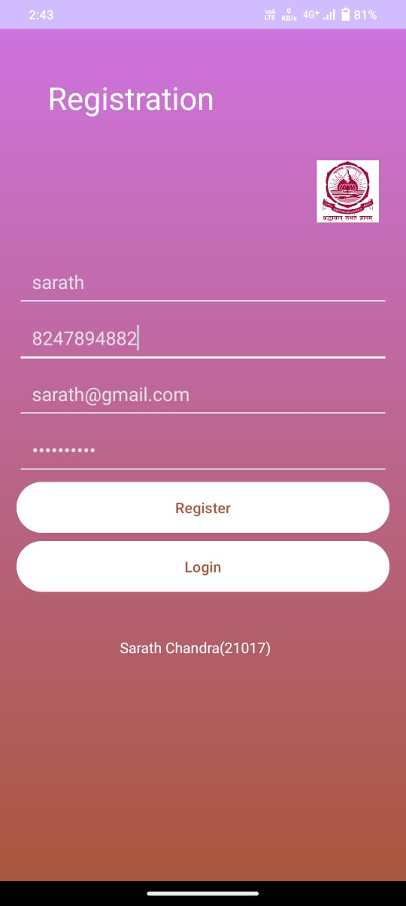

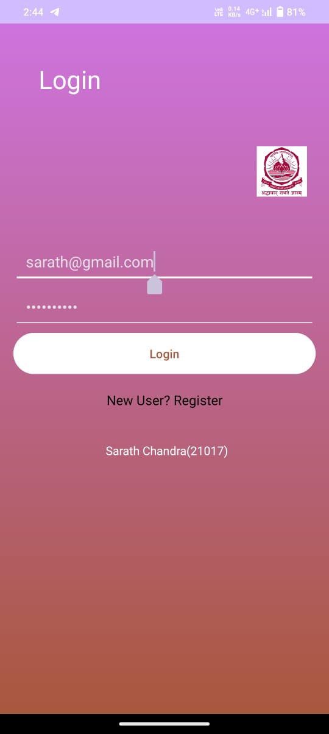

1. **Welcome Page:**

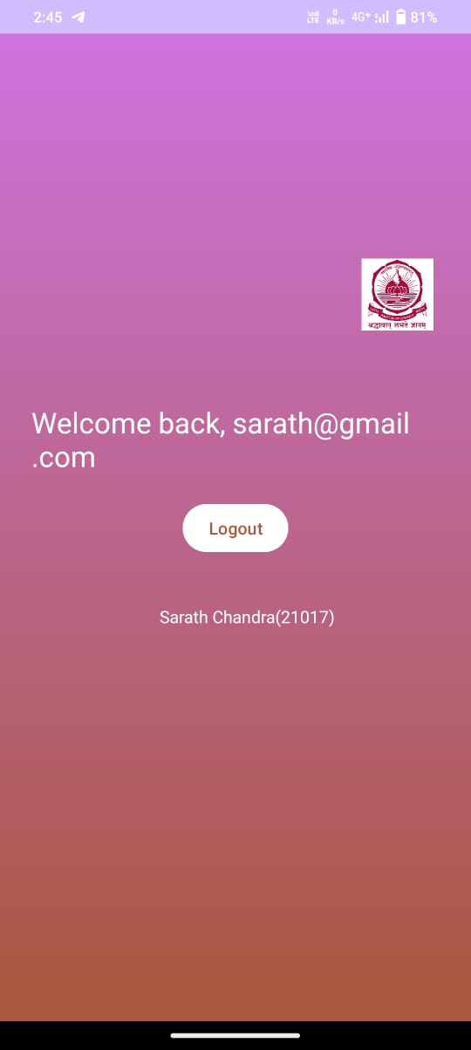

1. **Database in Sqlite:**

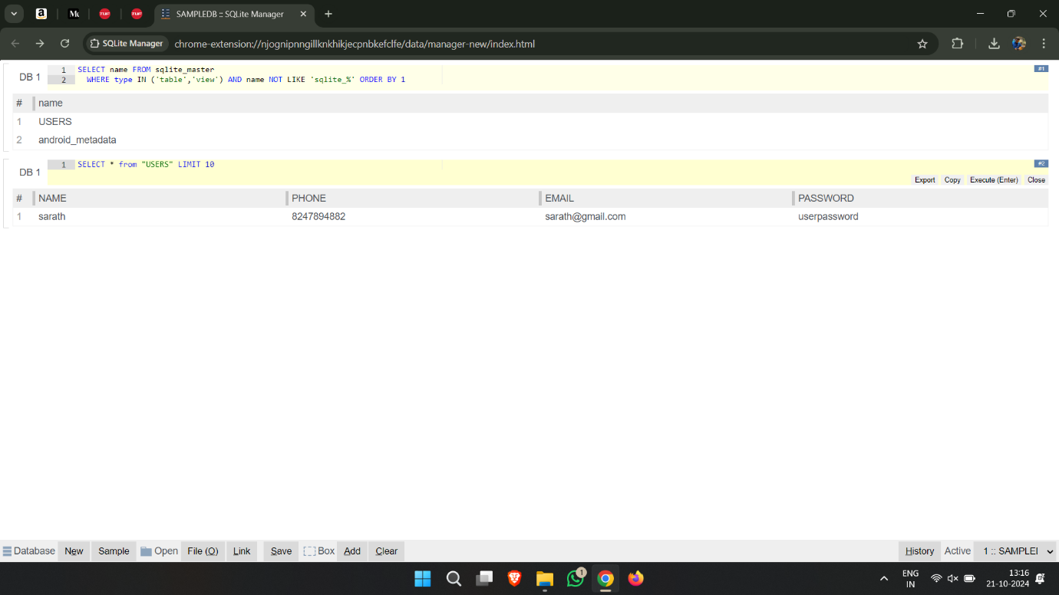

**Result:**

1. Created a Registration page

2. Created a Login Page

3. Created Logout Page

4. Created Welcome back “gmail id” Page