# Cloud Computing Internship - Task 1

Introduction to Cloud Computing

## Key Concepts

Cloud computing provides computing resources over the internet, including servers, storage, databases, networking, software, and analytics.  
  
**IAAS (Infrastructure as a Service):** Provides virtualized hardware such as servers, storage, and networking. Users manage their own OS, middleware, and applications.  
**Examples:** AWS EC2, Google Compute Engine, Azure Virtual Machines.  
  
**PAAS (Platform as a Service**): Provides hardware and platform tools for application development. Users focus on building applications without managing infrastructure.  
**Examples:** Google App Engine, AWS Elastic Beanstalk, Azure App Services.  
  
**SAAS (Software as a Service):** Delivers complete applications over the internet. Users simply access the software without worrying about infrastructure or maintenance.  
**Examples:** Google Workspace, Microsoft 365, Dropbox.  
  
**Regions:** Geographical areas hosting cloud data centers.  
**Availability Zones:** Independent data centers within a region for redundancy and reliability.

## 2. Platform Screenshots

* AWS Console

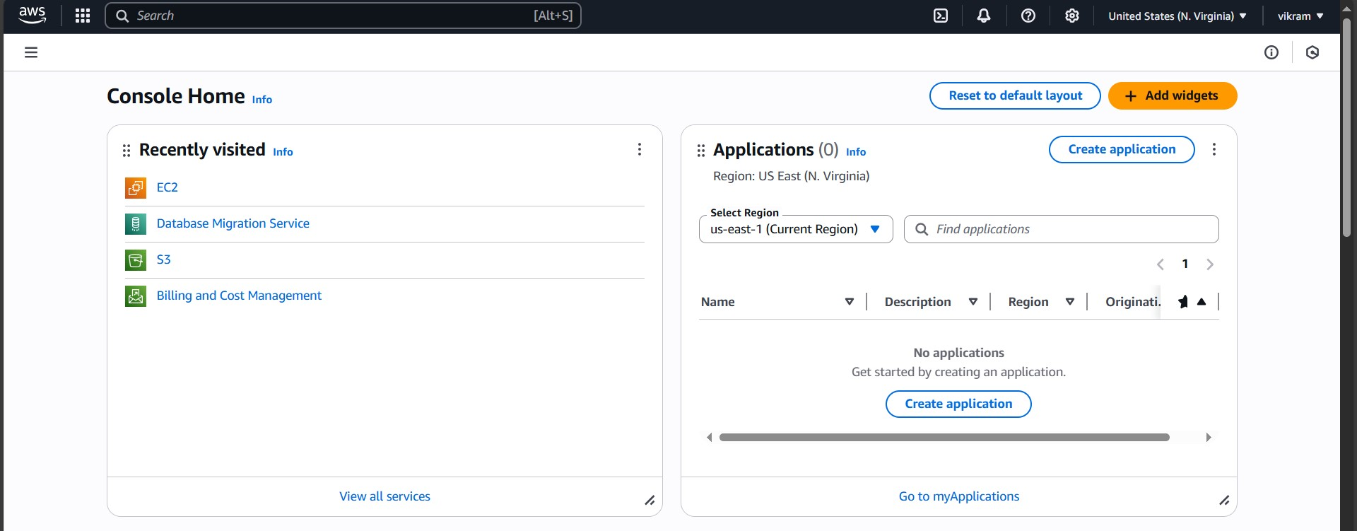

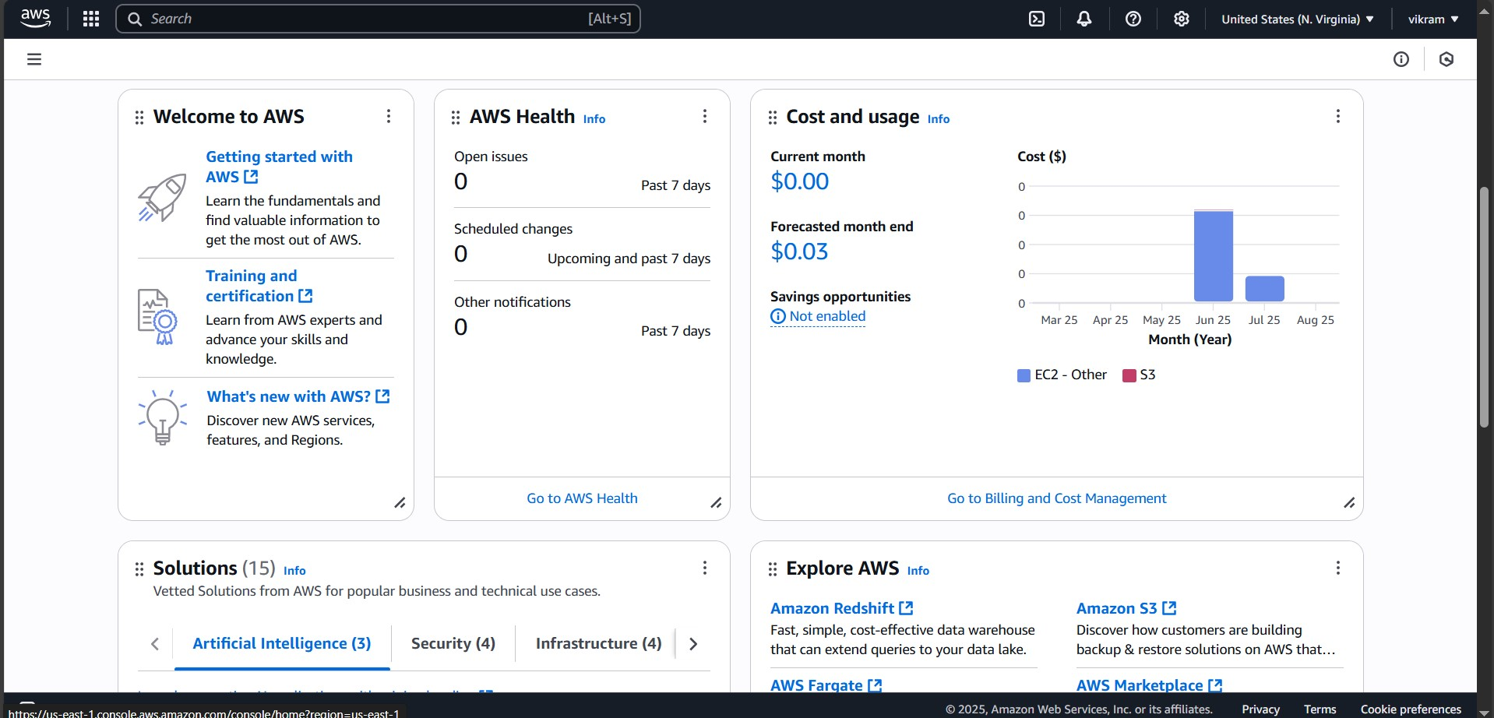

* Google Cloud Console

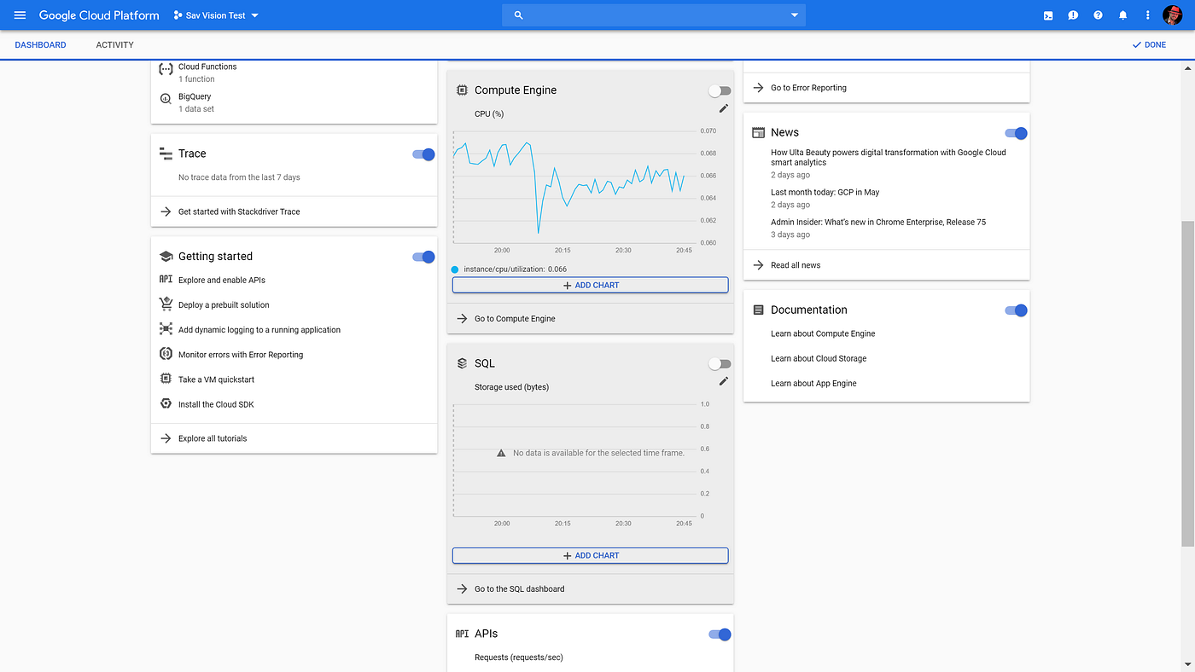

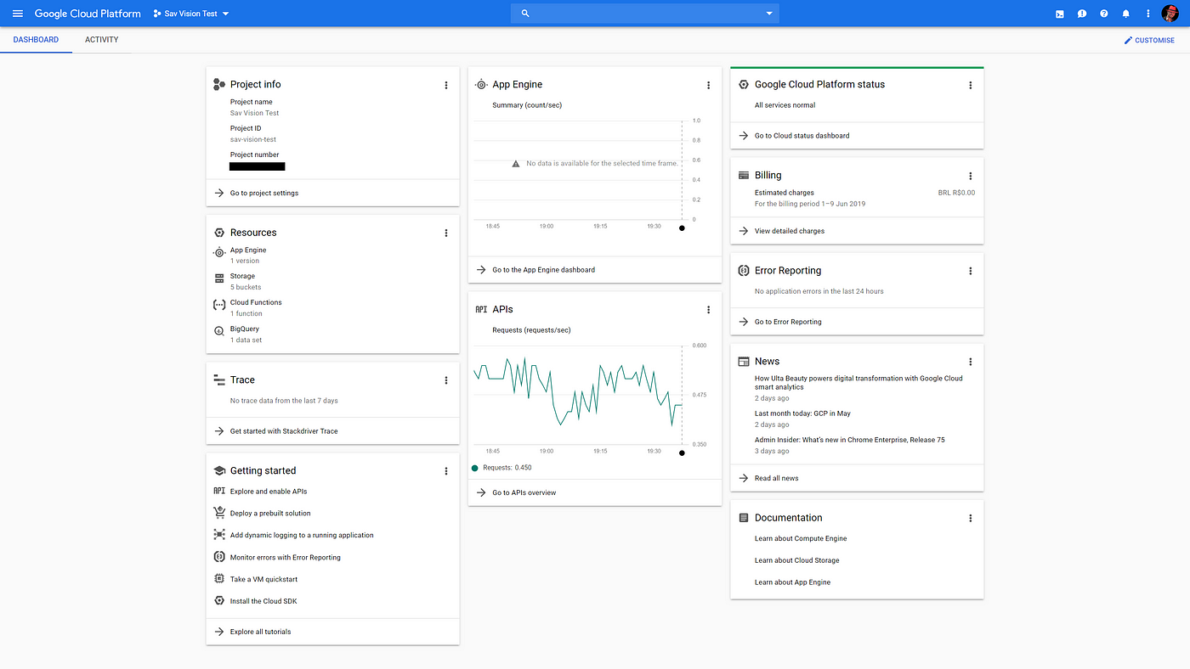

* Azure Portal

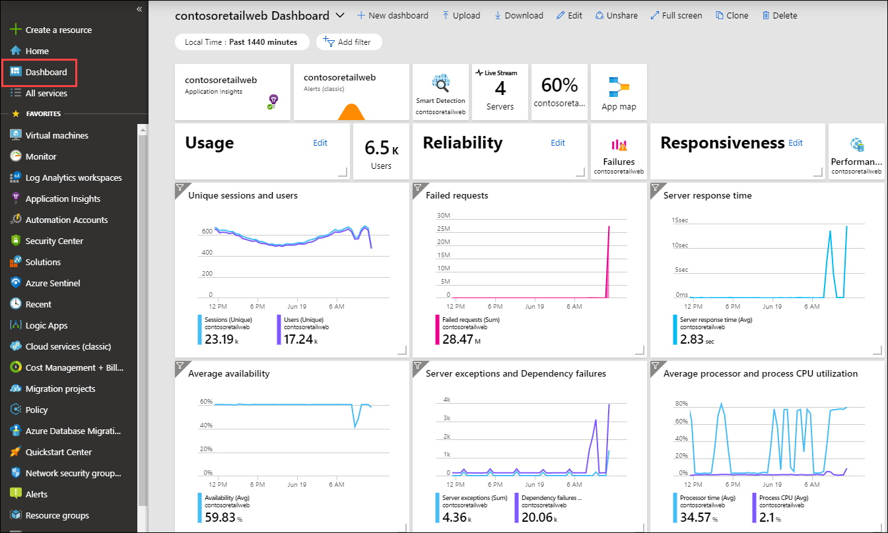

## 3. Real-World Use Cases of Cloud Computing

* Netflix – Uses AWS for global video streaming infrastructure.
* Spotify – Uses Google Cloud for big data analytics and recommendations.
* NASA – Processes satellite and rover data using cloud resources.
* Zoom – Relies on cloud platforms for scalable video conferencing.
* Airbnb – Uses AWS and Google Cloud for secure and scalable hosting of transactions.