# Cloud Computing Internship - Task 3

Deploy a Container

## 1. Aim

Containers are lightweight, portable, and scalable. They allow you to run applications in a consistent and reproducible way. In this task, we deploy a Python application inside a container on an AWS EC2 instance and explore its features.

## 2. Steps to Deploy the Container

1. Create an EC2 instance in AWS using Red Hat as the operating system.  
2. Connect to the instance via SSH using MobaXterm.  
3. Install container engine (Podman with docker compatibility) on the EC2 instance:  
 sudo dnf update -y  
 sudo dnf install -y podman-docker  
4. Set docker alias to podman:  
 alias docker=podman  
5. Pull the Python container image:  
 docker pull python  
6. Run the Python container interactively:  
 docker run -it --name=my_python python  
7. Inside the container, run a test command:  
 print('Hello from Python in a Docker container!')  
8. Exit the container using:  
 exit()

## 3. Output

Below is the screenshot of the Python application running inside the container:

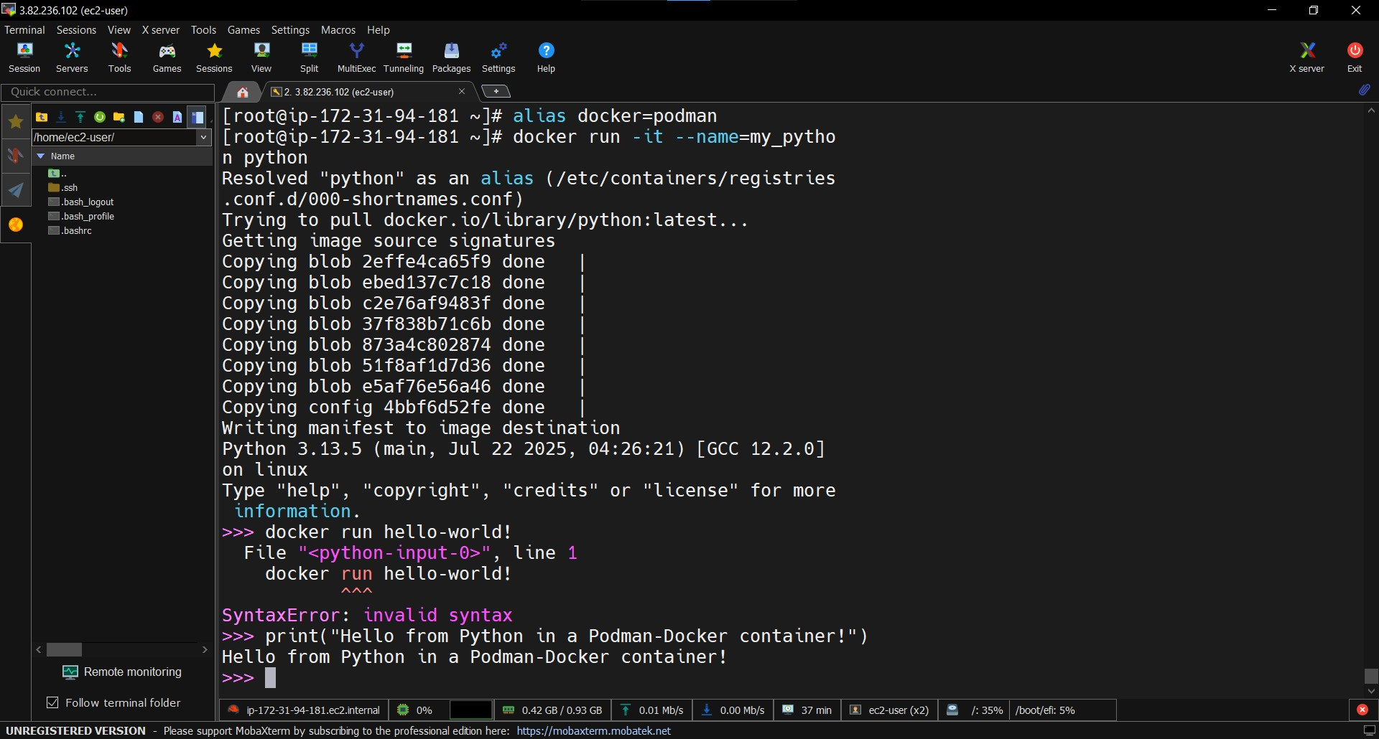

## 4. Conclusion

This task demonstrates how containers provide a consistent environment for running applications. Using Podman with Docker compatibility on AWS EC2 allowed us to bypass RHEL Docker installation issues and successfully deploy and run a Python container.