# Cloud Computing Internship - Task 4

Monitor Your Infrastructure

## 1. Aim

Monitoring is crucial for maintaining the health and performance of your cloud infrastructure. In this task, we set up AWS CloudWatch alarms to monitor CPU utilization for an EC2 instance.

## 2. Steps to Monitor the Infrastructure

1. Open the AWS Management Console and navigate to the EC2 Dashboard.  
2. Select your running EC2 instance.  
3. Click on 'Actions' → 'Monitor and troubleshoot' → 'Manage CloudWatch alarms'.  
4. Click 'Create alarm'.  
5. Select the 'CPU Utilization' metric for the instance.  
6. Set the alarm condition:  
 - Whenever CPU utilization is >= 70%  
 - Period: 5 minutes  
7. Set the alarm name to 'Monitoring-CPU-Utilization'.  
8. (Optional) Add a description.  
9. Click 'Create' to save the alarm.  
10. Navigate to the CloudWatch Dashboard to monitor CPU utilization.  
11. Observe the graphs and metrics; the alarm will trigger if the threshold is exceeded.

## 3. Output

- Create /edit alarm page with your CPU utilization

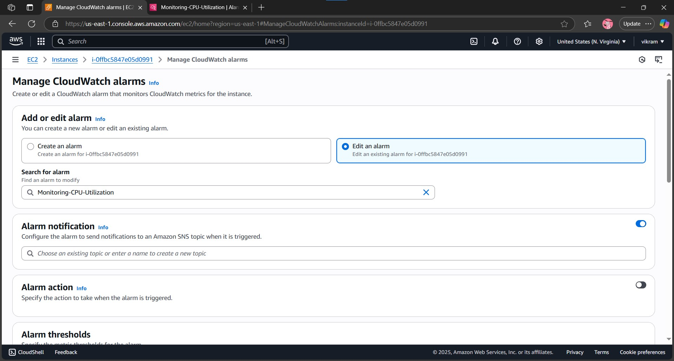

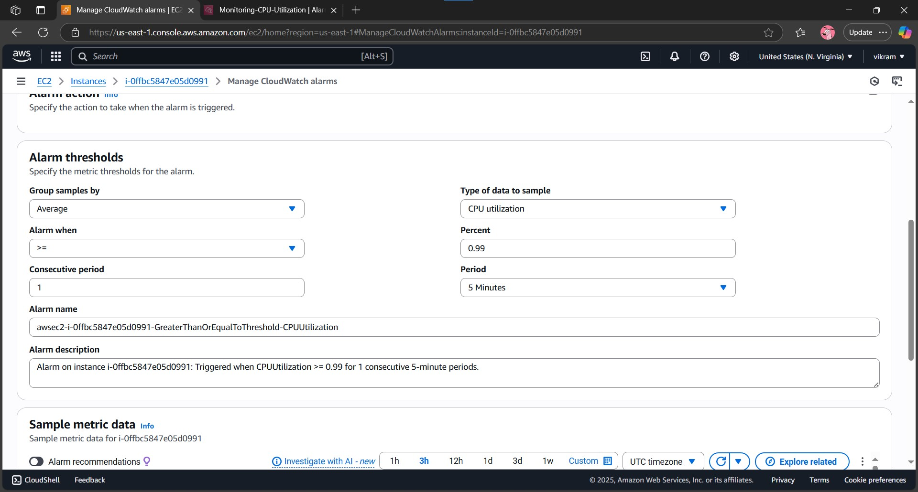

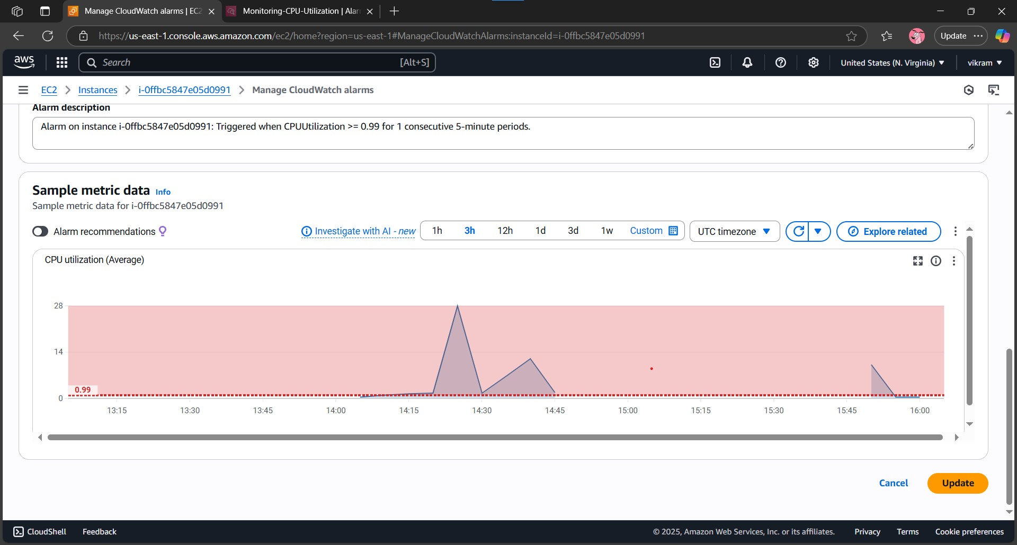

- CloudWatch dashboard showing CPU utilization graph.

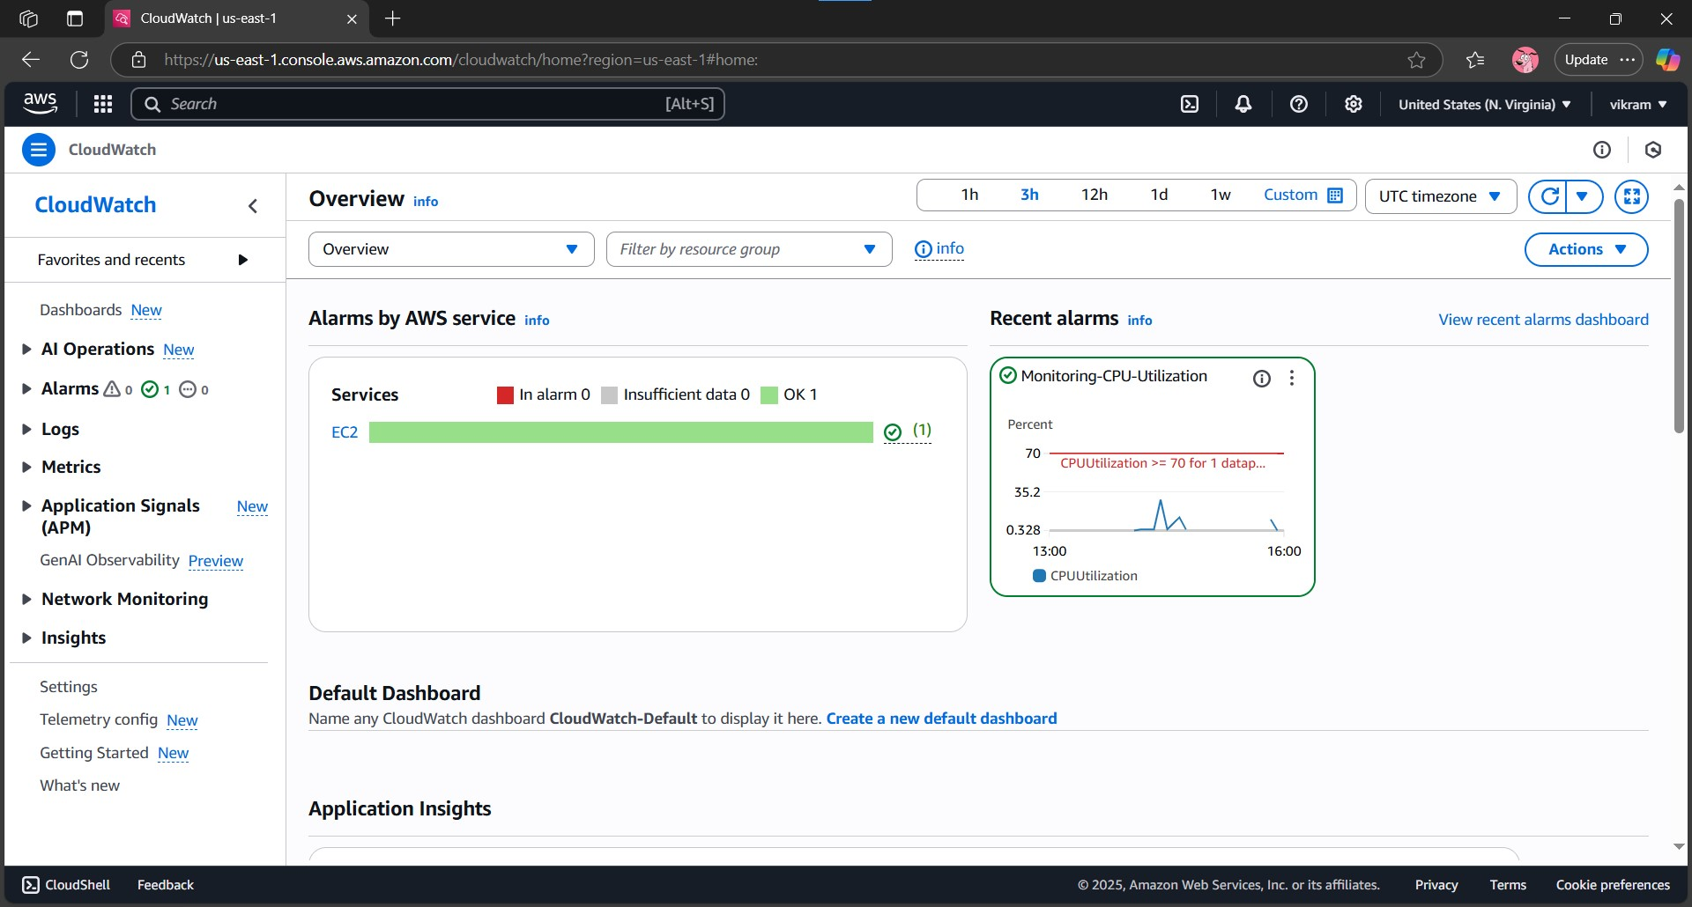

- Alarm list showing the active alarm.

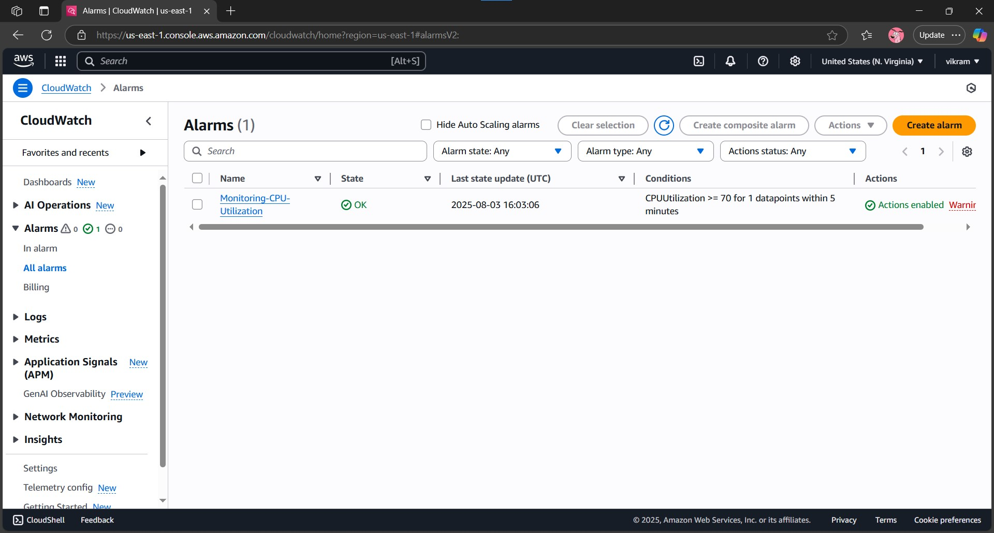

## 4. Conclusion

Using AWS CloudWatch alarms, we can effectively monitor the performance of EC2 instances. This enables proactive action when CPU usage crosses critical thresholds, ensuring smooth system performance.