# Cloud Computing Internship - Task 5

AWS EC2 Instance and Storage Implementation

## 1. Aim

Implementing AWS EC2 Instances and storage:  
- Creating and configuring AWS EC2 instances to host virtual machines.  
- Utilizing Amazon Elastic Block Store (EBS) for scalable and persistent block storage.  
- Connecting to VMs using Remote Desktop Protocol (RDP) or SSH.  
- Implementing Amazon Simple Storage Service (S3) for scalable and durable object storage.  
- Leveraging Amazon Elastic Compute Cloud (EC2) for running applications and services on virtual machines.

## 2. Steps to Implement AWS EC2 and Storage

1. Sign in to the AWS Management Console.  
2. Navigate to EC2: In the AWS Management Console, locate the 'Services' dropdown and select 'EC2' under the 'Compute' section.  
3. Launch an Instance:  
 - Click on the 'Instances' link in the EC2 dashboard.  
 - Click the 'Launch Instance' button.  
4. Choose an Amazon Machine Image (AMI):  
 - Select an AMI for the operating system you want to install (e.g., Amazon Linux, Ubuntu, Windows Server).  
5. Choose an Instance Type:  
 - Select the hardware configuration for your instance (e.g., t2.micro for free tier).  
6. Configure Instance Details:  
 - Set the number of instances, network settings, and advanced options (defaults are fine for basic setups).  
7. Add Storage:  
 - Specify the amount of storage (EBS volumes) for your instance.  
 - Add additional volumes if needed.  
8. Review and Launch:  
 - Review all settings and click 'Launch'.  
9. Install PuTTY (for Windows) or use MobaXterm:  
 - Use these tools to connect to your EC2 instance via SSH.  
10. Connect to Your Instance:  
 - Use the private key associated with your key pair to connect securely.  
 - For Linux/Mac: SSH from terminal.  
 - For Windows: Use PuTTY or MobaXterm.  
11. Install the Operating System:  
 - Once connected, install any necessary packages or configure your OS as you would on a physical server.

## 3. Output

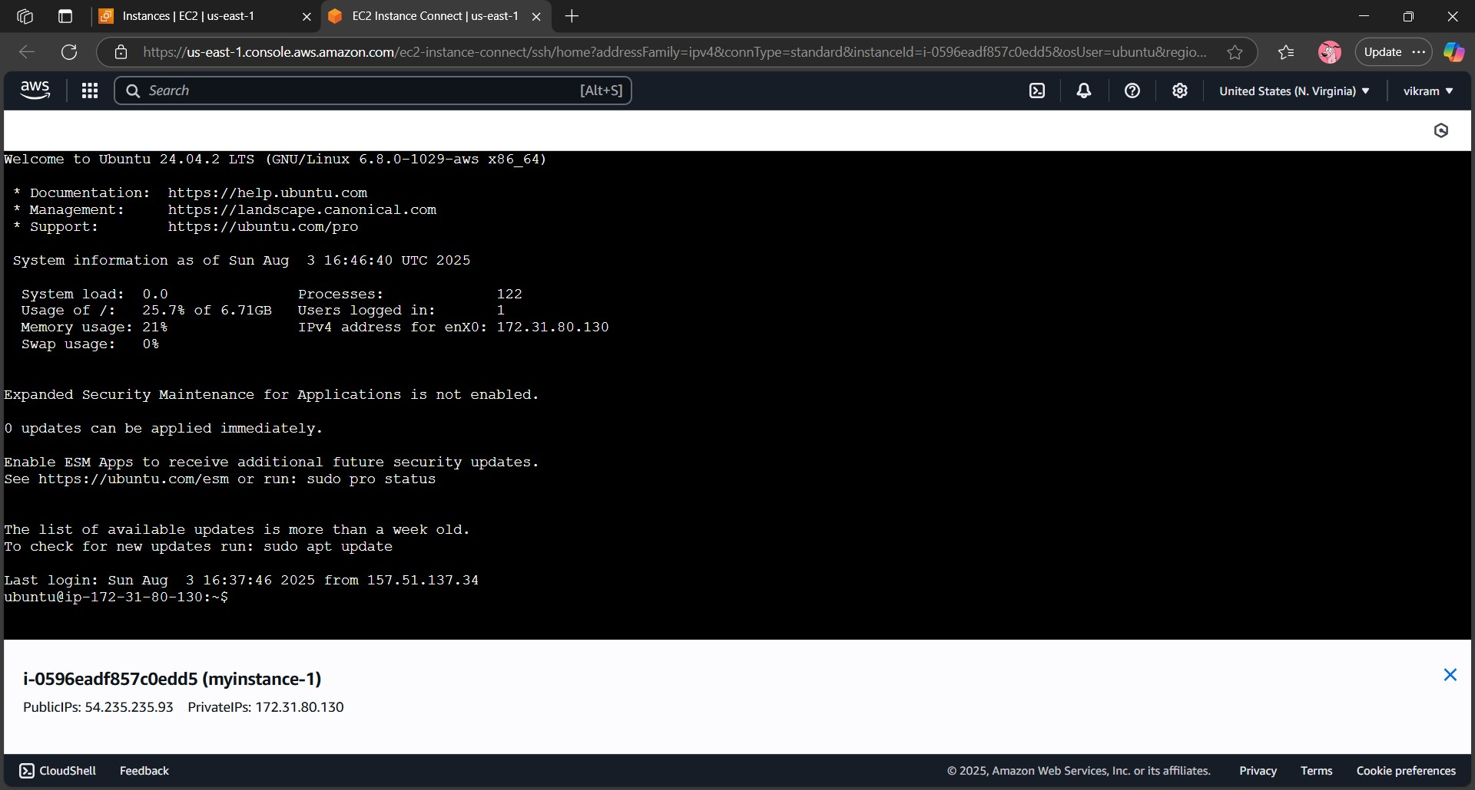

## 4. Conclusion

By creating and configuring an AWS EC2 instance with EBS storage and connecting via SSH/RDP, we can host applications and store data in a scalable, durable environment. AWS S3 complements this by providing object storage for unstructured data.