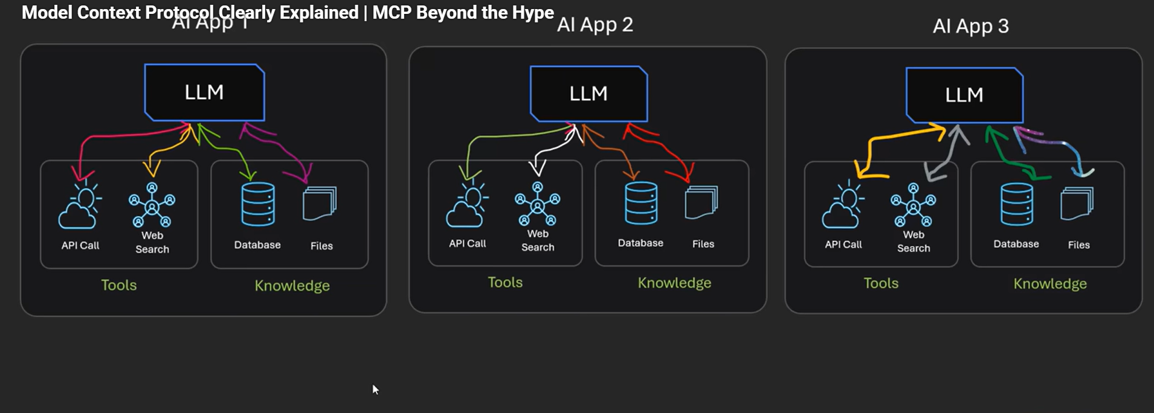
Model Context Protocol (MCP) is a standard way for AI models (like LLMs) to connect with:
- Tools
- Databases
- APIs
- Files
- Applications
without writing custom integrations every time.
AI Model ←→ MCP Client ←→ MCP Server ←→ Tools/Data

Imagine all the companies in the world building millions of application, a lot of glue code.
MCP is like a usb c port cable wherein you can connect any powerbank etc etc.

MCP vs Function Calling (Important)
Many beginners confuse this.
Function Calling (Old Way)
Model calls a function defined inside your app.
Tightly coupled.

MCP (New Way)
Functions live in external servers.
Loose coupling.
Much more powerful.

ADVANTAGES:
Standardization, faster development,model agnostic(llm can be anything), loosely coupled tools, code reusability, scalability, build server once reuse anywhere
There are 3 main parts:
1️⃣ MCP Host (AI App)
Example:
- Chat app
- Coding assistant
- Agent system
This is where the user interacts.

2️⃣ MCP Client
The client:
- Talks to MCP servers
- Sends requests
- Receives responses
- Manages connections

3️⃣ MCP Server
The server exposes:
- Tools (functions)
- Resources (data)
- Prompts
Example:
- Database server
- GitHub server
- File system server
- CRM server

📦 What MCP Can Provide
MCP servers expose 3 main things:
1. Tools
Functions AI can call.
Example:
get_weather(city)
run_sql(query)
create_ticket()

2. Resources
Data the model can read.
Example:
- Documents
- Files
- Logs
- Database tables

3. Prompts
Reusable prompt templates.

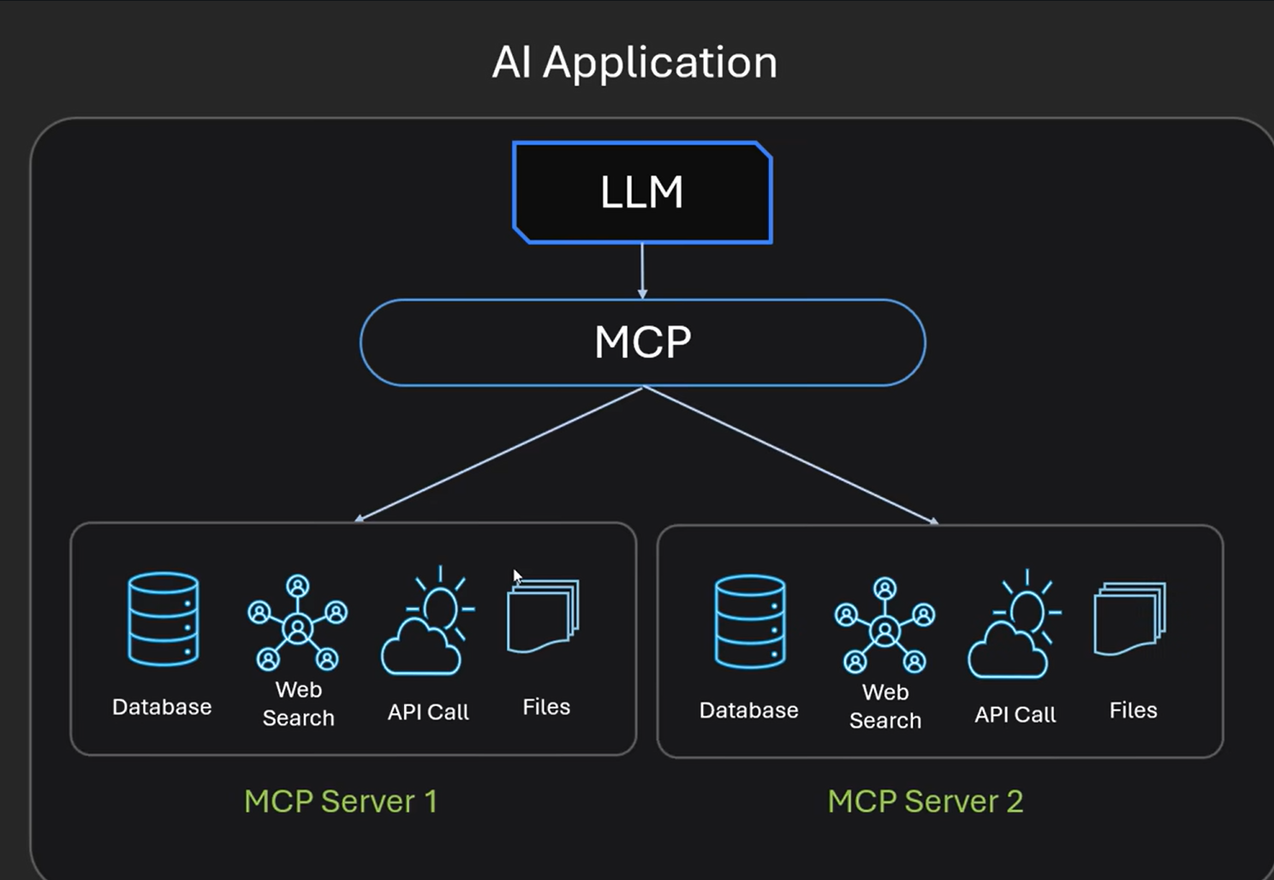
Llm interacts with MCP to interact with server 1(yahoo) and server2
Ease of maintaining code
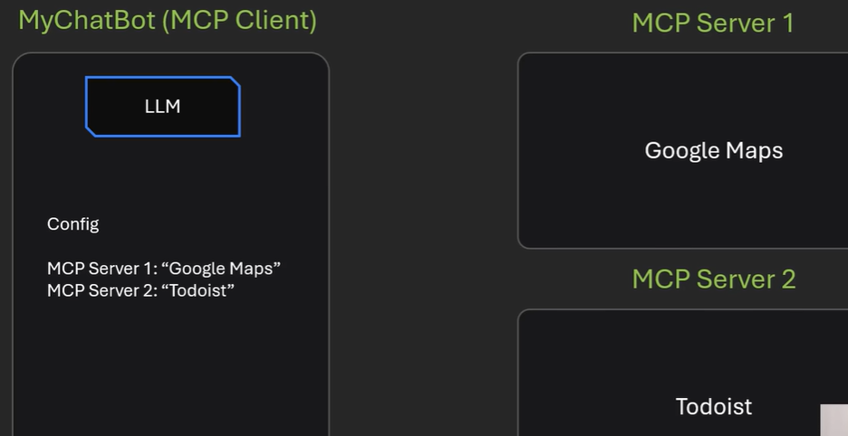

Google maps , todoist already existing
When the client starts, we configure mcp server 1, mcp server 2 . It will make a call to each of the servers to list all their toold and that server returns all the tools and its capabilities.
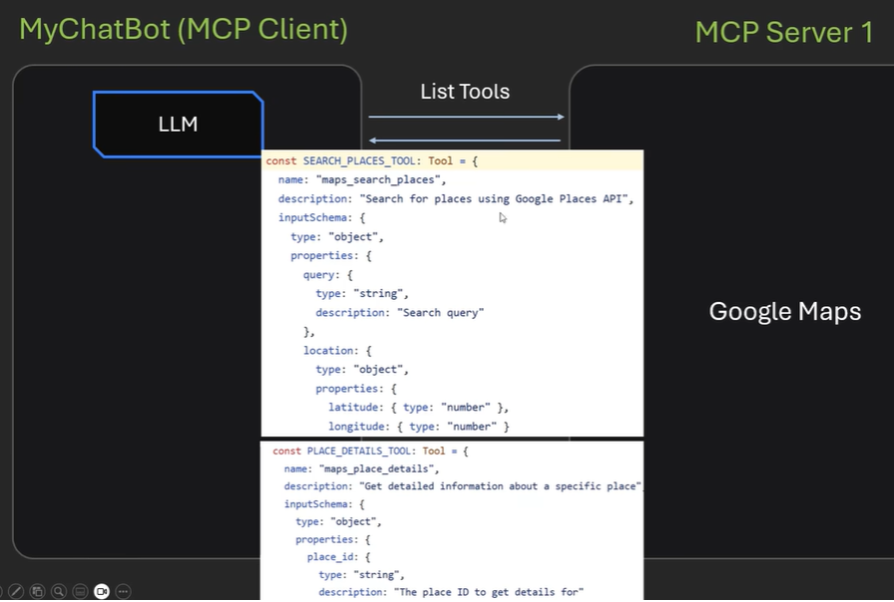

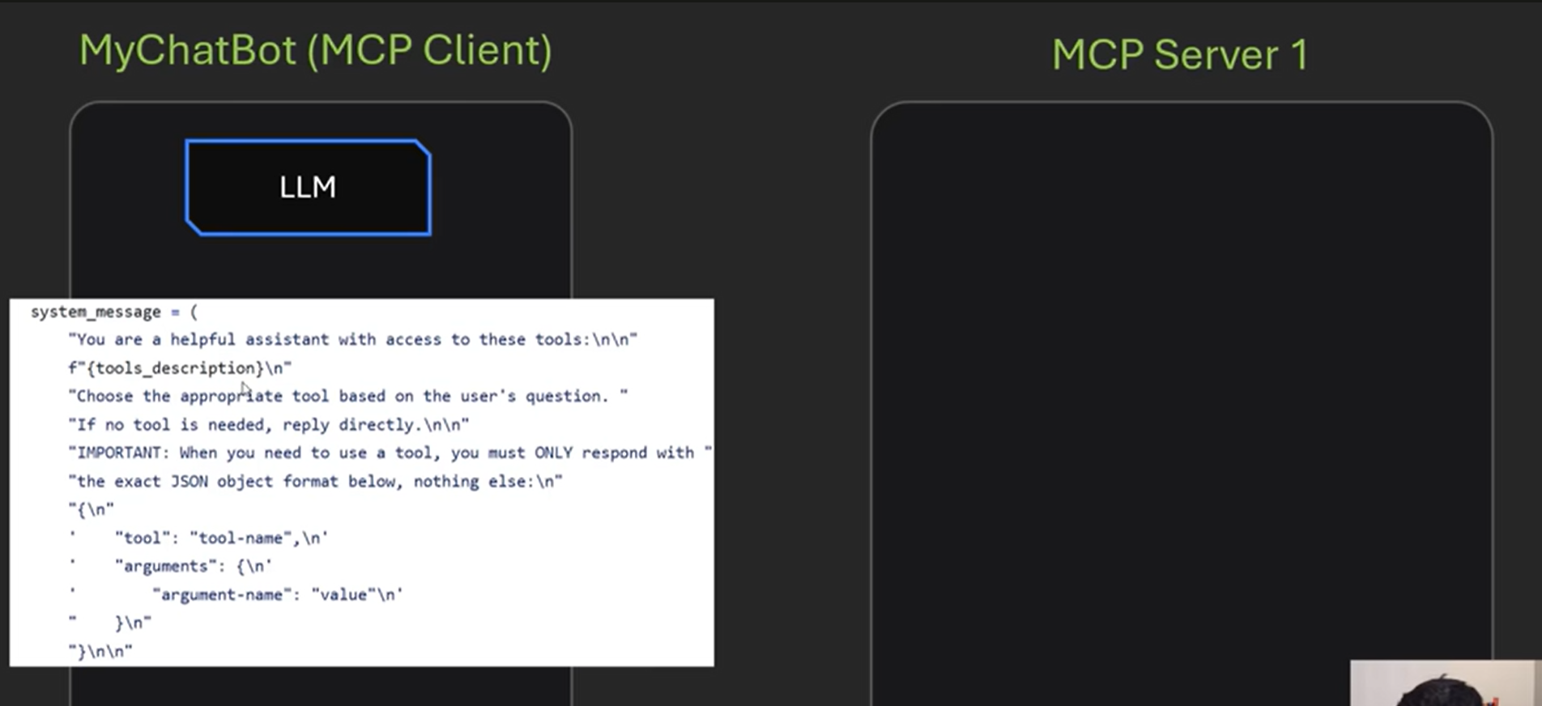
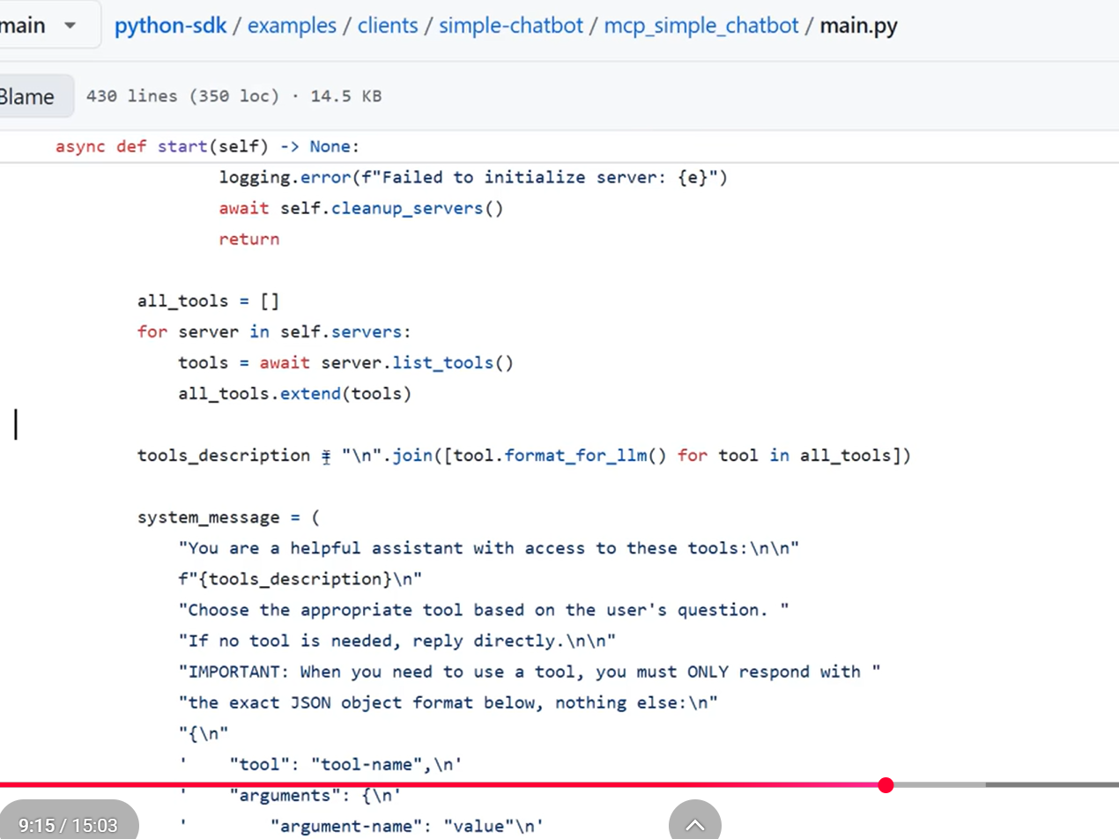
Above code listing all the servers and accessing the tools within them
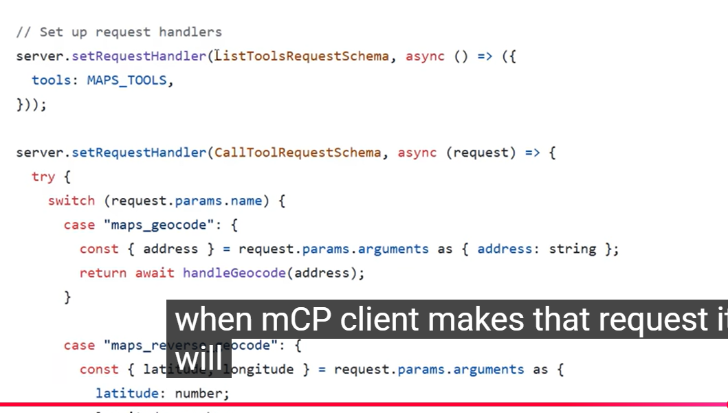
Resources:
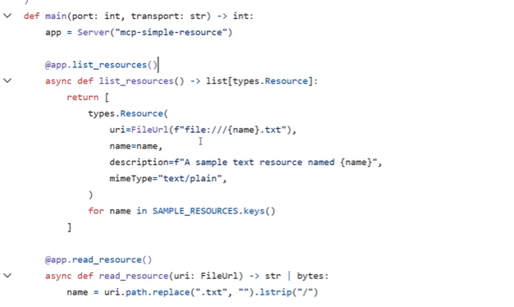

MCP Server has 3 capabilities:
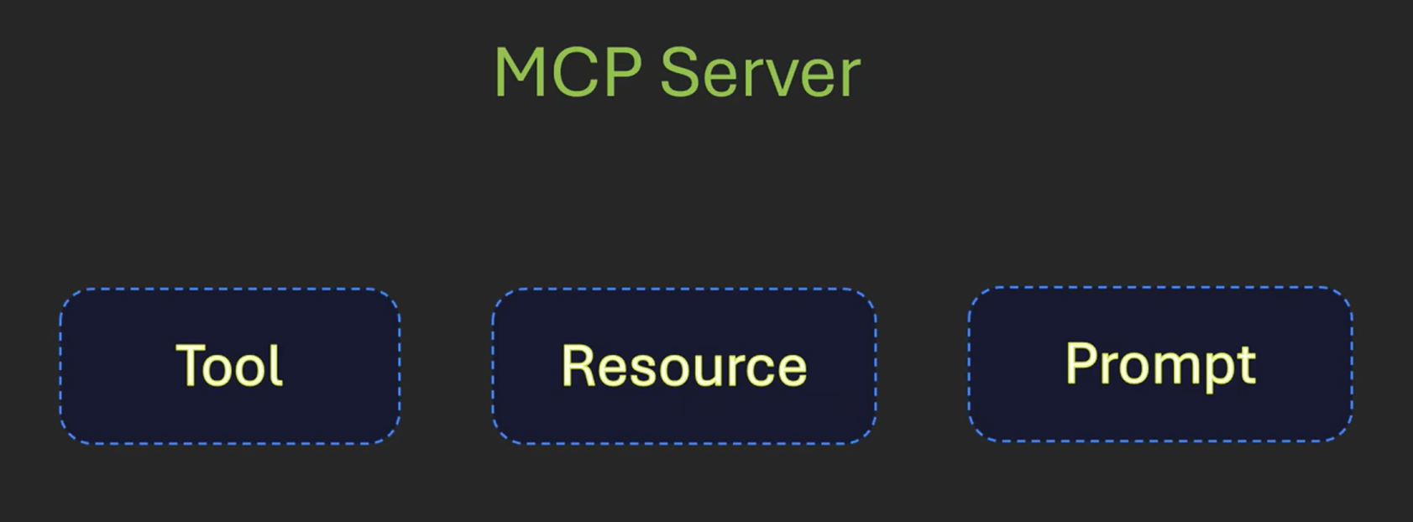
python-sdk/examples/clients/simple-chatbot at main · modelcontextprotocol/python-sdk · GitHub

┌────────────────────┐
│ Chat Application │
│ (LLM Orchestrator) │
└─────────┬──────────┘
│
┌────────────────┴──────────────┐
│ │
┌────────────────────┐ ┌────────────────────┐
│ Server A │ │ Server B │
│ Data & Intelligence │ │ External Services │
│ │ │ │
│ • RAG Tool │ │ • Maps Tool │
│ • NL2SQL Tool │ │ • Weather API │
│ • Analytics Tool │ │ • Complaint API │
│ • ML Prediction │ │ • Notifications │
└────────────────────┘ └────────────────────┘

server_b/
│
├── app.py
├── tools/
│ ├── maps.py
│ ├── weather.py
│ ├── complaints.py
│ ├── notifications.py
│
└── data/
└── complaints.json

Transport mechanism – communication between the client and the mcp server how it is going to happen.

