IBM VIT – Agentic AI May 2026

Assignment 1: Smart College Assistant using LangChain Tool Calling Agent

Name : SARATHY P
Reg No : 23MID0094
Batch : IBM Agentic AI -08 (Slot 2)
Email ID : sarathy.p2023@vitstudent.ac.in
Course Title : Agentic AI

QUESTION :
Develop an AI-powered College Assistant using LangChain Tool Calling Agent that can automatically identify user requests and invoke the appropriate tool(s) to provide accurate responses.
Requirements
Create the following tools using the @tool decorator:
1. Attendance Calculator
Inputs: Total Classes, Attended Classes
Outputs: Attendance Percentage, Exam Eligibility Status
Rule:
- Attendance ≥ 75% → Eligible for Exam
- Attendance < 75% → Not Eligible for Exam
2. Result Calculator
Inputs: Marks of 5 Subjects
Outputs: Average Marks, Grade, Pass/Fail Status
Average | Grade
≥ 90 | A
75–89 | B
60–74 | C
< 60 | D
Pass if Average ≥ 50.
3. Fee Balance Calculator
Inputs: Total Course Fee, Amount Paid
Output: Pending Fee Amount
4. Library Fine Calculator
Input: Number of Delayed Days
Output: Fine Amount
Rule: Fine = ₹5 × Delayed Days
5. Hostel Fee Calculator
Inputs: Monthly Hostel Fee, Number of Months Stayed
Output: Total Hostel Fee

Technical Requirements
Your solution must use:
- Python
- LangChain
- Ollama/OpenAI Model
- @tool
- create_tool_calling_agent()
- AgentExecutor
- ChatPromptTemplate
- verbose=True
Test Cases
Query 1
I attended 72 classes out of 90. Am I eligible for exams?
Query 2
My marks are 95, 90, 88, 91 and 87. What is my grade?
Query 3
My course fee is 50000 and I have paid 35000. How much fee is pending?
Query 4
I returned a library book 8 days late. What is the fine amount?
Query 5
Hostel fee is 6000 per month and I stayed for 5 months. Calculate my hostel fee.
Multi-Tool Challenge
I attended 80 classes out of 100.
My marks are 90, 85, 88, 92 and 95.
My course fee is 60000 and I paid 45000.
Provide:
1. Attendance Status
2. Grade
3. Pending Fee
The agent should automatically invoke multiple tools and provide a consolidated response.
Bonus Challenge
Create a Student Information Tool that retrieves student details from a Python dictionary using Student ID.
SOURCE CODE:
from langchain_core.tools import tool
from langchain_core.prompts import ChatPromptTemplate
from langchain.agents import AgentExecutor, create_tool_calling_agent
from langchain_ollama import ChatOllama

# STUDENT DATABASE (BONUS TOOL)

student_db = {
"ST101": {
"name": "Lathika",
"department": "Computer Science",
"semester": 5
},
"ST102": {
"name": "Pavindhar",
"department": "Electronics",
"semester": 3
},
"ST103": {
"name": "Nandana",
"department": "Information Technology",
"semester": 7
}
}

# TOOL 1 – ATTENDANCE CALCULATOR

@tool
def check_attendance(total_classes: int, attended_classes: int) -> dict:
"""
Calculate attendance percentage and exam eligibility.

Args:
total_classes: Total number of classes held.
attended_classes: Number of classes attended by the student.

Returns:
A dict with attendance_percent and exam_status.
"""
percentage = (attended_classes / total_classes) * 100
status = "Eligible for Exam" if percentage >= 75 else "Not Eligible for Exam"
return {
"attendance_percent": round(percentage, 2),
"exam_status": status
}

# TOOL 2 – RESULT CALCULATOR

@tool
def calculate_result(
subject1: float,
subject2: float,
subject3: float,
subject4: float,
subject5: float
) -> dict:
"""
Calculate average marks, grade, and pass/fail status for 5 subjects.

Args:
subject1: Marks in subject 1.
subject2: Marks in subject 2.
subject3: Marks in subject 3.
subject4: Marks in subject 4.
subject5: Marks in subject 5.

Returns:
A dict with average_marks, grade, and result_status.
"""
average = (subject1 + subject2 + subject3 + subject4 + subject5) / 5

if average >= 90:
grade = "A"
elif average >= 75:
grade = "B"
elif average >= 60:
grade = "C"
else:
grade = "D"

result = "PASS" if average >= 50 else "FAIL"

return {
"average_marks": round(average, 2),
"grade": grade,
"result_status": result
}

# TOOL 3 – FEE BALANCE CALCULATOR

@tool
def calculate_fee_balance(total_course_fee: float, amount_paid: float) -> dict:
"""
Calculate the pending course fee amount.

Args:
total_course_fee: Total fee for the course.
amount_paid: Amount already paid by the student.

Returns:
A dict with pending_fee.
"""
pending_fee = total_course_fee - amount_paid
return {"pending_fee": pending_fee}

# TOOL 4 – LIBRARY FINE CALCULATOR

@tool
def calculate_library_fine(delayed_days: int) -> dict:
"""
Calculate library fine based on number of delayed days.
Fine = ₹5 × delayed_days.

Args:
delayed_days: Number of days the book was returned late.

Returns:
A dict with fine_amount.
"""
fine_amount = delayed_days * 5
return {"fine_amount": fine_amount}

# TOOL 5 – HOSTEL FEE CALCULATOR

@tool
def calculate_hostel_charges(monthly_hostel_fee: float, months_stayed: int) -> dict:
"""
Calculate total hostel fee based on monthly fee and duration.

Args:
monthly_hostel_fee: Fee charged per month for hostel.
months_stayed: Number of months the student stayed.

Returns:
A dict with total_hostel_fee.
"""
total_fee = monthly_hostel_fee * months_stayed
return {"total_hostel_fee": total_fee}

# BONUS TOOL – STUDENT INFORMATION LOOKUP

@tool
def get_student_record(student_id: str):
"""
Retrieve student information using a Student ID.

Args:
student_id: The unique student identifier (e.g., ST101).

Returns:
Student details dict or a not-found message.
"""
if student_id in student_db:
return student_db[student_id]
return "Student Record Not Found"

# TOOLS LIST

tools = [
check_attendance,
calculate_result,
calculate_fee_balance,
calculate_library_fine,
calculate_hostel_charges,
get_student_record
]

# OLLAMA MODEL (swap model name as needed)
# Other options: "llama3.1", "mistral", "phi3"

llm = ChatOllama(
model="qwen2.5",
temperature=0
)

# PROMPT TEMPLATE

prompt = ChatPromptTemplate.from_messages([
(
"system",
"""
You are SmartCollegeBot, an intelligent assistant for college students.

Your responsibilities:
- Attendance Management
- Result Analysis
- Fee Management
- Hostel Fee Calculation
- Library Fine Calculation
- Student Information Retrieval

Instructions:
- Carefully understand the student's request.
- If the request needs one tool, call only that tool.
- If the request requires multiple calculations, invoke multiple tools
and provide a well-structured summary report.
- Keep responses neat, clear, and professional.
- Always include the ₹ symbol for monetary values.
"""
),
("human", "{input}"),
("placeholder", "{agent_scratchpad}")
])

# CREATE AGENT & EXECUTOR

agent = create_tool_calling_agent(
llm=llm,
tools=tools,
prompt=prompt
)

agent_executor = AgentExecutor(
agent=agent,
tools=tools,
verbose=True
)
# CONSOLE APPLICATION

print("""

SMART COLLEGE ASSISTANT
SARATHY P – 23MID0094

Available Services:
1. Attendance Calculator
2. Result Calculator
3. Fee Balance Calculator
4. Library Fine Calculator
5. Hostel Fee Calculator
6. Student Information Lookup

Type 'exit' to quit.
""")

while True:
user_query = input("\nAsk Your Question : ").strip()

if not user_query:
continue

if user_query.lower() == "exit":
print("\nThank you for using Smart College Assistant. Goodbye!")
break

try:
response = agent_executor.invoke({"input": user_query})
print("\n")
print("ASSISTANT RESPONSE")
print("\n")
print(response["output"])
print("\n")
except Exception as e:
print(f"\nError: {e}")

OUTPUT:
Query 1: I attended 72 classes out of 90. Am I eligible for exams?
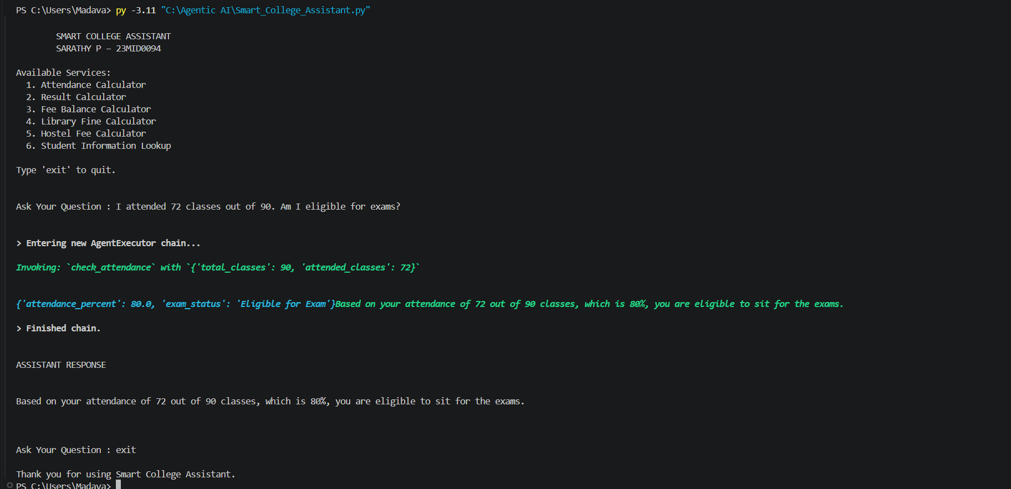

Query 2: My marks are 95, 90, 88, 91 and 87. What is my grade?
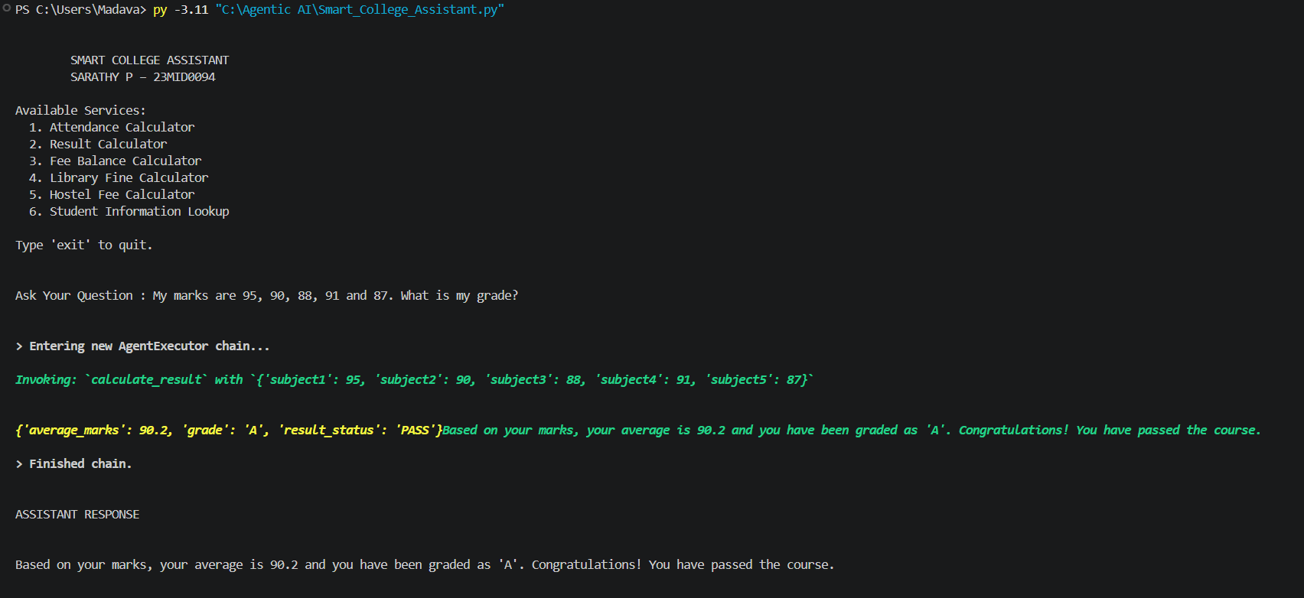

Query 3: My course fee is 50000 and I have paid 35000. How much fee is pending?
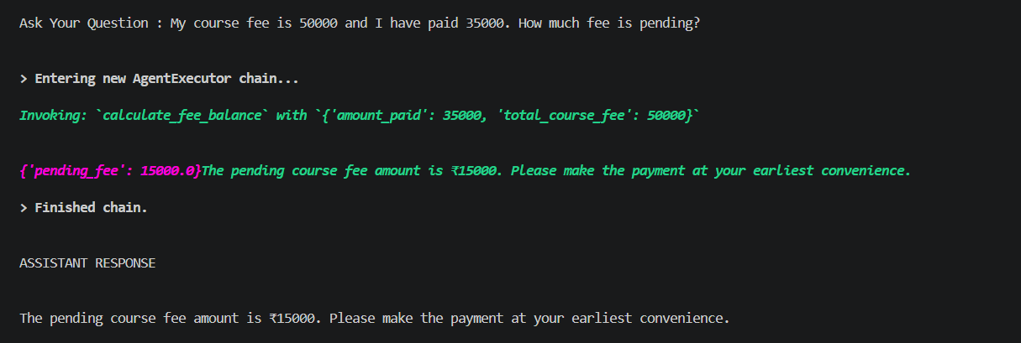

Query 4: I returned a library book 8 days late. What is the fine amount?
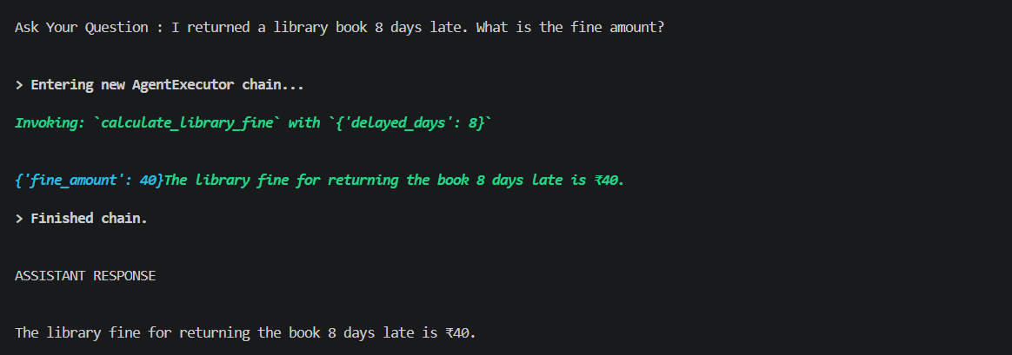

Query 5: Hostel fee is 6000 per month and I stayed for 5 months. Calculate my hostel fee.
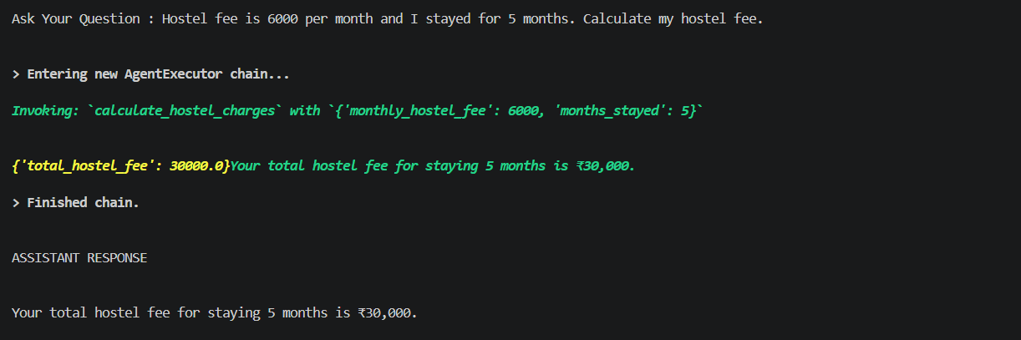

Multi-Tool Challenge
I attended 80 classes out of 100. My marks are 90, 85, 88, 92 and 95. My course fee is 60000 and I paid 45000.
Provide:
1. Attendance Status 2. Grade 3. Pending Fee
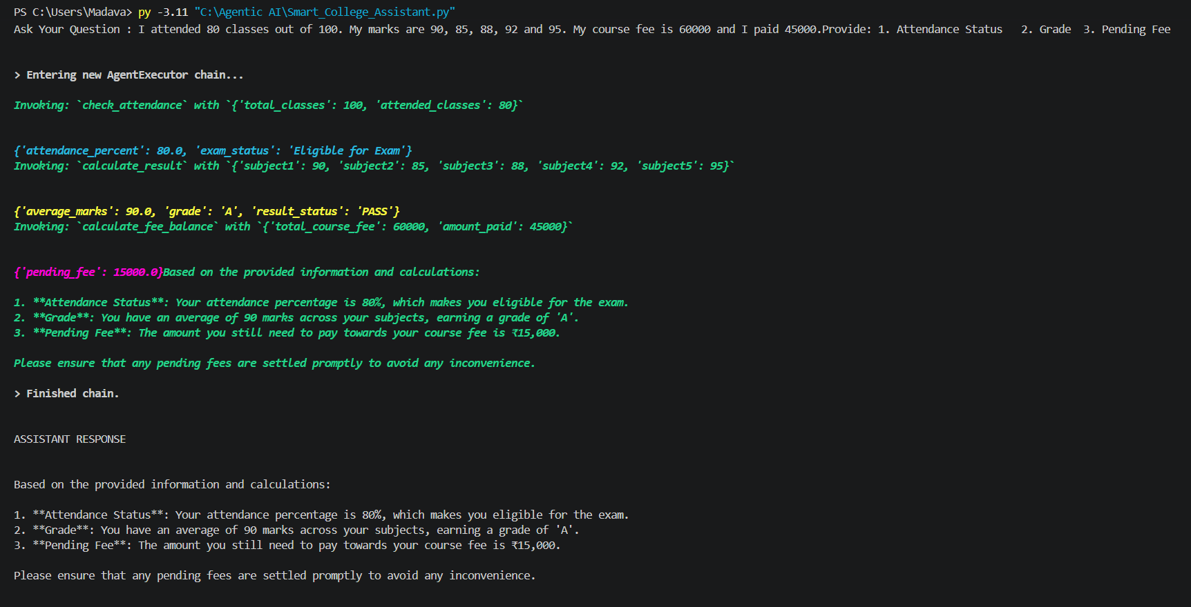

Bonus Challenge:
Create a Student Information Tool that retrieves student details from a Python dictionary using Student ID.
