IOT Based Smart Baby Cradle System

Usha K

Department of Electrical and Electronics Engineering

Manoj Sarathy G S

Department of Electronics and Communication Engineering

Suvashwin V

Department of Electrical and Electronics and Engineering

Sri Sivasubramaniya Nadar College of Engineering

Chennai, India

Hayden C

Department of Information Technology

*Abstract*— Over the past few years, the integration of IOT and embedded systems has transformed and revolutionized the landscape of many industries, including infant care. This paper discusses the design and implementation of a low-cost, IoT based Smart Baby Cradle System that aims to help parents in real-time baby monitoring and cradle automation. The system is designed around an ESP32-CAM microcontroller that integrates various sensors- sound sensor, PIR (movement) sensor and moisture sensor- to detect a baby’s cry, body movement and urination respectively. When recognising distress calls in the form of crying, the system employs a servo motor to gently swing the cradle mimicking parental action. Concurrently, the ESP32-CAM streams the live video of the baby to a connected mobile device on the Blynk IoT platform facilitating remote monitoring. The cradle can be controlled both automatically and manually with the help of real-time notifications and sensor updates that can be accessed through a mobile application. In addition, an OLED display is employed to provide local feedback about the status of the baby. This work introduces a secure, scalable response for infant care solution with lightweight hardware and open-source platforms to keep it cost-effective as well as deployment-friendly

***Keywords—*** *baby cradle, IoT, embedded system, ESP32-CAM, real-time monitoring. Sensor integration, Blynk application, infant care automation.*

I. Introduction

Smart automation technologies have slowly become an integral part in healthcare, homes and lifestyle spaces- transforming not only efficiency but also safety and convenience. In the realm of child care, the combined use of embedded systems with Internet of Things (IoT) solutions provides an opportunity to help and assist parents in real-time monitoring and responsive caregiving. Conventional baby cradles, while effective in calming infants, are not intelligent and cannot be operated remotely, which restricts the freedom and situational awareness of parents, especially in a dual-income or busy households.

XXX-X-XXXX-XXXX-X/XX/$XX.00 ©20XX IEEE

Recent publications report remarkable advancements in this field. Real-time health monitoring through using embedded platforms has been shown to enhance parental responsiveness and awareness [1]. Technological advancements in cry detection, particularly infant sound discrimination from environmental noise, has rendered event-based interventions more precise [2]. Low-cost cradle systems that can trigger upon detecting distress signals have opened the possibility for self-sustaining infant soothing systems [3]. Integration of wireless sensors and cloud connectivity have further enhanced the potential for remote monitoring, making the system more responsive and more actively involving the parents [4]. The integration of GSM-based alert systems and mobile notification platforms have enhanced the real-time communication between the cradle and the caregiver [5], while cloud-integrated video streaming has enhanced visibility and control in infant monitoring applications [6].

This project suggests an integrated, modular and real-time IoT-Based Smart Baby Cradle system that provides multiple points of baby monitoring – cry detection, motion detection, detection of urination and live video feed- within an integrated system. Developed around an ESP32-CAM microcontroller, the system provides both automatic and manual control of the cradle, real-time status report through an OLED display and easy interaction through the Blynk platform. The suggested system not only provides improved baby safety and comfort, but also provides parents with timely alerts and remote monitoring, thus improving the overall quality of baby care through smart automation.

II. LITERARY SURVEY

Over the past decade, several smart infant care systems have appeared that take advantage of the capabilities of embedded systems and IoT to improve parental observation and automation. Previous works have established the key approaches to remote monitoring of infant behaviour and health.

Early attempts at IoT-based infant care involved simple physiological monitoring. A real-time pulse and body temperature monitoring system was developed using a Raspberry Pi with cloud connectivity for immediate access to care-givers [1]. This marked a step towards network-connected embedded systems for infant health. To enhance responsiveness, audio-based recognition systems were used. One of them employed voice filtering in order to identify a baby's

cry amidst ambient noise, thereby avoiding spurious alarms in automated care systems [2].

Automation based on auditory input became more important with low-cost smart cradle systems that initiated swinging motions upon crying. These designs show the feasibility of cry-activated motor control by microcontrollers [3]. Later advancements incorporated multiple sensors with Wi-Fi boards to transmit real-time data to mobile interfaces, increasing parental interaction and system transparency [4].

Initiatives to make notifications more dependable led to the addition of GSM modules, which give SMS alerts on vital events like motion or water sensing even while being offline [5]. More recent innovations have included the use of cloud services combined with video streaming, combining Firebase or MQTT protocols with camera modules to give real-time streams and activity logs directly to mobile apps [6].

Comprehensively, these papers cover core features such as cry detection, moisture detection, motion tracking, and remote cradle control. However, most of the existing systems cover individual features or lack real-time video and application-based control. The proposed system in this paper builds on these contributions by integrating all core features—cry, motion, and urination detection, live video streaming, and Blynk-based application control—on an integrated and affordable platform controlled ESP32-CAM microcontroller.

III. System Architecture and Design

The smart baby cradle system is designed to monitor three important aspects of an infant’s status: crying**,** bodymovement and urination. The sensor readings are continuously collected and analysed to calculate optimal moments for initiating automated responses—like cradle oscillation—or alerting parents through a mobile application. The system also allows manual control through the Blynk IoT platform, promoting flexibility and allowing parent monitor from different locations.

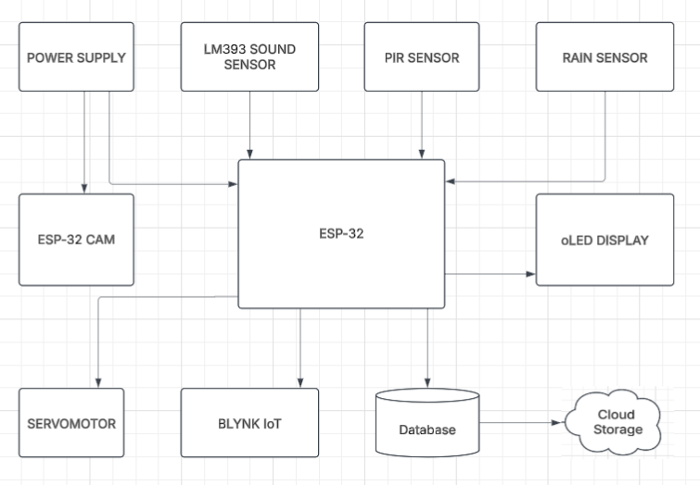

Figure 1 Block diagram of the proposed system

The architecture follows a modular design, making it easily extensible. Each component is connected to the ESP32-CAM, which acts as the central processing and communication unit.

The ESP32 microcontroller shown in Fig 2 serves as the main controller and video streaming unit. It handles the logic for sensor integration, triggers the servo motor, and establishes wireless communication via Wi-Fi. The onboard camera module enables live video streaming, viewable through mobile or browser, allowing parents to monitor their baby remotely.

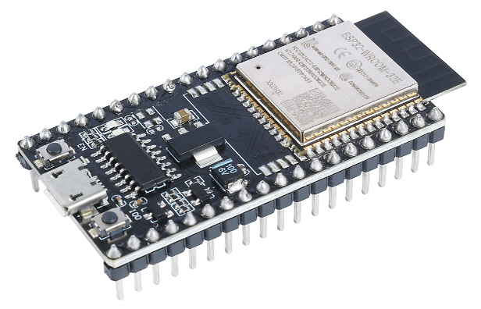

Figure 2 ESP32

The sound sensor shown in Fig 3 detects the baby’s cry by measuring ambient noise levels. Upon exceeding a predefined threshold, the system interprets this as crying and automatically activates the **servo motor** to swing the cradle. This mimics a natural soothing action, reducing parental delay in response.

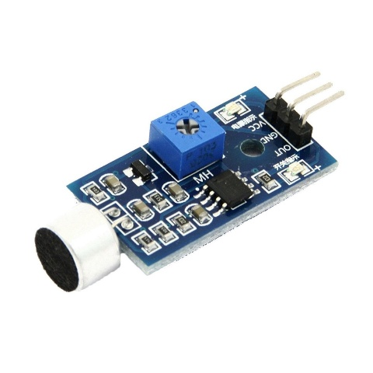

Figure 3 Sound sensor

The PIR sensor shown in Fig 4 monitors baby movement within the cradle. It detects changes in infrared radiation due to motion, providing information on the baby’s current activity. This helps in maintaining a log of the baby’s physical behaviour and adds to the monitoring data.

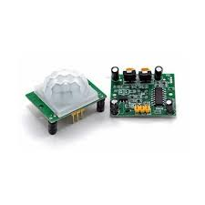

Figure 4 PIR sensor

A rain sensor shown in Fig 5 is placed under the baby to detect urination or moisture. It triggers alerts when wetness is detected, helping parents respond promptly to hygiene needs. This addition makes the system more holistic and practical for real-life infant care scenarios.

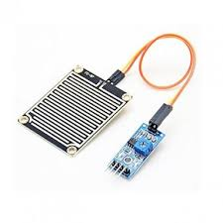

Figure 5 Rain sensor

A single-channel servo motor shown in Fig 6 is used to provide the mechanical swinging motion of the cradle. Controlled by the ESP32-CAM, it operates either in automatic mode (when the baby cries) or manual mode (via app input). The motor was selected for its low power consumption and ease of integration.

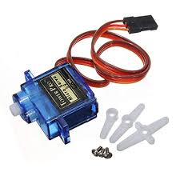

Figure 6 Servo motor

An OLED display shown in Fig 7 provides real-time feedback on the system status. Parameters such as cry detection, movement, moisture level, and current system mode (manual/automatic) are displayed. This allows for quick local monitoring without relying solely on the mobile interface.

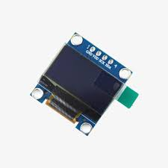

Figure 7 OLED Display

The system leverages the Blynk platform shown in Fig 8 for remote interaction. Parents receive real-time alerts and can control the cradle’s swing function or activate a buzzer from their mobile devices. The app also visualizes sensor states and live video feed, enhancing usability and trust.

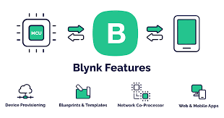

Figure 8 Blynk Application

IV. Methodology

The methodology focuses on real-time monitoring of the infant’s physical state and environmental cues, followed by context-aware responses such as cradle swinging and parental alerts. All data processing and system control are handled by the ESP32-CAM module, which acts as the central unit of the system.

*A. Sensor-Based Data Acquisition*

The system constantly collects sensor information that correspond to the baby's activity and requirements as follows:

* Ambient noise in the range of the cradle is detected by an audio sensor. When it goes beyond a threshold value in amplitude of detected noise, it is identified as the crying baby. The signal automatically triggers the servo motor to swing the cradle in an effort to soothe the child. This hands-free automation replicates the soothing motion that would otherwise be provided by the caregivers.
* A Passive Infrared (PIR) sensor is installed to detect motion inside the cradle. It senses variations in infrared radiation caused by the baby’s movement. Detected motion is logged to help track the baby’s activity levels, providing valuable insight into restfulness or agitation.
* A rain (moisture) sensor is placed beneath the infant to sense the occurences of urination. When moisture is detected, an alert is generated to inform the caregiver, promoting timely hygiene management and reducing discomfort for the baby.

*B. Cradle Actuation via Servo Motor*

The mechanical motion of the cradle is provided by a servo motor that is attached to the ESP32-CAM. The controller provides a Pulse Width Modulation (PWM) signal when a cry detection signal is sensed, resulting in a gentle swinging of the cradle for a specific amount of time. It is also made possible to manually trigger the motor through the application, thereby providing caregivers with automatic control when needed.

The system can be operated in two modes:

* *Automatic Mode*: Activated by sensor events (e.g., crying).
* *Manual Mode*: Controlled by user input through the Blynk mobile app

*C. Real-Time Monitoring using ESP32-CAM*

The ESP32-CAM module integrates both processing capabilities and camera interface, to provide real-time video streaming of the baby. The video feed is transmitted through local Wi-Fi or internet and can be accessed or monitored through the Blynk app or any compatible browser, depending on the network configuration. Remote monitoring of the baby's status allows parents to monitor the baby's status remotely, thus improving the system's sensor-based data.The integration of ESP32-CAM offers the advantage of low power consumption and miniature size, enabling image taking, improving performance and real-time processing of control signals.

*D. IoT Integration with Blynk App*

The Blynk IoT platform acts as the user-facing and user-friendly platform, allowing caregivers to interact with the system in real time. Through the Blynk mobile application, users receive:

* Push notifications for detected events (crying, moisture, motion),
* System status visualization, including cradle mode and sensor states,
* Manual control functions for swinging the cradle or sounding a buzzer,
* Live video preview of the baby via camera widget or stream.

The app communicates securely with the ESP32-CAM via Wi-Fi and the Blynk cloud, enabling remote access regardless of the user’s physical proximity to the cradle.

*E. Local Feedback Display*

For real-time local monitoring, a 0.96" I2C OLED screen is used to display the key system metrics:

* Cry status (Crying/Silent)
* Movement detection (Yes/No)
* Moisture level (Dry/Wet)
* Operating mode (Auto/Manual)

This display provides instant real-time feedback for nearby caregivers, reducing the need to depend on the mobile app for basic and regular updates.

Together, this integrated methodology forms a closed-loop, sensor-enabled intelligent system that is capable of recognizing the requirements of babies, acting in response, and alerting caregivers appropriately at all times irrespective of their location.

V. Implementation and Hardware Design

The prototype of the IoT-based Smart Baby Cradle System was physically constructed and tested in a controlled environment. The design integrates all essential components—sensors, actuators, controller, display unit, and mobile interface—mounted on a custom-made model cradle. This section outlines the hardware setup, working environment, and visual validation of the system.

*A. System Integration and Testing Environment*

The prototype of the smart cradle system is shown in Fig 9. All hardware modules were connected to the central ESP32-CAM board, which was powered using a regulated 5V DC supply. The model cradle was constructed using lightweight materials to accommodate the mounted sensors and allow swinging via a servo motor.

Figure 9. Smart cradle system and laptop displaying the live ESP32-CAM stream.

*B. Real-Time Camera Streaming*

The livestream browser interface of the ESP32-CAM is shown in Fig 10. The ESP32-CAM module streams live video to the web interface using its onboard camera, enabling caregivers to remotely observe the baby’s condition. The video feed can be accessed over a local IP through any browser.

Figure 10. ESP32-CAM live stream interface

*C. OLED Display Output*

The OLED display shown in Fig 11 shows the current cradle status, motion detection and moisture sensor output. The OLED display (0.96", I2C) provides localized visual feedback of real-time system data, including the baby's status (crying or silent), motion detection, urination status, and current operating mode (manual or automatic). This helps caregivers quickly assess system activity without relying solely on the mobile app.

Figure 11. OLED display

*D. Blynk App Interface*

The mobile app interface along with system indicators and cradle control status is shown in Fig 12. The Blynk mobile application acts as the remote control and monitoring panel for the entire system. It features indicators for each detector (cry, motion, wetness) and offers a button for manual cradle control. The app receives real-time notifications and allows seamless user interaction from anywhere.

Figure 12. Blynk mobile app interface

VI. Conclusion

The IoT-based Smart Baby Cradle System developed in this work demonstrates the potential of embedded technologies in enhancing infant care through automation, monitoring, and remote control. Through the integration of an ESP32-CAM microcontroller with cry, motion, and moisture sensors, the system successfully identifies major infant movements and reacts accordingly by swinging the cradle automatically or alerting caregivers in real time. The inclusion of live video streaming and OLED-based status display further guarantees the reliability and usability of the system.

The employment of the Blynk IoT platform allows for easy mobile-controlled operation and immediate alerts, so that parents are able to check the status of the child irrespective of the physical distance. The cost-effectiveness, modularity, and ease of deployment are of central focus in the design, so that it is an appropriate solution in actual home surroundings, particularly when continuous physical monitoring is not feasible.

Briefly, this project combines advanced sensing, wireless communication, and responsive actuation into a comprehensive and scalable system for modern infant care. Upgrades in the future include cry classification using machine learning, temperature sensing, or sleep pattern exploration to provide caregivers with more informative information and support.

**References**

[1] Kaur, R., and Jasuja, A., “Health Monitoring Based on IoT Using Raspberry Pi,” Proceedings of IEEE International Conference on Computing, Communication and Automation (ICCCA), pp. 1221–1226, 2015.  
doi:10.1109/CCAA.2015.7148601

[2] Anju Krishna G. and Harsha Ponnamma Dev, “Cry Recognition System for Infant Monitoring,” International Research Journal of Engineering and Technology (IRJET), vol. 6, no. 5, pp. 2372–2376, May 2019.

[3] M. Goyal and D. Kumar, “Automatic Smart Cradle System for Baby Monitoring,” International Journal of Computer Applications (IJCA), vol. 162, no. 12, pp. 25–28, Mar. 2017.  
doi:10.5120/ijca2017913793

[4] Sharma, A., et al., “Wireless Infant Monitoring Using IoT and Microcontroller,” Proceedings of IEEE International Conference on Recent Advances and Innovations in Engineering (ICRAIE), pp. 1–5, 2018.

[5] P. Bodade and M. Thakare, “Design of Infant Monitoring System Using GSM and IoT,” International Journal of Innovative Research in Electrical, Electronics, Instrumentation and Control Engineering, vol. 8, no. 2, pp. 24–28, Feb. 2020.

[6] Patel, A., Vyas, R., and Pandya, D., “IoT Based Smart Baby Cradle System with Live Video Monitoring,” International Journal of Innovative Research in Science, Engineering and Technology (IJIRSET), vol. 10, no. 6, pp. 5179–5185, Jun. 2021.