Exp:01 EXP 1: HTML & CSS
Date:07/02/25
AIM:
a) Create a web page to embed a map along with hot spot, frames & links.
b)Create a web page using an embedded, external and inline CSS file.
HTML FILE:
<!DOCTYPE html>
<html>
<head>
<title>Hotspot</title>
<!-- Link to the external CSS file -->
<link rel="stylesheet" type="text/css" href="hotspot.css">
<style>

h1 {
text-align: center;
color: #333;
margin-top: 20px;
}
</style>
</head>
<body>

<h1>Interactive Map of India</h1>

<img src="https://www.mapsofindia.com/images2/india-map-2019.jpg" usemap="#indiamap" width="900" height="720" alt="Map of India">

<map name="indiamap">
<area shape="rect" coords="324,578,407,535" alt="Tamil Nadu" href="https://en.wikipedia.org/wiki/Tamil_Nadu">
<area shape="rect" coords="343,655,398,599" alt="Tamil Nadu" href="https://en.wikipedia.org/wiki/Tamil_Nadu">
<area shape="rect" coords="407,538,395,602" alt="Tamil Nadu" href="https://en.wikipedia.org/wiki/Tamil_Nadu">
<area shape="rect" coords="346,653,397,605" alt="Tamil Nadu" href="https://en.wikipedia.org/wiki/Tamil_Nadu">
<area shape="rect" coords="406,537,324,579" alt="Tamil Nadu" href="https://en.wikipedia.org/wiki/Tamil_Nadu">
</map>
</body>
</html>
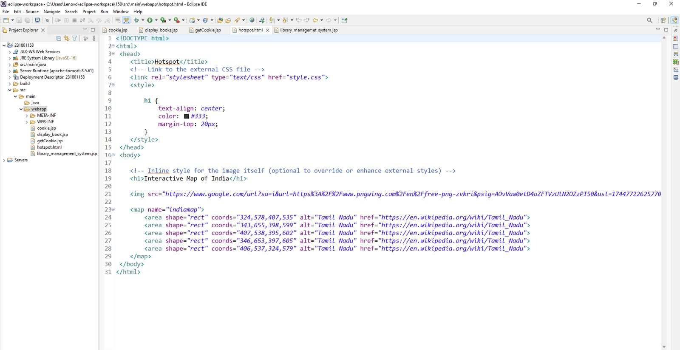
CSS FILE:
@charset "ISO-8859-1";
body {
font-family: Arial, sans-serif;
margin: 0;
padding: 0;
background-color: #f4f4f4;
}

img {
display: block;
margin: 0 auto;
border-radius: 8px;
box-shadow: 0 4px 6px rgba(0, 0, 0, 0.1);
}

/* Styling for the map areas */
area {
outline: none;
border: none;
transition: transform 0.3s ease-in-out;
}

area:hover {
transform: scale(1.1);
}

OUPUT:
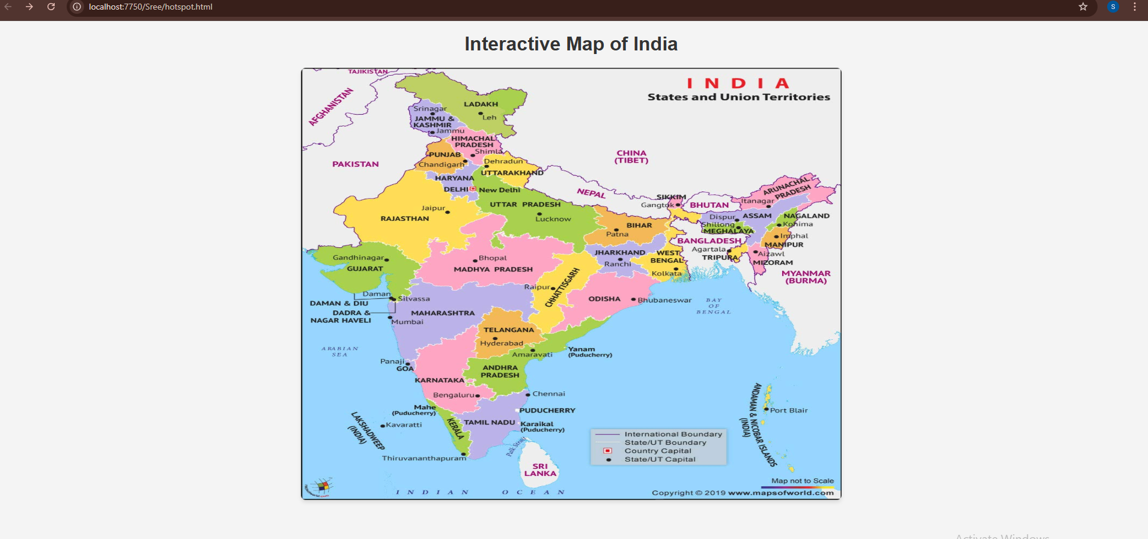
RESULT:
Thus the program for HTML and CSS executed successfully.

