Exp:02 19.02.24 | Write JavaScript to validate the  following fields of the Registration page.

AIM:
a) First Name (Name should contains alphabets and the length Should not be less than 6 characters).
b) Password (Password should not be less than 6 characters length).
c) E-mail id (should not contain any invalid and must follow the standard pattern name@domain.com)
d) Mobile Number (Phone number should contain 10 digits only).
e) Last Name and Address (should not be Empty)
PROGRAM:
<!DOCTYPE html>
<html>
<head>
<meta charset="ISO-8859-1">
<title>Insert title here</title>
</head>
<body>
<form onsubmit="return validateForm()">
<label for="firstName">First Name:</label>
<input type="text" id="firstName" name="firstName" required><br>

<label for="lastName">Last Name:</label>
<input type="text" id="lastName" name="lastName" required><br>

<label for="password">Password:</label>
<input type="password" id="password" name="password" required><br>

<label for="email">Email:</label>
<input type="email" id="email" name="email" required><br>

<label for="mobileNumber">Mobile Number:</label>
<input type="text" id="mobileNumber" name="mobileNumber" required><br>

<label for="address">Address:</label>
<textarea id="address" name="address" required></textarea><br>

<input type="submit" value="Register">
</form>
<script type="text/javascript">
function validateForm() {
// Validate First Name
var firstName = document.getElementById("firstName").value;
var namePattern = /^[A-Za-z]+$/;
if (firstName.length < 6 || !namePattern.test(firstName)) {
alert("First Name must contain only alphabets and be at least 6 characters long.");
return false;
}

// Validate Password
var password = document.getElementById("password").value;
if (password.length < 6) {
alert("Password must be at least 6 characters long.");
return false;
}

/
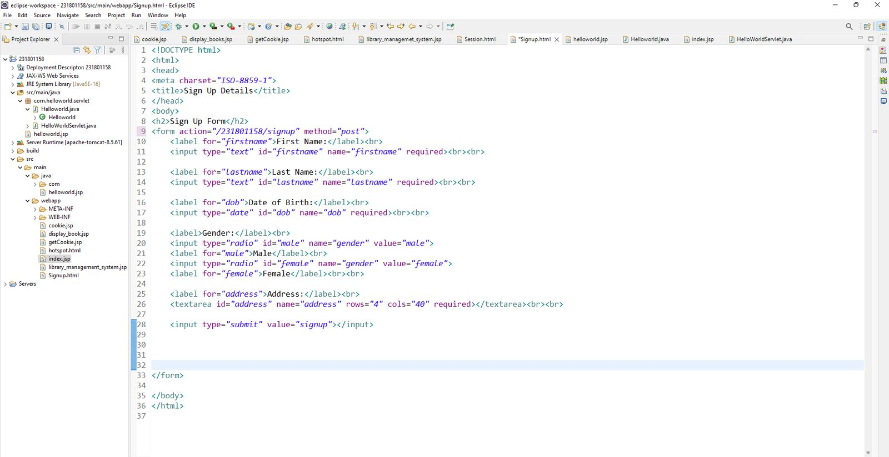


RESULT:
Thus the program for Registration Page executed successfully using javascript.

