Aim:
To print the “Hello World” program in web page using servlet.
PROGRAM:
package com.saravanan.servlet;

import java.io.IOException;
import java.io.PrintWriter;

import javax.servlet.ServletException;
import javax.servlet.annotation.WebServlet;
import javax.servlet.http.HttpServlet;
import javax.servlet.http.HttpServletRequest;
import javax.servlet.http.HttpServletResponse;

/**
* Servlet implementation class HelloWorld
*/
@WebServlet("/HelloWorld")
public class HelloWorld extends HttpServlet {
private static final long serialVersionUID = 1L;

/**
* @see HttpServlet#HttpServlet()
*/
public HelloWorld() {
super();
// TODO Auto-generated constructor stub
}

/**
* @see HttpServlet#doGet(HttpServletRequest request, HttpServletResponse response)
*/
protected void doGet(HttpServletRequest request, HttpServletResponse response) throws ServletException, IOException {
PrintWriter P= response.getWriter();
P.println("hello world");
}

/**
* @see HttpServlet#doPost(HttpServletRequest request, HttpServletResponse response)
*/
protected void doPost(HttpServletRequest request, HttpServletResponse response) throws ServletException, IOException {
// TODO Auto-generated method stub
doGet(request, response);
}

}

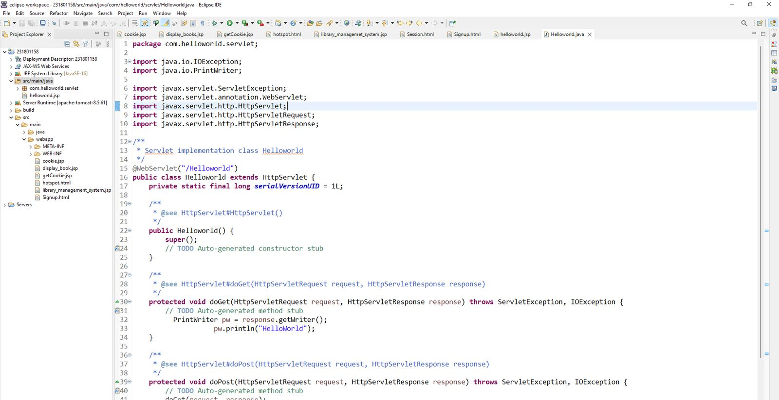

OUTPUT:
