EXP:10 TO DEVELOP ANDRIOD APPLICATION TO
CHAANGE COLOR AND FONT
AIM:
To change the color and font of the andriod application
PROGRAM:
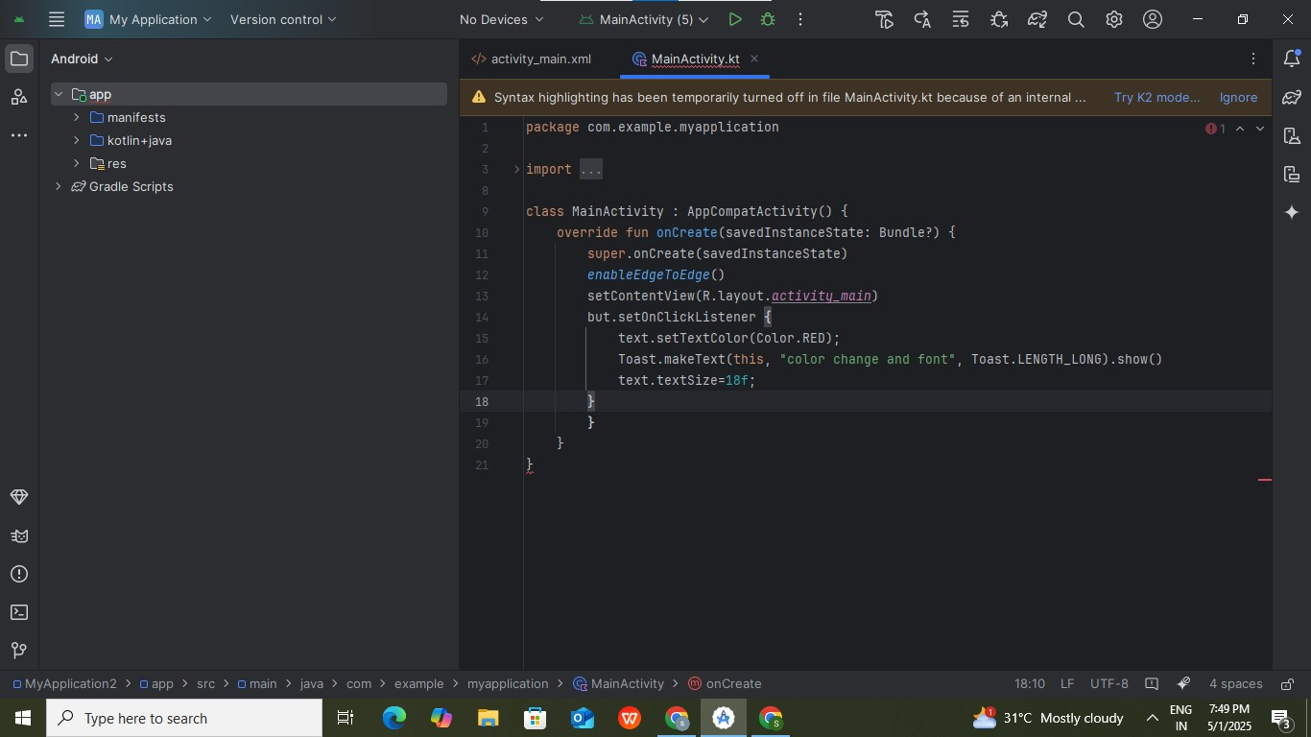

OUTPUT
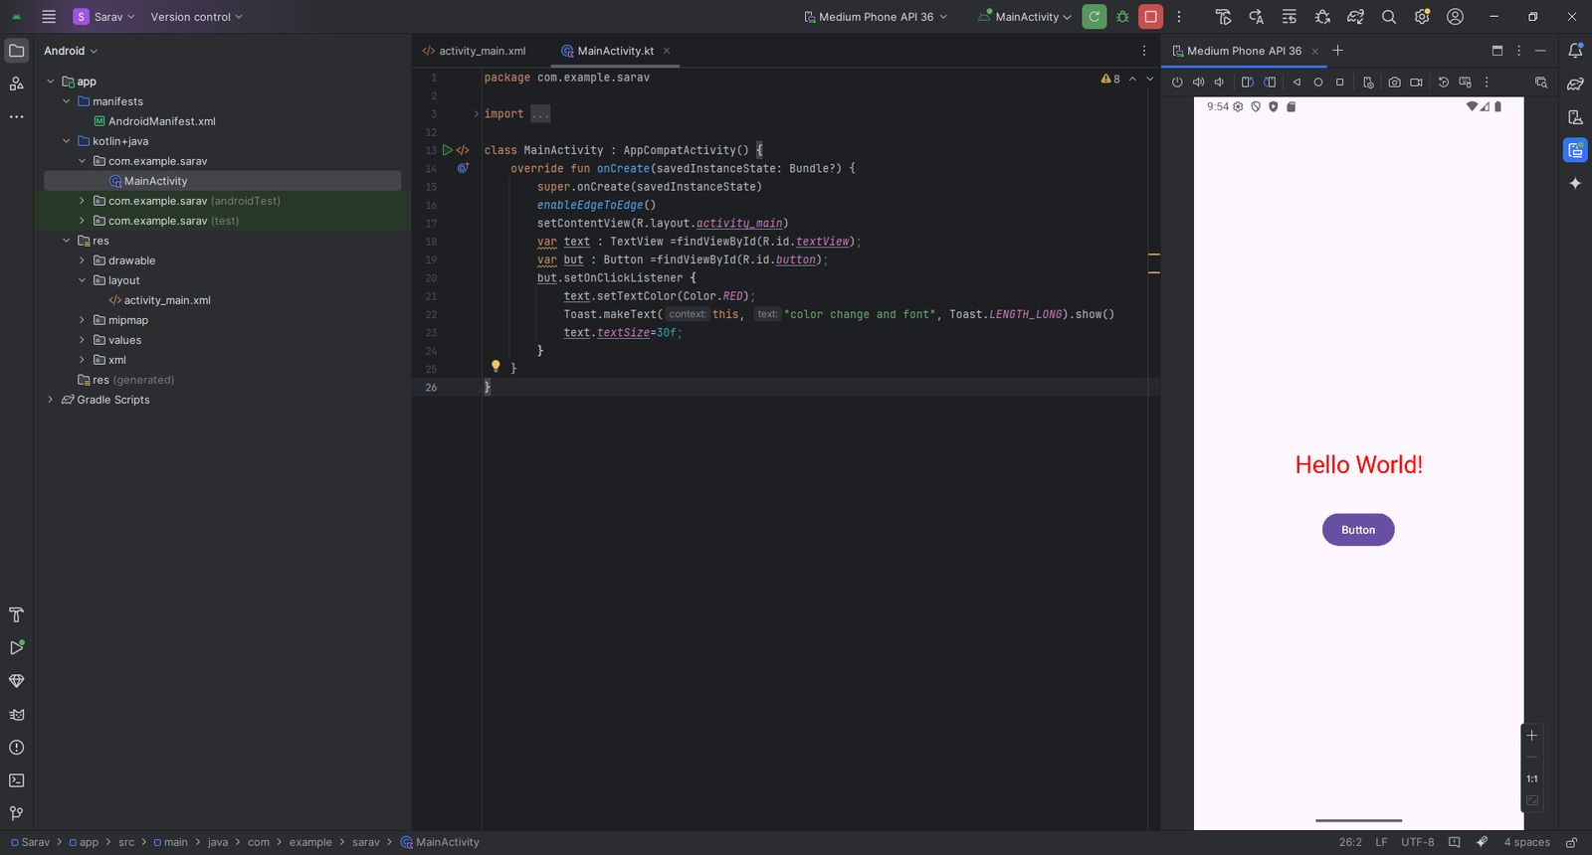

RESULT:
Thus the program was executed successfully

