Exp No: 7  Date:19.04.25 | Write a Servlet program to store a user's preferences (like theme or language) using cookies. Retrieve and display these preferences on subsequent visits.

AIM :
To Write a Servlet program to store a user's preferences (like theme or language) using cookies. Retrieve and display these preferences on subsequent visits.

PROGRAM:
<%@ page language="java" contentType="text/html; charset=ISO-8859-1"
pageEncoding="ISO-8859-1"%>
<!DOCTYPE html>
<html>
<head>
<meta charset="ISO-8859-1">
<title>Cookies</title>
</head>
<body>
<form method = "post" >
<p>
<label>Username: </label>
<input type="text" name="username">
</p>
<p>
<label> password: </label>
<input type="password" name = "password">
</p>
<button type="submit"> Submit </button>

</form>
<%
// Request form method == Post
if ("POST".equals(request.getMethod())) {
// Get submitted preferences
String user = request.getParameter("username");
String pass = request.getParameter("password");
if(user.equals("admin") && pass.equals("admin123") ){

Cookie username = new Cookie("username", user);
username.setMaxAge(60*60);
username.setPath("/");
response.addCookie(username);

response.sendRedirect("getcookie.jsp");

}
}
// Get current preference values
%>
</body>
</html>
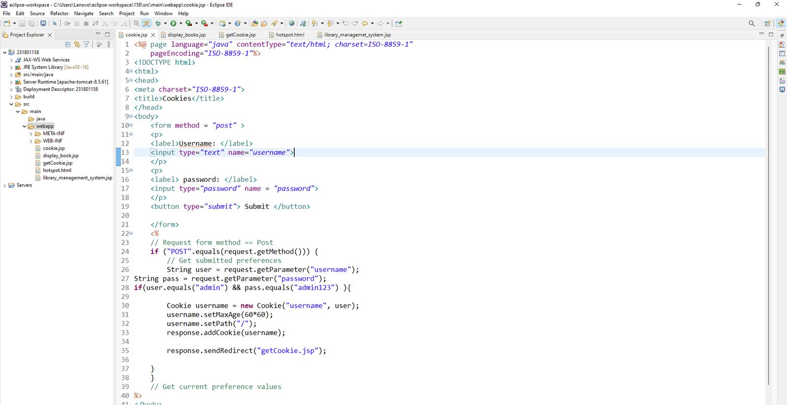
<%@ page language="java" contentType="text/html; charset=ISO-8859-1"
pageEncoding="ISO-8859-1"%>
<!DOCTYPE html>
<html>
<head>
<meta charset="ISO-8859-1">
<title>Get Cookie</title>
</head>
<body>
<%
Cookie[] cookies = request.getCookies();
String cookieName = "username";
if (cookies != null) {
for (Cookie cookie : cookies) {
if (cookieName.equals(cookie.getName())) {
System.out.println("username "+cookie.getName());
out.println(cookie.getValue());
}
}
}
%>
</html>

OUTPUT:
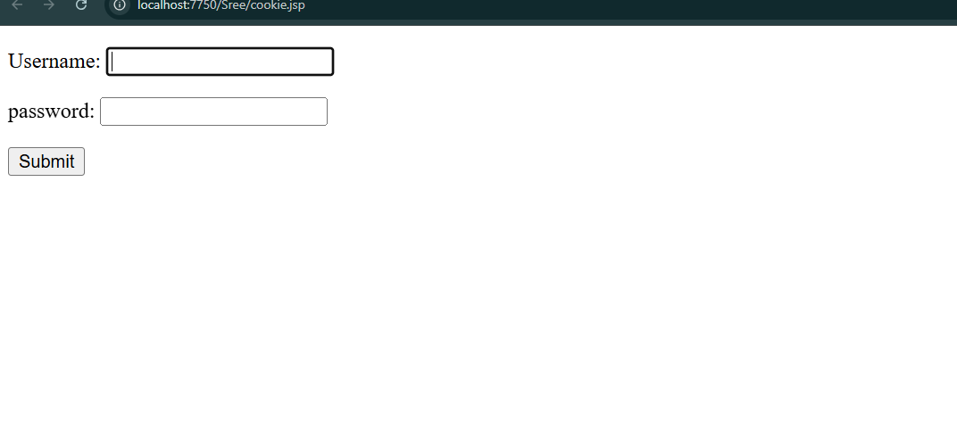

EXP 7
PROGRAM:
<%@ page language="java" contentType="text/html; charset=ISO-8859-1"
pageEncoding="ISO-8859-1"%>
<!DOCTYPE html>
<html>
<head>
<meta charset="ISO-8859-1">
<title>Cookies</title>
</head>
<body>
<form method = "post" >
<p>
<label>Username: </label>
<input type="text" name="username">
</p>
<p>
<label> password: </label>
<input type="password" name = "password">
</p>
<button type="submit"> Submit </button>

</form>
<%
// Request form method == Post
if ("POST".equals(request.getMethod())) {
// Get submitted preferences
String user = request.getParameter("username");
String pass = request.getParameter("password");
if(user.equals("admin") && pass.equals("admin123") ){

Cookie username = new Cookie("username", user);
username.setMaxAge(60*60);
username.setPath("/");
response.addCookie(username);

response.sendRedirect("getcookie.jsp");

}
}
// Get current preference values
%>
</body>
</html>
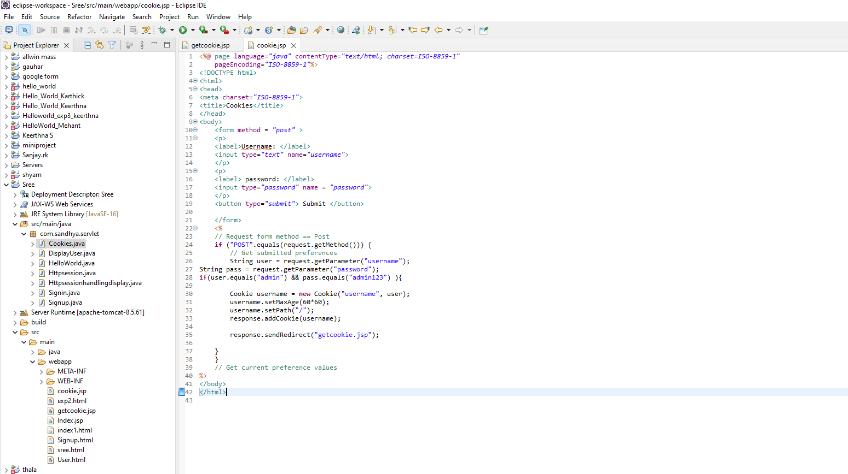
<%@ page language="java" contentType="text/html; charset=ISO-8859-1"
pageEncoding="ISO-8859-1"%>
<!DOCTYPE html>
<html>
<head>
<meta charset="ISO-8859-1">
<title>Get Cookie</title>
</head>
<body>
<%
Cookie[] cookies = request.getCookies();
String cookieName = "username";
if (cookies != null) {
for (Cookie cookie : cookies) {
if (cookieName.equals(cookie.getName())) {
System.out.println("username "+cookie.getName());
out.println(cookie.getValue());
}
}
}
%>
</html>
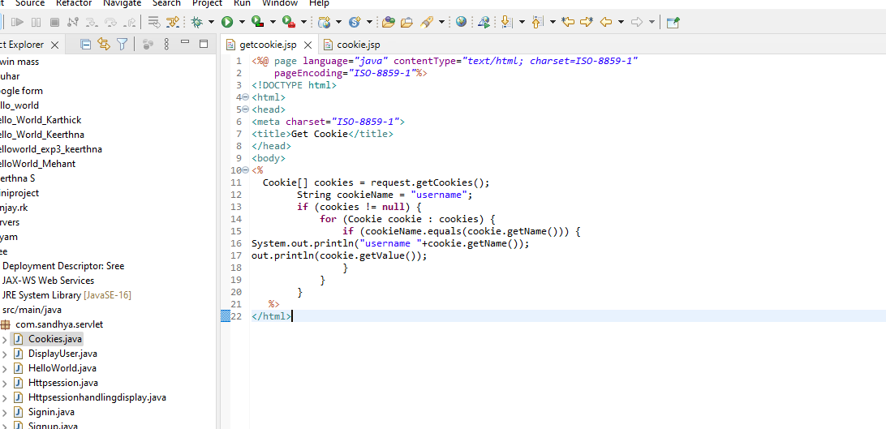
OUTPUT:
