# CHAPTER 1 INTRODUCTION

# 1.1 IMAGE PROCESSING

Image processing is a method to convert an image into digital form and perform some operations on it, in order to get an enhanced image or to extract some useful information from it. The purposes of image processing are visualization, image sharpening and restoration, image retrieval, measurement of pattern and image recognition. The various image processing techniques are image pre-processing, image enhancement, image segmentation, feature extraction and image classification.

In image pre-processing the image data is improved by suppressing unwanted distortions. Image enhancement is the process of improving the quality of a digitally stored image by manipulating the image with software. Image segmentation is the process of partitioning a digital image into multiple segments. Feature extraction a type of dimensionality reduction that efficiently represents interesting parts of an image as a compact feature vector. Image classification refers to the process of categorizing all pixels in a digital image into one of several land covers classes.

**Medical imaging** is the technique and process of creating visual representations of the interior of a body for clinical analysis and medical intervention, as well as visual representation of the function of some organs or tissues. Medical imaging seeks to reveal internal structures hidden by the skin and bones, as well as to diagnose and treat disease. Medical imaging also establishes a database of normal anatomy and physiology to make it possible to identify abnormalities.

# 1.2 DEEP LEARNING

Deep learning is an artificial intelligence (AI) function that imitates the workings of the human brain in processing data and creating patterns for use in decision making. Deep learning is a subset of machine learning in artificial intelligence that has networks capable of learning unsupervised from data that is unstructured or unlabeled. Also known as deep neural learning or deep neural network.

Deep learning architectures such as deep neural networks, deep belief networks, recurrent neural networks and convolutional neural networks have been applied to fields including computer vision, machine vision, speech recognition, natural language processing, audio recognition, social network filtering, machine translation, bioinformatics, drug design, medical image analysis, material inspection and board game programs, where they have produced results comparable to and in some cases surpassing human expert performance.

Most modern deep learning models are based on artificial neural networks, specifically, Convolutional Neural Networks (CNN)s, although they can also include propositional formulas or latent variables organized layer-wise in deep generative models such as the nodes in deep belief networks and deep Boltzmann machines.

In deep learning, each level learns to transform its input data into a slightly more abstract and composite representation. In an image recognition application, the raw input may be a matrix of pixels; the first representational layer may abstract the pixels and encode edges; the second layer may compose and encode arrangements of edges; the third layer may encode a nose and eyes; and the fourth layer may recognize that the image contains a face. Importantly, a deep learning process can learn which features to optimally place in which level on its own.

# 1.3 SYSTEM OVERVIEW

The IQ level estimation of adult brain is analyzed using structural MRI. The various stages of process are been executed for accuracy. The human intelligence is based on different physical structure of brain. The brain MRI analysis process is been detected using brain extraction tool or extraction tool kit. Noise technique is used to process denoising mechanism which is been done using fuzzy c means and expectation maximization algorithm. The processing mechanisms deals with how efficient these two algorithms work when compared to all specific algorithms. The stage of region growing groups the specific gray scale image of the brain into the specific processed segmented image for analysis. This method is used to estimate the IQ level test and to produce the result of the segmented image structure using some parameters. These parameters analyzes and give us a specific output range of how the image is been segmented at different stages of procedures developed.

# 1.4 SCOPE OF THE PROJECT

Segmenting white matter and gray matter from brain anatomical structures is vital to know abnormalities in brain activity. Proportion of white matter, gray matter in Adult brain is also important in estimating IQ level of an individual. Brain connectivity & neurological diseases can also be analyzed. An IQ test measures a person's cognitive ability compared to the population at large. They can help diagnose intellectual disabilities or measure someone’s intellectual potential.

# CHAPTER 2 LITERATURE SURVEY

1. **Suhas.S and C R Venugopal,”MRI Image preprocessing and Noise**

**removal technique using linear and nonlinear filters”,International Conference on Electrical, Electronics, Communication, Computer and Optimization Techniques (ICEECCOT), 2017.**

Linear and Non-Linear filters have analyzed to find out the statistical parameters of noise removal techniques, developed.The filters have been used to estimate noise removal techniques.Gaussian filter,median filter,mean filter,arithmetic mean filter have been applied on brain and spinal cord images.The approach would generally retain the structural details of the medical image and improves the accuracy of MRI images.The output image efficiency has been measured by the statistical parameters like root mean square error(RMSE),signal-to noise ratio(SNR),peak signal-to-noise ratio(PSNR). The goal of any denoising technique is to remove noise.The noise can also originate due to grains in the film or due to the inevitable noise present in an ideal photon detector.Natural images that are affected by Gaussian noise,whereas magnetic resonance images(MRI) are affected by Rician noise filter. Median filter can remove the imprint of input noise values with drastically large magnitudes and this is a major benefit over linear filters.

If the techniques of noise removal has not be maintained carefully otherwise the image will lead to a blurred state.When the level of noise was high,details and edges were not regained sufficiently.

# José V. Manjón ,” MRI Preprocessing”,© Springer International Publishing Switzerland 2017 53 L. Martí-Bonmatí, A. Alberich-Bayarri (eds.), Imaging Biomarkers, 2017

Standardized space making possible meaningful comparisons has done to set the images using image acquisition and image observation.The preprocessing techniques have been developed using denoising and inhomogeneity correction.Current state-of-the-art denoising methods were based on patch wise image preprocessing approaches exploiting sparseness or self-similarity properties of the medical images or both. The method can also be useful if a superresolution step has been applied to increase the resolution of image processes.

The process aimed to improve image data quality analysis to a specific geometric space but has been difficult to restore the original signal of the images.Their components caused a blur in the edges of image space.

# R. Meena Prakash and R. Shantha Selva Kumari ,”Spatial Fuzzy C Means and Expectation Maximization Algorithms with Bias Correction for Segmentation of MR Brain Images “,2017

Fuzzy C means algorithm(FCM) and Expectation Maximization algorithms(EM) have the most prevalent methods for automatic segmentation of MRI brain images.The advanced method have validated extensive experiments on both simulated and real brain images from standard database.The major difficulties associated with those conventional methods for MRI brain image segmentation were the Intensity Non-uniformity (INU) and noise. EM and FCM with spatial information and bias correction were done to overcome those effects.Spatial information have incorporated by convolving the posterior probability during

E-step of the EM algorithm with mean filter.It has been shown that the method outperforms the conventional and state -of-the art methods

Quantitative and qualitative results are only 25% more than the convolution methods.It is one of the difficult methods to implement.

# Song Yuheng1, Yan Hao*,*”Automatic region based brain classification of MRI:T1 data”,2016.

Spatial fuzzy means and expectation maximization algorithm using the preprocessing technique provides a noise removal analysis using denoising by applying gaussian and low pass filter analysis.The segmented region divides into non overlapped regions by region growing method analysis.The feature space clustering method has used to segment the pixels in the image space with the corresponding feature points.The approach to brain extraction tool has been used for the removal of skull outline analysis with hough transform analysis.Edge detection segmentation algorithm refers to the use of different regions of the pixel gray or color discontinuity detection area of the edge in order to achieve image segmentation.CNN model is used to frame the ROI,and then segmented by non machine learning segmentation method to improve the segmentation effect.

Intensities of predominant tissue types may generally overlap other tissue types. The comparison with existing techniques demonstrated that the performance of the proposed approach has been achieved through higher K-similarity index.

# Sudip Kumar Adhikari, Jamuna Kanta Sing, Dipak Kumar Basub, Mita Nasipurib, ”Conditional spatial fuzzy C-means clustering algorithm for segmentation of MRI images “, 2015

Fuzzy C means algorithm(FCM) and Conditional spatial Fuzzy C-means algorithm(csFCM) has been used for segmentation of MRI brain images.It has been achieved through the incorporation of conditioning effects imposed by an auxiliary (conditional) variable corresponding to each pixel, which describes a level of involvement of the pixel in the constructed clusters, and spatial information into the membership functions.Their advanced method was validated by extensive experiments on both simulated and real brain images from standard database.

It could produce superior segmentation results even in the presence of noise and intensity inhomogeneity in MRI data.The presence of high % of IIH (Idiopathic Intracranial Hypertension) along with noise in MRI data might degrade the performance.

# B. Shanthi Gowri and Gnanambal Ilango,“Region Growing Segmentation of MRI -A Metric Topological Approach”,IEEE Seventh National Conference on Computing, Communication and Information Systems (NCCCIS),2015.

Seeded region growing and LTHV algorithm for segmentation of MRI brain images have used to process into non-overlapped regions.A novel region growing segmentation algorithm have been based on metric topological neighbourhoods. The quality of segmentation have measured by using the new objective measure entropy along with traditional validity measures like accuracy, PSNR and MSE.A

new seeded region growing segmentation algorithm has applied to segment the region of interest from the medical images.It generally based on metric topological neighbourhoods of different metrics and grouping criterion.The amount of information present in the original image has approached the segmented portion which provides the effectiveness of algorithm by retaining the essential information without loss of data.The concept retained maximum fidelity of the image.It depends on intensity ,edges and so on.The changes in the single parameter affects the desired output in a very large scale.

# Shaswati Roy and Pradipta Maji,”A Simple Skull Stripping Algorithm for Brain MRI”,IEEE,2015.

Removing skull from T1-weighted brain MR images has removed cerebral tissues like skull,scalp and dura from brain images.The method could be more robust by selecting the optimum values of morphology opening and closing sizes based on image characteristics.S3 method has been used to analyze the experimental results on both synthetic as well as real images.Brain anatomy and image intensity characteristics can be implemented as a part of brain image processing system.The algorithm was generally compared with brain extraction tool and brain surface destructor analysis.It used adaptive intensity thresholding followed by morphological operations, for increased robustness, on brain magnetic resonance (MR) images.It did not require any user intervention or setting any external initial parameters to extract the brain matter and thus qualify to be an automatic method.

Ability to provide good spatial resolution by selecting the range of optimum values.Final results tend to depend on the original orientation of the volume structure been developed.

# Anagha S.Kulkarni and R.S.Kamathee,” MRI Brain Image Segmentation by Edge Detection and Region Selection “,International Journal of Technology and Science, Issue. 2, Vol. 1, May 2014

Brain image segmentation using canny detector analysis technique have used to detect the low error rate and good localization using region selection and edge detection.The method were used to compare with the k-means clustering algorithm.Region based method segment the tissue connectivity present in interested brain structure.It has been used to extract white and gray matter analysis to segment through region growing analysis.Detection of images have done via k-means clustering method by comparing the canny detector analysis.The edge map derived from the edge detector of different scales represents the edges of different strengths and accuracy.

Adjacent tissues have been separated due to the small intensity change analysis and the gray level discontinuity analysis was small.

# Rafael M. Luque-Baena ,“MRI Segmentation of the Human Brain: Challenges,Methods, and Applications “,2014

Different types of preprocessing methods available for image processing like image registration,bias field correction,different segmentation methods like manual segmentation,intensity based methods have done to process the MRI segmentation.The advances in brain MRI imaging have provided large amount of

data with an increasingly high level of quality.Computational efficiency would be particularly important in real time processing applications such as computer guided surgery.They have explained all the methods but they did not determine the appropriate method.They did not even explained the segmented image results and it’s uses.Image registration have required in brain MRI segmentation for the alignment of multimodal images of the same subject taken from different points and different viewpoints.

Based on the uses,the method has to be chosen.The predetermined ideas were not applicable for real time clinical settings.

# Manoj Kumar V and Sumithra M G,”An improved region growing based segmentation algorithm for brain MRI”, 2013

Improved region based growing algorithm using Region of Interest selection,seed point selection and region extraction have been done to process the tumour cells exactly.The parameters used by them for segmentation were pixel value , volume , mean and standard deviation.Seeded region growing method have been used for the region extra.The regions were iteratively grown by comparing all unallocated neighbouring pixels to the region.Region growing method extracted the tumour exactly.Preprocessing eliminated the noise and unwanted region that leads to a better output.It includes ROI selection,denoising and image enhancement.The difference between a pixel's intensity value and the region's mean, δ, have been used as a measure of similarity.

The primary disadvantage of region growing method, that it required manual interaction to obtain the seed point. Region growing could also be sensitive to noise, causing extracted regions to have holes.

# CHAPTER 3 SYSTEM ANALYSIS

* 1. **EXISTING SYSTEM**

Image segmentation is done using different kinds of algorithms like Fuzzy C means algorithm which was completely automatic.The other techniques used to segment MRI brain image are Edge detection and Region selection.Method will separate out white matter,gray matter and CSF structure from brain image. The quality of segmentation is measured using the new objective measure entropy along with the traditional validity measures accuracy, PSNR and MSE.Segmentation with preprocessing gives good quality and accurate output than the segmentation without preprocessing. Some segmentations has also provided the identification methodologies of abnormalities in the brain.MRI brain image segmentations was done using Region growing algorithm,Improved region growing algorithm,Edge detection and Edge selection so on.

# Disadvantages of the Existing System

* + - * The result is binary. It sometimes need a measure of 'how much' the edge qualifies as an edge (e.g. intensity image coming from a Sobel amplitude edge detector)
      * The amount of parameters leads to infinitely tweaking for getting just that little better result.
      * One still need to connect the resulting edges to extract the complete edges that seem so obvious for the human eye+mind.
      * Also due to the gaussian smoothing: the location of the edges might be off, depending on the size of the gaussian kernel.

# PROPOSED SYSTEM

Adult Structural MRI is collected and various stages such as Image preprocessing,Image segmentation and IQ level estimation is done.Image preprocessing is done using various techniques such as filtering,bias correction,contrast enhancement and inhomogeneity is done.Image segmentation and IQ level estimation is done using region growing method,estimation of white matter and gray matter.Intelligence parameter include brain volume,white matter,gray matter and cortical thickness. MRI brain image will be preprocessed using gray scale image filter which converts the image into Gray - scale image and median image filter which is used for denoising.Using Region growing algorithm,the image will be segmented into White matter(WM) , Gray matter(GM). And also volume of the brain is calculated. Based on those values,IQ level will be estimated.

# Advantages of the Proposed System

* + - * Region growing method can correctly separate the regions that have the same properties we define.
      * Region growing method can provide the original images which have clear edges with good segmentation results.
      * The concept is simple. We only need a small number of seeded points to represent the property we want to grow the region.
      * One can determine the seeded points and the criteria as desires.
      * One can choose the multiple criteria at the same time.

# REQUIREMENTS SPECIFICATION

* + 1. **Hardware Requirements**
* Hard Disk: 40GB and above
* RAM: 512MB and above
* Processor: Pentium IV and above

# Software Requirements

* Windows operating system XP and above
* MEVISLAB Version 2.7.1 and above

# LANGUAGE SPECIFICATION

* + 1. **MEVISLAB**

**MeVisLab** is a cross-platform application framework for medical image processing and scientific visualization. It includes advanced algorithms for image registration, segmentation, and quantitative morphological and functional image analysis. An IDE for graphical programming and rapid user interface prototyping is available.

MeVisLab is written in C++ and uses the Qt framework for graphical user interfaces. It is available cross-platform on Windows, Linux, and Mac OS X. A freeware version of the MeVislab SDK is available. Open source modules are delivered as MeVisLab Public Sources in the SDK and available from the MeVisLab Community and Community Sources project.To support the creation of image processing networks, MeVisLab offers an IDE that allows data-flow modelling by visual programming. Important IDE features are the multiple document interface (MDI), module and connection inspectors with docking ability, advanced search, scripting and debugging consoles, movie and screenshot generation and galleries, module testing and error handling support.

MeVisLab has been used in a wide range of medical and clinical applications, including surgery planning for liver,lung,head and neck and other body regions, analysis of dynamic, contrast enhanced breast and Prostate MRI, quantitative analysis of neurologic and cardiovascular image series,orthopedic quantification and visualization, tumor lesion volumetry and therapy monitoring,enhanced visualization of mammograms, 3D breast ultrasound and tomosynthesis image data, and many other applications. MeVisLab is also used as a training and teaching tool for image processing and visualization techniques.

MeVisLab is and has been used in many research projects, including:

* + - * VICORA VICORA Virtuelles Institut für Computerunterstützung in der klinischen Radiologie (2004–2006)
      * DOT-MOBI
      * HAMAM

# CHAPTER 4

**SYSTEM DESIGN**

* 1. **SYSTEM ARCHITECTURE**

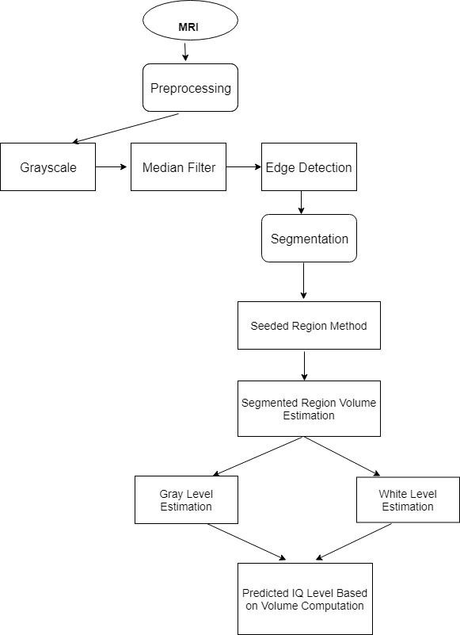

**Figure 4.1 Architecture of proposed system**

In the figure 4.1,the input is given as an MRI(Magnetic Resonance Imaging) image is a radio technology scan that uses magnetism,radio waves and a computer to produce images of body structures.In order to obtain an efficient segmented image the input image is been preprocessed by some procedures involved.By preprocessing,the input is been detected by noise reduction and gray scale conversion technique.In the noise reduction technique,denoising mechanism is involved to reconstruct a signal from a noisy one and to preserve useful information to the processing methods involved in it. Median filter and gray image filter is used to pre-process the image.It will be converted into gray scale conversion mechanism in which the value of each pixel is a single sample representing only an amount of light,that is it carries only intensity information.The converted gray image is subjected to median filter for denoising salt and pepper type noise. Once the image is been preprocessed it is been given to the image segmentation module.The segmentation module uses a region growing algorithm technique.Using this algorithm the image will be segmented into white matter(WM),gray matter(GM) and CerebroSpinal Fluid(CSF).By this mechanism the image may be segmented into non-overlapped regions.Based on these segmented values,IQ level is been estimated.The output of the segmentation module produces segmented image of the preprocessed image.The output of the two algorithms are compared qualitatively and quantitatively.By these techniques involved the output is been developed as the segmented image.

# SEQUENCE DIAGRAM

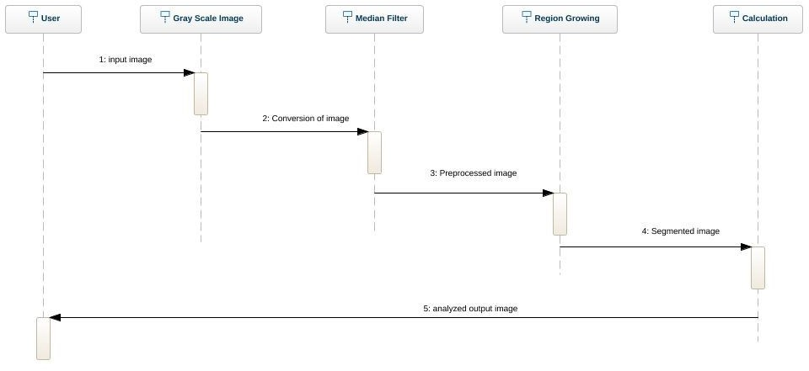

**FIGURE 4.2 SEQUENCE DIAGRAM**

In Figure 4.2, the input image is given by the user to the Gray scale module. The Gray scale image module converts normal image to gray image. Once the image is converted, the gray image is given as input to Median Filter. Median Filter performs the function of noise removal. After noise removal, the pre-processed image is given as input to segmentation process i.e., region growing. At this stage, the image is segmented and calculation of white matter and grey matter is done. The overall output is displayed to the user.

# USE CASE DIAGRAM

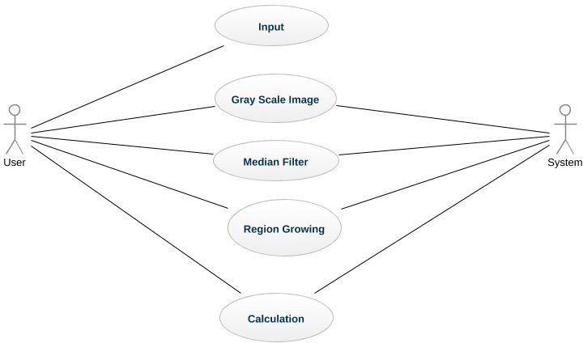

**FIGURE 4.3 USE CASE DIAGRAM**

In the Figure 4.3, the input image is given to the gray scale image use case which converts the image into gray image. Gray image is sent to median filter use case which removes the noise present in the input image. The pre-processed image is segmented by the region growing use case which segments the image. The output of the algorithm is analyzed and white and gray matter is calculated. After this calculation, the result is shared to the user.

# STATE DIAGRAM

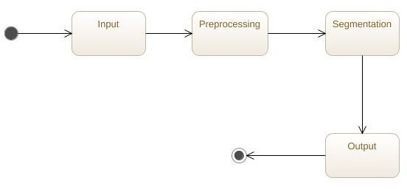

**FIGURE 4.4 STATE DIAGRAM**

In the Figure 4.4, the taken image is subjected to different states. Initially, it is subjected to input state which takes the image for further processing. After the completion of input state, the image is subjected to preprocessing state. At this state, the image is initially converted to gray image using gray scale and then it is denoised using median filter. The preprocessed image is given to segmentation state in which the input is segmented and analyzed for output. The result is given to the output state which will display it to the user.

# CHAPTER 5 MODULE DESCRIPTION

* 1. **MODULES**

The modules are

* + - Gray Scale
    - Median Filter
    - Edge Detection Algorithm
    - Region Growing Method
    - IQ Level Estimation

# PRE-PROCESSING

Pre-processing is a common name for operations with images at the lowest level of abstraction - both input and output are intensity images. The aim of pre-processing is an improvement of the image data that suppresses unwilling distortions or enhances some image features important for further processing, although geometric transformations of images (e.g. rotation, scaling, and translation) are classified among preprocessing methods here since similar techniques are used.

Image filtering is used to:

* + - Remove noise
    - Sharpen contrast
    - Highlight contours
    - Detect edges

The pre-processing step is accomplished by the use of **Gray Scale** and

**Median Image Filter** among the various linear and non-linear filters.

# GRAY SCALE

Black and white photographs are not really just black and white, but also contain various shades of gray known as grayscale. Grayscale can be an economical color scheme, wherein the only color values might be 8, 16, or 256 shades of gray.

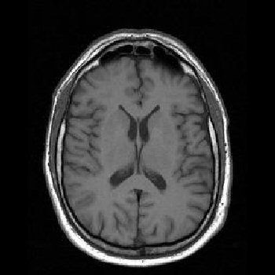

# FIGURE 5.1.1 Grayscale image conversion

The process of converting an image to Grayscale.As a first step, we might try replacing the color values of each pixel with their average, as follows:

# average = (r + g + b) / 3 (1) image.setPixel(x, y, (average, average, average))

Although this method is simple, it does not reflect the manner in which the different color components affect human perception. The human eye is actually more sensitive to green and red than it is to blue. As a result, the blue component appears darker than the other two components. A scheme that combines the three components needs to take these differences in luminance into account. A more accurate method would weight green more than red and red more than blue. Therefore, to obtain the new RGB values, instead of adding the color values up and dividing by three, we should multiply each one by a weight factor and add the results. Psychologists have determined that the relative luminance proportions of green, red, and blue are .587, .299, and .114, respectively. Note that these values add up to 1.

# Example code :

def grayScale(image):

"""Converts the argument image to grayscale.""" for y in xrange(image.getHeight()):

for x in xrange(image.getWidth()): (r, g, b) = image.getPixel(x, y) r = int(r * 0.299)

g = int(g * 0.587) b = int(b * 0.114) lum = r + g + b

image.setPixel(x, y, (lum, lum, lum))

# MEDIAN IMAGE FILTER

Median filtering is a nonlinear method used to remove noise from images. It is widely used as it is very effective at removing noise while preserving edges. It is particularly effective at removing ‘salt and pepper’ type noise. The median filter works by moving through the image pixel by pixel, replacing each value with the median value of neighbouring pixels. The pattern of neighbours is called the "window", which slides, pixel by pixel over the entire image pixel, over the entire image. The median is calculated by first sorting all the pixel values from the window into numerical order, and then replacing the pixel being considered with the middle (median) pixel value.

Commonly the salt and pepper noise may affect the medical scanned image.

So median filter is used to remove salt and pepper noise and preserves edges.

# M = [Im_min + (N/2 – Fn) fn].* C (2) Equation 1. Median filter to remove salt and pepper noise.

Where

Im_min - Lower boundary of the median class. N - Sum of frequencies.

Fn - n number of frequencies with cumulative frequency before the median class.

fn - n frequencies of the median class.

C - Size of the median class.

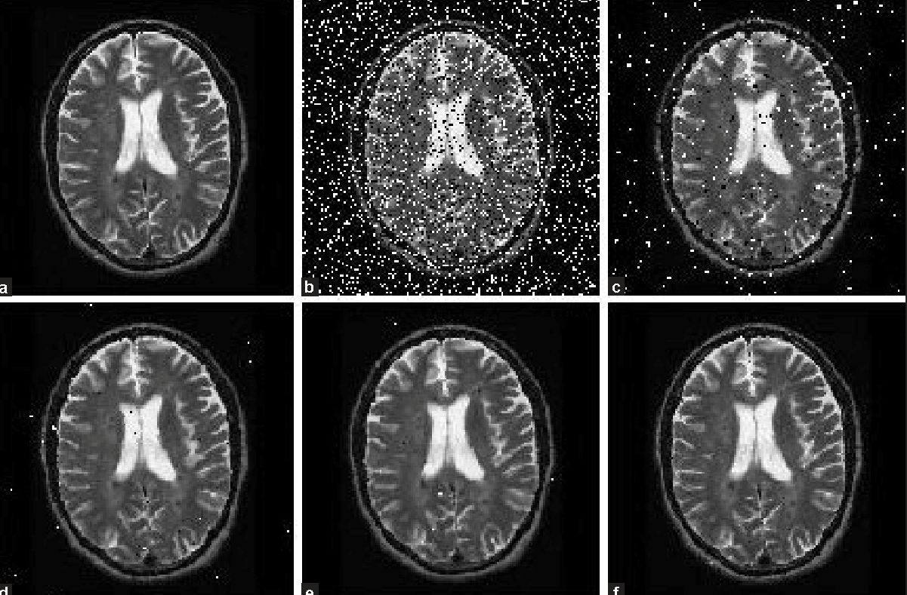

# Figure 5.1.2 Image denoising

This median filter follows the following steps which are denoted below:

* Find out the sum of frequencies and cumulative frequency of image.
* Compute median class.
* Select lower boundary of the median class.
* Find out frequency and size of the median class.

This is a linear interpolation which finds where the actual median would be if you assume that the data are uniformly distributed within the median class. Median filter is an order statistic method is able to remove speckle or salt and pepper noise. The noise segregates itself in front of the median and the median never comes near it,while still giving a nice estimate of central tendency.

There are other approaches that have different properties that might be preferred in particular circumstances:

* + Avoid processing the boundaries, with or without cropping the signal or image boundary afterwards.
  + Fetching entries from other places in the signal. With images for example, entries from the far horizontal or vertical boundary might be selected.
  + Shrinking the window near the boundaries, so that every window is full.

Average (or mean) filtering is a method of ‘smoothing’ images by reducing the amount of intensity variation between neighbouring pixels. The average filter works by moving through the image pixel by pixel, replacing each value with the average value of neighbouring pixels, including itself.

There are some potential problems :

* + A single pixel with a very unrepresentative value can significantly affect the average value of all the pixels in its neighbourhood.
  + When the filter neighbourhood straddles an edge, the filter will interpolate new values for pixels on the edge and so will blur that edge. This may be a problem if sharp edges are required in the output.

Hence, normalizing is important in median filter to keep the image pixel values between 0 and 255 and to keep the border values unchanged.

# EDGE DETECTION ALGORITHM

Edge detection is a critical element in image processing, since edges contain a major function of image information. The function of edge detection is to identify the boundaries of homogeneous regions in an image based on properties such as intensity and texture. Many edge detection algorithms have been developed based on computation of the intensity gradient vector, which, in general, is sensitive to noise in the image. In order to suppress the noise, some spatial averaging may be combined with differentiation such as the Laplacian of Gaussian operator and the detection of zero crossing.

Canny operator consists of the main processes as shown in Figure 5.1.3. The first order Gaussian function is defined as:

G(x,y,σ)= (1/2πσ 2)e(−x 2+y 2/2σ 2) (3)

The Gaussian smoothing function smoothes out the image to have a noise-free image prior to applying the derivative function. The derivative function is approximated using a 3 x 3 kernel that is applied on the horizontal (Gx) and vertical (Gy) direction of an image.

Conventional Canny algorithm works as follows:

* + - * Smooth an image with Gaussian filter.
      * Calculate gradient magnitude and gradient direction.
      * “Non - maximal suppression” to ensure the desired edge with one single pixel width.
      * Determine two threshold values, and then select possible edge points and trace edges.

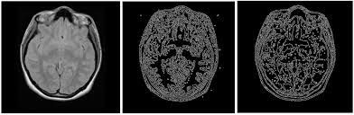

# FIGURE 5.1.3 Edge Detection Algorithm

**Error rate:**

The edge detector should respond only to edges, and should find all of them; no edges should be missed.

# Localization:

The distance between the edge pixels as found by the edge detector and the actual edge should be as small as possible.

# Response:

The edge detector should not identify multiple edge pixels where only a single edge exists.

# Advantages of canny edge detection algorithm:

* + - * + Less Sensitive to noise
        + Remove streaking problem
        + Adaptive in nature
        + Good localization

# REGION GROWING METHOD

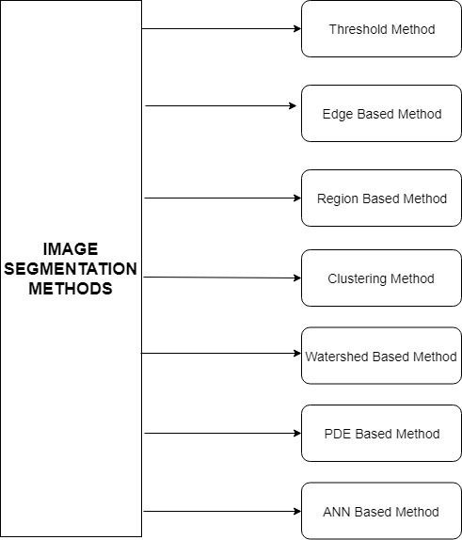Image segmentation is the process of partitioning a digital image into multiple segments (sets of pixels, also known as super-pixels). The goal of segmentation is to simplify and/or change the representation of an image into something that is more meaningful and easier to analyze. Image segmentation is typically used to locate objects and boundaries (lines, curves, etc.) in images. More precisely, image segmentation is the process of assigning a label to every pixel in an image such that pixels with the same label share certain characteristics. Various image segmentation techniques are shown in Figure 5.1.4.1.

# Figure 5.1.4.1 Image segmentation techniques

The result of image segmentation is a set of segments that collectively cover the entire image, or a set of contours extracted from the image . Each of the pixels in a region are similar with respect to some characteristic or computed property, such as color, intensity, or texture. Adjacent regions are significantly different with respect to the same characteristics.

Region growing is a region-based image segmentation method also called pixel based image segmentation.Region growing method is used to partition an image into non overlapped regions in the image. Region growing method can correctly separate the region and provide good segmentation results. The region growing and mathematical morphological methods are the non-brain region and done by extraction of the brain region. The main aim of region growing images is to individual pixels are called seeds in an input image and starts with initial seeds and grows with neighbouring pixels.Region growing is grown from initial seed and compared with 8-connected neighbourhood pixels and 4-connected neighbourhood pixels.First process or iteration, 8-neighbor pixels in the 3X3 neighbourhood pixels of the center pixel satisfying the condition.

 (4)

The region growing is the pixel at the center is the seed point for the region growing process. The pixel value falls within growing criteria and satisfy the condition then to add the region otherwise any neighbouring pixels remain then not satisfying the condition then selected from region.

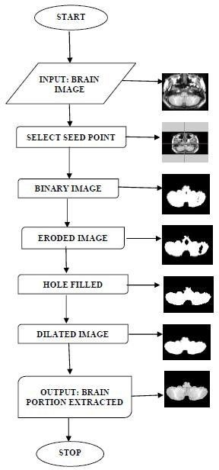

# Figure 5.1.4.2 Proposed Region Growing Method

The 8 pixels in the 3x3 neighbourhood of the center pixel are grouped together to a 3x3 size square shape.A binary image is a digital image that has two possible values for each pixel.Two colors are been used for the binary image i.e

black and white represented by 0 and 1.Morphological operations are used either to separate or join region.The Dilation and erosion are the basic morphological operations.Erosion removes pixels on the object boundaries whereas Dilation adds pixels to it by using the structuring element(SE).The eroded image is received as:

 (5)

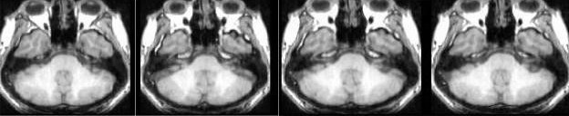

1. **Input Image**

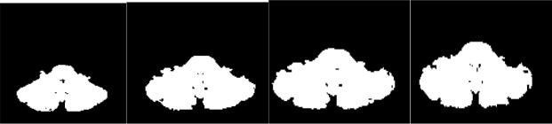

1. **Segmented Image**

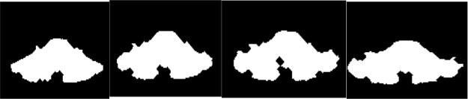

1. **Eroded Image**



1. **Hole Filled**

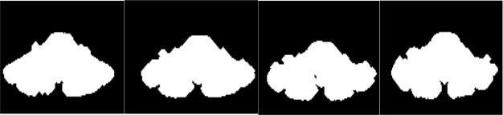

1. **Dilated Image**

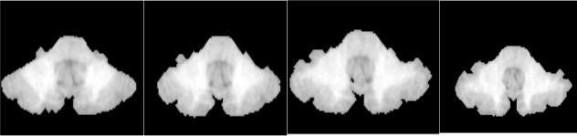

1. **Extracted Image**

**FIGURE 5.1.4.3 Region Growing Method procedure**

The experiments by using the region growing method in MRI brain images collected from IBSR (Internet Brain Segmentation Repository) and gold standard images.A hole is an area of dark pixels in region surrounded by a connected border of foreground pixels in binary image and the use of dilation.The MRI brain images, Not extracted for the brain portion in the upper slices, bottom slices and the same problem has been reported in BET and BSE also. The results shows that region growing method worked well on normal Brain datasets.Thus the SRG(Seeded Region Growing) method is a suitable method to segment the brain from MRI brain images.

# IQ LEVEL ESTIMATION

First of all, the concept of IQ was developed by either the German psychologist and philosopher Wilhelm Stern in 1912, or by Lewis Terman in 1916, depending on which sources you consult. Intelligence testing was first done on a large scale before either of these dates. In 1904 psychologist Alfred Binet was commissioned by the French government to create a testing system to differentiate intellectually normal children from those who were inferior.

From the calculated volumes of White matter, Gray matter and total volume of the brain,IQ level is calculated using the following formula:

*IQ Level*

= (*V olume of WM* ÷ *V olume of GM* )

× *T otal V olume of Brain*

**(6)**

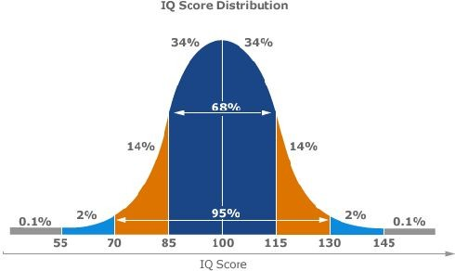

# FIGURE 5.1.4 IQ SCORE DISTRIBUTION

The corresponding volumes are calculated by scanning the input and counting all voxels which are within a given interval in an image.

From Binet's work the IQ scale called the "Binet Scale," (and later the "Simon-Binet Scale") was developed. Sometime later, "intelligence quotient," or "IQ," entered our vocabulary. Lewis M. Terman revised the Simon-Binet IQ Scale, and in 1916 published the Stanford Revision of the Binet-Simon Scale of Intelligence (also known as the Stanford-Binet). The following scale resulted for classifying IQ scores:

|  |  |
| --- | --- |
| **IQ Range Classification** | |
| Above 140 | Genius or almost genius |
| 120-140 | Very superior intelligence |
| 110-119 | Superior intelligence |
| 90-109 | Average or normal intelligence |
| 80-89 | Dullness |
| 70-79 | Borderline deficiency in intelligence |
| Below 70 | Feeble-mindedness |

# Table 1. IQ Scale based on scores

Some of the highest IQ scores ever possible are listed below for statistical analysis. The highest possible IQ level is 260 - 300.

|  |  |
| --- | --- |
| **Name IQ Scores** | |
| Johann Wolfgang von Goethe | 210 |
| Emanuel Swedenborg | 205 |
| Gottfried Wilhelm von Leibniz | 205 |
| John Stuart Mill | 200 |
| Blaise Pascal | 195 |
| Ludwig Wittgenstein | 190 |
| Bobby Fischer | 187 |
| Galileo Galilei | 185 |
| René Descartes | 180 |
| Madame De Stael | 180 |
| Immanuel Kant | 175 |
| Sofia Kovalevskaya | 170 |
| Thomas Chatterton | 170 |
| Charles Darwin | 165 |
| Wolfgang Amadeus Mozart | 165 |
| Albert Einstein | 161 |
| George Eliot (Mary Ann Evans) | 160 |
| Nicolaus Copernicus | 160 |

# Table 2. Statistics of Geniuses IQ scores

**CHAPTER 6**

**CONCLUSION AND FUTURE ENHANCEMENT**

* 1. **CONCLUSION**

For an image, pre processing is necessary. Initially, an image is converted to gray image using gray scale image converter. The pre-processing steps include intensity normalization, background removal by thresholding method and intensity enhancement. Among them, gray image is accomplished by the median filter to remove the salt and pepper noise. The pre processed image is segmented using region growing method after edge is detected using edge detection method. White matter and Gray matter have been detected efficiently using region growing method. Volume of the brain is also calculated. Using the values of white matter, gray matter, volume of the brain and the predefined values for the IQ level segregation categories, the IQ level of the brain can be estimated.

# FUTURE ENHANCEMENT

As future work, we are trying to detect IQ level with more parameters like volume of the brain, White matter, Gray matter volume of the whole brain, cortical thickness and parietal lobes using three dimensional images. Further improvement

can be done with the curvatures of the brain which will also use 3D images for IQ level estimation.

# APPENDIX 1

**SAMPLE CODING**

**PRE-PROCESSING :**

# MeVis module import from mevis import * import sys

import cv import numpy

def median_filter(data, filter_size): temp = []

indexer = filter_size // 2 for i in range(len(data)):

for z in range(filter_size):

if i + z - indexer < 0 or i + z - indexer > len(data) - 1: for c in range(filter_size):

temp.append(0)

else:

if j + z - indexer < 0 or j + indexer > len(data[0]) - 1: temp.append(0)

else:

for k in range(filter_size):

temp.append(data[i + z - indexer][j + k - indexer])

temp.sort()

data[i][j] = temp[len(temp) // 2] temp = []

return data

# SEGMENTATION :

# MeVis module import from mevis import * import sys

import cv import numpy

def simple_region_growing(img, seed, threshold=1):

try:

dims = cv.GetSize(img) except TypeError:

raise TypeError("(%s) img : IplImage expected!" % (sys._getframe().f_code.co_name))

# img test

if not(img.depth == cv.IPL_DEPTH_8U):

raise TypeError("(%s) 8U image expected!" % (sys._getframe().f_code.co_name)) elif not(img.nChannels is 1):

raise TypeError("(%s) 1C image expected!" % (sys._getframe().f_code.co_name)) # threshold tests

if (not isinstance(threshold, int)) :

raise TypeError("(%s) Int expected!" % (sys._getframe().f_code.co_name)) elif threshold < 0:

raise ValueError("(%s) Positive value expected!" % (sys._getframe().f_code.co_name))

# seed tests

if not((isinstance(seed, tuple)) and (len(seed) is 2) ) : raise TypeError("(%s) (x, y) variable expected!" % (sys._getframe().f_code.co_name))

if (seed[0] or seed[1] ) < 0 :

raise ValueError("(%s) Seed should have positive values!" % (sys._getframe().f_code.co_name))

elif ((seed[0] > dims[0]) or (seed[1] > dims[1])):

raise ValueError("(%s) Seed values greater than img size!" % (sys._getframe().f_code.co_name))

reg = cv.CreateImage( dims, cv.IPL_DEPTH_8U, 1) cv.Zero(reg)

#parameters

mean_reg = float(img[seed[1], seed[0]]) size = 1

pix_area = dims[0]*dims[1]

contour = [] # will be [ [[x1, y1], val1],..., [[xn, yn], valn] ] contour_val = []

dist = 0

# TODO: may be enhanced later with 8th connectivity orient = [(1, 0), (0, 1), (-1, 0), (0, -1)] # 4 connectivity cur_pix = [seed[0], seed[1]]

#Spreading

while(dist<threshold and size<pix_area):

#adding pixels for j in range(4):

#select new candidate

temp_pix = [cur_pix[0] +orient[j][0], cur_pix[1] +orient[j][1]]

#check if it belongs to the image

is_in_img = dims[0]>temp_pix[0]>0 and dims[1]>temp_pix[1]>0 #returns boolean #candidate is taken if not already selected before

if (is_in_img and (reg[temp_pix[1], temp_pix[0]]==0)): contour.append(temp_pix) contour_val.append(img[temp_pix[1], temp_pix[0]] )

reg[temp_pix[1], temp_pix[0]] = 150 #add the nearest pixel of the contour in it

dist = abs(int(numpy.mean(contour_val)) - mean_reg)

dist_list = [abs(i - mean_reg) for i in contour_val ] dist = min(dist_list) #get min distance

index = dist_list.index(min(dist_list)) #mean distance index size += 1 # updating region size

reg[cur_pix[1], cur_pix[0]] = 255

#updating mean MUST BE FLOAT

mean_reg = (mean_reg*size + float(contour_val[index]))/(size+1) #updating seed

cur_pix = contour[index]

#removing pixel from neigbourhood del contour[index]

del contour_val[index]

return reg

# APPENDIX 2 SCREENSHOTS INPUT FILE

**MEVISLAB NETWORK**

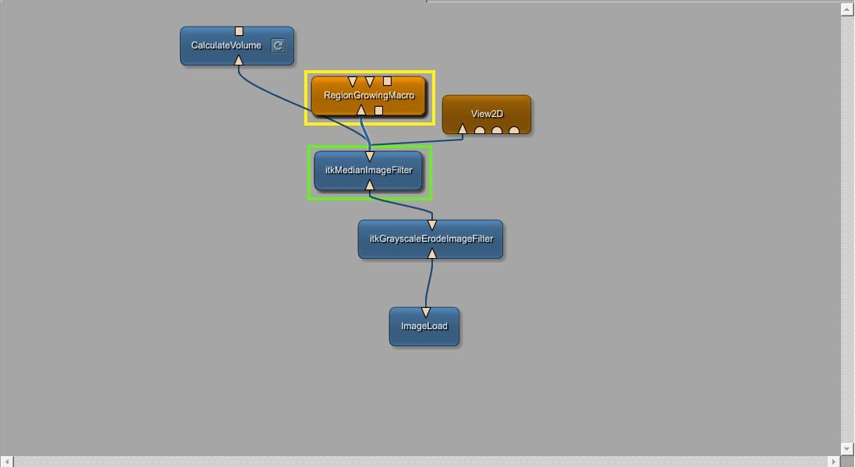

**SEEDING POINTS FEEDING AND OUTPUT IN REGION GROWING METHOD**

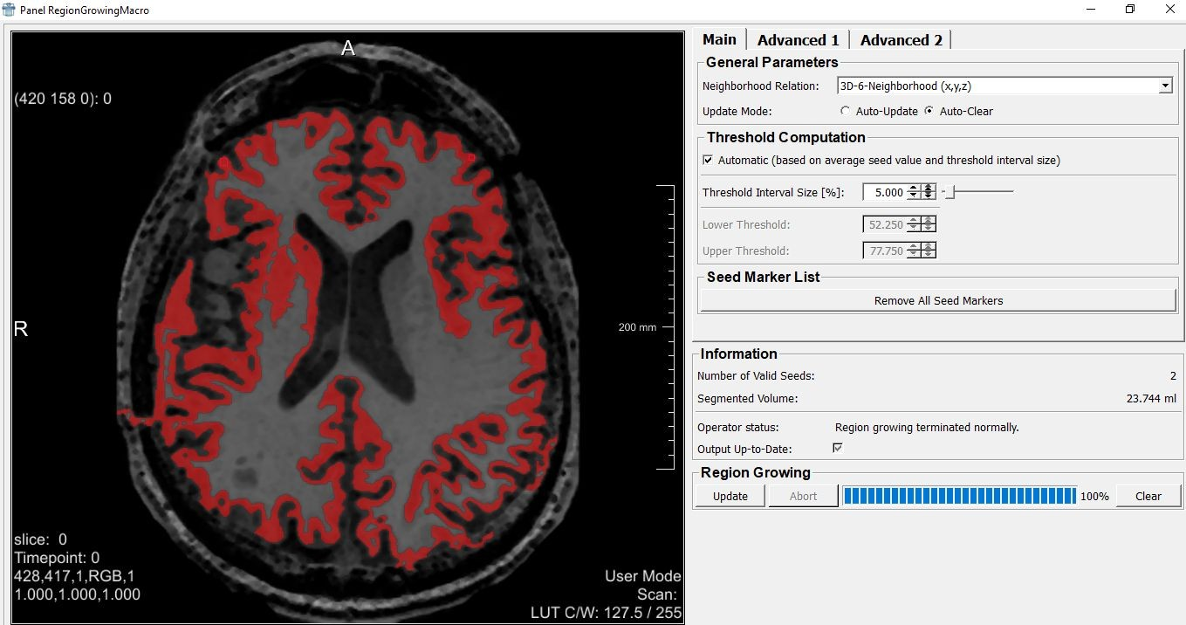

**IQ LEVEL ESTIMATION**

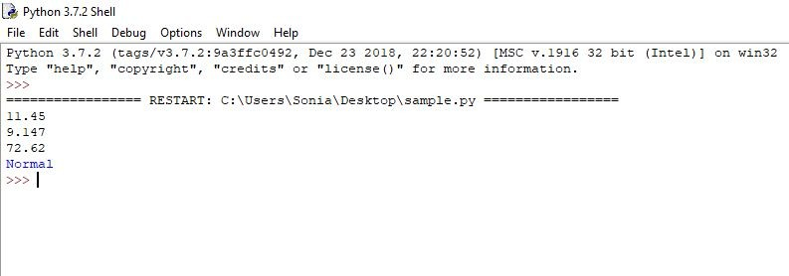

**REFERENCES**

1. Suhas.S and C R Venugopal,”MRI Image preprocessing and Noise removal technique using linear and nonlinear filters”**,**International Conference on Electrical, Electronics, Communication, Computer and Optimization Techniques (ICEECCOT)**,** 2017.
2. José V. Manjón ,” MRI Preprocessing”,© Springer International Publishing Switzerland 2017 53 L. Martí-Bonmatí, A. Alberich-Bayarri (eds.), Imaging Biomarkers, 2017
3. R. Meena Prakash and R. Shantha Selva Kumari **,”**Spatial Fuzzy C Means and Expectation Maximization Algorithms with Bias Correction for Segmentation of MR Brain Images “,2017
4. Song Yuheng1, Yan Hao*,*”Automatic region based brain classification of MRI:T1 data”,2016
5. Shaswati Roy and Pradipta Maji,”A Simple Skull Stripping Algorithm for Brain MRI”,IEEE,2015.
6. B. Shanthi Gowri and Gnanambal Ilango,“Region Growing Segmentation of MRI -A Metric Topological Approach”,IEEE Seventh National Conference on Computing, Communication and Information Systems (NCCCIS),2015.
7. Manjón JV, Coupe P, Buades A,”MRI noise estimation and denoising using non-local PCA. Med Image Anal”,2015,22:35–47.
8. Sudip Kumar Adhikari, Jamuna Kanta Sing, Dipak Kumar Basub, Mita Nasipurib, ”Conditional spatial fuzzy C-means clustering algorithm for segmentation of MRI images “, 2015
9. Anagha S.Kulkarni and R.S.Kamathee,” MRI Brain Image Segmentation by Edge Detection and Region Selection “,International Journal of Technology and Science, Issue. 2, Vol. 1, May 2014
10. Rajan J, Den Dekker A, Sijbers J, “A new non local maximum likelihood estimation method for Rician noise reduction in magnetic resonance images

using the Kolmogorov-Smirnov test. Sig Process”,2014,103:16–23.

1. Rafael M. Luque-Baena **,“**MRI Segmentation of the Human Brain:

Challenges,Methods, and Applications “,2014

1. Manoj Kumar V and Sumithra M G,”An improved region growing based segmentation algorithm for brain MRI”, 2013
2. Dinesh D. Patil and Sonal G. Deore , “Medical Image Segmentation: A Review”, International Journal of Computer Science and Mobile Computing, 2, pp. 22-27, 2013.
3. Geng-Cheng Lin , Wen-June Wang , Chung-Chia Kang and Chuin-Mu Wang, “Multispectral MR images segmentation based on fuzzy knowledge and modified seeded region growing”, Magnetic Resonance Imaging , 30, pp. 230-246, 2012 .
4. Gnanambal Ilango and R. Marudhachalam, “Topological Concepts Applied to Image Segmentation”, Journal of Advanced Studies in Topology, Vol. 4, No. 1, pp. 128-132, 2013.