NAVEX IRM MCP Server
Concept, Architecture & Setup — A Team Briefing
Prepared for engineering teams and solution architects

Contents
Contents 2
1. What Is an MCP Server? 3
What the server exposes 3
2. Is NAVEX Data Exposed to AI Because of the MCP Server? 3
What gets exposed, and when 3
Where the data actually goes 3
3. Architecture at a Glance 4
4. Setup (High Level) 4
5. Use Cases 5
Example: creating a user in NAVEX 5
6. Pros and Cons 5
7. Billing 6
8. Key Takeaways 6

1. What Is an MCP Server?
A Model Context Protocol (MCP) server is an open, standardized adapter that securely connects AI models to external tools, databases, and APIs. Instead of giving an AI model direct and potentially unsafe - access to sensitive company systems, the AI connects to the MCP server. The server handles translation, context management, and security.
In plain terms: it is a controlled doorway. The AI agent never touches NAVEX directly. It asks the MCP server to perform a specific, with the pre-approved action, and the server carries out that action on the agent's behalf.

What the server exposes
An MCP server publishes a defined set of capabilities rather than open access. These fall into two groups:
- Tools : a specific operation the AI can invoke - for example, querying records, updating a field, or creating a user (CRUD Operations).
- Resources : read-only references the AI can look up, such as the list of components or fields available in NAVEX.
Because every capability is explicitly defined, the AI can only do what the server allows nothing more.

2. Is NAVEX Data Exposed to AI Because of the MCP Server?
Yes, but only the specific data an AI agent actually requests, never to the whole NAVEX tenant. The MCP server does not bulk-stream data anywhere. It exposes capabilities, and data flows to the AI only when the agent invokes a tool and receives a response.

What gets exposed, and when
When an agent calls something like get_record or search_records, the NAVEX response travels back through the MCP server into the AI model's context window. At that moment and only then, those fields are seen by the model. Anything the agent does not call is never exposed. Exposure is request-scoped, not ambient. A resource such as the field list for a component only reveals metadata if it is actually read.

Where the data actually goes
The MCP server itself is just a local process bridge, it does not send data to Anthropic, OpenAI, or anyone else. The exposure happens one layer up, at whichever AI model the client uses:
- Hosted model API : tool results transit to that provider and are governed by its retention and training terms. For example, Anthropic's commercial and API terms do not train on your data by default; consumer tiers differ.
- Self-hosted / local model : data never leaves your boundary.
This distinction is the one that matters most for the compliance story: it is a property of the deployment you choose, not of the server code.

3. Architecture (High Level)
The diagram below shows both how a request flows at runtime and how the server is deployed.
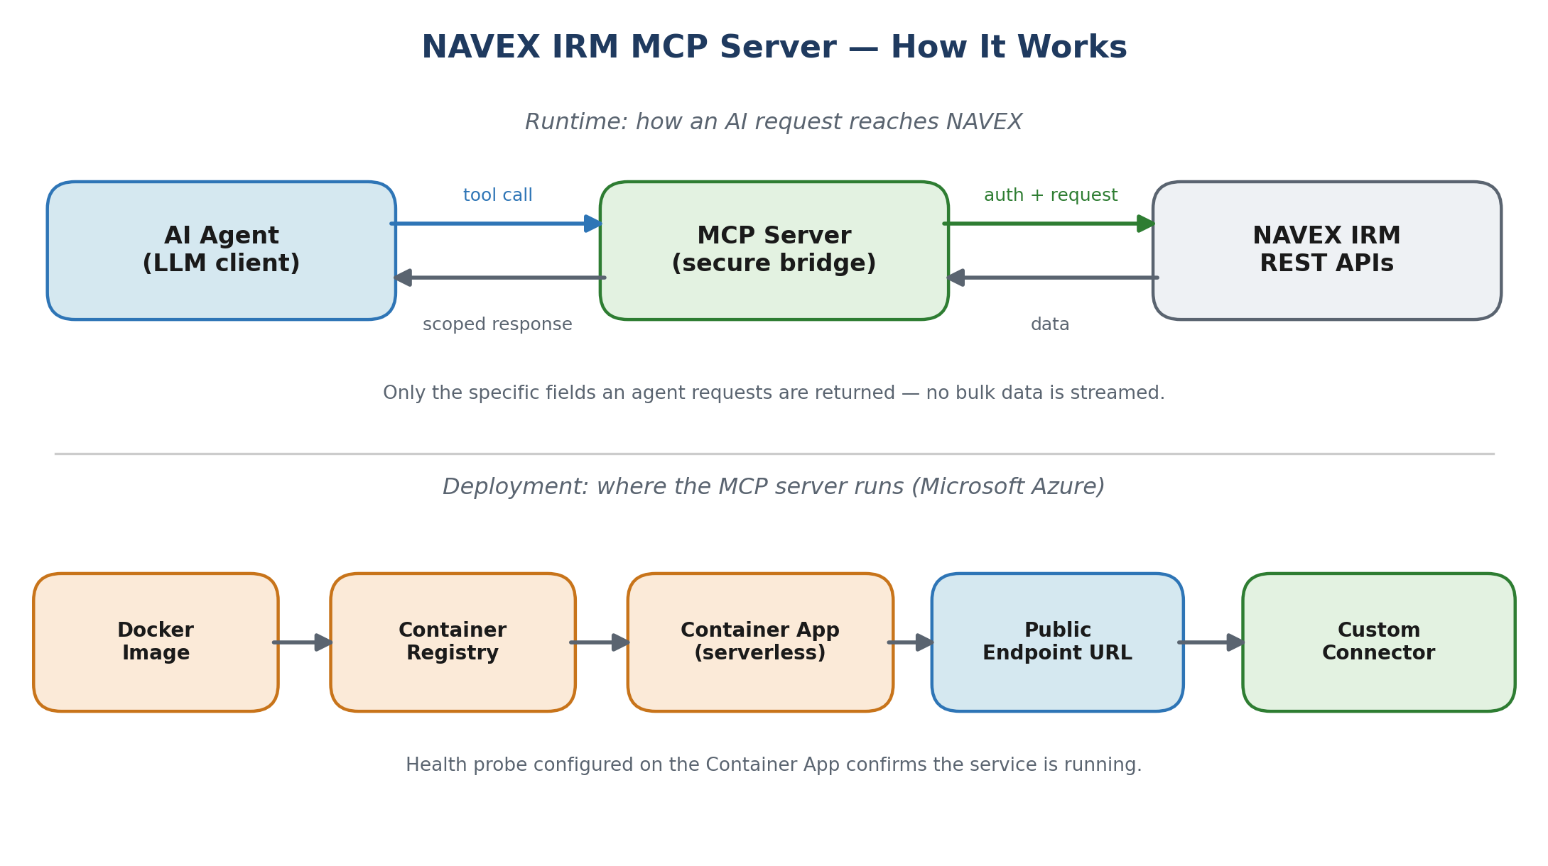

4. Setup (High Level)
The MCP server is packaged as a container and hosted on Microsoft Azure. The following steps describe the deployment at a high level — the goal is a single secure endpoint URL that a NAVEX custom connector can call.
- Access Azure — sign in to the Azure portal (portal.azure.com) with the deployment account.
- Create a Resource Group — a Resource Group acts as the container for all related Azure resources, keeping the deployment organized and easy to manage.
- Add a Container Registry — add an Azure Container Registry and load the MCP server's Docker image into it. The registry stores the built image ready for deployment.
- Add a Container App — create a serverless Azure Container App that runs the image from the registry. This is the layer where the MCP server is actually configured and exposed as an Azure endpoint.
- Configure a health probe — configure a health probe on the Container App. This is mandatory — it lets Azure confirm the service is running and restart it if it becomes unhealthy.
- Use the generated URL — the Container App generates a public endpoint URL once configured. This URL is what you register inside the NAVEX custom connector so the platform can reach the MCP server.
In short: Docker image → Container Registry → serverless Container App (with health probe) → public URL → NAVEX custom connector.

5. Copilot Agent Configuration (High Level)
Once the MCP server is reachable at its public URL, the AI agent is built in Microsoft Copilot Studio. The following steps describe the configuration at a high level - the goal is a governed Copilot agent that can call the NAVEX MCP tools through a custom connector.
- Open Copilot Studio - sign in to Copilot Studio (copilotstudio.microsoft.com) and create or open the NAVEX IRM agent in the target environment.
- Import the custom connector - create a custom connector from the MCP connector definition, set its authentication to Basic, and point its Host at the Container App's public URL. The connector is the bridge between Copilot and the MCP server.
- Create the NAVEX connection - add a connection on the connector using a dedicated NAVEX API account that is Active, local (NAVEX IRM authentication), API-enabled, and least-privilege. SSO / SAML accounts cannot perform API logins.
- Add the connector as a tool - in the agent, go to Tools, Add a tool, and select the NAVEX connector. All NAVEX MCP tools (discovery, search, create, update, workflow, reports, assessments) appear automatically.
- Turn on generative orchestration - in Settings, Generative AI, enable generative orchestration so the agent can decide which tools to call from a plain-language request.
- Add the agent instructions - paste the operating instructions into Overview, Instructions. These enforce discovery-first behaviour, confirmation before any write, and explicit human approval before any deletion.
- Apply governance on sensitive tools - set 'Ask before running' on all create, update, delete, transition, vote, import, and assessment tools, while leaving read-only tools open. This keeps a human in the loop for any change to NAVEX data.
- Add starter prompts - add a few example prompts (explore components, show fields, count records, export a report) so users have a guided entry point.
- Test and publish - validate behaviour in the test pane, then publish the agent to the chosen channel, for example Microsoft Teams or the email flow.
In short: public URL -> custom connector (Basic auth) -> NAVEX API connection -> add as tool -> generative orchestration on -> instructions + governance -> test -> publish.

6. Use Cases
Once connected, an AI agent can perform real NAVEX operations through natural-language requests. Typical examples include:
- generate and send out a report (CSV, PDF, or XLSX).
- update fields on existing records.
- fetch data by filtering on specific criteria.
- reset a user's password.
- add a member to a group.
- create a new user.

Example: creating a user in NAVEX
A request as simple as “create a user in NAVEX” can be fulfilled with the following details:
Field | Value
Full name | abc xyz
Email | abcxyz@hp.com
Username | abcxyz@hp.com
Password | Reset2026
Account type | Vendor Contact
Security configuration | Standard login

7. Pros and Cons
Like any integration layer, the MCP approach involves trade-offs. The table below summarizes the main ones.
Pros | Cons
Security boundary — the AI never touches NAVEX directly; access is limited to defined tools. | Adds an extra component to build, host, and maintain.
Request-scoped exposure — only the data an agent asks for is ever seen. | Data sent to a hosted model is governed by that provider's terms — deployment choice matters.
Natural-language operations — non-technical staff can trigger real actions safely. | Requires Azure hosting, which carries an ongoing (though modest) cost.
Auditable and centralized — all access flows through one controlled, loggable layer. | Initial setup needs cloud and NAVEX API familiarity.
Reusable — the same connector serves many use cases and agents. | Capabilities are limited to the tools explicitly built into the server.

8. Billing
Costs are viewed and managed in the Azure pricing portal. The deployment uses serverless, consumption-based services, so spend scales with usage rather than fixed servers. The main cost drivers are:
Azure resource | How it is billed
Container App (serverless) | Consumption-based: charged for the compute and requests actually used. Scales to near-zero when idle.
Container Registry | Flat tier-based fee (Basic / Standard / Premium) for storing the Docker image.
Networking / egress | Small charges for outbound data transfer.
Resource Group | No charge itself — only the resources inside it are billed.
For a single MCP server with moderate use, this typically remains a low monthly cost. Exact figures should be confirmed in the Azure pricing portal for your region and chosen tiers.

9. Key Takeaways
- An MCP server is a secure, controlled bridge between AI agents and NAVEX — the AI never connects to NAVEX directly.
- Data exposure is request-scoped: only what an agent explicitly asks for is ever seen by the model.
- Where data goes depends on the model deployment (hosted vs. self-hosted), not the server code — this is the core of the compliance story.
- Deployment is a clean chain on Azure: Docker image → registry → serverless Container App → public URL → NAVEX custom connector.
- It unlocks safe, natural-language operations — reports, field updates, user and group management — at a modest, usage-based cost.

