NAVEX IRM MCP Server
Architecture Overview — a plain-language guide for the team
Version 1.0 · 26 June 2026

What this is
NAVEX IRM is the platform that holds our risk, compliance, and third-party-risk data. We built a small service — the NAVEX IRM MCP Server — that sits in front of NAVEX and gives the rest of our tools one clean, secure way to read and write that data.
It does two jobs at once. It lets Power Automate cloud flows talk to NAVEX through a simple connector, and it lets AI agents and developer tools talk to NAVEX through a modern interface (MCP). Both go through the same service, so there is one place to manage security, logging, and reliability.

Why we built it
NAVEX signs callers in with a session cookie that gets refreshed over time. Power Platform can’t manage that on its own, so today every one of our 30+ flows re-implements the same login and cookie-handling logic by hand. That is repetitive, easy to get wrong, and impossible to govern in one place. There was also no clean way for AI agents to use NAVEX at all.
The facade fixes both: it owns the NAVEX login once, for everyone, and exposes a simple, consistent interface on top.

The big picture
Everything flows through the facade. Users work in the tools they already know; those tools call the facade; the facade is the only thing that talks to NAVEX.
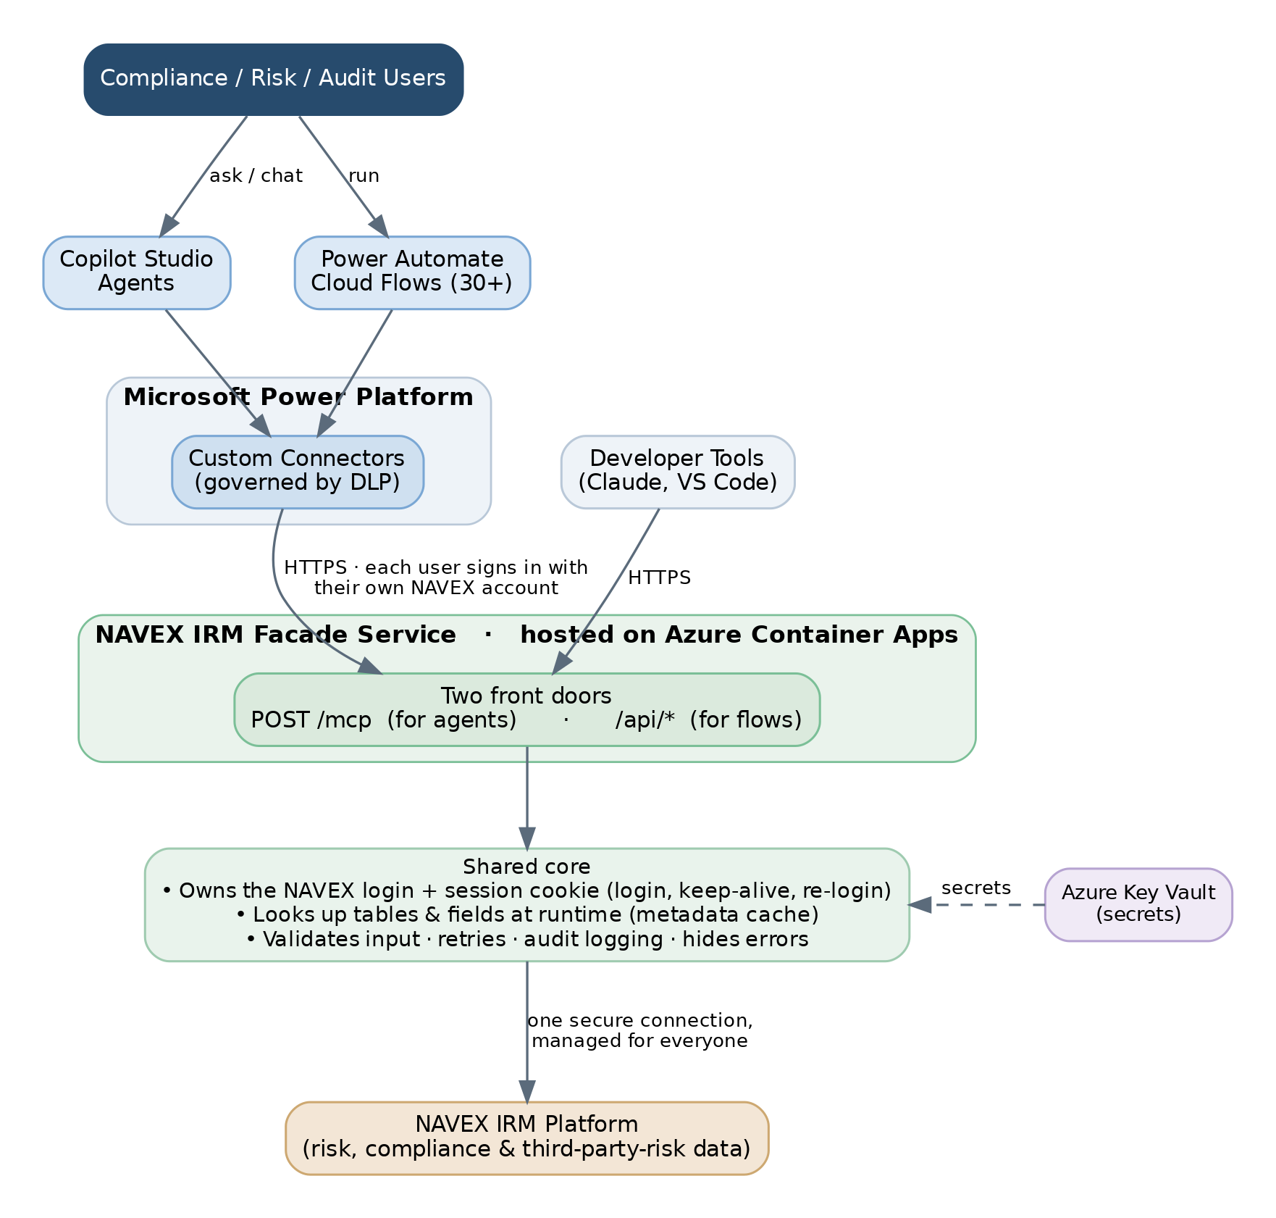
How the pieces fit together. The facade is the single, governed doorway to NAVEX.

How it works, step by step
When any tool makes a request, the facade does the following:
- It checks who is calling. Each caller signs in with their own NAVEX username and password, so they only ever see and change what their NAVEX permissions allow.
- It handles the NAVEX login behind the scenes — getting the session cookie, keeping it alive, and signing back in automatically if it expires. No tool ever has to deal with cookies.
- It figures out the right tables and fields at run time. NAVEX table and field layouts differ per tenant, so the facade looks them up (and caches them) instead of hard-coding anything.
- It does the work — read, search, create, update, run a report, and so on — retrying briefly if NAVEX is busy.
- It records an audit line (who did what, when, and whether it worked) and returns a clean result, with any sensitive internal detail stripped out.
What the facade can do: look up tables and fields, read and search records, create and update records, move items through workflows, export reports (CSV / PDF / Excel), issue assessments, manage attachments, and manage users and groups — all subject to the caller’s NAVEX permissions.

Security, in plain terms
- Everyone uses their own NAVEX account. Permissions and the NAVEX audit trail stay tied to the real person — there is no shared, anonymous access.
- Passwords and cookies never leave the service. They are used to talk to NAVEX and are never exposed to the calling tools or written into flow definitions; logs hide them.
- Nothing is stored. The facade keeps no copy of NAVEX data — it just passes requests through.
- Deletes are deliberate. Anything destructive has to be explicitly confirmed before it runs.
- Every action is logged. We keep an audit line for each request — the caller, the action, and the outcome.

Where it runs
The facade is a small container that runs on Azure Container Apps. It can scale to a few copies under load, its secrets are stored in Azure Key Vault, and it has a built-in health check. It reaches our NAVEX instance over a secure connection; our Power Platform tools reach it over HTTPS.

Why we built it this way
Choice | Reason
One service, two front doors | Agents and classic flows need different styles of interface — but they can share one core for login, logging, and reliability.
Each user signs in as themselves | Keeps NAVEX permissions and audit accurate; nothing extra to provision.
Look up tables/fields at run time | NAVEX layouts vary by tenant and change over time, so nothing is hard-coded.
Host on Azure Container Apps | Simple to deploy and scale, with secrets kept in Key Vault.
In short: one secure, well-behaved doorway to NAVEX that our flows and our AI tools can both rely on — instead of every flow reinventing the same plumbing.

