NAVEX IRM MCP Server
End-to-End Solution Architecture
Model Context Protocol server + REST facade for Microsoft Power Platform

Field | Value
Document type | Solution Architecture Document (SAD)
Audience | Architecture Review Board · Power Platform / Integration · Security & Compliance
Status | For review
Version | 1.0
Date | 26 June 2026
Author | Aravind (Power Platform team), with architecture research support

Contents

1. Executive Summary
The NAVEX IRM platform (v6.1, formerly Lockpath/Keylight) holds the organisation’s integrated risk, compliance, and third-party risk data. Its REST API authenticates with session cookies — a model that Microsoft Power Platform connectors and Copilot Studio cannot manage natively. As a result, the team’s 30+ Power Automate cloud flows each re-implement NAVEX login, cookie handling, and retry logic, and there is no supported path for Copilot Studio agents to work with NAVEX data at all.
This solution introduces a single facade service — the NAVEX IRM MCP Server — that owns the NAVEX session lifecycle server-side and exposes two front doors over one shared core:
- POST /mcp — a Model Context Protocol (MCP) endpoint over Streamable HTTP, consumed by Copilot Studio agents (and any MCP client, including Claude and VS Code).
- /api/* — a REST facade published as a Power Platform custom connector, onto which the existing cloud flows migrate, replacing hand-rolled HTTP-action chains with single connector actions.
Both surfaces share server-side NAVEX session management (Login → cookie → Ping keep-alive → re-login), a Dynamic Content Framework (DCF) metadata cache, Zod validation, audit logging, outbound throttling/retries, and error sanitization. The service is a stateless, horizontally-scalable TypeScript/Node 20 container deployed on Azure Container Apps, with secrets in Azure Key Vault.
The default and only out-of-the-box inbound authentication is HTTP Basic with each caller’s own NAVEX username/password, so NAVEX-side permissions and audit attribution are preserved end-to-end. API-key access mapped to a shared service account is a deliberate, hard opt-in.
Recommendation to the board: approve the architecture as described. It is a low-risk, incremental modernisation: it removes duplicated session logic from every flow, unlocks the agent use case the business wants, and adds no new identity store. Residual risks (session concurrency limits, password-rotation breakage, future per-user audit needs) are identified in §12 with concrete mitigations.

2. Goals, Scope, and Non-Goals

2.1 Business goals
- Give Copilot Studio agents safe, governed access to NAVEX IRM records, workflows, reports, and assessments.
- Eliminate per-flow NAVEX session/cookie handling across 30+ Power Automate cloud flows.
- Preserve per-user NAVEX permissions and audit attribution.
- Keep the solution production-grade: typed, validated, observable, tested, and deployable through standard Azure tooling.

2.2 In scope
NAVEX IRM backend integration; the facade service (MCP + REST); Copilot Studio agent integration; Power Automate flow migration; Azure hosting and deployment topology; security model; observability and operations.

2.3 Non-goals (v1)
- Per-user OAuth → per-user NAVEX account mapping (on-behalf-of). Deferred; revisited if audit requirements demand server-issued per-user identity beyond Basic pass-through (§12).
- A certified/public Power Platform connector (this is an org-internal custom connector).
- Replacing or modifying NAVEX itself, or building net-new NAVEX data models.
- A persistent application datastore — the service is intentionally stateless aside from in-memory session/metadata caches.

3. Context and Drivers
NAVEX IRM exposes a conventional REST API at https://[instance]:[port]/[service]/[call] (JSON or XML, GET/POST/DELETE, case-sensitive call names) across four service groups:
Service group | Responsibilities
SecurityService | Login / Logout / Ping; user and group CRUD
ComponentService | DCF metadata discovery, record CRUD, workflow transition/vote, attachments, import
ReportService | ExportReport (CSV / PDF / XLSX)
AssessmentService | IssueAssessment
Two characteristics shape the entire design:
- Session-cookie auth. SecurityService/Login returns an encrypted cookie that must accompany every subsequent call; Ping refreshes it; permissions follow the logged-in account’s Security Role. Power Platform connectors support None / API key / OAuth 2.0 — not cookie jars — so a facade must bridge the two auth models and never expose cookies or passwords to clients.
- Dynamic Content Framework (DCF). Components (tables), fields (schema), and records (rows) are tenant-specific and must be discovered at runtime via GetComponentList / GetFieldList. Nothing may be hardcoded.
On the Power Platform side, as of mid-2026 MCP is generally available in Copilot Studio and consumed through custom connectors over the Streamable HTTP transport (SSE was deprecated for Copilot Studio in August 2025). Crucially, MCP serves the agent layer only — classic deterministic cloud flows consume connectors, not MCP tools. This split is the reason the facade exposes two front doors rather than one.

4. Architecture Overview

4.1 System context
At the highest level, business users interact through Copilot Studio agents and Power Automate flows; both reach the facade through DLP-governed Power Platform custom connectors. Developer MCP clients can call the same /mcp endpoint directly. The facade is the only component that talks to the NAVEX IRM API, and the only holder of NAVEX session state.
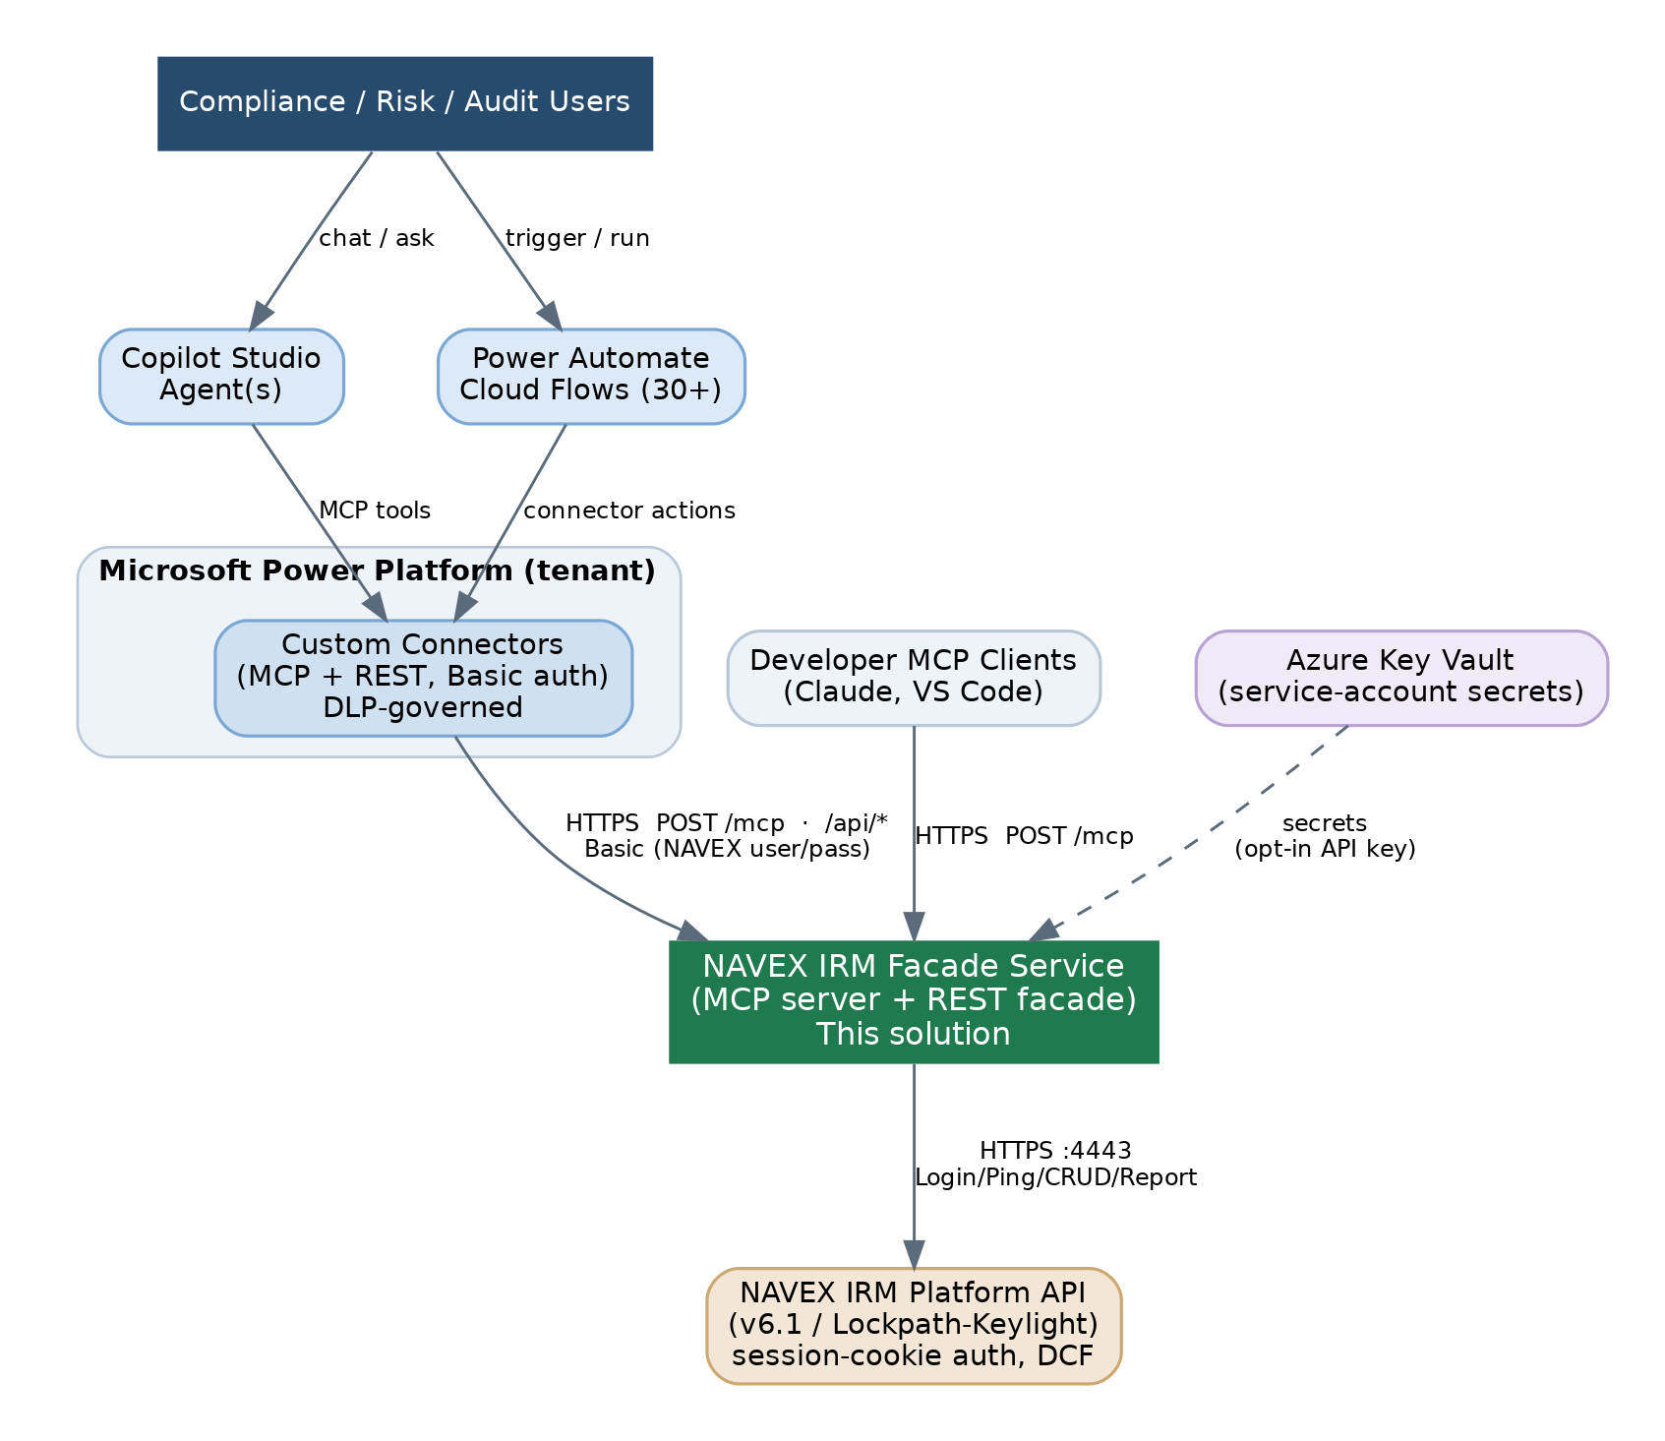
Figure 1 — System context. The facade is the single integration point to NAVEX; all callers authenticate with their own NAVEX credentials over HTTPS.

4.2 Architectural style and key decisions
The solution is a single deployable facade with a shared core and two protocol adapters. This is captured in five Architecture Decision Records (docs/adr/), summarised here:
ADR | Decision | Rationale (short)
0001 | Streamable HTTP transport for MCP | Only transport Copilot Studio supports; SSE deprecated Aug 2025.
0002 | Server-side NAVEX session management | Connectors can’t manage cookie jars; cookies/passwords must never reach clients.
0003 | Dual exposure — MCP for agents + REST connector for flows | Agents and classic flows consume different contract styles; one shared core serves both.
0004 | TypeScript + official MCP SDK + Zod, metadata-driven tools | Reference-quality SDK; DCF is dynamic so tools resolve IDs at runtime.
0005 | Basic auth (NAVEX user/pass) as strict default | Preserves per-user permissions and audit attribution; no service account yet provisioned.
ADR-0005 supersedes the inbound-auth portion of ADR-0002: Basic pass-through is the strict default; the shared-service-account API key is an opt-in.

5. Component Architecture

5.1 Internal structure
The Express application is organised into an HTTP edge (two front doors plus a health probe), an authentication middleware, and a shared core that is instantiated per credential set. Tool groups and navex:// resources are metadata-driven and Zod-validated; the NavexClient is the single owner of the NAVEX session cookie.
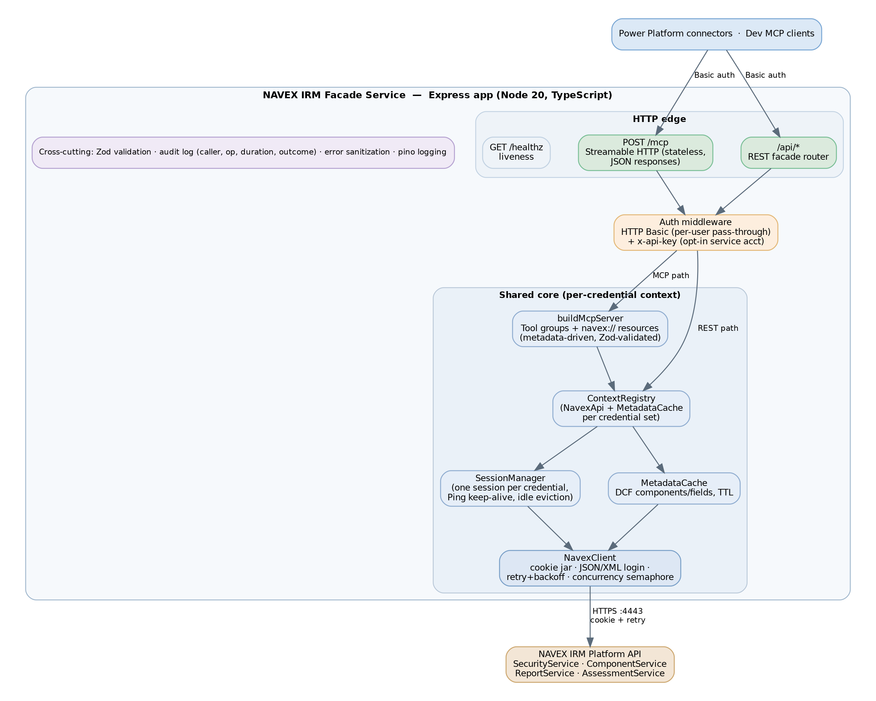
Figure 2 — Component view. Auth resolves the caller, the ContextRegistry hands back a per-credential NavexApi + MetadataCache, and the NavexClient performs the throttled, retrying, cookie-bearing call to NAVEX.

5.2 Responsibilities
Component | Responsibility
POST /mcp | Stateless Streamable HTTP MCP endpoint. A fresh McpServer + transport is built per request, bound to the caller’s NAVEX context. enableJsonResponse returns plain JSON (not SSE frames) for cleaner traversal of the Power Platform connector gateway. GET/DELETE return 405 (stateless).
/api/* router | REST facade consumed by the custom connector: metadata, record CRUD/search, workflow transition/vote, report export, assessments, user/group CRUD. Each operation is audit-logged with HTTP status mapping.
GET /healthz | Unauthenticated liveness/readiness probe; reports active NAVEX session count; makes no NAVEX call.
Auth middleware | Strict inbound auth. Decodes HTTP Basic into per-request credentials and a caller identity; optionally validates x-api-key against configured keys using constant-time comparison.
SessionManager | Holds one NavexClient per distinct credential set (keyed by SHA-256 of credentials). Pings live sessions on an interval; logs out and evicts idle sessions past the TTL.
ContextRegistry | Layers a NavexApi + MetadataCache over each SessionManager client so metadata caching survives across requests for the same caller.
MetadataCache | TTL-cached DCF components and fields; resolves component aliases/short names and human field names to NAVEX IDs; supports manual invalidation.
NavexApi | Typed wrapper over NAVEX service calls (components, fields, records, workflows, reports, assessments, users, groups).
NavexClient | Low-level HTTP client. Owns the cookie lifecycle (JSON login + automatic XML fallback), one-shot re-login on 401, retry with exponential backoff + jitter, a concurrency semaphore, binary export handling, and a 60-second login-lockout guard.
Cross-cutting | Zod validation at every boundary; audit log (caller, operation, duration, outcome — no payloads); error sanitization; structured pino logging with credential redaction.

5.3 Tool and resource surface (MCP)
Tools are grouped and exposed by buildMcpServer. All are metadata-driven — callers pass component aliases and field names; IDs resolve at runtime. Destructive tools require confirm: true and are flagged for human-in-the-loop confirmation.
Group | Tools
Session | ping, logout, refresh_metadata
Metadata | list_components, get_component, get_fields, get_field, get_lookup_options
Records | get_record, search_records, count_records, create_record, update_record, delete_record, import_file
Workflow | get_workflows, get_workflow, transition_record, vote_record
Reports | export_report (CSV/PDF/XLSX)
Assessments | issue_assessment
Attachments | list_attachments, get_attachment, upload_attachment, delete_attachments
Users / Groups | get_user, list_users, get_user_count, create_user, update_user, delete_user, get_group, list_groups, create_group, update_group, delete_group
Resources: navex://components, navex://components/{id}, navex://components/{id}/fields, navex://components/{alias}/workflows, navex://users, navex://groups.

6. Security Architecture

6.1 Inbound authentication (strict default)
HTTP Basic with NAVEX username/password is the default and only out-of-the-box mechanism for both /mcp and /api/*. The facade logs into NAVEX as the calling user and isolates that session per credential set, so:
- Per-user NAVEX permissions are preserved (each caller only does what their NAVEX Security Role allows).
- NAVEX-side audit logs attribute actions to the real user, not a shared account.
- There are no shared inbound secrets to rotate; removing a NAVEX user automatically revokes facade access.
API-key auth is a hard opt-in. It activates only when both API_KEYS and the NAVEX service-account credentials (NAVEX_SERVICE_USERNAME / NAVEX_SERVICE_PASSWORD) are configured; setting one without the other fails at startup. When enabled, an x-api-key maps to the shared service account and is validated with a constant-time comparison. Any x-api-key presented when the feature is disabled is rejected with a clear message.

6.2 Credential and session handling
- NAVEX cookies and passwords never leave the server process; the NavexClient is their sole owner.
- Logs redact credentials; login diagnostics only ever log a boolean result or an error/WAF page preview, never credential values.
- Sessions are keyed by a SHA-256 hash of the credentials, not the plaintext.
- Errors crossing the boundary are sanitized — no stack traces, no internal URLs.
- A 60-second login-lockout guard prevents aggressive agent retries from locking NAVEX accounts.

6.3 Data-handling posture
- The service is stateless apart from in-memory session and metadata caches; it persists no NAVEX record data.
- Attachment and import payloads (base64, up to a 25 MB request limit) pass through; they are not stored.
- Deletes are soft-deletes in NAVEX, but delete_* operations are still treated as destructive and gated behind explicit confirmation.
- The audit log records who did what, when, and the outcome — never record payloads.

6.4 Defence in depth and future hardening
For stronger inbound governance without code changes, the service can be fronted by Azure API Management to add Entra ID OAuth 2.0, per-subscriber quotas, and IP restrictions. Power Platform DLP policies classify both custom connectors so agents and flows are governed centrally.

7. Request Lifecycle and Session Management
The diagram below traces a single request from inbound Basic auth through context resolution, the lazy NAVEX login, the throttled/retrying NAVEX call, and the audit-logged response — plus the background maintenance loop that keeps sessions warm.
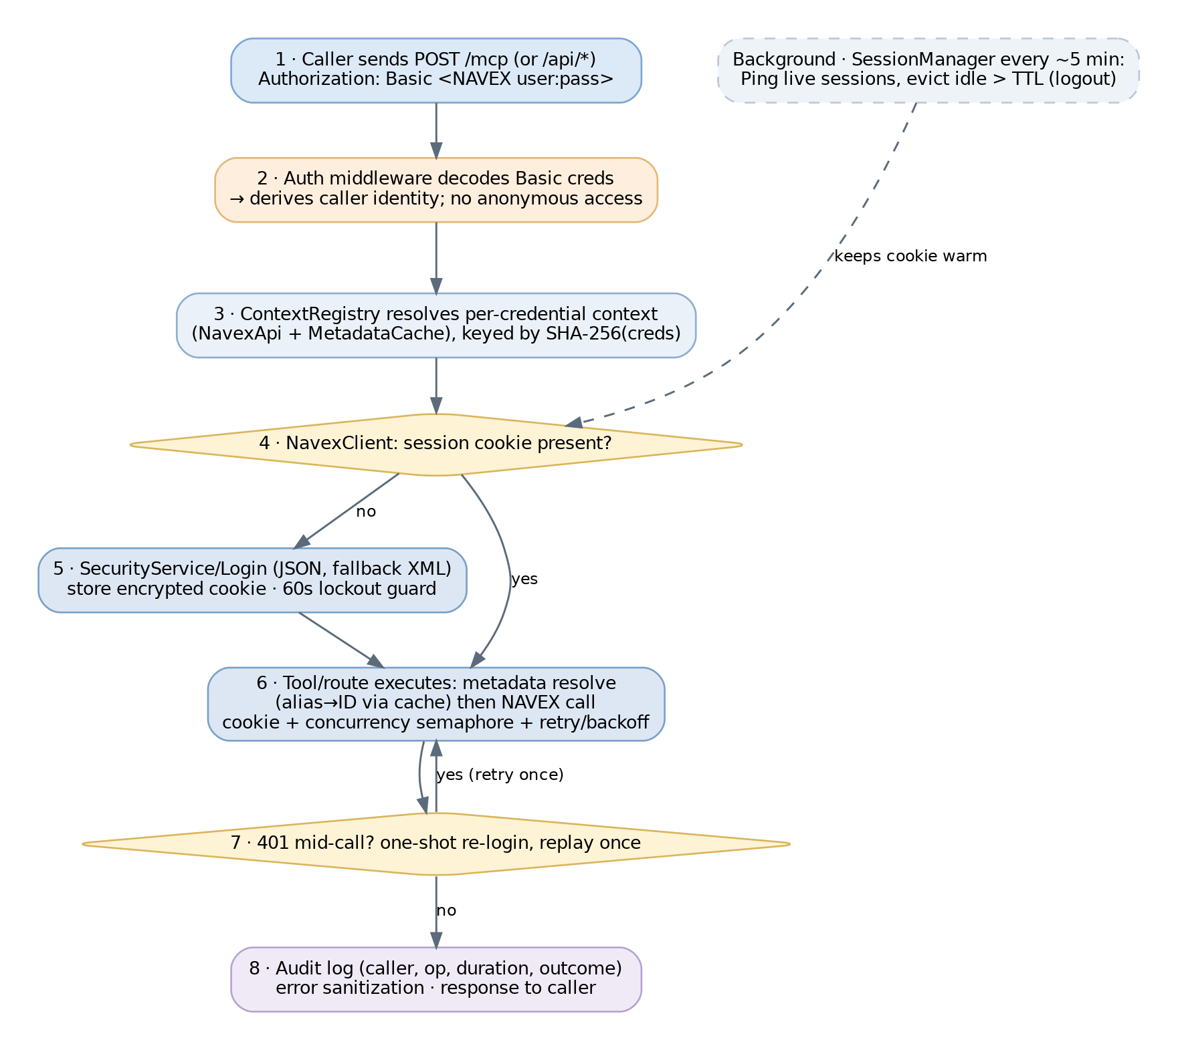
Figure 3 — Request and session lifecycle. Login is lazy and collapsed across concurrent callers; a mid-call 401 triggers exactly one re-login and replay; idle sessions are pinged or evicted by a background loop.
Key behaviours:
- Lazy, collapsed login. The first call for a credential set logs in; concurrent login attempts collapse into a single in-flight promise.
- JSON-first with XML fallback. Login tries the JSON body first and automatically falls back to the XML login format for Keylight-era instances that require it.
- Self-healing sessions. A 401 during a call clears the cookie, re-logs in once, and replays the request a single time.
- Keep-alive and eviction. SessionManager runs roughly every 5 minutes (SESSION_PING_INTERVAL_MS): it pings authenticated sessions and logs out + evicts any idle longer than SESSION_IDLE_TTL_MS (default 15 min). The interval timer is unref’d so it never blocks shutdown.
- Throttling and retries. A per-client semaphore caps concurrency against NAVEX (NAVEX_MAX_CONCURRENT, default 4); retryable failures back off exponentially with jitter up to NAVEX_RETRY_MAX (default 3).
- Graceful shutdown. On shutdown all sessions are logged out and cleared.

8. Data and Metadata Flow
Because DCF structures are tenant-specific, every write or query first resolves schema:
- The caller passes a component alias / short name and human field names.
- MetadataCache.resolveComponent matches the alias (case-insensitive) against cached GetComponentList output, falling back to a live lookup if stale or missing.
- Field names resolve to NAVEX field IDs via cached GetFieldList output.
- Lookup fields resolve label → record ID via get_lookup_options before any write.
- The typed NavexApi performs the call; results return to the caller.
Metadata is cached with a TTL (METADATA_CACHE_TTL_MS, default 10 min) and can be force-refreshed via the refresh_metadata tool / cache invalidation after admin schema changes. This keeps tools tenant-portable and cuts redundant discovery calls, at the cost of a short staleness window after a schema change (mitigated by the short TTL and manual invalidation).
Agent safety rule: the NAVEX API does not enforce required fields. Agents must read Required=true from get_fields, restate the exact fields and values they intend to write, and obtain explicit user confirmation before any create/update. This orchestration contract is documented in docs/AGENT_FLOWS.md.

9. Deployment Architecture
The facade is packaged as a multi-stage Docker image (Node 20 Alpine, non-root user, built-in /healthz HEALTHCHECK) and deployed to Azure Container Apps. Power Platform reaches it through the custom connectors; the container reaches NAVEX on its API port (commonly 4443).
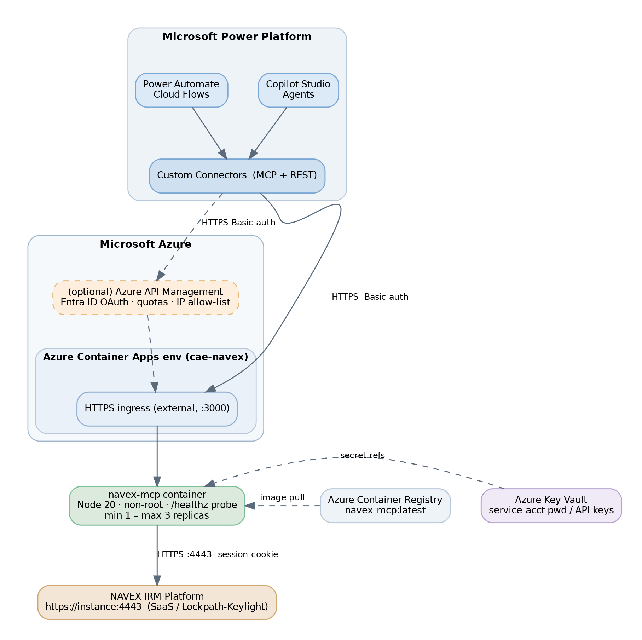
Figure 4 — Deployment topology. Container Apps runs 1–3 replicas behind external HTTPS ingress; images come from ACR, secrets from Key Vault; optional APIM fronts the service for OAuth/quota/IP governance.

9.1 Topology notes
- Min replicas = 1 keeps NAVEX sessions and the metadata cache warm (avoids cold-login latency on every scale-to-zero).
- Scaling. Scaling out is safe because the service is stateless across replicas; each replica maintains its own in-memory session/metadata caches per credential set. No cross-replica session affinity is required, though warm-cache benefits are per-replica.
- Egress / ingress. The app must reach the NAVEX instance on its API port; Power Platform must reach the app’s HTTPS ingress.
- Secrets. Service-account password and API keys are bound from Key Vault via Container Apps secret references — never in source or image.

9.2 Configuration surface
Variable | Required | Purpose
NAVEX_BASE_URL | yes | NAVEX API base, e.g. https://yourco.lockpath.app:4443
NAVEX_SERVICE_USERNAME / _PASSWORD | for API-key auth | Least-privilege service account (API Access enabled)
API_KEYS | optional | Comma-separated keys (min 16 chars) accepted in x-api-key
NAVEX_LDAP_SETTINGS_ID | optional | LDAP Profile ID for LDAP/SSO-backed NAVEX accounts
PORT / LOG_LEVEL | no | Default 3000 / info
SESSION_IDLE_TTL_MS / _PING_INTERVAL_MS / METADATA_CACHE_TTL_MS | no | Session and cache tuning
NAVEX_MAX_CONCURRENT / NAVEX_RETRY_MAX | no | Outbound throttling and retry budget
Configuration is validated at startup with Zod; invalid values fail fast with field names only (never raw values), and the API-key/service-account invariant is enforced before the server starts.

9.3 Integration wiring (summary)
- Copilot Studio (agents). Because the MCP onboarding wizard does not offer Basic auth, the MCP connector is imported manually from docs/connector/mcp-connector.swagger.yaml (security pre-defined as Basic; x-ms-agentic-protocol: mcp-streamable-1.0 on the /mcp POST). Destructive tools are marked as requiring human confirmation.
- Power Automate (flows). Import docs/connector/rest-connector.swagger.yaml as a custom connector (Basic auth). Flows migrate incrementally: each Login → call → cookie chain collapses to a single connector action.

10. Quality Attributes (Non-Functional Requirements)
Attribute | How the architecture addresses it
Security | Per-user Basic pass-through; opt-in API key with constant-time compare; cookie/credential isolation; error sanitization; credential-redacting logs; startup config invariants.
Reliability | Self-healing sessions (re-login on 401); retries with backoff + jitter; login-lockout guard; health probe; graceful shutdown.
Performance / scalability | Stateless horizontal scaling (1–3 replicas); per-credential metadata caching; outbound concurrency semaphore; collapsed concurrent logins.
Observability | Structured pino logging; dedicated audit log (caller, op, duration, outcome); every MCP arrival logged for onboarding visibility; health endpoint surfaces active session count.
Maintainability | Clear module boundaries (tools/ vs server/api-routes over a shared core); TypeScript end-to-end; Zod schemas as the single source of input/output truth; ADRs record intent.
Portability / tenant-fit | Metadata-driven tools resolve all IDs at runtime; nothing tenant-specific is hardcoded.
Testability | Vitest suite with a mocked NAVEX API (injectable fetchFn); unit + integration coverage of client, cache, and server.
Governability | Both surfaces are Power Platform connectors, so DLP policies apply; optional APIM adds OAuth/quota/IP controls without code change.

11. Alternatives Considered
Decision point | Chosen | Alternatives rejected (why)
Transport | Streamable HTTP | stdio (not reachable by cloud); HTTP+SSE (deprecated for Copilot Studio).
Exposure | Dual MCP + REST connector, one core | MCP-only (leaves 30+ flows on raw HTTP); connector-only (forfeits agent tool discovery); two services (duplicated session logic).
Inbound auth | Basic pass-through default, API-key opt-in | API-key default with shared service account (coarse permissions, audit blame, none provisioned); full per-user OAuth→NAVEX OBO (mapping store + many accounts; overkill for v1).
Stack | TypeScript + official MCP SDK + Zod | C#/.NET SDK (spec mandates TS; TS SDK is reference impl).
Tool design | Metadata-driven (runtime ID resolution) | Hardcoded tool-per-component (breaks on every DCF change).

12. Risks, Assumptions, and Mitigations
# | Risk / assumption | Impact | Mitigation
1 | NAVEX session concurrency limits are unknown for the target instance. | Throttling or refused sessions under load. | Conservative per-client semaphore; validate the real limit before raising it.
2 | Basic auth stores a NAVEX password in each Power Platform connection. | Password rotation breaks connections until updated. | Document rotation procedure; consider APIM/OAuth at the gateway; removing the user revokes access cleanly.
3 | Metadata cache staleness after admin schema changes. | Brief window where tools see old schema. | Short TTL (default 10 min) + refresh_metadata manual invalidation.
4 | Future per-user audit beyond Basic pass-through (if API-key mode adopted). | NAVEX audit attributes actions to the service account. | Least-privilege role; facade-side audit captures the caller; revisit OBO mapping (ADR-0002).
5 | MCP SDK / transport spec drift. | Breakage on upgrade. | Pin SDK versions; re-verify against Copilot Studio at each upgrade.
6 | Service-account compromise (when API-key mode enabled). | Broad NAVEX access under one role. | Least-privilege role, Key Vault storage, scheduled rotation, audit alerting.
7 | ALM across Power Platform environments. | Connector drift between dev/test/prod. | Solution-aware deployment, environment-specific connector hosts, DLP classification.
Assumptions: the NAVEX instance exposes the documented v6.1 REST API and is reachable from Azure egress; callers have NAVEX accounts with API Access enabled; Copilot Studio MCP support remains GA on Streamable HTTP.

13. Operations and Observability
- Health & readiness. Alert on /healthz failures and on the container HEALTHCHECK.
- Audit integrity. Alert on spikes in audit success:false outcomes (auth failures, permission denials, upstream errors).
- Secret hygiene. Rotate API_KEYS and the service-account password on a schedule; bind from Key Vault.
- Capacity. Track active NAVEX session count (exposed by /healthz) and outbound retry rates; tune concurrency/TTLs from real traffic.
- Onboarding visibility. Every MCP request is logged with caller identity, method, and user-agent to ease Copilot Studio onboarding.

14. Roadmap (post-v1)
- Front with Azure API Management for Entra ID OAuth 2.0, quotas, and IP allow-listing.
- Optional per-user OAuth → NAVEX on-behalf-of mapping if audit requirements demand server-issued per-user identity.
- Optional stdio transport for local developer tooling.
- Expand automated test coverage and add load/concurrency validation against the production NAVEX instance.

Appendix A — Reference Map
Topic | Source in repository
Architecture decisions | docs/adr/0001–0005, docs/adr/README.md
Deployment (Azure, Copilot Studio, Power Automate) | docs/DEPLOYMENT.md, docs/AZURE_CONTAINER_APPS_DEPLOYMENT.md
Agent orchestration flows | docs/AGENT_FLOWS.md, docs/COPILOT_STUDIO_GUIDE.md
Connector specs | docs/connector/mcp-connector.swagger.yaml, docs/connector/rest-connector.swagger.yaml
Feasibility research | FEASIBILITY_REPORT.md
Core implementation | src/server/http.ts, src/middleware/auth.ts, src/services/*, src/clients/navex-client.ts, src/server/build-mcp.ts, src/server/api-routes.ts

