Added Playwright/JavaScript language combination in Fine tuning test data builder.
Prompt –
Context
Act as a senior software developer and analyse the fine-tuning-test-data-builder.html and add new framework combination – Playwright/JavaScript.

Instructions

[Mandatory] Analyse the fine-tuning-test-data-builder.html
[Mandatory] Add new framework combination – Playwright/JavaScript
[STRICT] Should not change existing implementation
[Mandatory] Should be able to generate jsonl file

Output
Give the updated html page as output. Which supports Playwright/JavaScript.

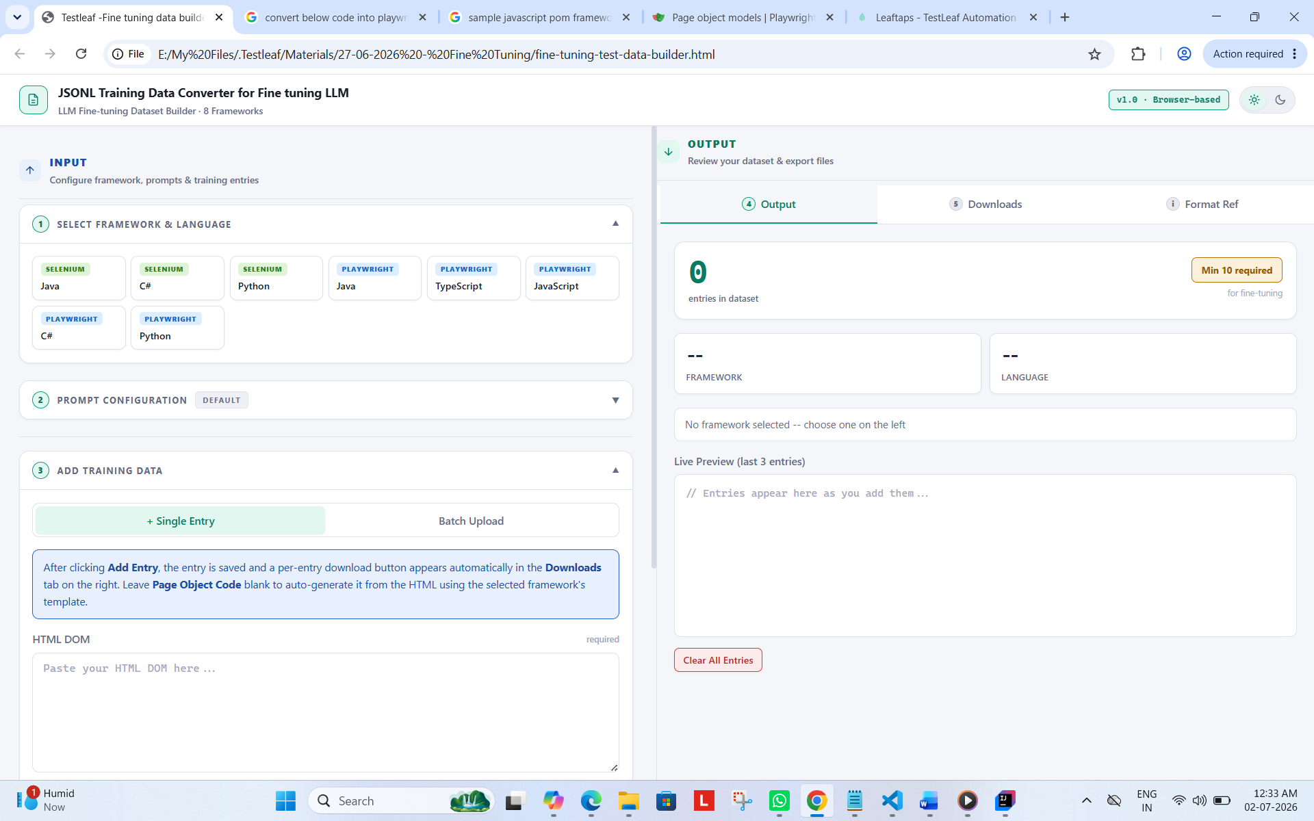
Customized prompt – based on selection
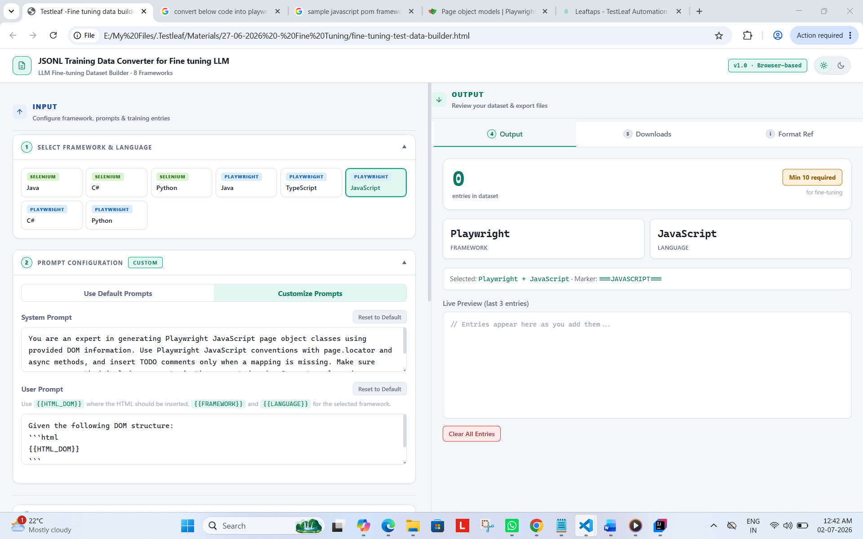
Processed Batch
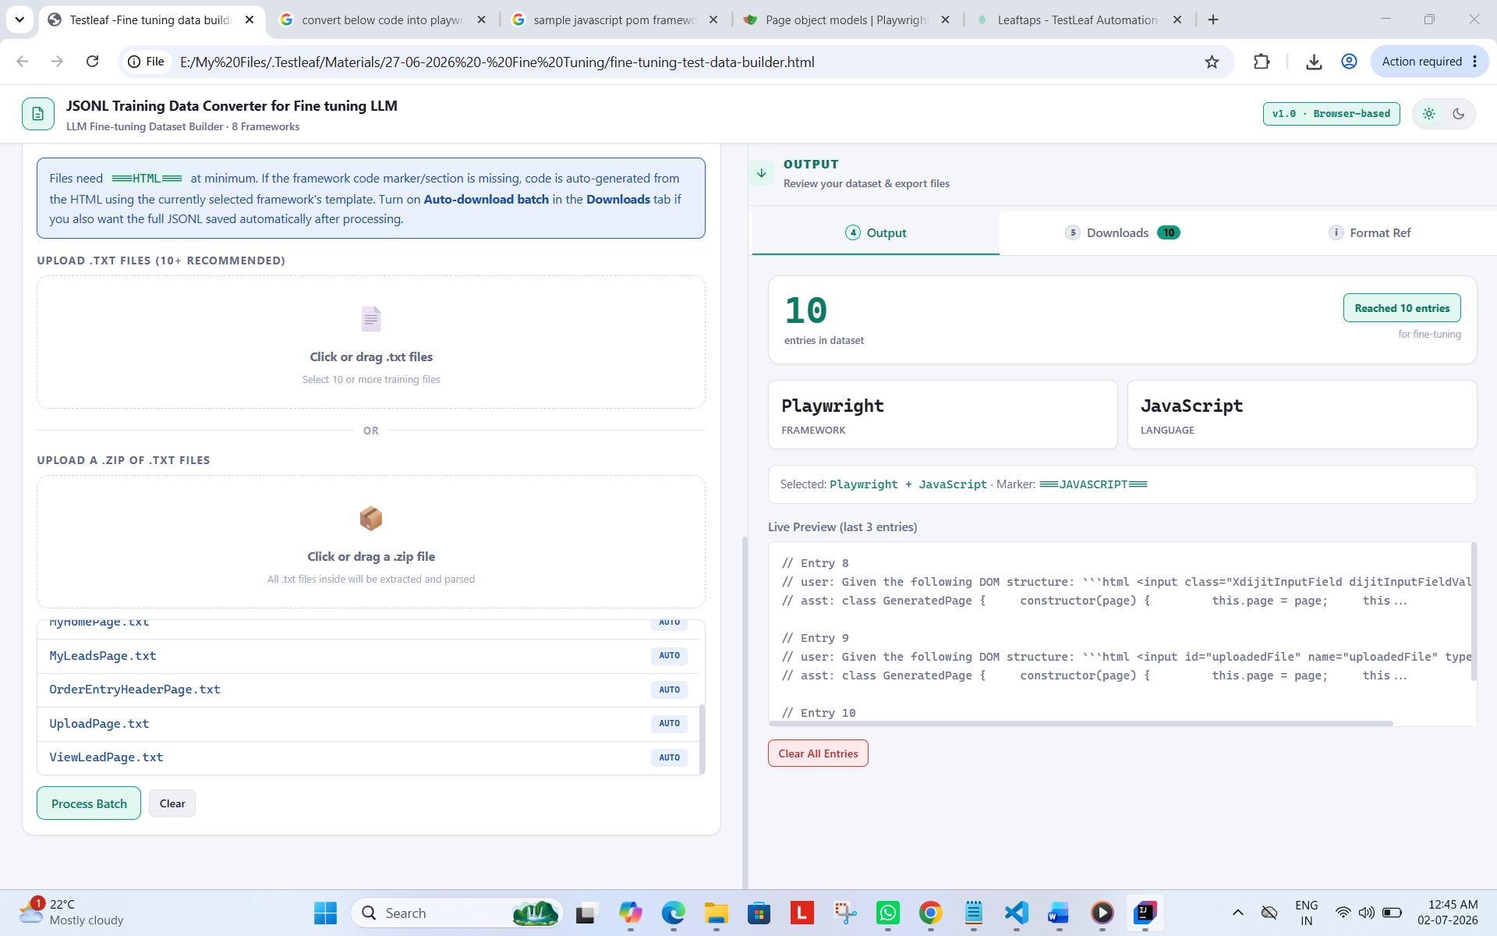
Jsonl – downloads
