Below are a few screenshots captured by me during testing.
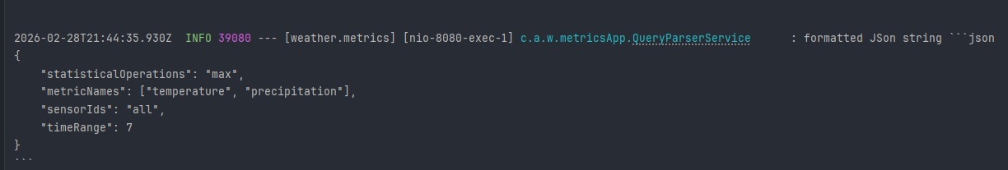
Fig 1 Above is the screenshot of the retrieved query values (from LLM) from the application logs the chat model based on the Fig 2 user prompt or input
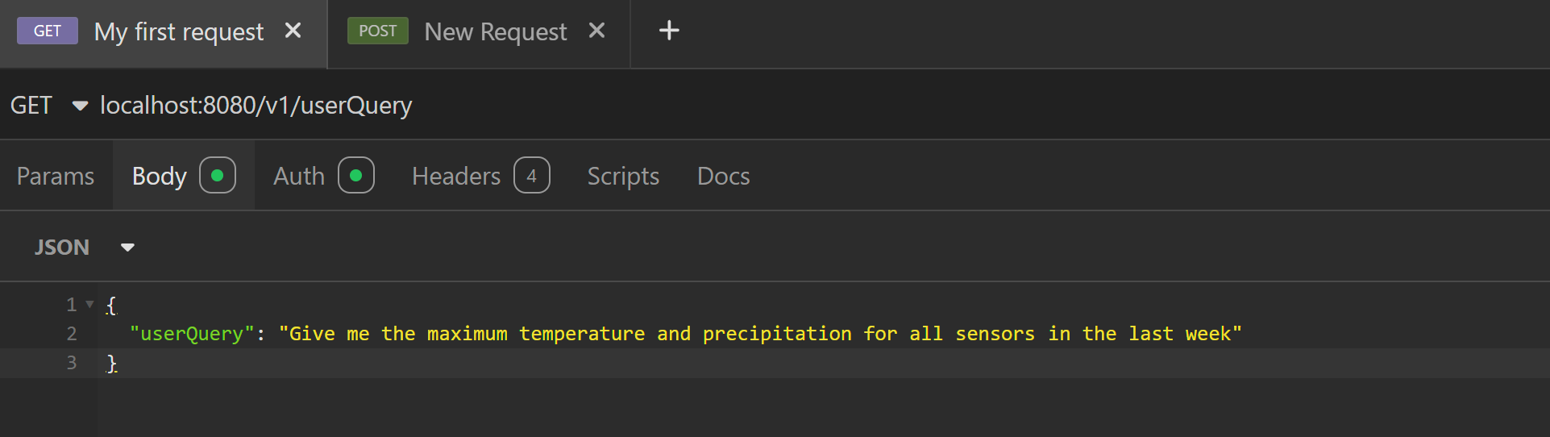
Fig 2 User prompt or query
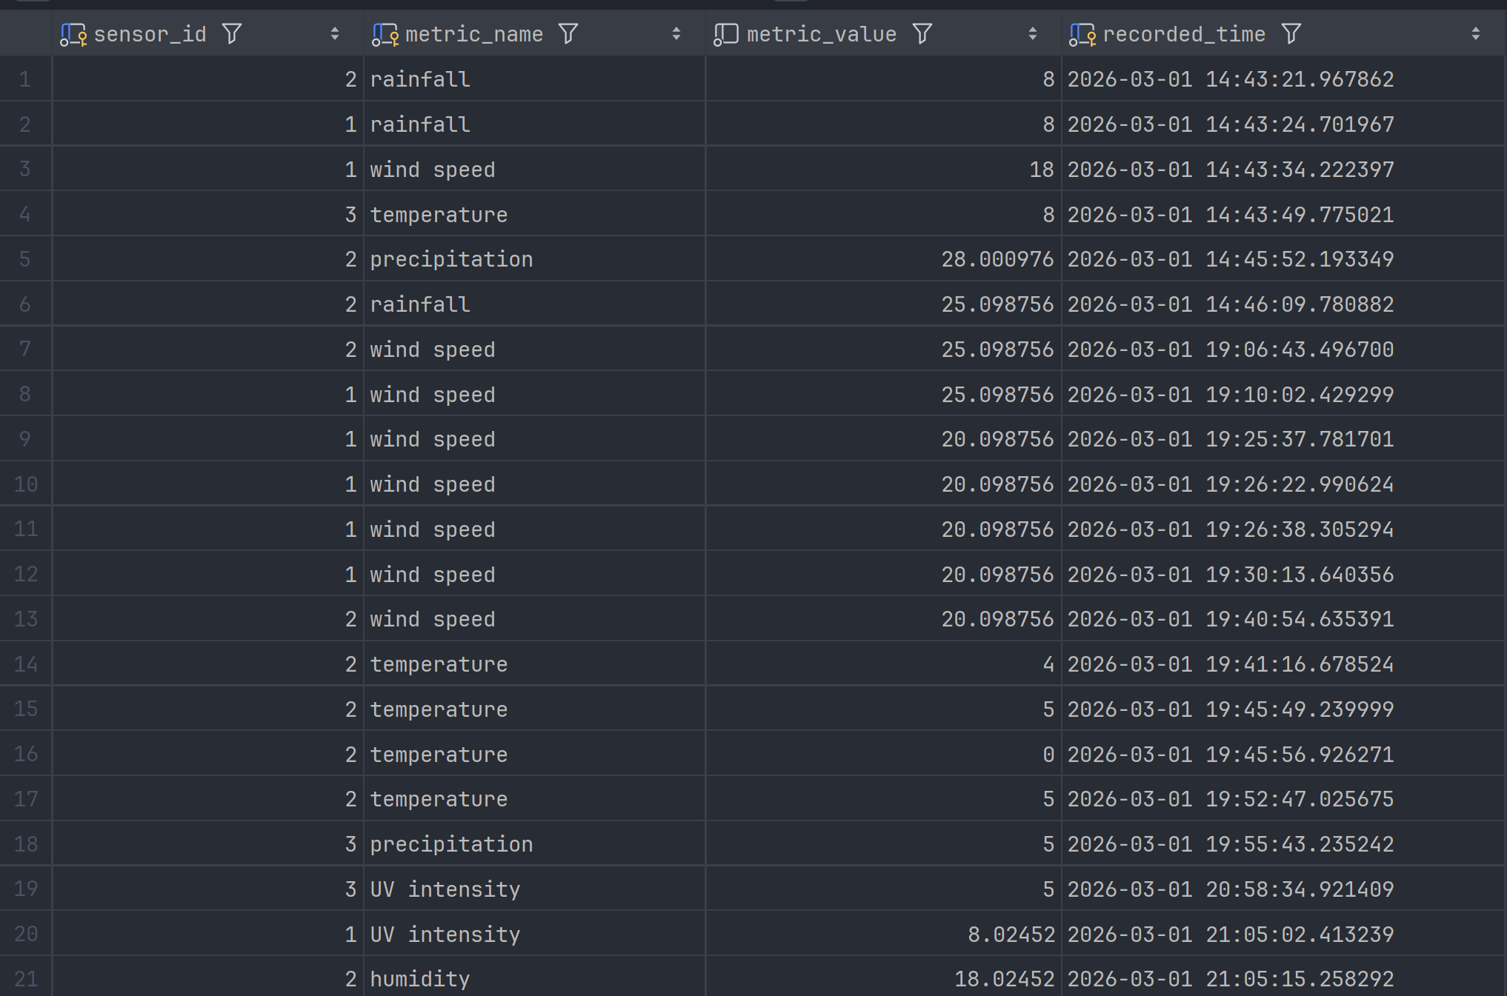
Fig 3 Table view or structure
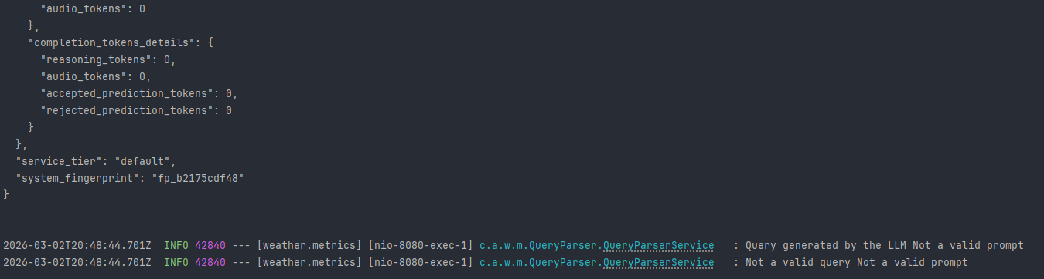
Fig 4 Log statement when an invalid prompt is given as input based on the input in Fig 5
Fig 5 Invalid user prompt
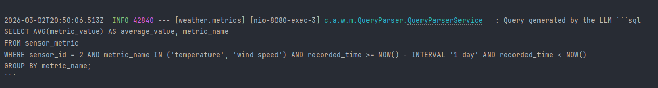
Fig 6 Sample SQL query (Select statement) generated by AI chat model based on the user input (Also the values are returned to the user via controller) in Fig 7
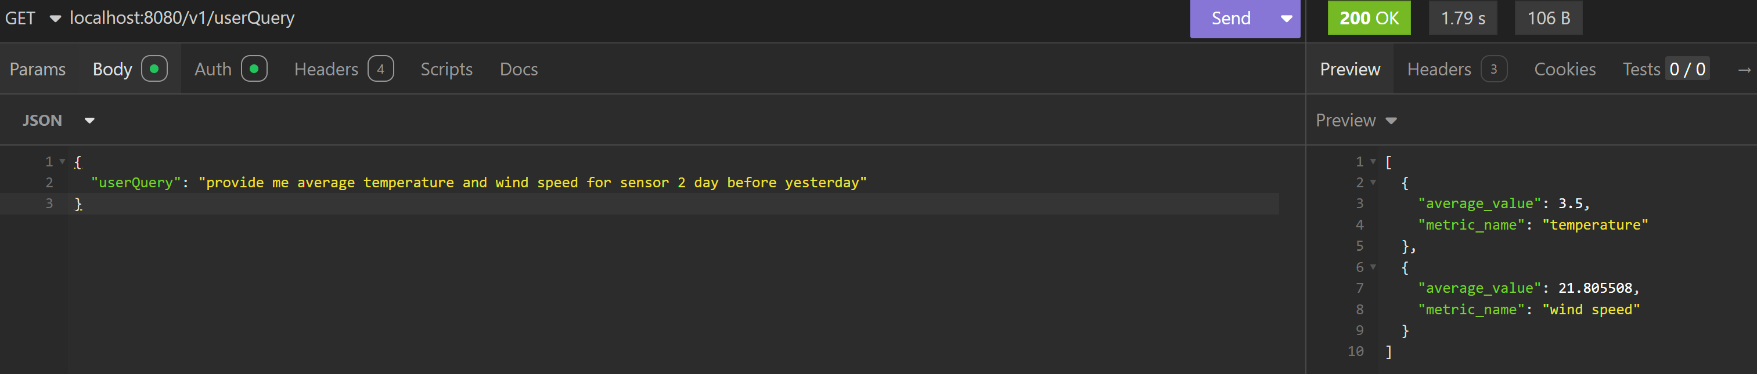
Fig 7 User input query
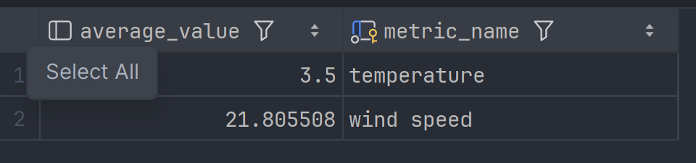
Fig 8 Table view from the Database when the query in Fig 6 was executed. These values match the values in Fig 7 returned to the user

