**INFINITI SQL TASK**

**QUESTION NO 1:**

select orders.orderNumber,products.productName,customers.customerName,payments.amount,payments.checkNumber from payments inner join customers on customers.customerNumber=payments.customerNumber inner join orders on orders.customerNumber=customers.customerNumber inner join orderdetails on orderdetails.orderNumber=orders.orderNumber inner join products on products.productCode=orderdetails.productCode where orders.orderNumber=10100;

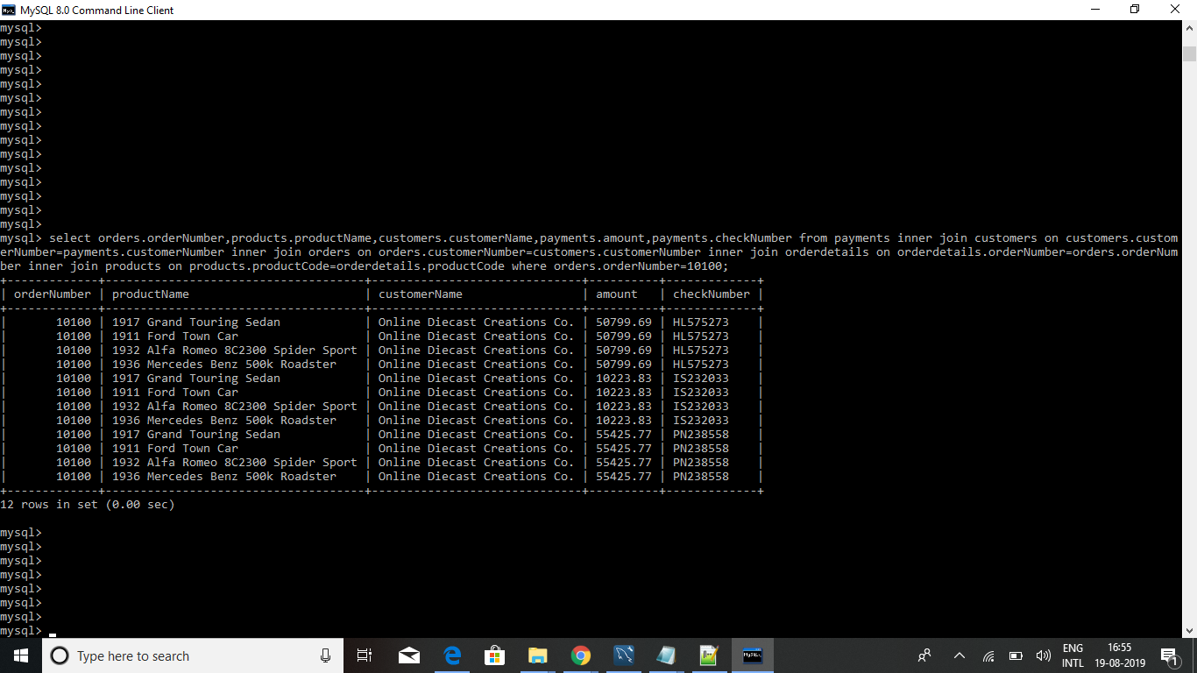

**QUESTION NO 2:**

select orders.orderNumber, sum(amount) as total_paid_amount_for_the_order_10100 from payments inner join customers on customers.customerNumber=payments.customerNumber inner join orders on orders.customerNumber=customers.customerNumber inner join orderdetails on orderdetails.orderNumber=orders.orderNumber inner join products on products.productCode=orderdetails.productCode where orders.orderNumber=10100;

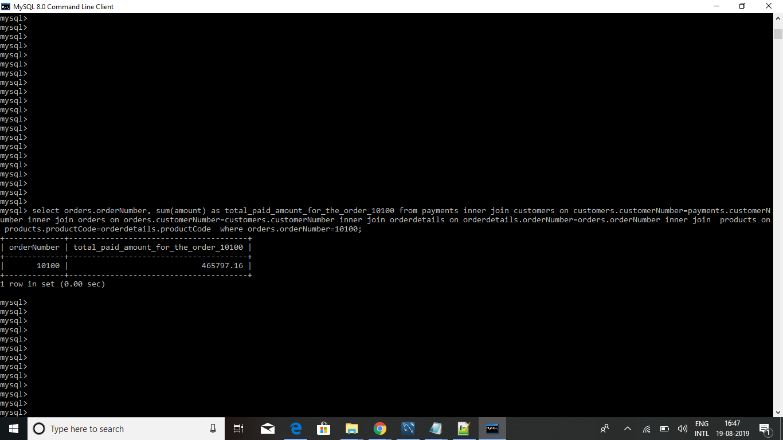

**QUESTION NO 3:**

select distinct orders.orderNumber,payments.checkNumber from payments inner join customers on customers.customerNumber=payments.customerNumber inner join orders on orders.customerNumber=customers.customerNumber inner join orderdetails on orderdetails.orderNumber=orders.orderNumber inner join products on products.productCode=orderdetails.productCode where orders.orderNumber=10100;

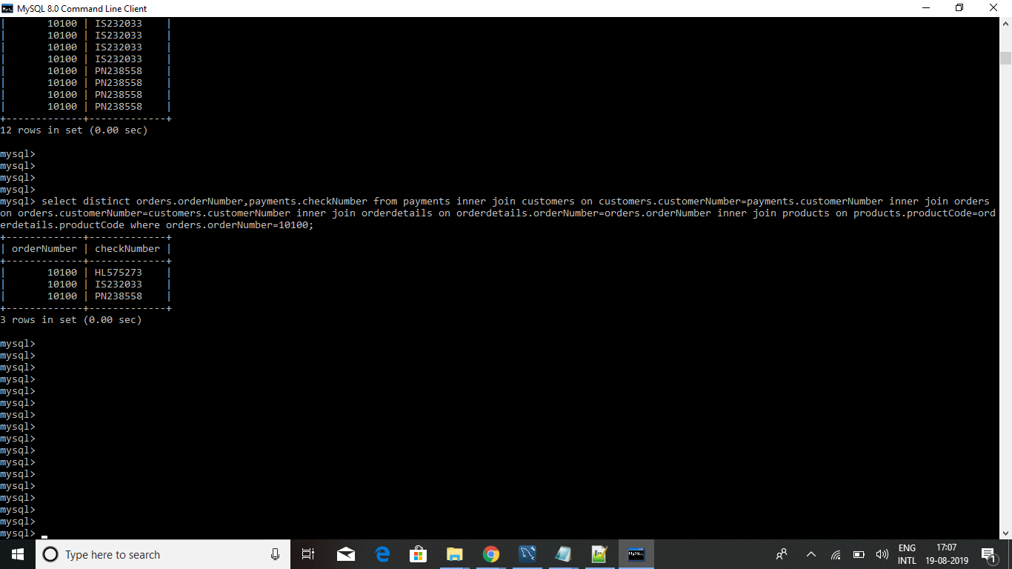

**QUESTION NO 4:**

select min(quantityInStock) as least_value_in_quantityInStock , max(quantityInStock) as max_value_in_quantityInStock from products;

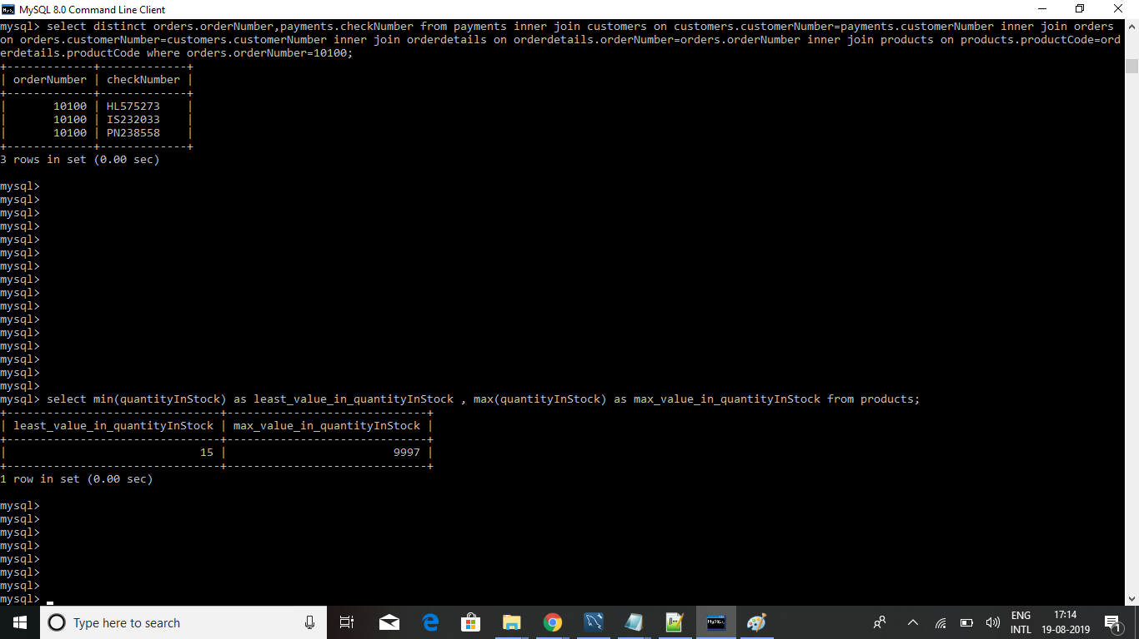

**QUESTION NO 5:**

select products.productCode,productlines.productLine,productlines.htmlDescription from productlines left join products on products.productLine=productlines.productLine order by productLine limit 6,3;

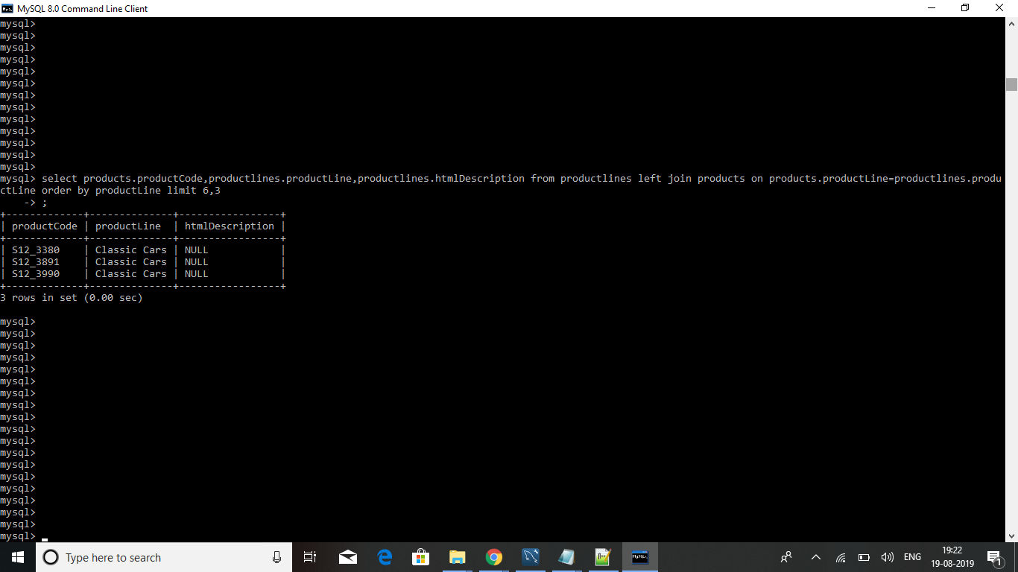

**QUESTION NO 6:**

select count(htmlDescription is null) as NULL_COUNT from productlines ;

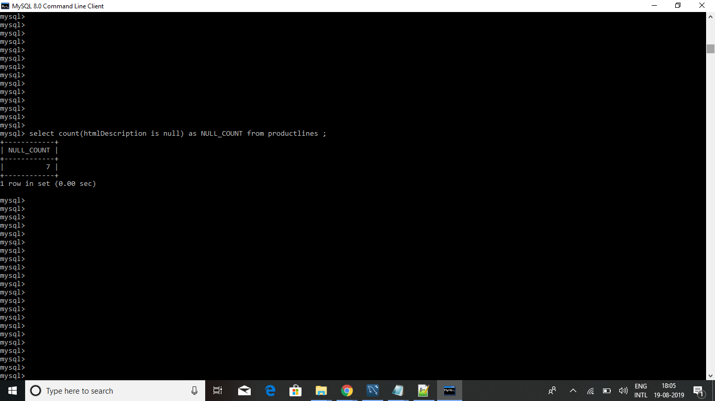

**QUESTION NO 7:**

select DATE_FORMAT('2019-07-18 12:49:24','%d-%b-%a' ) as output;

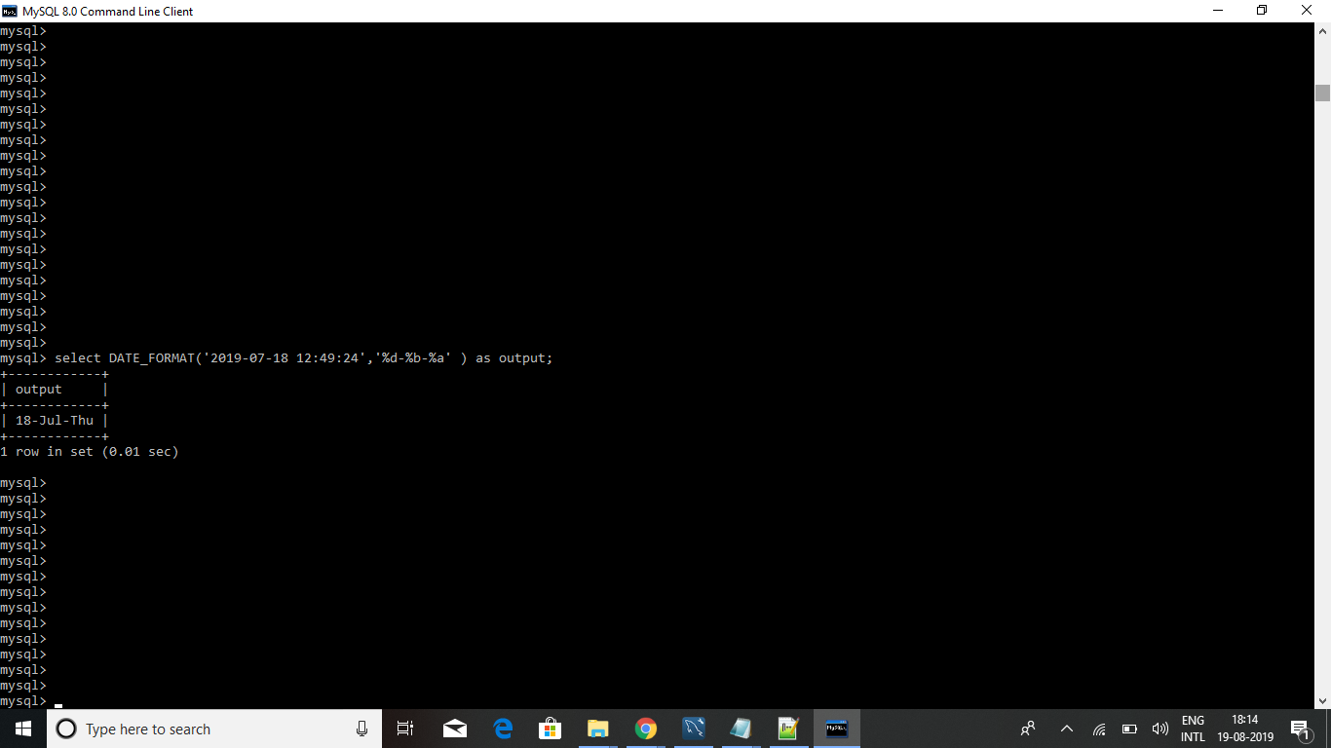

**QUESTION NO 8:**

select amount from payments order by amount desc limit 1 offset 2;

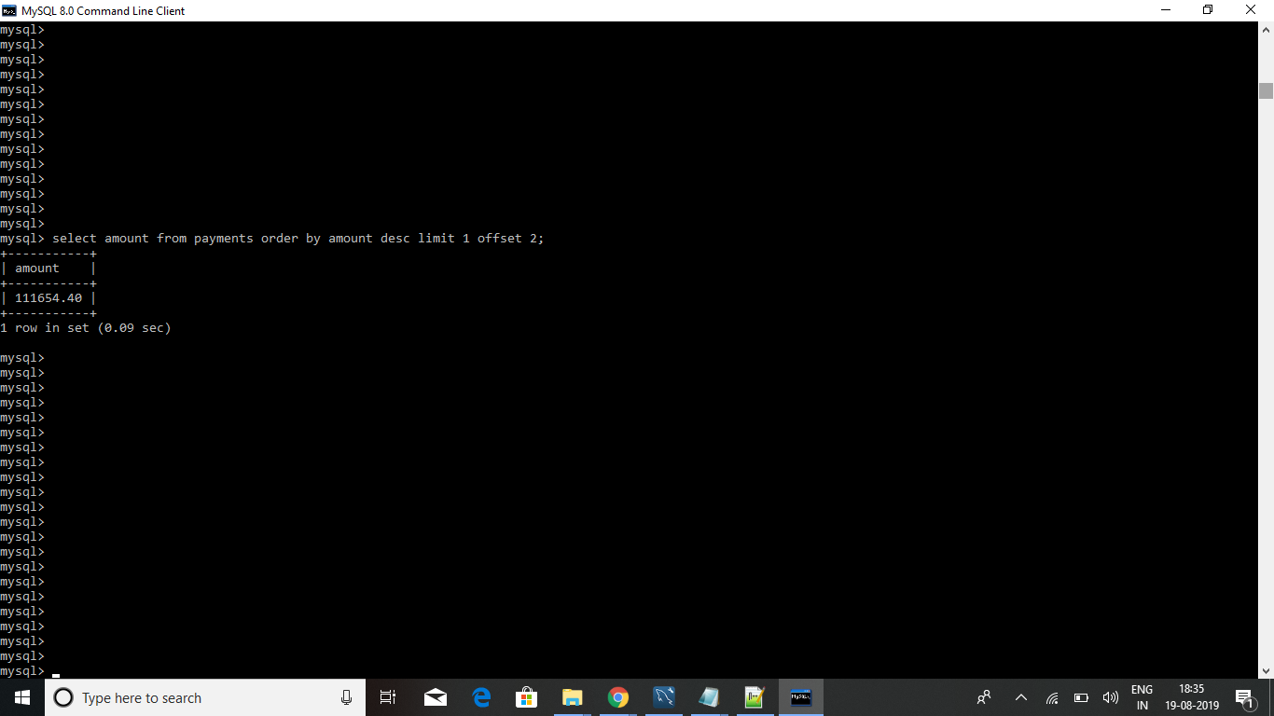

**QUESTION NO 9:**

select contactFirstName from customers where contactFirstName like 'C%a_' ;

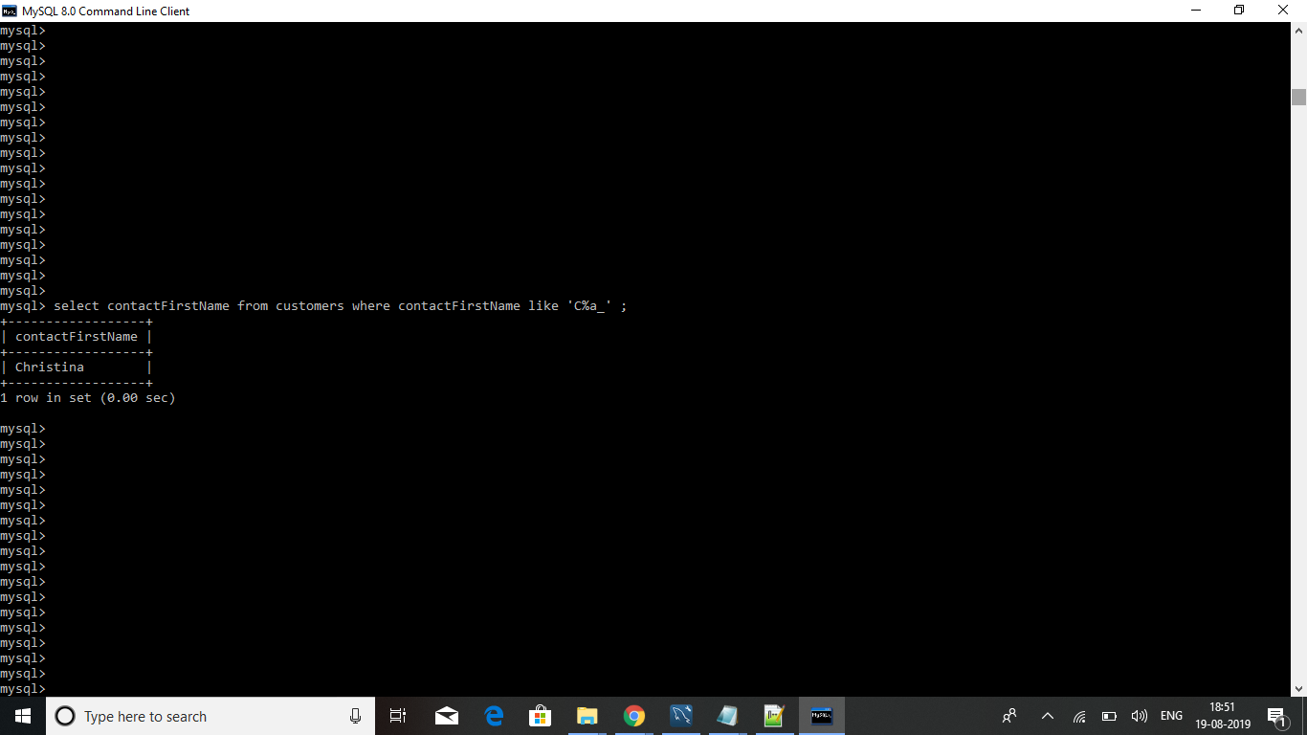

**QUESTION NO 10:**

select productlines.productLine,productlines.textDescription,productlines.htmlDescription,productlines.image from productlines left join products on products.productLine=productlines.productLine where productlines.productLine != products.productLine;

