ENHANCING ATM ACCESSIBILITY WITH VOICE ASSISTANT

## A PROJECT REPORT

***Submitted by***

|  |  |
| --- | --- |
| **KAMALAESHWARAN S** | **20205018** |
| **KARTHI K** | **20205019** |
| **SRINATH S** | **20205049** |
| **TAMIZHARASAN J** | **20205055** |

***in partial fulfillment for the award of the degree***

***of***

# BACHELOR OF TECHNOLOGY

***in***

## INFORMATION TECHNOLOGY

**ERODE SENGUNTHAR ENGINEERING COLLEGE**

**(AUTONOMOUS)**

**PERUNDURAI,** **ERODE-638057**

**MAY 2024**

# ERODE SENGUNTHAR ENGINEERING COLLEGE

**(AUTONOMOUS)**

**PERUNDURAI, ERODE – 57.**

# BONAFIDE CERTIFICATE

Certified that this Project report **“ENHANCING ATM ACCESSIBILITY WITH VOICE ASSISTANT”** is the bonafide work of  **KAMALAESHWARAN S (20205018), KARTHI K (20205019), SRINATH S**

**(20205049) and TAMIZHARASAN J (20205055)”** who carried out the project work under my supervision. Certified further that to the best of my knowledge the work reported herein does not form part of any other thesis or dissertation on the basis of which a degree or award was conferred on an earlier occasion on this or any other candidate.

|  |  |
| --- | --- |
| **SIGNATURE Dr.S.UMARANI M.E., Ph.D., SUPERVISOR**  Associate Professor, Information Technology,  Erode Sengunthar Engineering College ,  Perundurai, Erode-638 057. | **SIGNATURE Dr.M.P.THIRUVENKATASURESH**  **B.E, M.E., Ph.D., HEAD OF THE DEPARTMENT**  Professor and Head, Information Technology,  Erode Sengunthar Engineering College,  Perundurai,Erode-638 057. |

### Submitted for End Semester Project work Viva-voce Examination held on

**INTERNAL EXAMINER EXTERNAL EXAMINER**

# ACKNOWLEDGEMENT

It is our privilege to express our sincere and heart felt thanks to our Correspondent **Thiru G.KAMALAMURUGAN** for giving opportunity to study in this prestigious institution.

We feel immense pleasure and gratitude to thank our Secretary **Thiru. S.N.THANGARAJU** for his well intentioned support throughout our academic career.

We wish to express our gratitude for our Principal **Dr.V.VENKATACHALAM B.E., M.Tech., M.S., Ph.D.,** for his constant encouragement throughout our career.

We are profoundly greatful for the opportunity to express our thanks to **Dr.M.P.THIRUVENKATASURESH B.E., M.E., Ph.D.,** Head of the Department of Information Technology, for his invaluable guidance and support throughout our academic journey

We wish to express our gratitude for our Project Coordinator **Mr.T.PRASANTH M.E., (Ph.D).,** Assistant Professor, Department of Information Technology for his valuable support for our project.

We submit our sincere thanks to our beloved Project guide **Dr.S.UMARANI M.E., Ph.D.,** Associate Professor, Department of Information Technology for her valuable guidance in completing the project efficiently.

We put forward our sincere thanks to all our esteemed teaching, non- teaching staff members of Information Technology Department, parents and friends for their continuous support throughout this academic endeavor.

# TABLE OF CONTENTS

|  |  |  |
| --- | --- | --- |
| **CHAPTER**  **NO.** | **TITLE** | **PAGE**  **NO.** |
|  | **LIST OF FIGURES**  **LIST OF ABBREVIATIONS ABSTRACT** | i  ii iii |
| **1** | **INTRODUCTION** |  |
|  | 1.1 OVERVIEW | 1 |
|  | 1.2 TALKING ATM | 2 |
|  | 1.3 VISUAL IMPAIRMENT | 2 |
| **2** | **LITERATURE SURVEY** | 5 |
| **3** | **SYSTEM REQUIREMENTS** |  |
|  | 3.1 HARDWARE SPECIFICATIONS | 12 |
|  | 3.2 SOFTWARE SPECIFICATIONS | 12 |
|  | 3.3 SOFTWARE FEATURES | 13 |
| **4** | **SYSTEM ANALYSIS** |  |
|  | 4.1 EXISTING SYSTEM | 14 |
|  | 4.1.1 DISADVANTAGES | 14 |
|  | 4.2 PROPOSED SYSTEM | 15 |
|  | 4.2.1 ADVANTAGES | 15 |
|  | 4.2.2 KEY FEATURES | 15 |
|  | 4.3 ARCHITECTURE DIAGRAM | 17 |
| **5** | **SOFTWARE DESCRIPTION** |  |
|  | 5.1 INTRODUCTION | 18 |
|  | 5.2 GENESIS OF PYTHON | 18 |
|  | 5.3 PYTHON ECO-SYSTEM | 18 |
|  | 5.4 APPLICATIONS OF PYTHON | 19 |
|  | 5.5 PYTHON'S INFLUENCE ON MODERN COMPUTING | 19 |
|  | 5.6 CHALLENGES AND CONSIDERATIONS | 20 |

|  |  |  |
| --- | --- | --- |
|  | 5.7 ADVANTAGES OF PYCHARM | 20 |
|  | 5.8 NATURAL LANGUAGE PROCESSING | 21 |
|  | 5.9 INTENT RECOGNITION | 21 |
|  | 5.10 MACHINE LEARNING MODELS | 21 |
|  | 5.11 DIALOG MANAGEMENT | 21 |
| **6** | **MODULE DESCRIPTION** |  |
|  | 6.1 NATURAL LANGUAGE PROCESSING | 22 |
|  | 6.2 DIALOG MANAGEMENT | 23 |
|  | 6.3 SPEECH SYNTHESIS | 24 |
|  | 6.4 VOICE GUIDENCE | 25 |
|  | 6.5 USER INTERFACE | 26 |
|  | 6.6 TRANSACTION | 27 |
| **7** | **SYSTEM TESTING AND IMPLEMENTATION** | |
|  | 7.1 SYSTEM TESTING | 28 |
|  | 7.2 UNIT TESTING | 29 |
|  | 7.3 INTEGRATION TESTING | 29 |
|  | 7.4 IMPLEMENTATION | 30 |
| **8** | **CONCLUSION AND FUTURE SCOPE** |  |
|  | 8.1 CONCLUSION | 31 |
|  | 8.2 FUTURE SCOPE | 31 |
|  | **APPENDICES** | 33 |
|  | **SCREENSHOTS** | 47 |
|  | **REFERENCES** | 50 |

**LIST OF FIGURES**

|  |  |  |
| --- | --- | --- |
| **Figure No.** | **Figure Name** | **Page No.** |
| 4.1 | Data Flow Diagram for ATM Machine | 19 |
| 6.1 | Natural Language Processing | 22 |
| 6.2  6.3 | ATM User Interface  Voice Assistant Process | 26  26 |

# LIST OF ABBREVIATIONS

|  |  |
| --- | --- |
| **ATIS** | Air Travel Information System |
| **ATM** | Automated Teller Machine |
| **BTS** | Base Transmission Station |
| **GIL** | Global Interpreter Lock |
| **IBA** | Indian Bank Association |
| **NLP** | Natural Language Processing |
| **NLU** | Natural Language Understanding |
| **OAG** | Official Airline Guide |
| **PIN** | Personal Identification Number |
| **SRS** | Software Requirements Specification |
| **TS** | Text to Speech |
| **VATM** | Voice-Assisted ATM |
| **VI** | Vision Impairment |
| **VUI** | Voice User Interface |
| **WHO** | World Health Organization |

## ABSTRACT

The discuss process of design and development of talking ATM for visually impaired people. Automated Teller Machine (ATM) has become vital part of our life to perform financial transactions without intervention of human banker. ATM facilitates cash withdrawal, balance check, mini statement and fund transfer. But, these banking services using ATM cannot be directly used by some set of people of society such as people with low vision, visually impaired, illiterate as lack of accessing ATM through screens. Even they can be defrauded at ATM centers. To digitally include these set of people, talking ATMs are evolved, many ATMs employ headphone jack that facilitates user to do transaction with security.

The existing system for voice assisted ATM is a type of automated teller machine (ATM) that gives auditory instructions so that those who are unable to read can use the machine independently. [All](https://afribary.com/works/design-and-implementation-of-simulating-a-voice-aided-atm-system-for-blind-and-visual-impared-customers-of-nigerian-banks) [auditory data is given in private via a conventional](https://afribary.com/works/design-and-implementation-of-simulating-a-voice-aided-atm-system-for-blind-and-visual-impared-customers-of-nigerian-banks) [headphone jack on the machines face or a separately connected telephone handset.](https://afribary.com/works/design-and-implementation-of-simulating-a-voice-aided-atm-system-for-blind-and-visual-impared-customers-of-nigerian-banks) The voice assisted ATM can understand multiple languages and dialects, and can handle various banking transactions such as balance enquiry, cash withdrawal, fund transfer, etc. [The voice assisted ATM uses speech recognition technology to identify the](https://www.thehindu.com/sci-tech/technology/this-multi-lingual-bot-is-transforming-digital-banking-in-rural-india/article34196655.ece) [customers voice and verify their identity.](https://www.thehindu.com/sci-tech/technology/this-multi-lingual-bot-is-transforming-digital-banking-in-rural-india/article34196655.ece) The voice assisted ATM also provides feedback and confirmation messages to the customer during the transaction process.

The proposed Voice Assist ATM system aims to revolutionize the banking experience by integrating state-of-the-art voice recognition technology. This system will not only provide users with a secure and convenient means of accessing their accounts but also offer a more personalized interaction through natural language processing. With an emphasis on user-friendly design, the proposed system strives to enhance accessibility and streamline transactions, setting a new standard for efficient and inclusive banking services.

## CHAPTER 1 INTRODUCTION

An Automated Teller Machine, or ATM, is a technological marvel that graces the modern world. Nestled on street corners and within the walls of financial institutions, it beckons to individuals seeking to unlock the gates of their financial kingdom. This electronic sentinel, adorned with buttons and a screen, offers a portal to one's monetary realm. With a plastic card as the key, it ushers users into a realm of digital currency. Whether under the starry canopy of night or the bright embrace of the sun, the ATM stands at the ready. It offers its services with unwavering reliability, providing access to one's accounts, the ability to withdraw cash, check balances, and execute various financial transactions. In the rhythm of everyday life, it becomes a dependable companion. It whispers secrets encoded in PINs and dispenses crisp banknotes, forging a connection between personal finances and the vast realm of banking. With its discreet charm and subtle efficiency, the ATM plays an integral role in the modern world, simplifying financial interactions and granting access to one's financial universe with a touch, a card, and a code.

### OVERVIEW

ATMs are cash machines which enables bank customers to withdraw cash from electronic device without any human interaction i.e. cashier. Most of the ATM's allow cash withdrawal from machine not belonging to banks where customer does not have account through interbank networking. When a customer swipes card in a machine, account information stored in magnetic strip on card is read by card reader in machine. Then machine requests for entering pin which is encrypted and send via router to base transmission station (BTS). BTS transmits request to host processor linked with bank terminal. Host processor verifies pin with bank information. If customer requests for cash withdrawal then request is forwarded to host processor through networks for approval. The network demands bank to verify customer's account for balance through private network among them. After verification, e-fund is transferred from bank to host processor. In turn host processor sends approval code to ATM. An electronic eye counts currency and money comes out of the cash dispenser.

In India, Reserve Bank of India (RBI) circulars and the Indian Banks‟ Association (IBA) procedural guidelines on inclusive banking have established a strong basis for Inclusive Banking for Disabled Persons, particularly Blind and Low-Vision customers. This circular lays down standards of what is truly accessible ATMs. It mentions accessibility for wheel-chairs, Braille keypads, standardized user interface, IVRS-based menus, language support for Hindi and English, local language can be extended and security by option of screen-off.

### TALKING ATM

A Talking ATM is a remarkable innovation that enhances accessibility for individuals with visual impairments. This specialized ATM features an audio interface that provides spoken instructions and feedback to users, making it possible for them to independently perform financial transactions. The ATM is equipped with a headphone jack or built-in speaker, ensuring that users can listen to the instructions and responses clearly. It guides users through each step of the transaction process, from inserting their card to entering their Personal Identification Number (PIN), selecting the type of transaction, and receiving account balance or cash. The spoken instructions and options are designed to be intuitive, ensuring that users can navigate the machine with ease. This technology empowers individuals with visual impairments to manage their finances independently and with confidence. The Talking ATM exemplifies the inclusive and innovative spirit of our modern world, where technology is harnessed to break down barriers and provide equal access to financial services for all.

### VISUAL IMPAIRMENT

Visual or vision impairment (VI or VIP) is the partial or total inability of [visual](https://en.wikipedia.org/wiki/Visual_perception) [perception.](https://en.wikipedia.org/wiki/Visual_perception) For the former and latter case, the terms low vision and blindness respectively are often used. In the absence of treatment such as corrective eyewear, assistive devices, and medical treatment visual impairment may cause the individual difficulties with normal daily tasks including reading and walking. In addition to the various permanent conditions, fleeting temporary vision impairment, [amaurosis fug ax,](https://en.wikipedia.org/wiki/Amaurosis_fugax) may occur, and may indicate serious medical problems.

The most common causes of visual impairment globally are uncorrected [refractive errors](https://en.wikipedia.org/wiki/Refractive_errors) (43%), [cataracts](https://en.wikipedia.org/wiki/Cataract) (33%), and [glaucoma](https://en.wikipedia.org/wiki/Glaucoma) (2%). Refractive errors include [near-](https://en.wikipedia.org/wiki/Near-sightedness) [sightedness,](https://en.wikipedia.org/wiki/Near-sightedness) [far-sightedness,](https://en.wikipedia.org/wiki/Near-sightedness) [presbyopia,](https://en.wikipedia.org/wiki/Presbyopia) and [astigmatism.](https://en.wikipedia.org/wiki/Astigmatism_(eye)) Cataracts are the most common cause of blindness. Other disorders that may cause visual problems include [age-](https://en.wikipedia.org/wiki/Age-related_macular_degeneration) [related macular](https://en.wikipedia.org/wiki/Age-related_macular_degeneration) [degeneration,](https://en.wikipedia.org/wiki/Age-related_macular_degeneration) [diabetic retinopathy,](https://en.wikipedia.org/wiki/Age-related_macular_degeneration) [corneal clouding,](https://en.wikipedia.org/wiki/Corneal_opacification) [childhood](https://en.wikipedia.org/wiki/Corneal_opacification) [blindness,](https://en.wikipedia.org/wiki/Corneal_opacification) and a number of [infections.](https://en.wikipedia.org/wiki/Infection) Visual impairment can also be caused by problems in the [brain](https://en.wikipedia.org/wiki/Brain) due to [stroke,](https://en.wikipedia.org/wiki/Stroke) [premature birth,](https://en.wikipedia.org/wiki/Premature_birth) or trauma, among others. These cases are known as [cortical visual impairment.](https://en.wikipedia.org/wiki/Cortical_visual_impairment)

Screening for vision problems in children may improve future vision and educational achievement. Screening adults without symptoms is of uncertain benefit. Diagnosis is by an [eye exam.](https://en.wikipedia.org/wiki/Eye_exam) The [World Health Organization](https://en.wikipedia.org/wiki/World_Health_Organization) (WHO) estimates that 80% of visual impairment is either preventable or curable with treatment. This includes cataracts, the infections [river blindness](https://en.wikipedia.org/wiki/Onchocerciasis) and [trachoma,](https://en.wikipedia.org/wiki/Trachoma) glaucoma, diabetic retinopathy, uncorrected refractive errors, and some cases of childhood blindness.

Many people with significant visual impairment benefit from [vision rehabilitation,](https://en.wikipedia.org/wiki/Vision_rehabilitation) changes in their environment, and assistive devices. As of 2015, there were 940 million people with some degree of vision loss. 246 million had low vision and 39 million were blind. The majority of people with poor vision are in the [developing world](https://en.wikipedia.org/wiki/Developing_world) and are over the age of 50 years. Rates of visual impairment have decreased since the 1990s. Visual impairments have considerable economic costs both directly due to the cost of treatment and indirectly due to decreased ability to work.

* **Voice User Interface (VUI):** Implement a well-designed VUI that guides users through the ATM's functions using spoken instructions and responses. The interface should be intuitive and easy to navigate.
* **Speech Recognition:** Use advanced speech recognition technology to accurately interpret spoken commands and facilitate transactions. Ensure it is capable of understanding natural language and user-specific voice patterns.
* **Speech Synthesis:** Utilize high-quality text-to-speech synthesis for providing clear and natural auditory feedback to users.
* **Personalization:** Allow users to personalize their experience by adjusting language, voice speed, and volume settings according to their preferences.
* **Security:** Implement robust security measures, including voice biometrics, to ensure user identity verification and protect against unauthorized access.
* **Tactile Components:** Incorporate tactile elements such as Braille labels, raised buttons, or touch-sensitive surfaces on the ATM's physical interface to help users locate and operate the machine.
* **Audio Instructions:** Provide audible instructions for inserting cards, entering PINs, selecting transaction options, and conducting transactions.
* **Clear and Concise Instructions:** The voice guidance provided by the ATM should be clear, concise, and easy to understand. Instructions for completing transactions, navigating menus, and confirming actions can be communicated in a straightforward manner to avoid confusion.
* **Consistent Navigation Flow:** The ATM's voice interface should follow a consistent navigation flow to help users with visual impairments understand and predict the sequence of actions required to complete transactions. Consistency in voice prompts and menu structures enhances usability and reduces cognitive load.
* **Accessible Information Presentation:** Information presented through the voice interface should be structured in a way that is easy for users with visual impairments to comprehend. This includes providing transaction details, account balances, and other relevant information in a logical and organized manner.
* **Voice Feedback for Error Handling:** The voice assistant should provide clear feedback in case of transaction errors or invalid inputs. Users with visual impairments rely on auditory cues to understand the status of their transactions and to troubleshoot any issues that may arise during the interaction.
* **Customizable Settings:** The ATM's voice interface should offer customizable settings that allow users to adjust speech rate, volume, and language preferences according to their individual needs and preferences. Customization options enhance the user experience and accommodate a diverse range of users with different accessibility requirements

## CHAPTER 2 LITERATURE SURVEY

### VOICE ENABLED ATM MACHINE WITH IRIS RECOGNITION FOR AUTHENTICATION

ATMs are a classic example of ubiquitous computing as they pervade our everyday life. Security is of paramount importance during ATM transactions. People choose passwords which are easy to remember, and, typically, easily predicted, or they change all PINs to be the same. Another concern is the accessibility of ATM machines to differently abled people. These concerns can be overcome by using iris recognition for authentication and voice enabled transactions in ATM machines. The iris patterns of the two eyes of an individual or those of identical twins are completely independent and uncorrelated. Iris recognition involves pre- processing, feature extraction and matching. Matching is done by comparing the user iris with the iris database images that were acquired at the time of opening an account in the bank.

Once the authenticity of the user iris is verified, the user is allowed to carry out further transactions using voice-based commands by speaking into a microphone. Traditionally, access to secure areas or sensitive information has been controlled by possession of a particular artifact (such as a card or key) and/or knowledge of a specific piece of information such as a Personal Identification Number (PIN) or a password. Today, many people have PINs and passwords for a multitude of devices, from the car radio and mobile phone, to the computer, web-based services and their bank information.

Term biometrics refers to any and all of a variety of identification techniques, which are based on some physical or behavioral characteristics of the individual, contrasted with those of the wider population. Physiological biometric techniques include those based on the verification of fingerprint, hand and/or finger geometry, eye (retina or iris), face, wrist (vein), and so forth. Behavioral techniques include those based on voice, signature, typing behavior, and pointing. Iris recognition is a rapidly expanding method of biometric authentication that uses pattern-recognition techniques on images of irises to uniquely identify an individual have been extensively deployed in commercial iris recognition systems for various security applications.

The iris patterns of the two eyes of an individual or those of identical twins are completely independent and uncorrelated. Iris recognition system can be used to either prevent unauthorized access or identity individuals using a facility. When installed, this requires users to register their system. A distinct iris code is generated for every iris image enrolled and is saved within the system. Once registered, a user can present his iris to the system and get identified. Enrollment takes less than 2 minutes. Authentication takes less than 2 seconds.

Voice-activated automatic teller machines were designed to help people with visual impairments, including some elderly people, make financial transactions. Not every blind person can read Braille, and so ATM‟s equipped with Braille keypads does not always suffice. In addition, Braille keypads may allow blind people to enter the information they need to, but they does not provide a means of delivering directions to visually impaired customers. Therefore, unless a blind person were to walk into a bank already knowing exactly how to use the ATM, it might not be possible for him or her to make transactions without assistance from a bank employee. Indeed, in the past, some visually-impaired people tended to avoid ATM‟s altogether. However, a voice-activated ATM solves most, if not all, of those problems.

### THE ATIS SPOKEN LANGUAGE SYSTEMS PILOT CORPUS

Speech research has made tremendous progress in the past using the following paradigm define the research problem, collect a corpus to objectively measure progress, and solve the research problem. Natural language research, on the other hand, has typically progressed without the benefit of any corpus of data with which to test research hypotheses. We describe the Air Travel Information System (ATIS) pilot corpus, a corpus designed to measure progress in Spoken Language Systems that include both a speech and natural language component. This pilot marks the first full-scale attempt to collect such a corpus and provides guidelines for future efforts. The ATIS corpus provides an opportunity to develop and evaluate speech systems that understand spontaneous speech. This corpus differs from its predecessor, the Resource Management corpus (Price e.g al, 1988), in at least four significant ways. Instead of being read, the speech has many of the characteristics of spontaneous spoken language (e.g., dysfluencies, false starts, and colloquial pronunciations). The speech collection occurs in an office environment rather

than a sound booth. The grammar becomes part of the system under evaluation rather than given part of the experiment. The reference answer consists of the actual reply for the utterance rather than an orthographic transcription of the speech.

The evaluation methodology supported by ATIS depends on having a comparable representation of the answer for each utterance. This is accomplished by limiting the utterances to database queries~ and the answers to a ground set of tuples from a fixed relational database. The ATIS corpus comprises the acoustic speech data for a query, transcriptions of that query, a set of tuples that constitute the answer, and the SQL expression for the query that produced the answer tuples. The ATIS database consists of data obtained from the Official Airline Guide (OAG, 1990), organized under a relational schema. The database remained fixed throughout the pilot phase. It contains information about flights, fares, airlines, cities, airports, and ground services, and includes twenty-five supporting tables. The large majority of the questions posed by subjects can be answered from the database with a single relational query. To collect the kind of English expected in a real working system, we simulate one.

The subject, or "travel planner," is in one room, with those running the simulation in another. The subject speaks requests over a microphone and receives both a transcription of the speech and the answer on a computer screen. A session lasts approximately one hour, including detailed preliminary instructions and an exit questionnaire. Two "wizards" carry out the simulation: one transcribes the query while the other produces the answer. The transcriber interprets any verbal editing by the subject and removes dysfluencies in order to produce an orthographic transcription of what the subject intended to say. At the same time, the answerer uses a natural language-oriented command language to produce an SQL expression that elicits the correct answer for the subject. On-line utilities maintain a complete log of the session, including time stamps.

At the conclusion of the session, the utterances are sorted into categories to determine those utterances suitable for objective evaluation. Finally, each utterance receives three different transcriptions. First, a checked version of the transcription produced during the session provides an appropriate input string for evaluating text based natural language systems. Second, a slightly expanded version of this serves as a prompt in collecting a read version of the spontaneously spoken sentences.

Finally, subjects were given instructions regarding the operation of the system. The "system", from the subjects perspective, consisted of a 19 inch color monitor running the X Window System, and a head-mounted Senheiser (HMD 410-6) microphone. A desk mounted Crown (PCC-160 phase coherent cardioid) microphone was also used to record the speech. The "office" contained a spare-station CPU and disk to replicate office noise, and a wall map of the United States to help subjects solve their scenarios. The monitor screen was divided into two regions: a large, scrollable window for system output and a smaller window for speech interaction.

### AUTOMATED BIOMETRIC VOICE-BASED ACCESS CONTROL IN AUTOMATICTELLER MACHINE

An automatic teller machine requires a user to pass an identity test before any transaction can be granted. The current method available for access control in ATM is based on smartcard. Efforts were made to conduct an interview with structured questions among the ATM users and the result proofed that many problems was associated with ATM smartcard for access control. Among the problems are; it is very difficult to prevent another person from attaining and using a legitimate persons card, also conventional smartcard can be lost, duplicated, stolen or impersonated with accuracy. To address the problems, the paper proposed the use of biometric voice based access control system in automatic teller machine. In the proposed system, access will be authorized simply by means of an enroll user speaking into a microphone attached to the automatic teller machine. There are 2 phases in implementation of the proposed system: first training phase, second testing or operational phase as discussed in section 4 of this paper.

The biometric recognition systems, used to identify person on the basis of physical or behavioral characteristics (voice, fingerprints, face, iris, etc.), have gained in popularity during recent years especially in forensic work and law enforcement applications. Automatic Teller Machine was invented to address the following issues in banking system: Long queue in banking hall, Quick access to fund withdrawal, banking at any time, Improvement in the quality of banking services to customers. Safety of bank customer fund in banking has always been a concern since ATM was introduced. Access control for automatic teller machine represent an important tool for protecting hank customers fund

and guarantee that the authentic owner of the ATM card [smartcard] is the one using it for transaction. The most important authentication method for ATM is based on smartcard [Njemanze, P.C. 2007). It is very difficult to prevent another person from attaining and using a legitimate person's card.

The conventional smartcard can be lost, duplicated, stolen, forgotten or impersonated with accuracy. This conventional security procedure in ATM cannot guarantee the required security for ATM. An intelligent voiced-based access control system, which is biometric in nature, will enable automatic verification of identity by electronic assessment of one or more behavior and/or physiological characteristics of a person. Recently biometric methods used for personal authentication utilize such features as face, voice, hand shape, finger print and Iris. In other to overcome the problems of smartcard access control in ATM. This paper proposed an intelligent voice based access control system which is a biometric technique that offers an ability to provide positive verification of identity from individual voice characteristics to access automatic teller machine.

ATM and it model network, drawback in smartcard based access control for ATM based on survey of 1000 users of ATMs, proposed voiced based access control and conclusion that compare the advantages of the system over current: available technology. In other to verify whether the PIN of a particular users is correct or not, the class card will have the information of the cardholder i.e. card number, PIN, and Account number. The controller will interact with the bank the bank using the information of the card holder in order to get the authorization to pay (or not) request amount. The bank interface will send the request to the accounting class, which belongs to the bank package, in other to call the debit method of the accounting class.

### DESIGNING TALKING ATM SYSTEM FOR PEOPLE WITH VISUAL IMPAIRMENTS

Discuss process of design and development of talking ATM for visually impaired people. Automated Teller Machine (ATM) has become vital part of our life to perform financial transactions without intervention of human banker. ATM facilitates cash withdrawal, balance check, mini statement and fund transfer. But, these banking services using ATM cannot be directly used by some set of people of society such as people with low vision, visually impaired, illiterate as lack of accessing ATM through screens. Even they can be defrauded at ATM centers. To digitally include these set of people, talking ATMs are evolved. Talking ATM provides accessibility to ATM services by providing audio component. Many ATMs employ headphone jack that facilitates user to do transaction with security. The audio information is generated either using pre-recorded speech corpus or through speech synthesis engine. The paper summarizes how ATM works, need, proposed solution of talking ATM for visually impaired users, design and development talking ATM using concatenated Text To Speech.

### AUTOMATED BIOMETRIC VOICE BASED ACCESS CONTROL IN AUTOMATICTELLER MACHINE

An automatic teller machine requires a user to pass an identity test before any transaction can be granted. The current method available for access control in ATM is based on smartcard. Efforts were made to conduct an interview with structured questions among the ATM users and the result proofed that lot of problems was associated with ATM smartcard for access control. Among the problems are; it is very difficult to prevent another person from attaining and using a legitimate persons card, also conventional smartcard can be lost, duplicated, stolen or impersonated with accuracy. To address the problems, the paper proposed the use of biometric voice based access control system in automatic teller machine. In the proposed system, access will be authorized simply by means of an enroll user speaking into a microphone attached to the automatic teller machine. There are 2 phases in implementation of the proposed system.

The first training phase, second testing or operational phase as discussed in section 4 of this paper. The biometric recognition systems, used to identify person on the basis of physical or behavioral characteristics (voice, fingerprints, face, iris, etc.), have gained in popularity during recent years especially in forensic work and law enforcement applications. Automatic Teller Machine was invented to address the following issues in banking system: Long queue in banking hall, Quick access to fund withdrawal, banking at any time, Improvement in the quality of banking services to customers. Safety of bank customer fund in banking has always been a concern since ATM was introduced.

Access control for automatic teller machine represent an important tool for protecting bank customers fund and guarantee that the authentic owner of the ATM card [smartcard] is the one using it for transaction. The most important authentication method for ATM is based on smartcard. It is very difficult to prevent another person from attaining and using a legitimate person's card. The conventional smartcard can be lost, duplicated, stolen, forgotten or impersonated with accuracy. This conventional security procedure in ATM cannot guarantee the required security for ATM. An intelligent voiced-based access control system, which is biometric in nature, will enable automatic verification of identity by electronic assessment of one or more behavior and/or physiological characteristics of a person. Recently biometric methods used for personal authentication utilize such features as face, voice, hand shape, finger print and Iris. In other to overcome the problems of smartcard access control in ATM. This paper proposed an intelligent voice based access control system which is a biometric technique that offers an ability to provide positive verification of identity from individual voice characteristics to access automatic teller machine.

The use of voice as a biometric characteristic offers advantages such as: it is well accepted by the uses, can be recorded by regular microphones, the hardware costs are reduced, etc. The paper discusses; ATM and it model network, drawback in smartcard based access control for ATM based on survey of 1000 users of ATMs, proposed voiced based access control and conclusion that compare the advantages of the system over current: available technology. In other to verify whether the PIN of a particular users is correct or not, the class card will have the information of the cardholder i.e. card number, PIN, and Account number.

## CHAPTER 3 SYSTEM REQUIREMENTS

### HARDWARE SPECIFICATIONS

* + - Windows 8/10/11
    - 8GB RAM
    - 256 SSD

### SOFTWARE SPECIFICATION S ABOUT PYTHON

Python is a [high-level,](https://en.wikipedia.org/wiki/High-level_programming_language) [general-purpose programming language.](https://en.wikipedia.org/wiki/General-purpose_programming_language) Its design philosophy emphasizes [code readability](https://en.wikipedia.org/wiki/Code_readability) with the use of [significant indentation.](https://en.wikipedia.org/wiki/Off-side_rule) Python is [dynamically- typed](https://en.wikipedia.org/wiki/Type_system#DYNAMIC) and [garbage-collected.](https://en.wikipedia.org/wiki/Garbage_collection_(computer_science)) It supports multiple [programming](https://en.wikipedia.org/wiki/Programming_paradigm) [paradigms,](https://en.wikipedia.org/wiki/Programming_paradigm) including [structured](https://en.wikipedia.org/wiki/Structured_programming) (particularly [procedural](https://en.wikipedia.org/wiki/Procedural_programming)), [object-oriented](https://en.wikipedia.org/wiki/Object-oriented_programming) and [functional](https://en.wikipedia.org/wiki/Functional_programming) [programming.](https://en.wikipedia.org/wiki/Functional_programming) It is often described as a "batteries included" language due to its comprehensive [standard library. Guido](https://en.wikipedia.org/wiki/Standard_library) [van Rossum](https://en.wikipedia.org/wiki/Guido_van_Rossum) began working on Python in the late 1980s as a successor to the [ABC programming language](https://en.wikipedia.org/wiki/ABC_(programming_language)) and first released it in 1991 as Python 0.9.0. Python 2.0 was released in 2000 and introduced new features such as [list](https://en.wikipedia.org/wiki/List_comprehension) [comprehensions,](https://en.wikipedia.org/wiki/List_comprehension) [cycle-detecting](https://en.wikipedia.org/wiki/List_comprehension) garbage collection, [reference](https://en.wikipedia.org/wiki/Reference_counting) [counting,](https://en.wikipedia.org/wiki/Reference_counting) and [Unicode](https://en.wikipedia.org/wiki/Unicode) support. Python 3.0, released in 2008, was a major revision that is not completely [backward-compatible](https://en.wikipedia.org/wiki/Backward_compatibility) with earlier versions. Python 2 was discontinued with version

2.7.18 in 2020. Python consistently ranks as one of the most popular programming languages.

### WHAT CAN PYTHON DO

* Python can be used on a server to create web applications.
* Python can be used alongside software to create workflows.
* Python can connect to database systems. It can also read and modify files.
* Python can be used to handle big data and perform complex mathematics.
* Python can be used for rapid prototyping, or for production-ready software development.

### SOFTWARE FEATURES

* Python works on different platforms (Windows, Mac, Linux, Raspberry Pi, etc).
* Python has a simple syntax similar to the English language.
* Python has syntax that allows developers to write programs with fewer lines than some other programming languages.
* Python runs on an interpreter system, meaning that code can be executed as soon as it is written. This means that prototyping can be very quick.
* Python's syntax is designed to be simple, readable, and easy to understand, making it accessible for beginners and experienced developers alike.
* Python supports dynamic typing and provides built-in high-level data structures such as lists, dictionaries, and tuples, which simplify coding and promote rapid development.
* Python comes with a comprehensive standard library that includes modules and packages for various tasks, ranging from file I/O and networking to web development and data processing.
* Python is a cross-platform language, meaning that code written in Python can run on various operating systems, including Windows, macOS, and Linux, without modification.
* Python has a large and active community of developers who contribute to its ecosystem by creating libraries, frameworks, and tools. This community support fosters collaboration, learning, and innovation within the Python community.
* Python supports functional programming features such as lambda functions, list comprehensions, and map/filter/reduce functions, enabling developers to write concise and expressive code.
* Python can easily integrate with other languages and technologies, making it suitable for building versatile and interoperable systems. It has robust support for interfacing with C/C++ libraries, as well as seamless integration with web technologies and databases.

## CHAPTER 4 SYSTEM ANALYSIS

### EXISTING SYSTEM

The existing system for voice assisted ATM is a type of automated teller machine (ATM) that gives auditory instructions so that those who are unable to read can use the machine independently. [All auditory data is given in private via a conventional headphone](https://afribary.com/works/design-and-implementation-of-simulating-a-voice-aided-atm-system-for-blind-and-visual-impared-customers-of-nigerian-banks) [jack on the machines face or a separately connected telephone handset.](https://afribary.com/works/design-and-implementation-of-simulating-a-voice-aided-atm-system-for-blind-and-visual-impared-customers-of-nigerian-banks) The voice assisted ATM can understand multiple languages and dialects, and can handle various banking transactions such as balance enquiry, cash withdrawal, fund transfer, etc. [The voice](https://www.thehindu.com/sci-tech/technology/this-multi-lingual-bot-is-transforming-digital-banking-in-rural-india/article34196655.ece) [assisted ATM uses speech recognition technology to](https://www.thehindu.com/sci-tech/technology/this-multi-lingual-bot-is-transforming-digital-banking-in-rural-india/article34196655.ece) [identify the customers voice and](https://www.thehindu.com/sci-tech/technology/this-multi-lingual-bot-is-transforming-digital-banking-in-rural-india/article34196655.ece) [verify their identity2.](https://www.thehindu.com/sci-tech/technology/this-multi-lingual-bot-is-transforming-digital-banking-in-rural-india/article34196655.ece) The voice assisted ATM also provides feedback and confirmation messages to the customer during the transaction process. The voice assisted ATM aims to improve the accessibility and convenience of banking services for visually impaired and illiterate customers.

### DISADVANTAGES

Some of the drawbacks of voice assisted ATM are:

• **Privacy concerns:** Voice technology may increase security, but it also raises questions about privacy among some users. Some people may not feel comfortable speaking their personal information or banking requests in public places. [Voice assistants may also](https://finovate.com/3-benefits-and-drawbacks-of-voice-tech-for-banks/) [record or store user voice data, which could be vulnerable to hacking or misuse.](https://finovate.com/3-benefits-and-drawbacks-of-voice-tech-for-banks/)

• **Faulty voice recognition:** There are still some lingering concerns about how accurate voice recognition technologies are. Voice assistants may not understand users‟ commands or queries correctly, especially if there is background noise, different accents, or unclear pronunciation. [This could lead to errors or frustration for the users](https://finovate.com/3-benefits-and-drawbacks-of-voice-tech-for-banks/).

• **Regulatory complications:** Voice technology may face some legal or regulatory challenges in the banking industry. For example, voice assistants may need to comply with anti-money laundering laws, data protection laws, and consumer protection laws. [Banks may also need to](https://finovate.com/3-benefits-and-drawbacks-of-voice-tech-for-banks/) [ensure that voice assistants provide clear and consistent](https://finovate.com/3-benefits-and-drawbacks-of-voice-tech-for-banks/) [information and advice to customers.](https://finovate.com/3-benefits-and-drawbacks-of-voice-tech-for-banks/)

• **Lack of Offline Functionality:** Voice assistant ATMs may not be functional during network outages, limiting users' access to their accounts and funds in emergency situation.

• **Initial Implementation Costs:** The initial cost of implementing voice assistant ATM technology and ensuring compliance with accessibility standards can be relatively high for financial institutions.

### PROPOSED SYSTEM

The Voice-Assisted ATM (VATM) System is an innovative and inclusive solution designed to enhance the accessibility and usability of Automated Teller Machines (ATMs) for individuals with visual impairments or those who prefer voice-guided interactions. The system combines cutting-edge Text-to-Speech (TTS) technology with ATM hardware, ensuring a seamless and secure banking experience for all users.

### ADVANTAGES

* **Inclusivity:** The VATM System breaks down barriers by providing visually impaired individuals and those with limited literacy skills equal access to banking services.
* **Independence:** Users can confidently manage their accounts and conduct transactions without assistance, promoting independence and autonomy.
* **Efficiency:** Voice-guided interactions expedite the ATM process, benefiting all users by reducing transaction times.
* **Security:** The system integrates robust security measures, safeguarding sensitive financial information.

### KEY FEATURES

* **Voice Guidance:** The VATM System provides clear and natural voice guidance throughout the ATM interaction, making it accessible to individuals with visual impairments. Users can plug in their headphones or use the built-in speaker to listen to instructions.
* **User-Friendly Interface:** The system offers a simplified and intuitive user interface. Users can navigate through options, check account balances, withdraw cash, deposit funds, transfer money, and perform other standard banking operations with ease.
* **Enhanced Security:** Security is paramount, and the VATM System ensures the safety of transactions. It integrates advanced biometric authentication methods like fingerprint or voice recognition, in addition to traditional PIN entry, to validate user identities.
* **Multiple Languages:** The system supports multiple languages to cater to a diverse user base, making it accessible to customers with various linguistic backgrounds.
* **Transaction Verification:** Users receive verbal confirmation of their transaction details before completing any financial operation, enhancing transparency and reducing errors.
* **Accessibility Compliance:** The VATM System complies with accessibility standards and regulations, ensuring equal access to banking services for all individuals.
* **Guided Transactions:** The voice assistant should guide users through ATM transactions step-by-step, providing clear instructions and feedback to ensure successful completion of each transaction.
* **Personalization:** The voice assistant can offer personalized recommendations and services based on user preferences and transaction history, enhancing the user experience and making interactions more efficient.
* **Integration with Banking Services:** Integrating the voice assistant with banking services, such as account inquiries, fund transfers, bill payments, and card services, enables users to access a wide range of banking functionalities through voice commands.
* **Continuous Improvement:** Regular updates and improvements to the voice assistant's capabilities based on user feedback and usage data ensure that the ATM remains user- friendly, efficient, and aligned with evolving customer needs and preferences.
* **Error Handling**: Robust error handling mechanisms should be implemented to guide users in case of transaction errors or invalid inputs, providing clear instructions on how to resolve issues and complete transactions.

## ARCHITECTURE DIAGRAM

**START**

VOICE ASSISTANT ACTIVE

INPUT

RESPOND VOICE COMMAND

OBTAINING RESULT

WITHDRAWAL

**STOP**

OTHERS

Fig 4.1 Data Flow Diagram for ATM Machine

## CHAPTER 5 SOFTWARE DESCRIPTION

### INTRODUCTION

Python, often referred to as the "Swiss Army Knife" of programming languages, has become a powerhouse in the world of software development. Renowned for its versatility, readability, and simplicity, Python has evolved from a niche language into a dominant force used across industries, from web development and data science to artificial intelligence and scientific research. In this comprehensive exploration, we will delve into the essence of Python programming, its key features, applications, advantages, and the vibrant ecosystem that surrounds it.

### GENESIS OF PYTHON

Python was conceived in the late 1980s by Guido van Rossum, a Dutch programmer. Guido aimed to create a language that emphasized code readability and reduced the need for excessive syntactical elements. The result was Python, named after the British comedy group Monty Python, which Guido enjoyed. Python's first official release, Python 0.9.0, came in February 1991.

### PYTHON ECOSYSTEM

* Python's strength is amplified by its extensive ecosystem of libraries, frameworks, and tools:
* NumPy: For efficient numerical operations and array processing.
* pandas: For data manipulation and analysis.
* Matplotlib and Seaborn: For data visualization.
* Django and Flask: For web development.
* Tensor Flow and PyTorch: For deep learning and machine learning.
* SciPy and SymPy: For scientific computing and symbolic mathematics.
* Requests: For making HTTP requests and working with APIs.

### APPLICATIONS OF PYTHON

**Python's versatility shines through in its broad range of applications:**

* + - **Web Development:** Frameworks like Django and Flask have made Python a popular choice for building dynamic and scalable web applications. Python's simplicity and support for web standards simplify web development tasks.
    - **Data Science and Analysis:** Python is the go-to language for data scientists. Libraries like NumPy, pandas, and Matplotlib provide robust tools for data manipulation, analysis, and visualization.
    - **Machine Learning and AI:** Python's libraries, such as Tensor Flow, Torch, and scikit - learn, are foundational in the field of artificial intelligence and machine learning. Python's syntax and ecosystem make it accessible for both beginners and experts in the field.
    - **Scientific Computing:** In scientific research, Python is widely used for simulations, data analysis, and visualization. Libraries like SciPy and SymPy cater to the specific needs of scientists and researchers.
    - **Scripting:** Python's simplicity and cross-platform compatibility make it an ideal choice for writing scripts to automate tasks, from system administration to data processing.
    - **Education:** Python's readability and gentle learning curve make it an excellent language for teaching programming. Many educational institutions use Python as a first programming language.
    - **Game Development:** Python, along with libraries like Pygame, enables game developers to create 2D games and prototypes efficiently.

### PYTHON’S INFLUENCE ON MODERN COMPUTING

* Python has not only become a popular programming language in its own right but has also played a significant role in the development of other languages and technologies. Some notable examples include:
* JavaScript: JavaScript, the language that powers web development, borrowed Python's syntax for creating JSON (JavaScript Object Notation), a widely used data interchange format.
* Ruby: Ruby, another dynamically typed language, was influenced by Python's readability and simplicity, and shares similar philosophies.

### CHALLENGES AND CONSIDERATIONS

**While Python offers numerous advantages, it is not without its challenges:**

* **Performance:** Python, being an interpreted language, may not be as performant as lower- level languages like C or C++. However, performance-critical sections can be optimized using libraries or by interfacing with compiled languages.
* **Global Interpreter Lock (GIL):** Python's GIL can limit its ability to fully utilize multi- core processors in multithreaded programs. This limitation can be mitigated through multiprocessing or using Python libraries optimized for multi-threading.
* **Packaging and Dependency Management:** Managing dependencies and packaging in Python projects can be challenging.

### ADVANTAGES OF PYCHARM

* **Productivity:** PyCharm's intelligent code completion, quick fixes, and comprehensive debugging tools boost productivity, allowing developers to focus on writing quality code.
* **Code Quality:** PyCharm's code inspections and adherence to PEP 8 guidelines help maintain code quality and readability, reducing errors and bugs.
* **Collaboration:** Seamless integration with version control systems and collaboration tools facilitates team development and project management.
* **Extensibility:** The ability to extend PyCharm's functionality through plugins and integrations ensures it can adapt to diverse project requirements.
* **Cross-Platform:** PyCharm is available for Windows, macOS, and Linux, ensuring a consistent experience across different operating systems.
* **Education:** PyCharm's simplicity and educational features make it an ideal choice for teaching and learning Python programming.

### NATURAL LANGUAGE PROCESSING (NLP)

* **Part-of-Speech (POS) Tagging:** Identifying the grammatical parts of words in a sentence.
* **Named Entity Recognition (NER):** Identifying and classifying named entities like names, locations, organizations, etc.
* **Tokenization:** Breaking down text into individual words or tokens.
* **Stemming and Lemmatization:** Normalizing words to their base or root form.
* **Text Classification:** Categorizing text into predefined categories or intents.

### INTENT RECOGNITION

* **Intent Classification:** Identifying the intent or purpose behind a user's input (e.g., asking for information, making a request, expressing a sentiment).
* **Entity Extraction:** Identifying specific pieces of information (entities) from user input relevant to the intent (e.g., extracting dates, locations, names, amount).

### MACHINE LEARNING MODELS

* + - **Supervised Learning:** Training models using labeled data to predict intents or extract entities from new user inputs. Common algorithms include Support Vector Machines (SVM), Random Forests, and Neural Networks (e.g., LSTM, Transformers).
    - **Unsupervised Learning:** Using clustering algorithms to group similar user queries together based on their content or structure.
    - **Reinforcement Learning:** Training chatbots to learn from interactions with users and optimize their responses over time.

### DIALOG MANAGEMENT

* + - State Tracking: Maintaining the context of the conversation and tracking the current state (e.g., user's current task or intent).
    - Contextual Understanding: Using contextual embedding (e.g., BERT, GPT) to capture the context of a conversation and generate more relevant responses.

## CHAPTER 6 MODULE DESCRIPTION

Making modules for voice assistant ATM software is a challenging and rewarding task. Voice assistants are becoming more popular and useful in various domains, especially in banking and finance. They can provide customers with convenient and secure access to their accounts, transactions, and services. However, developing voice assistant ATM software requires careful design, implementation, and testing of various modules, such as speech recognition, natural language understanding, dialogue management, and speech synthesis.

### NATURAL LANGUAGE PROCESSING

Natural language understanding is the module that extracts the meaning and intention of the user's text input. It needs to be able to handle different types of queries, such as information- seeking, transactional, or conversational. It also needs to deal with ambiguity, anaphora, ellipsis, and slang. Natural language understanding can be implemented using various techniques, such as rule-based systems, machine learning models, or semantic parsing.

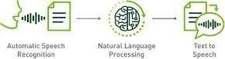

Fig 6.1 Natural Language Processing

* **Speech Recognition**: NLP enables the system to convert spoken language into text. This involves processing audio inputs and transcribing them into understandable text data.
* **Entity Recognition**: NLP can identify specific entities mentioned in the user's query, such as the amount of money to withdraw, account numbers, or transaction types.
* **Natural Language Understanding (NLU)**: This involves parsing and comprehending the meaning behind user queries. NLU helps in extracting actionable

information from the user's input.

* **Language Generation**: Beyond understanding, NLP can also be used to generate natural language responses back to the user. This could involve confirming actions, providing transaction summaries, or handling error messages.
* **Dialogue Management**: NLP helps in managing the flow of conversation, keeping track of context, and maintaining a coherent dialogue between the user and the system.

### DIALOG MANAGEMENT

Dialogue management is the module that controls the flow and logic of the conversation between the user and the voice assistant. It needs to be able to handle different scenarios, such as greeting, authentication, confirmation, error handling, and feedback. It also needs to adapt to the user's preferences, context, and emotions. Dialogue management can be implemented using various techniques, such as finite state machines, frame-based systems, or reinforcement learning.

* **Context Handling**: Dialogue managers need to keep track of the context of the conversation to understand the user's current intent and provide relevant responses. Context includes information like previous user inputs, system actions, and the overall state of the conversation.
* **Intent Recognition and State Tracking**: As the conversation progresses, the dialogue manager continuously interprets the user's intents and updates the dialogue state accordingly. This involves recognizing the purpose behind each user utterance and mapping it to predefined actions or states within the system.
* **Turn Taking and Utterance Management**: Dialogue managers handle the turn- taking mechanism, deciding when the system should respond to the user and what information or prompts to provide next. This involves managing the timing and sequence of interactions to maintain a natural and efficient conversation.
* **Error Handling and Recovery**: Dialogue managers need to handle errors gracefully, such as when the user's intent is unclear or when the system encounters difficulties in understanding the user input. Effective error handling involves strategies like clarification prompts, fallback mechanisms, or context-based recovery strategies.
* **Multi-Turn Dialogue Control**: In complex interactions (like banking transactions at an ATM); dialogue managers orchestrate multi-turn conversations, where the user

might perform a series of related actions (e.g., checking balance, transferring funds). The manager needs to guide the conversation flow through these steps smoothly.

* **Personalization and Adaptation**: Advanced dialogue management systems can adapt to individual user preferences and behaviour over time. They may incorporate user history and feedback to personalize the conversation experience and improve user satisfaction.

### SPEECH SYNTHESIS

Speech synthesis is the module that converts the voice assistant's text output into speech. It needs to be natural, expressive, and intelligible. It also needs to match the voice assistant's personality, tone, and style. Speech synthesis can be implemented using various techniques, such as concatenative synthesis, parametric synthesis, or neural network synthesis.

* **Output Generation**: When the voice assistant needs to respond to a user's query or provide information, speech synthesis converts pre-defined text responses into natural-sounding speech. This allows the ATM system to communicate transaction details, account balances, or prompts for further actions audibly to the user.
* **Enhancing Accessibility**: Speech synthesis makes ATMs more accessible to users who may have difficulty reading text on screens. By converting information into spoken language, the voice assistant ensures that all users, including those with visual impairments, can interact effectively with the ATM.
* **Natural Interaction**: Voice assistants powered by speech synthesis offer a more natural and intuitive interaction experience.
* **Guided Instructions**: Speech synthesis can provide step-by-step instructions for ATM transactions, guiding users through the process verbally. This can be particularly useful for users who are unfamiliar with the ATM interface or need assistance during complex transactions.
* **Error Handling and Confirmation**: Speech synthesis helps in conveying important messages such as transaction confirmations, errors, or prompts for further actions audibly. This ensures that users receive immediate feedback and understand the status of their transactions without relying solely on screen displays.

### VOICE GUIDANCE

Voice Guidance ATM is a feature that allows customers with visual impairments or other disabilities to use an automated teller machine (ATM) with audio instructions. The feature can be activated by plugging in a headset to the ATM's audio jack, or by pressing a button on the keypad. The voice guidance will then guide the customer through the steps of using the ATM, such as inserting the card, entering the PIN, selecting the transaction type, and confirming the amount. The voice guidance will also provide feedback on the status of the transaction. The (tts) text to speech , voice library is used to make this system work.

* **Transaction Assistance**: Voice guidance provides step-by-step instructions to users for performing various ATM transactions such as cash withdrawals, balance inquiries, fund transfers, bill payments, and more. Users can interact with the ATM by speaking commands and receiving verbal prompts and confirmations.
* **Accessibility**: Voice guidance makes ATMs more accessible to individuals with visual impairments or those who prefer audio-based interactions. By using spoken instructions, users can navigate through different options and complete transactions without needing to read the screen.
* **User Authentication**: Voice assistants can verify user identity using voice biometrics or by prompting the user to enter a PIN or answer security questions verbally. This ensures secure access to the ATM's functionalities.
* **Transaction Confirmation**: After each transaction, the voice assistant provides verbal confirmation of the action taken, the amount transacted, and the remaining balance if applicable. This helps users verify their transactions and ensures accuracy.

### USER INTERFACE

An ATM interface UI is the graphical user interface that allows customers to interact with an automated teller machine (ATM). The UI design should be clear, intuitive, and secure, as well as consistent with the brand identity of the bank or financial institution. Some of the key elements of an ATM interface UI are:

* A welcome screen that greets the customer and prompts them to insert their card or scan their QR code.
* A language selection screen that allows the customer to choose their preferred language from a list of options.
* A PIN entry screen that asks the customer to enter their personal identification number (PIN) using a keypad or a touchscreen. The UI should provide feedback on the number of digits entered and mask the PIN for security purposes.

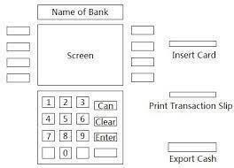

Fig 6.2 ATM User Interface

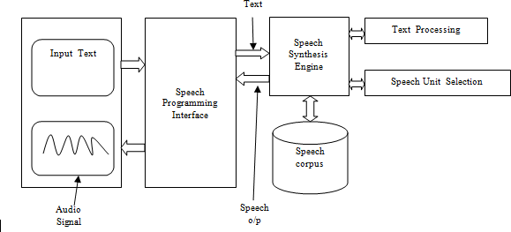Fig 6.3 Voice Assistant Process

### TRANSACTION

An ATM transaction is a process of withdrawing or depositing money from an automated teller machine (ATM) using a debit or credit card. An ATM transaction typically involves the following steps:

The user insert the card into the ATM and enters their personal identification number (PIN).

* + - The ATM verifies the card and PIN and connects to the user's bank or card issuer.
    - The ATM displays the available options for the user, such as checking balance, withdrawing cash, depositing cash or checks, transferring funds, etc.
    - The user selects the desired option and follows the instructions on the screen.
    - The ATM performs the transaction and prints a receipt for the user.
    - The ATM returns the card to the user and ends the session.
    - The user activates the voice assistant on their smartphone or a dedicated device and commands it to initiate a transaction at an ATM.
    - The voice assistant may prompt the user for authentication, typically through voice biometrics or a secondary method like a PIN or fingerprint scan on their smartphone.
    - The user specifies the type of transaction they want to perform, such as withdrawal, deposit, balance inquiry, or transfer.
    - The user provides specific details related to the transaction, such as the amount to withdraw or deposit, the account to transfer funds from or to, or any other relevant information.
    - Once the transaction details are confirmed, the voice assistant communicates with the ATM system, either through a direct connection or via an intermediary platform. The ATM processes the transaction based on the instructions received.
    - The user receives confirmation of the transaction status through the voice assistant, which may include details like the amount withdrawn, the new account balance, or a transaction reference number.
    - The user can then choose to perform additional transactions, end the session, or take other actions as needed.
    - The users can use voice commands to quickly access emergency services or contact their bank's customer support team directly from the ATM, ensuring prompt assistance and support when needed most.
    - Voice assistants can offer contextual assistance during transactions by providing relevant information or guidance based on the user's current location, time of day, or transaction history, ensuring a more personalized and intuitive banking experience.

## CHAPTER 7

**TESTING AND IMPLEMENTATION**

### SYSTEM TESTING

System testing is a type of software testing that evaluates the overall functionality and performance of a complete and fully integrated software solution. It tests if the system meets the specified requirements and if it is suitable for delivery to the end-users. This type of testing is performed after the integration testing and before the acceptance testing. System Testing is a type of [software testing](https://www.geeksforgeeks.org/software-testing-basics/) that is performed on a complete integrated system to evaluate the compliance of the system with the corresponding requirements. In system testing, integration testing passed components are taken as input. The goal of integration testing is to detect any irregularity between the units that are integrated together.

System testing detects defects within both the integrated units and the whole system. The result of system testing is the observed behavior of a component or a system when it is tested. System Testing is carried out on the whole system in the context of either system requirement specifications or functional requirement specifications or in the context of both. System testing tests the design and behavior of the system and also the expectations of the customer. It is performed to test the system beyond the bounds mentioned in the [software](https://www.geeksforgeeks.org/software-engineering-quality-characteristics-of-a-good-srs/) [requirements specification (SRS).](https://www.geeksforgeeks.org/software-engineering-quality-characteristics-of-a-good-srs/) System Testing is basically performed by a testing team that is independent of the development team that helps to test the quality of the system impartial. It has both functional and non-functional testing. System Testing is a black-box testing. System Testing is performed after the integration testing and before the acceptance testing.

* + - **Test Environment Setup:** Create testing environment for the better quality testing.
    - **Create Test Case:** Generate test case for the testing process.
    - **Create Test Data:** Generate the data that is to be tested.
    - **Execute Test Case:** After the generation of the test case and the test data, test cases are executed.
    - **Defect Reporting:** Defects in the system are detected.

### UNIT TESTING

### Unit testing is a software testing technique where individual units or components of a software application are tested independently to ensure they behave as expected. Its features include:

### Isolation: Tests are conducted on individual units in isolation, ensuring that any failures are localized and easy to identify.

### Automation: Unit tests are typically automated, allowing for quick and frequent testing without manual intervention.

### Repeatability: Unit tests should produce the same result every time they are run, providing consistent feedback on the correctness of the unit.

### Fast Execution: Unit tests are designed to be fast, enabling developers to run them frequently during development to catch issues early.

### Coverage: Unit tests aim to cover all possible scenarios for a unit, ensuring comprehensive testing of its functionality.

### INTEGERATION TESTING

### Integration testing is a software testing technique where individual units or components are combined and tested as a group to ensure they interact correctly. Its features include:

### Testing Interactions: Integration tests focus on testing the interactions and interfaces between different components or modules of a system.

### Identifying Interface Issues: Integration tests help identify issues such as data format mismatches, communication problems, or compatibility issues between components.

### End-to-End Scenarios: Integration tests often involve testing end-to-end scenarios, simulating how different parts of the system work together to accomplish a task.

### Dependency Management: Integration tests verify that dependencies between components are managed properly and that changes to one component do not adversely affect others.

### Realistic Environment: Integration tests are conducted in a realistic environment compared to unit tests, where components are tested in isolation. This helps uncover issues that may only arise when components interact in a real-world setting.

### IMPLEMENTATION

Implementation is the realization of a design so that it can be executed on a computer. This includes the realization of: the system's classes; the user interface; and the database structures. Testing comprises all activities to accomplish a satisfactory level of confidence that the system under development fulfills it intended purpose. Objects of testing can be documents (such as specifications) or software (such as a module). The goal of testing is to find errors and remove the causes of the errors.

Testing and implementation are obviously closely connected. If a concept is to be executed on a computer, as the definition of “implementation” states, then the implementation must run without errors, otherwise the concept has not been implemented (or at least not correctly implemented). In practice, implementation and testing go hand- in-hand. In the blood bank automation the system test cases are done with the admin, donor, receptor. All these are tested with the expected results and it was obtained. Based on the search results, here are the steps to implement a voice assistant,

* Understand the need for a voice assistant in an ATM system, especially for visually impaired people.
* Design and develop a talking ATM system that provides audio components using either pre-recorded speech corpus or through a speech synthesis engine.
* Provide language selection, volume level selection, screen visibility options, and ATM machine orientation before starting the ATM operations.
* Synchronize the screen text and audio.
* Use concatenated-based text-to-speech system to generate audio components.
* Enable deployed ATMs with talking features without changing the complete software.
* Use a speech application interface to handle the synchronization of text on the screen and audio.
* Use a microphone to capture sound waves and generate electrical impulses, and a soundcard to convert the voice signal into a digital signal.
* Use speech synthesis and speech recognition for interaction with the ATM system instead of a standard keypad or touch screen.

## CHAPTER 8 CONCLUSION AND FUTURE SCOPE

### CONCLUSION

The Voice-Assisted Automated Teller Machine System stands as a beacon of innovation and inclusion in the world of banking technology. Its introduction has heralded a new era of accessibility, ensuring that every individual, regardless of their abilities or literacy, can engage with the financial world confidently and independently. With its user-friendly interface, natural voice guidance, and speech recognition capabilities, the ATM System has not only broken down barriers but also enhanced the overall banking experience. It empowers individuals with visual impairments, reduces the reliance on written instructions, and streamlines ATM transactions for all users. In a rapidly evolving technological landscape, the VATM System serves as a testament to the financial industry's dedication to ensuring that banking services are universally accessible. As we move forward, this remarkable system paves the way for greater financial inclusion, promising a future where all can manage their finances with ease and dignity.

### FUTURE SCOPE

The future scope for ATM voice assistants is promising, as it can enhance user experiences, improve accessibility, and provide greater security. Here are some potential developments and opportunities for ATM voice assistants:

### Improved User Experience:

* + Enhanced Natural Language Processing (NLP) and speech recognition technology will enable more intuitive and user-friendly interactions with ATMs.
  + Personalization features could provide tailored recommendations and services based on user preferences and history.

### Accessibility:

* + ATM voice assistants can play a crucial role in making banking services more accessible to individuals with disabilities, such as those with visual impairments or limited dexterity.
  + Integration with screen reading software and compatibility with various assistive

devices can further improve accessibility.

### Multilingual Support:

* + ATM voice assistants can be expanded to support multiple languages, catering to diverse customer bases in different regions.
  + This can also include regional dialects and accents for more accurate communication.

### Enhanced Security:

* + Biometric authentication methods, such as voice recognition, can add an extra layer of security to ATM transactions.
  + Continuous improvements in voice biometrics technology can make it even more reliable for authentication.

### Advanced Transaction Features:

* + Voice assistants can be integrated with more advanced banking services, such as fund transfers, bill payments, and account management.
  + This can reduce the need for physical visits to bank branches and enhance self-service capabilities.

### Multilingual and Global Support:

* + Language Expansion: Supporting an even wider array of languages and dialects to cater to the diverse global population.
  + Cross-Border Transactions: Allowing travelers and international users to access their accounts and conduct transactions conveniently in different countries.

### User Feedback and Continuous Improvement:

* + Feedback Loops: Establishing efficient channels for users to provide feedback, which can drive ongoing improvements in voice assistant ATM systems.
  + AI Learning and Adaptation: Implementing machine learning to make voice assistants more adaptive to user behavior and preferences.

## APPENDICES

**SOURCE CODE**

# importing speech recognition package from google import speech recognition as

import play sound # to play saved mp3 filefrom gtts import gTTS # google text to speechimport # to save/open files

import wolframalpha # to calculate strings into formula

from selenium import webdriver # to control browser operations

num = 1def

assistant_speaks(o utput):global num

# num to rename every audio file # with different name to remove ambiguitynum += 1 print("PerSon : ", output)

toSpeak = gTTS(text = output, lang ='en', slow

= False)# saving the audio file given by google text tospeech file = str(num)+".mp3 toSpeak.save(file)

ildef

# play sound package is used to play the same file.play sound. playsound(file, True)

os.remove(f

get_audio():

rObject = sr.Recognizer()audio

=''

with sr.Microphone() as source: print("Speak...")

# recording the audio using speech recognition audio = rObject.listen(source, phrase_time_limit =

5)print("Stop.") # limit 5 secs try:

text = rObject.recognize_google(audio, language ='en- US')print("You : ", text)

return text

except:

assistant_speaks("Could not understand your audio, PLease try again

!")return 0

if name == " main ": assistant_speaks("What's your name,Human?")name ='Human' name = get_audio() assistant_speaks("Hello, " + name + '.')

while(1):

assistant_speaks("What can i do for you?")text = get_audio().lower()

if text == 0:

continue

if "exit" in str(text) or "bye" in str(text) or "sleep" in str(text): assistant_speaks("Ok bye, "+ name+'.')

break

# calling process text to process the query process_text(text)

### PYTHON CODE :

import os

from flask import Flask, render_template, request, redirect, url_forimport json app = Flask(nam e)from bot import *

@app.route('/')def index():

return render_template('index.html', selected_language=default_language) @app.route('/set_language', methods= ['POST']) def set_language():

global default_language

selected_language = request.form['language']default_language = selected_language return redirect(url_for ('greeting', language=selected_language)) @app.route('/bot/<language>')def greeting(language):

return render_template('bot.html', selected_language=language) @app.route("/get", methods= ["POST"])def chatbot_response():

msg = request.form["msg"]

# Load and process the intents JSON filedata_file = open(r"intents.json").read() intents = json.loads(data_file)

# Rest of your existing code

if msg.startswith('my name is'):name = msg[11:]

ints = predict_class(msg, model) res1 = getResponse(ints, intents) res = res1.replace("{n}", name)

elif msg.startswith('hi my name is'):name = msg[14:]

ints = predict_class(msg, model) res1 = getResponse(ints, intents) res = res1.replace("{n}", name)

else:

ints = predict_class(msg, model)res = getResponse(ints, intents) # word_to_translate = "Hello"

# target_language = "English"audio_file = 'output.mp3'

if default_language == "English":text_to_audio(res, lang='en') if text_to_audio(res, lang='en'):if os.path.exists(audio_file): play_adio(audio_file)os.remove(audio_file)

else:

print("Error: Audio file not found.")return res

elif default_language == "Hindi":target_language = 'hi' translated_word = translate_word(res, target_language) text_to_audio(translated_word, lang='hi') # 'hindi'

# Check if the file exists

if text_to_audio(res, lang='hi'):if os.path.exists(audio_file): play_audio(audio_file)os.remove(audio_file)

else:

print("Error: Audio file not found.")

print(f"{res} in {target_language} is: {translated_word}")return translated_word elif default_language == "Tamil":target_language = 'ta'

translated_word = translate_word(res, target_language)# text_to_audio(translated_word, lang='ta')

# text_to_audio(translated_word, lang='hi') # 'hindi'# Check if the file exists if text_to_audio(translated_word, lang='hi'):if os.path.exists(audio_file): play_audio(audio_file)os.remove(audio_file)

else:

print("Error: Audio file not found.")

print(f"{res} in {target_language} is: {translated_word}")return translated_word # return res

if name == ' main ': app.run(debug=True,port=7074)

### CHAT BOT CODE :

# libraries import random

import numpy as npimport pickle

import json

from flask import Flask, render_template, request from flask_ngrok import

run_with_ngrokimport nltk

from keras.models import load_model from nltk.stem import WordNetLemmatizerlemmatizer = WordNetLemmatizer()

# chat initialization

model = load_model("chatbot_model.h5") # intents = json.loads(open("intents.json").read()) data_file = open(r"intents.json").read() words = pickle.load(open("words.pkl", "rb")) classes = pickle.load(open("classes.pkl", "rb"))

# chat functionalities

def clean_up_sentence(sentence):

sentence_words = nltk.word_tokenize(sentence)

sentence_words = [lemmatizer.lemmatize(word.lower()) for word in sentence_words]return sentence_words

# return bag of words array: 0 or 1 for each word in the bag that exists in the sentencedef bow(sentence, words, show_details=True):

# tokenize the pattern

sentence_words = clean_up_sentence(sentence) # bag of words - matrix of N words, vocabulary matrixbag = [0] * len(words)

for s in sentence_words: for i, w in

enumerate(words):if w == s:

# assign 1 if current word is in the vocabulary positionbag[i] = 1

if show_details:

print("found in bag: %s" % w)return np.array(bag)

def predict_class(sentence, model):

# filter out predictions below a threshold

p = bow(sentence, words, show_details=False)res = model.predict(np.array([p]))[0]

ERROR_THRESHOLD = 0.25

results = [[i, r] for i, r in enumerate(res) if r > ERROR_THRESHOLD]# sort by strength of probability results.sort(key=lambda x: x[1],

reverse=True)return_list = []

for r in results:

return_list.append({"intent": classes[r[0]], "probability": str(r[1])})return return_list

def getResponse(ints, intents_json):tag = ints[0]["intent"] list_of_intents = intents_json["intents"]for i in list_of_intents:

if i["tag"] == tag: result =

random.choice(i["responses"]) break

return result

from googletrans import Translator def translate_word(word,

target_language='en'):translator = Translator()

translation = translator.translate(word, dest=target_language)return translation.text

# word_to_translate = "Hello"

# target_language = "ta" # Change this to the language code you want, e.g., 'es' for Spanish#

# translated_word = translate_word(word_to_translate, target_language)

# print(f"{word_to_translate} in {target_language} is: {translated_word}")

from gtts import gTTSimport os

def text_to_audio(text, lang='en'): tts = gTTS(text=text, lang=lang,

slow=False)try: os.remove("output.m

p3")except: pass

tts.save("output.m p3")

# os.system("mpg321 output.mp3") # For Linux# os.system("start output.mp3") #

For Windows return True

import pygame

import pygame

def play_audio(audio_file):pygame.init() pygame.mixer.init()

try:

pygame.mixer.music.load(audi o_file)print("Playing audio...") pygame.mixer.music.play()

while pygame.mixer.music.get_busy(): pygame.time.Clock().tick(10)

except Exception as e: print("Error playing audio:", e)

finally: pygame.mixer.music.st op()pygame.quit()

# if name == " main ":

# audio_file = "path_to_your_audio_file.mp3" # Replace with the path to your audio file# play_audio(audio_file)

### CHAT BOT FRONT END DESIGN :

<!DOCTYPE html>

<html lang="en">

<head>

<meta charset="UTF-8">

<meta name="viewport" content="width=device-width, initial-scale=1.0">

<title>ATM Assistant ChatBot</title>

<style>

body {

font-family: 'Arial', sans-serif;

background: rgba(255, 255, 255, 0.5) url ('/static/secondpage.jpg') no-repeat center center fixed;background-size: cover;

padding: 5px 10px;color:

#333; display:

flex;

align-items:

center;

color: #FF0000; text-align: center;

}

form {

margin-top: 20px;

}

label {

color: #3498db; font- weight: bold;

}

select { padding: 5px; font- size: 16px;

border: 1px solid #3498db;border- radius: 4px;

}

button { background-color:

#3498db;color: #fff; padding: 5px 10px;border:

none; border- radius: 4px; cursor: pointer;

}

#chatbox { max-height: 300px; overflow-y: auto;

}

}

Input text { width: 70%; padding: 5px; font- size: 16px;

border: 1px solid #3498db;border- radius: 4px;

}

#send {

margin-left: 10px;

}

</style>

</head>

<body>

<div class="row">

<div class="col-md-10 mr-auto ml-auto">

<h1>ATM Assistant ChatBot</h1>

<form>

<div id="chatbox">

<div class="col-md-8 ml-auto -auto text-center">

<p class="bot Text"><span>Hi! I'm Your assistant.</span></p>

</div>

</div>

<div id="user Input" class="row">

<div class="col-md-10">

<input id="text" type="text" name="msg" placeholder="Message" class="form- control">

<button type="submit" id="send" class="btn btn-warning">Send</button>

</div>

</div>

</form>

</div>

</div>

<script src="https://ajax.googleapis.com/ajax/libs/jquery/3.2.1/jquery.min.js"></script>

<script>

$(document).ready(function() {

});

$.ajax({ data: {

msg: raw Text,

},

type: "POST",

url: "/get",

}).done(function(data) {

var bot Html = '<p class="bot Text"><span>' + data + "</span></p>";

$("#chatbox").append($.parseHTML(botHtml))

; document.getElementById("user Input").scrollIntoView({

block: "start", behavior:

"smooth",

});

});

event.preventDefault();

});

});

</script>

</body>

</html>

### CHAT BOT INDEX PAGE DESIGN :

<!DOCTYPE html>

<html lang="en">

<head>

<meta charset="UTF-8">

<meta name="viewport" content="width=device-width, initial-scale=1.0">

<title>Language Selection</title>

<style>

body {

font-family: 'Arial', sans-serif;

background-image: url('/static/firstpage.jpg'); /* Replace with your actual image URL */background-size: cover;

background-repeat: no- repeat;color: #333;

}

h1 {

color: #3498db;

}

p {

color: #FF0000; margin-bottom: 20px;font-size: 16px;

}

form {

margin-bottom: 20px;

}

label {

color: #3498db; font- weight: bold;

}

select { padding: 5px; font- size: 16px;

border: 1px solid #3498db;border- radius: 4px;

}

button { background-color:

#3498db;color: #fff; padding: 5px

10px;border:

none; border- radius: 4px; cursor: pointer;

}

bottom: 0;

width: 100%; background-color: #f2f2f2;padding:

10px;

box-shadow: 0px 0 px 10px rgba(0, 0, 0, 0.1);text-align: center;

}

.social-links a { display: inline- block;margin: 0 10px; color: #3498db;

text-decoration: none;font-size: 20px;

}

.social-links img {

width: 30px; /* Adjust the size as needed */ height: 30px; /* Adjust the size as needed */margin: 0 10px;

}

</style>

</head>

<body>

<div class="container">

<h1>Welcome!</h1>

<p>Select your preferred language:</p>

<form action="/set_language" method="post">

<label for="language">Language:</label>

<select name="language" id="language">

<option value="English" {% if selected_language =='English' %}selected{% endif

%}>English</option

>

<option value="Tamil" {% if selected_language =='Tamil' %}selected{% endif

%}>Tamil</option>

<option value="Hindi" {% if selected_language =='Hindi' %}selected{% endif

%}>Hindi</option>

</select>

<button type="submit">Set Language</button>

</form>

<!-- <p class="bot">bot in {{ selected_language }}: {% if selected_language == 'English'

%}Hello!{% elif selected_language == 'Spanish' %}¡Hola!{% endif %}</p> -->

</div>

<!-- Social Links -->

<div class="social-links">

<a href="https:/[/www.facebook.com/](http://www.facebook.com/)" target="_blank"><img src="/static/facebook.png"alt="Facebook"></a>

<a href="https://[www.linkedin.com/](http://www.linkedin.com/)" target="_blank"><img src="/static/linkedin.png"alt="LinkedIn"></a>

<a href="https://github.com/" target="_blank"><img src="/static/github.png" alt="GitHub"></a>

<a href="https://gmail.com/" target="_blank"><img src="/static/whatsapp.png" alt="Gmail"></a>

</div>

</body>

</html>

### JSON SOURCE CODE :

"intents": [{

"tag": "greetings",

"patterns": ["hi there", "hello","haroo","yaw","wassup", "hi", "hey", "holla", "hello"],"responses": ["hello thanks for checking in", "hi there, how can i help you"], "context": [""]

},

{

"tag": "goodbye",

"patterns": ["bye", "good bye", "see you later"], "responses": ["have a nice time, welcome back again", "bye bye"],"context": [""]

},

{

"tag": "thanks",

"patterns": ["Thanks", "okay","Thank you","thankyou", "That's helpful", "Awesome, thanks",

"Thanks for helping me", "wow", "great"],

"responses": ["Happy to help!", "Any time!","you're welcome", "My pleasure"], "context": [""]

"tag": "noanswer",

"patterns": [""],

"responses": ["Sorry, I didn't understand you", "Please give me more info", "Not sure I]

"tag": "check_balance",

"patterns": ["Check my balance", "What's my account balance", "Balance inquiry"], "responses": ["Sure, let me check your account balance for you.", "Checking your account balance.

Please wait."], "context": [""]

},

{

"tag": "withdrawal",

"patterns": ["Withdraw money", "ATM withdrawal", "Can I get cash"], "responses": ["Certainly, I can assist you with ATM withdrawals. Please specify the amount.",

"Ready to help you with your cash withdrawal. How much would you like to withdraw?"],"context": [""]

},

{

"tag": "transfer",

"patterns": ["Transfer funds", "Send money to another account", "Money transfer"], "responses": ["Sure, I can guide you through the process of transferring funds. Please provide the

necessary details.", "Transferring funds? Great! Let's get started."],"context": [""]

},

{

"tag": "deposit",

"patterns": ["Make a deposit", "Deposit money", "Add funds to account"], "responses": ["Sure, I can help you with making a deposit. Do you have cash or a check?", "Ready

to assist with your deposit. Please specify the amount and type of funds."],"context": [""]

},

{

"tag": "lost_card",

"patterns": ["Lost my ATM card", "Report lost card", "Stolen card"],

"responses": ["I'm sorry to hear that. Let's take steps to secure your account. Please provide your

account details.", "Oh no! Let's report your lost card and ensure the security of your account. Can youverify your identity?"],

"context": [""]

},

{

"tag": "pin_reset",

"patterns": ["Forgot ATM PIN", "Reset PIN", "Change my PIN"],

"responses": ["No worries! We can reset your ATM PIN. Please follow the instructions on the

screen or provide additional details for assistance.", "Happens to the best of us! Let's reset your ATM PIN.Can you confirm some account details for verification?"], "context": [""]

}

]

}

## SCREENSHOTS

Index Page of the Chat Bot with various Language Options

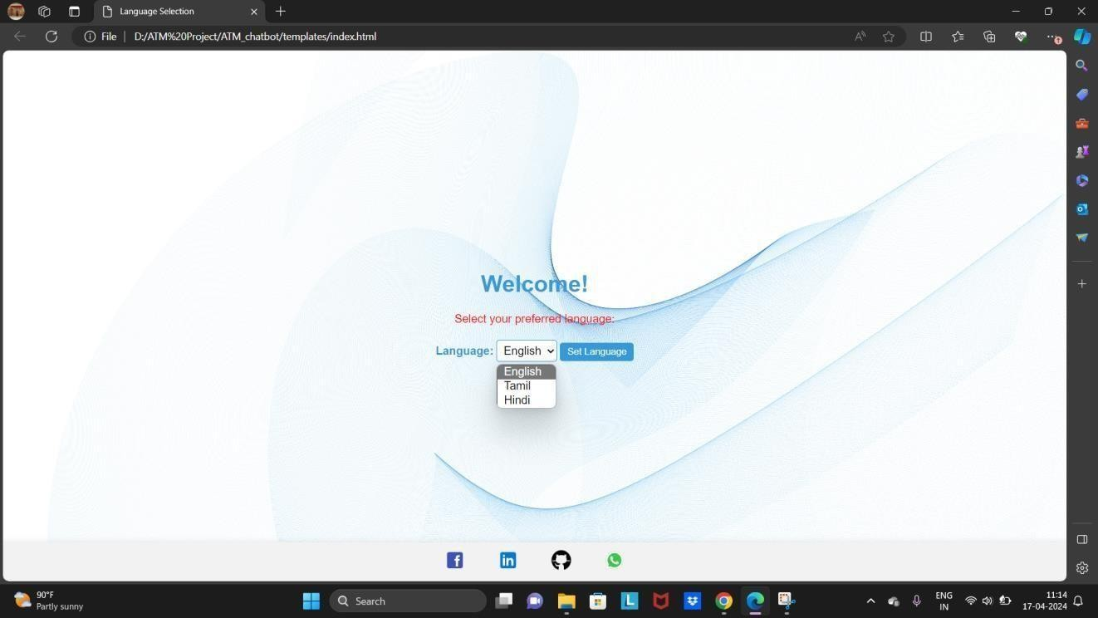

Interface of the ATM Chat Bot for User Queries

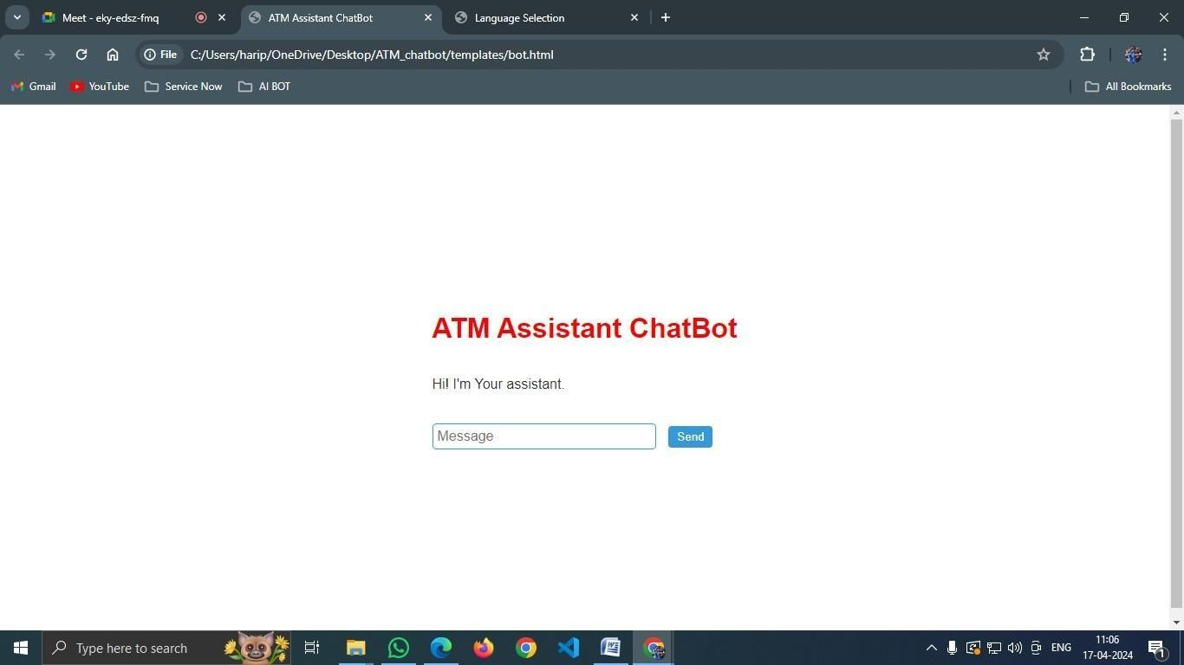

Develop an advanced ATM chatbot equipped with Tamil language capabilities

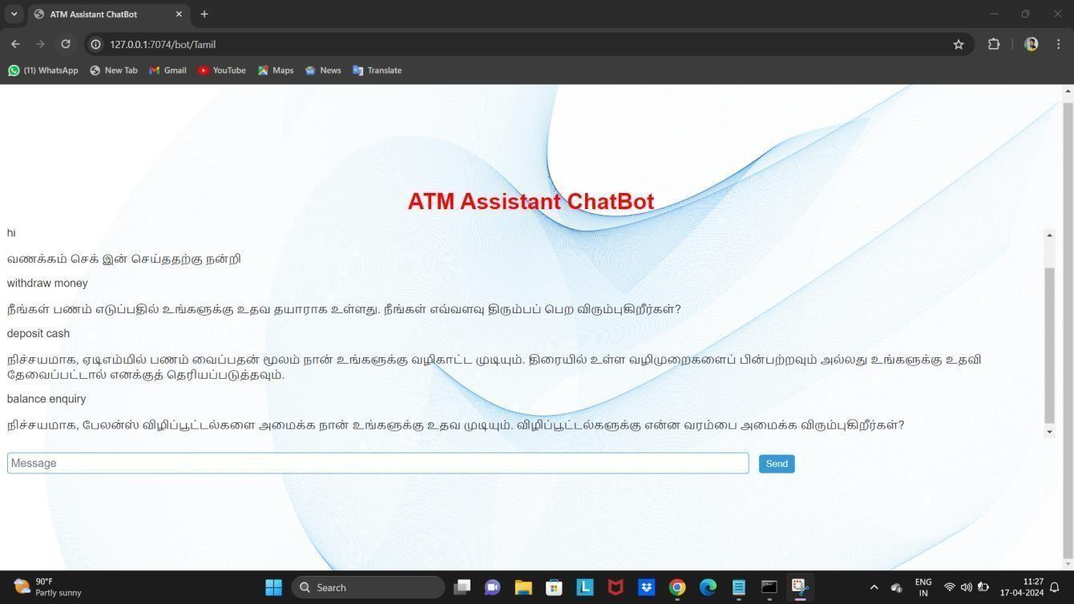

Develop an advanced ATM chatbot equipped with English language capabilities

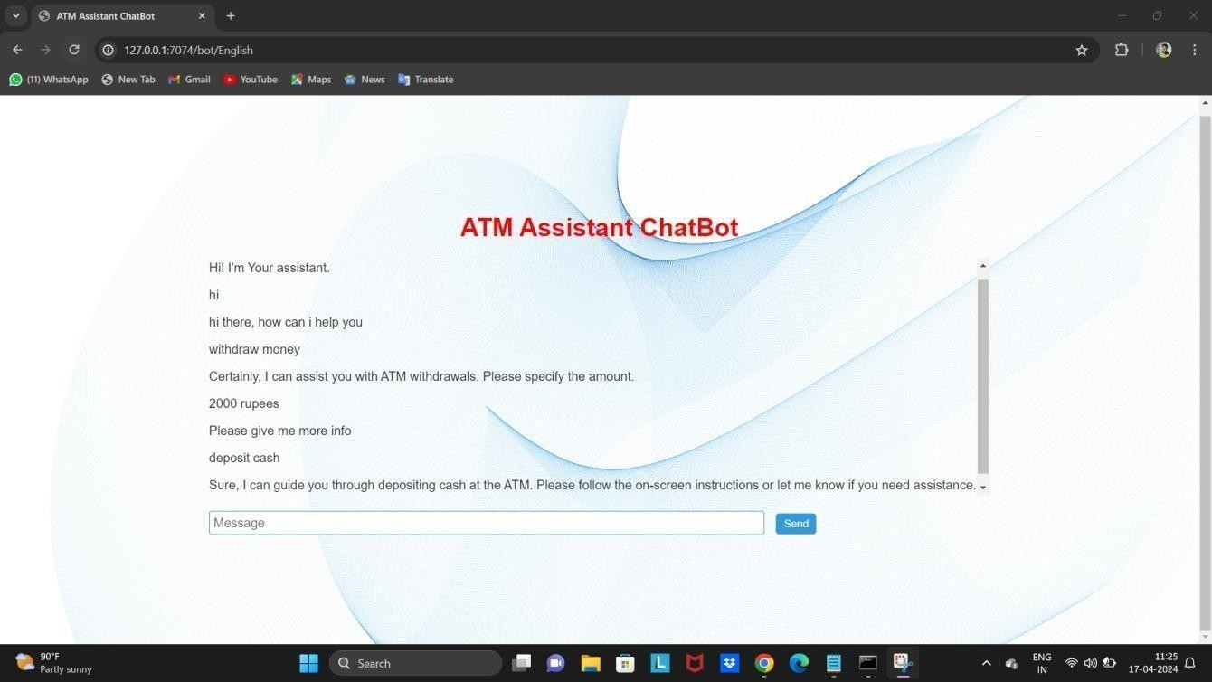

Develop an advanced ATM chatbot equipped with Hindi language capabilities

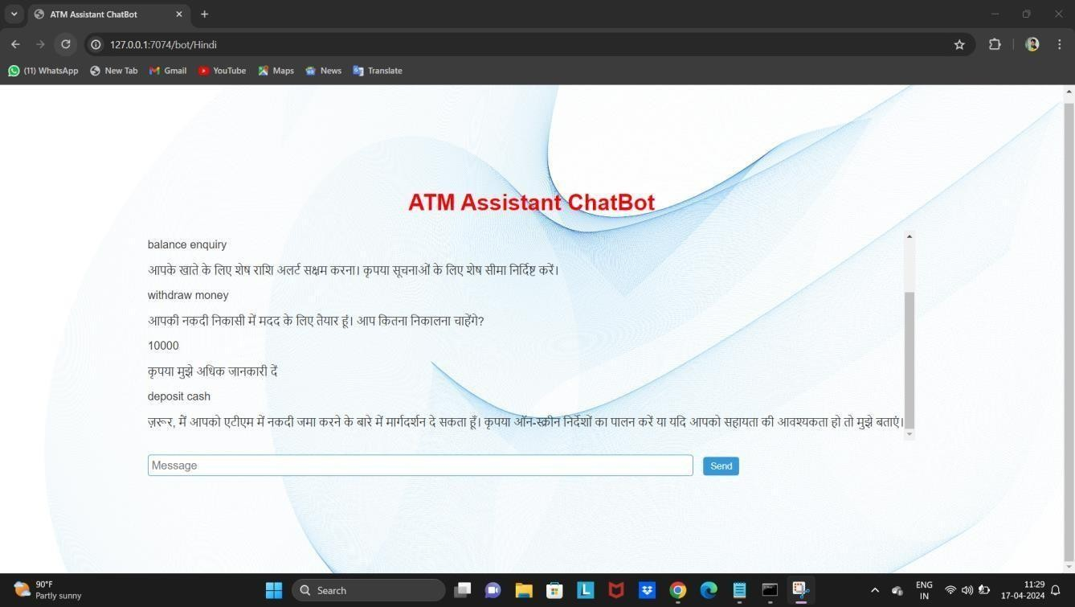

## REFERENCES

1. BatizLazo B, (2009), ‘Voice enabled atm machine with iris recognition for authentication’, Business History 51(1) Volume 350, Pp. 1–27.
2. Batiz-Lazo B., Reid R., (2008), ‘The ATIS spoken language systems pilot corpus’, IEEE History of Telecommunications Conference, Paris. volume 19(1) Pp. 177-205.
3. Damodar Magdum, Manisha Shukla Dubey, Tejaswini Patil, Ronak Shah, Swapnil Belhe, Mahesh Kulkarni, (2015), ‘Automated biometric voice-based access control in automatic teller machine’ IEEE Xplore, Spaces. volume 7 Pp. 657-660.
4. Itunuoluwa Isewon, Jelili Oyelade, Olufunke Oladipupo, (2014), ‘Design and Implementation of Text to Speech Conversion for Visually Impaired People’ International Journal of Applied Information Systems (Ijais), Foundation of Computer Science Fcs, NewYork, usa Volume 7, ISSN 2249-0864 pp. 1234-1239
5. Kishore, P.V.V., Prasad, M.V.D., Prasad, C.R. and Rahul, R., (2015), ‘Automated biometric voice based access control in automatic teller machine’, International Conference on Signal Processing and Communication Engineering, In Association with IEEE Pp. 34-38.
6. Karthik, G.V.S., Fathima, S.Y., Rahman, M.Z.U., Ahamed, S.R. And Lay- Ekuakille, A., (2013), ‘Efficient Signal Conditioning Techniques for Brain Activity in Remote Health Monitoring Network’, IEEE Sensors Journal, 13(9), pp. 3273- 3283.
7. Manoj kumar V, S Prathap, B. Gowtham, G. Sri ram, (2016), ‘Peaking atm Using Speech Synthesis’, International Journal of Contemporary Research in Computer Science and Technology (Ijcrcst) Volume 2, Issue 3 pp.1274-1289.
8. Marketa Juzovaand, Daniel Tihelka (2014), ‘Minimum Text Corpus Selection for Limited Domain Speech Synthesis’. International Conference on Text, Speech, and Dialogue, pp 398-407.
9. Ramkiran, D.S., Madhav, B.T.P., Prasanth, A.M., Harsha, N.S., Vardhan, V., Avinash, K., Chaitanya, M.N. and Nagasai, U.S., (2015), ‘Novel Compact Asymmetrical Fractal Aperture Notch Band Antenna’, Leonardo Electronic Journal of Practices and Technologies, Volume 4, pp. 1-12.
10. Umar Dahiru, Sangeetha Elango, Riyaz Ahamed A (2015), ‘System Design for Talking asstm for The Blind Users’, International Journal of Information System and Engineering, Volume 1, pp. 657-670.