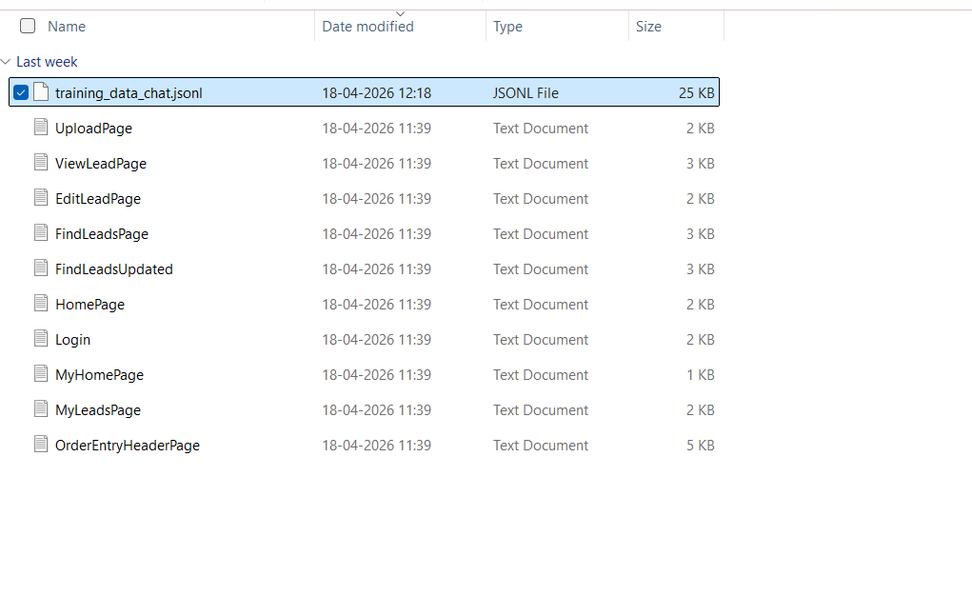
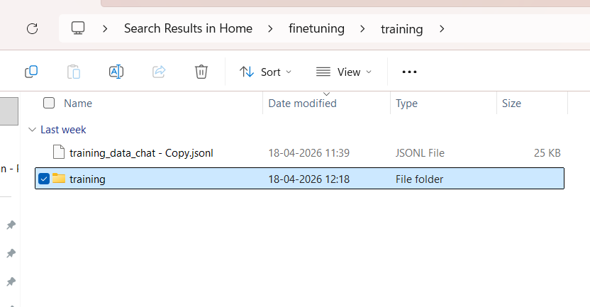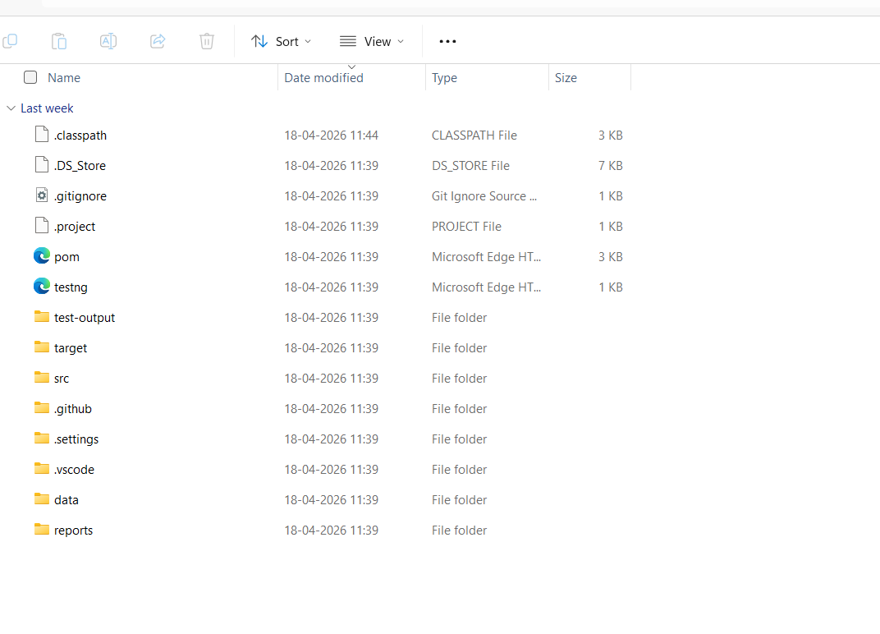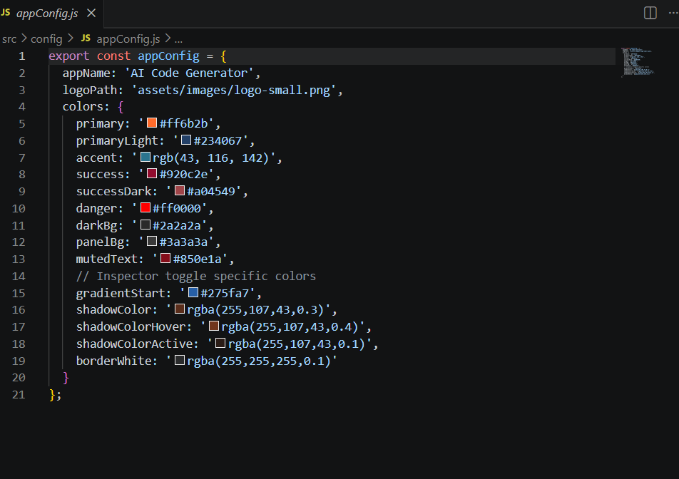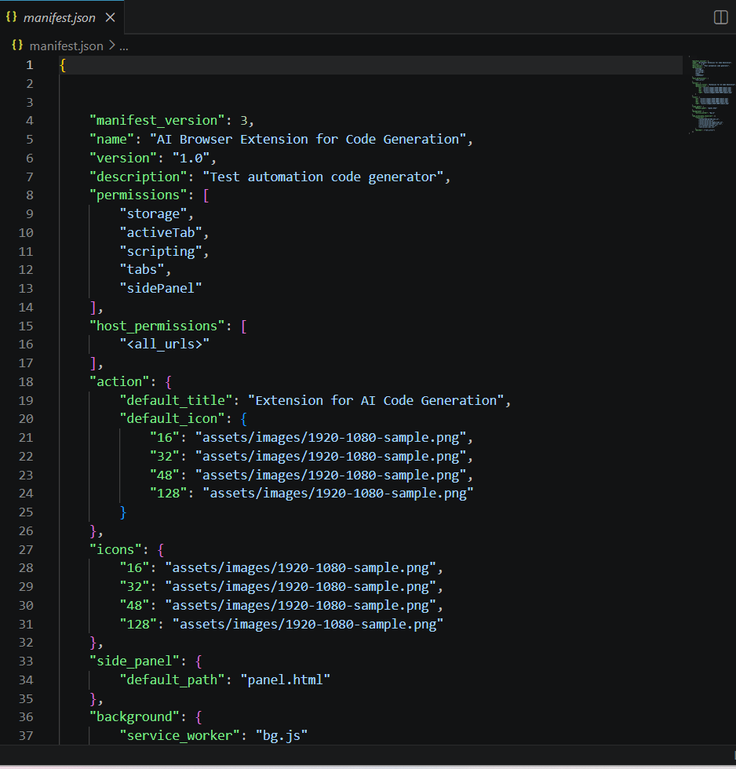

{"messages":[{"role":"system","content":"You are an expert in generating Selenium Java page object classes using provided DOM information. Follow the framework's guidelines: use SeleniumBase wrapper methods, proper locators, and insert TODO comments if a mapping is missing. Make sure every page method includes comments in your generated code as the training examples may not have comments"},{"role":"user","content":"Given the following DOM structure:\n```html\n<input type=\"text\" class=\"inputBox\" name=\"companyName\" size=\"30\" maxlength=\"100\" id=\"createLeadForm_companyName\">\n<input type=\"text\" class=\"inputBox\" name=\"firstName\" size=\"30\" maxlength=\"100\" id=\"createLeadForm_firstName\">\n<input type=\"text\" class=\"inputBox\" name=\"lastName\" size=\"30\" maxlength=\"100\" id=\"createLeadForm_lastName\">\n<input type=\"submit\" class=\"smallSubmit\" name=\"submitButton\" value=\"Create Lead\" id=\"ext-gen652\">\n```\nGenerate a Selenium Java page object class for this DOM."},{"role":"assistant","content":"package com.leaftaps.pages;\n\nimport com.framework.selenium.api.design.Locators;\nimport com.framework.testng.api.base.ProjectSpecificMethods;\n\n/**\n * Page object representing the Edit Lead page.\n * Provides methods to update lead details and submit changes.\n * @author Auto-generated\n */\npublic class EditLeadPage extends ProjectSpecificMethods {\n\n\t/**\n\t * Updates the company name in the Edit Lead form.\n\t * @param updcomnyName The new company name to enter\n\t * @return The current EditLeadPage instance\n\t */\n\tpublic EditLeadPage updateCompanyName(String updcomnyName) {\n\t\tclearAndType(locateElement(Locators.ID,\"updateLeadForm_companyName\"), updcomnyName);\n\t\treportStep(updcomnyName +\"Updated company name is entered successfully \", \"pass\");\n\t\treturn this;\n\t}\n\n\t/**\n\t * Clicks the Update button to submit the changes.\n\t * @return A new ViewLeadPage instance\n\t */\n\tpublic ViewLeadPage clickUpdateSubmit() {\n\t\tclick(locateElement(Locators.CLASS_NAME,\"smallSubmit\"));\n\t\treturn new ViewLeadPage();\n\t}\n\n}"}]}
{"messages":[{"role":"system","content":"You are an expert in generating Selenium Java page object classes using provided DOM information. Follow the framework's guidelines: use SeleniumBase wrapper methods, proper locators, and insert TODO comments if a mapping is missing. Make sure every page method includes comments in your generated code as the training examples may not have comments"},{"role":"user","content":"Given the following DOM structure:\n```html\n<input type=\"text\" size=\"20\" autocomplete=\"off\" id=\"ext-gen246\" name=\"id\" class=\" x-form-text x-form-field \" style=\"width: 214px;\"> \n<input type=\"text\" size=\"20\" autocomplete=\"off\" id=\"ext-gen248\" name=\"firstName\" class=\" x-form-text x-form-field \" style=\"width: 214px;\"> \n<input type=\"text\" size=\"20\" autocomplete=\"off\" id=\"ext-gen250\" name=\"lastName\" class=\" x-form-text x-form-field \" style=\"width: 214px;\"> \n<input type=\"text\" size=\"20\" autocomplete=\"off\" id=\"ext-gen252\" name=\"companyName\" class=\" x-form-text x-form-field \" style=\"width: 214px;\"> \n<button class=\"x-btn-text\" type=\"button\" id=\"ext-gen334\">Find Leads<\/button>\n```\nGenerate a Selenium Java page object class for this DOM."},{"role":"assistant","content":"package com.leaftaps.pages;\n\nimport com.framework.selenium.api.design.Locators;\nimport com.framework.testng.api.base.ProjectSpecificMethods;\n\n\n/**\n * Page object representing the Find Lead page.\n * Provides methods to search for leads and interact with search results.\n * @author Auto-generated\n */\npublic class FindLeadPage extends ProjectSpecificMethods {\n\n\t/**\n\t * Enters the first name in the Find Lead form.\n\t * @param findfirstname The first name to search for\n\t * @return The current FindLeadPage instance\n\t */\n\tpublic FindLeadPage enterLeadName(String findfirstname) {\n\t\tclearAndType(locateElement(Locators.XPATH,\"(//input[@name='firstName'])[3]\"), findfirstname);\n\t\treportStep(findfirstname +\" first name is entered successfully\", \"pass\");\n\t\treturn this;\n\t}\n\n\t/**\n\t * Enters the lead ID in the Find Lead form.\n\t * @param id The lead ID to search for\n\t * @return The current FindLeadPage instance\n\t */\n\tpublic FindLeadPage enterLeadID(String id) {\n\t\tclearAndType(locateElement(Locators.NAME,\"id\"), id);\n\t\treportStep(id +\" first name is entered successfully\", \"pass\");\n\t\treturn this;\n\t}\n\n\t/**\n\t * Clicks the Find Leads button to perform the search.\n\t * @return The current FindLeadPage instance\n\t */\n\tpublic FindLeadPage clickFindleadsButton() {\n\t\tclick(locateElement(Locators.XPATH,\"//button[text()='Find Leads']\"));\n\t\treportStep(\"FindLeads Button is clicked\", \"pass\");\n\t\treturn this;\n\t}\n\n\n}"}]}
{"messages":[{"role":"system","content":"You are an expert in generating Selenium Java page object classes using provided DOM information. Follow the framework's guidelines: use SeleniumBase wrapper methods, proper locators, and insert TODO comments if a mapping is missing. Make sure every page method includes comments in your generated code as the training examples may not have comments"},{"role":"user","content":"Given the following DOM structure:\n```html\n<input type=\"text\" size=\"20\" autocomplete=\"off\" id=\"ext-gen253\" name=\"id\" class=\" x-form-text x-form-field\" style=\"width: 214px;\">\r\n<input type=\"text\" size=\"20\" autocomplete=\"off\" id=\"ext-gen255\" name=\"firstName\" class=\" x-form-text x-form-field\" style=\"width: 214px;\">\r\n<input type=\"text\" size=\"20\" autocomplete=\"off\" id=\"ext-gen253\" name=\"id\" class=\" x-form-text x-form-field\" style=\"width: 214px;\">\r\n<input type=\"text\" size=\"20\" autocomplete=\"off\" id=\"ext-gen253\" name=\"id\" class=\" x-form-text x-form-field\" style=\"width: 214px;\">\r\n<button class=\"x-btn-text\" type=\"button\" id=\"ext-gen341\">Find Leads<\/button>\n```\nGenerate a Selenium Java page object class for this DOM."},{"role":"assistant","content":"package com.leaftaps.pages;\r\n\r\nimport com.framework.selenium.api.design.Locators;\r\nimport com.framework.testng.api.base.ProjectSpecificMethods;\r\n\r\n\r\n/**\r\n * Page object representing the Find Lead page.\r\n * Provides methods to search for leads and interact with search results.\r\n * @author Auto-generated\r\n */\r\npublic class FindLeadPage extends ProjectSpecificMethods {\r\n\r\n\t/**\r\n\t * Enters the first name in the Find Lead form.\r\n\t * @param findfirstname The first name to search for\r\n\t * @return The current FindLeadPage instance\r\n\t */\r\n\tpublic FindLeadPage enterLeadName(String findfirstname) {\r\n\t\tclearAndType(locateElement(Locators.XPATH,\"(//input[@name='firstName'])[3]\"), findfirstname);\r\n\t\treportStep(findfirstname +\" first name is entered successfully\", \"pass\");\r\n\t\treturn this;\r\n\t}\r\n\r\n\t/**\r\n\t * Enters the lead ID in the Find Lead form.\r\n\t * @param id The lead ID to search for\r\n\t * @return The current FindLeadPage instance\r\n\t */\r\n\tpublic FindLeadPage enterLeadID(String id) {\r\n\t\tclearAndType(locateElement(Locators.NAME,\"id\"), id);\r\n\t\treportStep(id +\" first name is entered successfully\", \"pass\");\r\n\t\treturn this;\r\n\t}\r\n\r\n\t/**\r\n\t * Clicks the Find Leads button to perform the search.\r\n\t * @return The current FindLeadPage instance\r\n\t */\r\n\tpublic FindLeadPage clickFindleadsButton() {\r\n\t\tclick(locateElement(Locators.XPATH,\"//button[text()='Find Leads']\"));\r\n\t\treportStep(\"FindLeads Button is clicked\", \"pass\");\r\n\t\treturn this;\r\n\t}"}]}
{"messages":[{"role":"system","content":"You are an expert in generating Selenium Java page object classes using provided DOM information. Follow the framework's guidelines: use SeleniumBase wrapper methods, proper locators, and insert TODO comments if a mapping is missing. Make sure every page method includes comments in your generated code as the training examples may not have comments"},{"role":"user","content":"Given the following DOM structure:\n```html\n<a style=\"color: black;\" href=\"/crmsfa/control/main?externalLoginKey=EL601288709152\">\nCRM/SFA\n<\/a>\n<input class=\"decorativeSubmit\" style=\"width:65px; margin-left:1px;\" type=\"submit\" value=\"Logout\">\n```\nGenerate a Selenium Java page object class for this DOM."},{"role":"assistant","content":"/**\n * Page object representing the Home page after login.\n * Provides methods to verify the home page and navigate to other pages.\n * @author Auto-generated\n */\npackage com.leaftaps.pages;\n\nimport com.framework.selenium.api.design.Locators;\nimport com.framework.testng.api.base.ProjectSpecificMethods;\n\n\npublic class HomePage extends ProjectSpecificMethods {\n\n\t/**\n\t * Verifies that the Home page is displayed.\n\t * @return The current HomePage instance\n\t */\n\tpublic HomePage verifyHomePage() {\n\t\tverifyDisplayed(locateElement(Locators.LINK_TEXT, \"CRM/SFA\"));\n\t\treportStep(\"Homepage is loaded\", \"pass\");\n\t\treturn this;\n\t}\n\n\t/**\n\t * Clicks the CRM/SFA link to navigate to MyHomePage.\n\t * @return A new MyHomePage instance\n\t */\n\tpublic MyHomePage clickCrmsfaLink() {\n\t\tclick(locateElement(Locators.LINK_TEXT, \"CRM/SFA\"));\n\t\treportStep(\"CRM/SFA link is clicked\", \"pass\");\n\t\treturn new MyHomePage();\n\t}\n\n\t/**\n\t * Clicks the Logout button to log out of the application.\n\t * @return A new LoginPage instance\n\t */\n\tpublic LoginPage clickLogOut() {\n\t\tclick(locateElement(Locators.CLASS_NAME, \"decorativeSubmit\"));\n\t\treportStep(\"Logout button is clicked\", \"pass\");\n\t\treturn new LoginPage();\n\t}\n\n}"}]}
{"messages":[{"role":"system","content":"You are an expert in generating Selenium Java page object classes using provided DOM information. Follow the framework's guidelines: use SeleniumBase wrapper methods, proper locators, and insert TODO comments if a mapping is missing. Make sure every page method includes comments in your generated code as the training examples may not have comments"},{"role":"user","content":"Given the following DOM structure:\n```html\n<input class=\"inputLogin\" type=\"text\" id=\"username\" name=\"USERNAME\" size=\"50\">\n<input class=\"inputLogin\" type=\"password\" id=\"password\" name=\"PASSWORD\" size=\"50\">\n<input class=\"decorativeSubmit\" type=\"submit\" value=\"Login\">\n```\nGenerate a Selenium Java page object class for this DOM."},{"role":"assistant","content":"/**\n * Page object representing the Login page.\n * Provides methods to interact with the login form fields and actions.\n * @author Auto-generated\n */\npackage com.leaftaps.pages;\n\nimport com.framework.selenium.api.design.Locators;\nimport com.framework.testng.api.base.ProjectSpecificMethods;\n\n\npublic class LoginPage extends ProjectSpecificMethods {\n\n\t/**\n\t * Enters the username in the login form.\n\t * @param uName The username to enter\n\t * @return The current LoginPage instance\n\t */\n\tpublic LoginPage enterUsername(String uName) {\n\t\tclearAndType(locateElement(Locators.ID,\"username\"),uName);\n\t\treportStep(uName+\" username is entered successfully\", \"pass\");\n\t\treturn this;\n\t}\n\n\t/**\n\t * Enters the password in the login form.\n\t * @param passWord The password to enter\n\t * @return The current LoginPage instance\n\t */\n\tpublic LoginPage enterPassword(String passWord) {\n\t\tclearAndType(locateElement(Locators.ID,\"password\"),passWord);\n\t\treportStep(passWord+\" password is entered successfully\", \"pass\");\n\t\treturn this;\n\t}\n\n\t/**\n\t * Clicks the Login button to submit the form.\n\t * @return A new HomePage instance\n\t */\n\tpublic HomePage clickLogin() {\n\t\tclick(locateElement(Locators.CLASS_NAME, \"decorativeSubmit\"));\n\t\treportStep(\"Login button is clicked successfully\", \"pass\");\n\t\treturn new HomePage();\n\t}\n\n}"}]}
{"messages":[{"role":"system","content":"You are an expert in generating Selenium Java page object classes using provided DOM information. Follow the framework's guidelines: use SeleniumBase wrapper methods, proper locators, and insert TODO comments if a mapping is missing. Make sure every page method includes comments in your generated code as the training examples may not have comments"},{"role":"user","content":"Given the following DOM structure:\n```html\n<a href=\"/crmsfa/control/leadsMain\" id=\"ext-gen614\">Leads<\/a>\n```\nGenerate a Selenium Java page object class for this DOM."},{"role":"assistant","content":"package com.leaftaps.pages;\n\nimport com.framework.selenium.api.design.Locators;\nimport com.framework.testng.api.base.ProjectSpecificMethods;\n\n/**\n * Page object representing the My Home page after navigating from HomePage.\n * Provides methods to navigate to the Leads page.\n * @author Auto-generated\n */\npublic class MyHomePage extends ProjectSpecificMethods {\n\n\t/**\n\t * Clicks the Leads link to navigate to MyLeadsPage.\n\t * @return A new MyLeadsPage instance\n\t */\n\tpublic MyLeadsPage clickLeadsLink() {\n\t\tclick(locateElement(Locators.LINK_TEXT, \"Leads\"));\n\t\treportStep(\"Leads link is clicked\", \"pass\");\n\t\treturn new MyLeadsPage();\n\t}\n\n}"}]}
{"messages":[{"role":"system","content":"You are an expert in generating Selenium Java page object classes using provided DOM information. Follow the framework's guidelines: use SeleniumBase wrapper methods, proper locators, and insert TODO comments if a mapping is missing. Make sure every page method includes comments in your generated code as the training examples may not have comments"},{"role":"user","content":"Given the following DOM structure:\n```html\n<a href=\"/crmsfa/control/createLeadForm\" id=\"ext-gen876\">Create Lead<\/a>\n```\nGenerate a Selenium Java page object class for this DOM."},{"role":"assistant","content":"// Package declaration for the pages in the leaftaps application\npackage com.leaftaps.pages;\n\n// Importing locator strategies and base methods for the project\nimport com.framework.selenium.api.design.Locators;\nimport com.framework.testng.api.base.ProjectSpecificMethods;\n\n/**\n * This class represents the My Leads page in the leaftaps application.\n * It provides methods to interact with elements and perform actions on the My Leads page.\n */\npublic class MyLeadsPage extends ProjectSpecificMethods {\n\n /**\n * Clicks on the 'Create Lead' link on the My Leads page.\n *\n * @return MyLeadsPage - returns the current page object for method chaining\n */\n public MyLeadsPage clickCreateLeadLink() {\n // Locate and click the 'Create Lead' link using LINK_TEXT locator\n click(locateElement(Locators.LINK_TEXT, \"Create Lead\"));\n // Log the action in the test report\n reportStep(\"Create Lead link is clicked\", \"pass\");\n // Return the current page object for further actions\n return this;\n }\n}"}]}
{"messages":[{"role":"system","content":"You are an expert in generating Selenium Java page object classes using provided DOM information. Follow the framework's guidelines: use SeleniumBase wrapper methods, proper locators, and insert TODO comments if a mapping is missing. Make sure every page method includes comments in your generated code as the training examples may not have comments"},{"role":"user","content":"Given the following DOM structure:\n```html\n<input class=\"XdijitInputField dijitInputFieldValidationNormal\" type=\"text\" autocomplete=\"off\" name=\"ComboBox_productId\" dojoattachevent=\"onkeypress, onkeyup, onfocus, onblur, compositionend\" dojoattachpoint=\"textbox,focusNode\" id=\"ComboBox_productId\" tabindex=\"1\" size=\"15\" maxlength=\"50\" wairole=\"combobox\" role=\"wairole:combobox\" value=\"\" valuenow=\"\" invalid=\"false\" disabled=\"false\">\r\n<input id=\"quantity\" name=\"quantity\" type=\"text\" size=\"10\" maxlength=\"\" class=\"inputBox\" value=\"1\" onchange=\"\" tabindex=\"2\">\r\n<a class=\"subMenuButton\" href=\"javascript:document.cartform.submit();\" id=\"ext-gen173\">Update<\/a>\n```\nGenerate a Selenium Java page object class for this DOM."},{"role":"assistant","content":"package com.leaftaps.pages;\r\n\r\nimport com.framework.selenium.api.design.Locators;\r\nimport com.framework.testng.api.base.ProjectSpecificMethods;\r\n\r\n/**\r\n * Page object representing the Order Entry Header page.\r\n * Provides methods to interact with the order entry fields and actions.\r\n * @author Auto-generated\r\n */\r\npublic class OrderEntryHeaderPage extends ProjectSpecificMethods {\r\n\r\n /**\r\n * Selects the store from the dropdown.\r\n * @param storeName The name of the store to select\r\n * @return The current OrderEntryHeaderPage instance\r\n */\r\n public OrderEntryHeaderPage selectStore(String storeName) {\r\n selectDropDownUsingText(locateElement(\"productStoreId\"), storeName);\r\n reportStep(storeName + \" store is selected successfully\", \"pass\");\r\n return this;\r\n }\r\n\r\n /**\r\n * Selects the sales channel from the dropdown.\r\n * @param channelName The name of the sales channel to select\r\n * @return The current OrderEntryHeaderPage instance\r\n */\r\n public OrderEntryHeaderPage selectSalesChannel(String channelName) {\r\n selectDropDownUsingText(locateElement(\"salesChannelEnumId\"), channelName);\r\n reportStep(channelName + \" sales channel is selected successfully\", \"pass\");\r\n return this;\r\n }\r\n\r\n /**\r\n * Enters the order name.\r\n * @param orderName The order name to enter\r\n * @return The current OrderEntryHeaderPage instance\r\n */\r\n public OrderEntryHeaderPage enterOrderName(String orderName) {\r\n clearAndType(locateElement(\"orderName\"), orderName);\r\n reportStep(orderName + \" order name is entered successfully\", \"pass\");\r\n return this;\r\n }\r\n\r\n /**\r\n * Enters the customer name.\r\n * @param customerName The customer name to enter\r\n * @return The current OrderEntryHeaderPage instance\r\n */\r\n public OrderEntryHeaderPage enterCustomerName(String customerName) {\r\n clearAndType(locateElement(\"ComboBox_partyId\"), customerName);\r\n reportStep(customerName + \" customer name is entered successfully\", \"pass\");\r\n return this;\r\n }\r\n\r\n /**\r\n * Enters the PO number.\r\n * @param poNumber The PO number to enter\r\n * @return The current OrderEntryHeaderPage instance\r\n */\r\n public OrderEntryHeaderPage enterPONumber(String poNumber) {\r\n clearAndType(locateElement(\"poNumber\"), poNumber);\r\n reportStep(poNumber + \" PO number is entered successfully\", \"pass\");\r\n return this;\r\n }\r\n\r\n /**\r\n * Selects the tracking code from the dropdown.\r\n * @param trackingCode The tracking code to select\r\n * @return The current OrderEntryHeaderPage instance\r\n */\r\n public OrderEntryHeaderPage selectTrackingCode(String trackingCode) {\r\n selectDropDownUsingText(locateElement(\"trackingCodeId\"), trackingCode);\r\n reportStep(trackingCode + \" tracking code is selected successfully\", \"pass\");\r\n return this;\r\n }\r\n\r\n /**\r\n * Enters the commission representative name.\r\n * @param salesRep The sales representative name to enter\r\n * @return The current OrderEntryHeaderPage instance\r\n */\r\n public OrderEntryHeaderPage enterCommissionRep(String salesRep) {\r\n clearAndType(locateElement(\"salesRepPartyId\"), salesRep);\r\n reportStep(salesRep + \" commission representative is entered successfully\", \"pass\");\r\n return this;\r\n }\r\n\r\n /**\r\n * Clicks the Update button to submit the order.\r\n * @return A new OrderEntryHeaderPage instance\r\n */\r\n public OrderEntryHeaderPage clickUpdate() {\r\n click(Locators.LINK_TEXT, \"Update\");\r\n reportStep(\"Update button is clicked successfully\", \"pass\");\r\n return this;\r\n }\r\n\r\n /**\r\n * Clicks the Cancel Order button to cancel the order.\r\n * @return A new OrderEntryHeaderPage instance\r\n */\r\n public OrderEntryHeaderPage clickCancelOrder() {\r\n click(Locators.LINK_TEXT, \"Cancel Order\");\r\n reportStep(\"Cancel Order button is clicked successfully\", \"pass\");\r\n return this;\r\n }\r\n\r\n}"}]}
{"messages":[{"role":"system","content":"You are an expert in generating Selenium Java page object classes using provided DOM information. Follow the framework's guidelines: use SeleniumBase wrapper methods, proper locators, and insert TODO comments if a mapping is missing. Make sure every page method includes comments in your generated code as the training examples may not have comments"},{"role":"user","content":"Given the following DOM structure:\n```html\n<input id=\"uploadedFile\" name=\"uploadedFile\" type=\"file\" size=\"30\" maxlength=\"\" class=\"inputBox\" onchange=\"\">\n<input type=\"submit\" value=\"Upload and Import\" class=\"smallSubmit\" onclick=\"submitFormAndReplaceButtonTextWithSingleClick(this, 'Uploading... Please Wait');\" id=\"ext-gen593\">\n```\nGenerate a Selenium Java page object class for this DOM."},{"role":"assistant","content":"package com.leaftaps.pages;\n\nimport com.framework.selenium.api.design.Locators;\nimport com.framework.testng.api.base.ProjectSpecificMethods;\n\n/**\n * Page object representing the Upload Lead page.\n * Provides methods to upload a file and import leads.\n * @author Auto-generated\n */\npublic class UploadLeadPage extends ProjectSpecificMethods {\n\n\t/**\n\t * Uploads a file for lead import.\n\t * @param fileName The file name to upload\n\t * @return The current UploadLeadPage instance\n\t */\n\tpublic UploadLeadPage uploadFile(String fileName) {\n\t\ttype(locateElement(Locators.ID,\"uploadedFile\"), fileName);\n\t\treportStep(fileName+\" is uploaded\", \"pass\");\n\t\treturn this;\n\t}\n\n\t/**\n\t * Clicks the Upload and Import button to import leads.\n\t * @return The current UploadLeadPage instance\n\t */\n\tpublic UploadLeadPage clickUploadAndImport() {\n\t\tclick(locateElement(Locators.XPATH,\"//input[@value='Upload and Import']\"));\n\t\treturn this;\n\t}\n\n}"}]}
{"messages":[{"role":"system","content":"You are an expert in generating Selenium Java page object classes using provided DOM information. Follow the framework's guidelines: use SeleniumBase wrapper methods, proper locators, and insert TODO comments if a mapping is missing. Make sure every page method includes comments in your generated code as the training examples may not have comments"},{"role":"user","content":"Given the following DOM structure:\n```html\n<div class=\"x-grid3-cell-inner x-grid3-col-partyId\" unselectable=\"on\" id=\"ext-gen781\"><a class=\"linktext\" href=\"/crmsfa/control/viewLead?partyId=10196\" id=\"ext-gen839\">10196<\/a><\/div>\r\n<div class=\"x-grid3-cell-inner x-grid3-col-firstName\" unselectable=\"on\" id=\"ext-gen840\"><a class=\"linktext\" href=\"/crmsfa/control/viewLead?partyId=10196\" id=\"ext-gen841\">TCS<\/a><\/div>\r\n<div class=\"x-grid3-cell-inner x-grid3-col-lastName\" unselectable=\"on\" id=\"ext-gen842\"><a class=\"linktext\" href=\"/crmsfa/control/viewLead?partyId=10196\" id=\"ext-gen874\">Abd<\/a><\/div>\r\n<div class=\"x-grid3-cell-inner x-grid3-col-companyName\" unselectable=\"on\" id=\"ext-gen857\"><a class=\"linktext\" href=\"/crmsfa/control/viewLead?partyId=10196\" id=\"ext-gen858\">M S<\/a><\/div>\n```\nGenerate a Selenium Java page object class for this DOM."},{"role":"assistant","content":"package com.leaftaps.pages;\r\n\r\nimport com.framework.selenium.api.design.Locators;\r\nimport com.framework.testng.api.base.ProjectSpecificMethods;\r\n\r\n/**\r\n * Page object representing the View Lead page.\r\n * Provides methods to verify lead details and perform actions like delete.\r\n * @author Auto-generated\r\n */\r\npublic class ViewLeadPage extends ProjectSpecificMethods {\r\n\r\n\t/**\r\n\t * Verifies the first name displayed on the View Lead page.\r\n\t * @param fName The expected first name\r\n\t * @return The current ViewLeadPage instance\r\n\t */\r\n\tpublic ViewLeadPage verifyFirstName(String fName) {\r\n\t\tverifyExactText(locateElement(Locators.ID,\"viewLead_firstName_sp\"), fName);\r\n\t\treportStep(fName+\" is matching with first name\", \"pass\");\r\n\t\treturn this;\r\n\t}\r\n\r\n\t/**\r\n\t * Verifies the company name displayed on the View Lead page.\r\n\t * @param CompanyName The expected company name\r\n\t * @return The current ViewLeadPage instance\r\n\t */\r\n\tpublic ViewLeadPage verifyCompanyName(String CompanyName) {\r\n\t\tverifyPartialText(locateElement(Locators.ID,\"viewLead_companyName_sp\"), CompanyName);\r\n\t\treturn this;\r\n\t}\r\n\r\n\t/**\r\n\t * Clicks the Delete link to delete the lead.\r\n\t * @return A new MyLeadsPage instance\r\n\t */\r\n\tpublic MyLeadsPage clickDeleteLeadLink() {\r\n\t\tclick(locateElement(Locators.LINK_TEXT,\"Delete\"));\r\n\t\treportStep(\" Clicked on DeleteLead Button\", \"pass\");\r\n\t\treturn new MyLeadsPage();\r\n\t}\r\n\r\n}"}]}

