Week 3 Day 1 Assignment
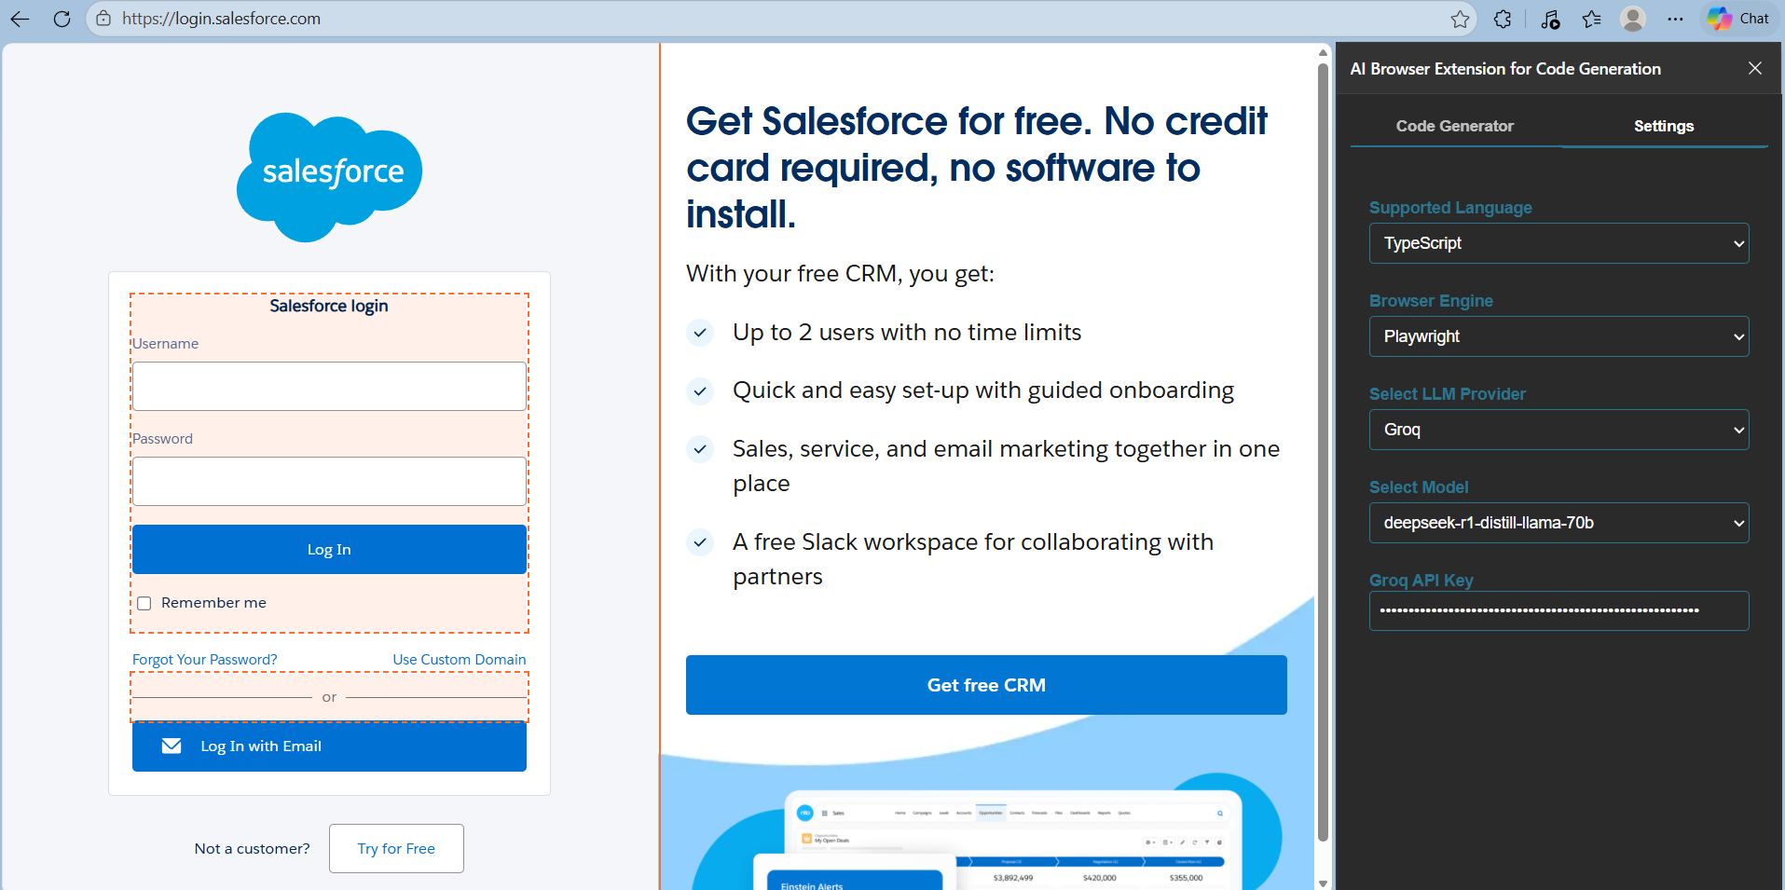

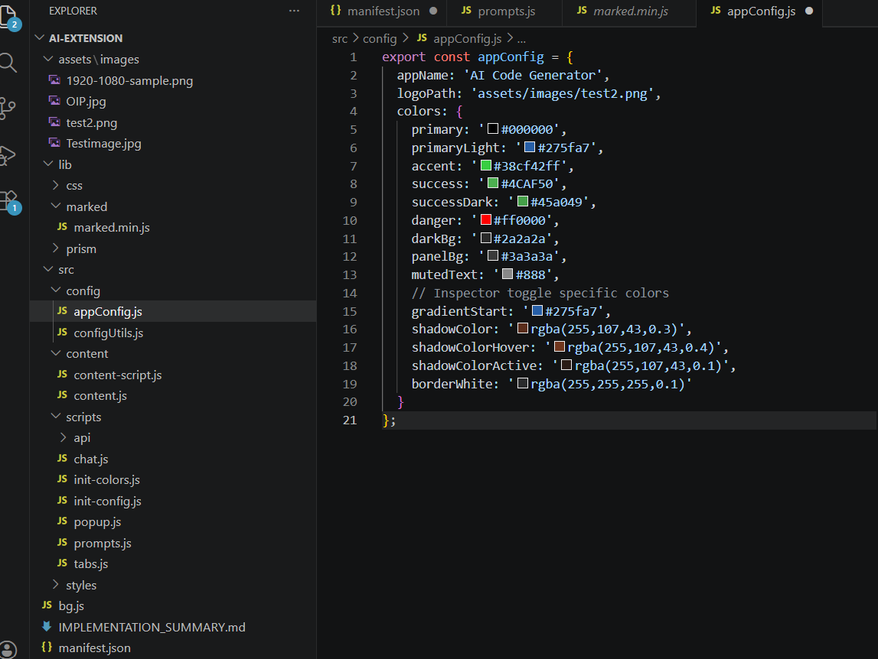

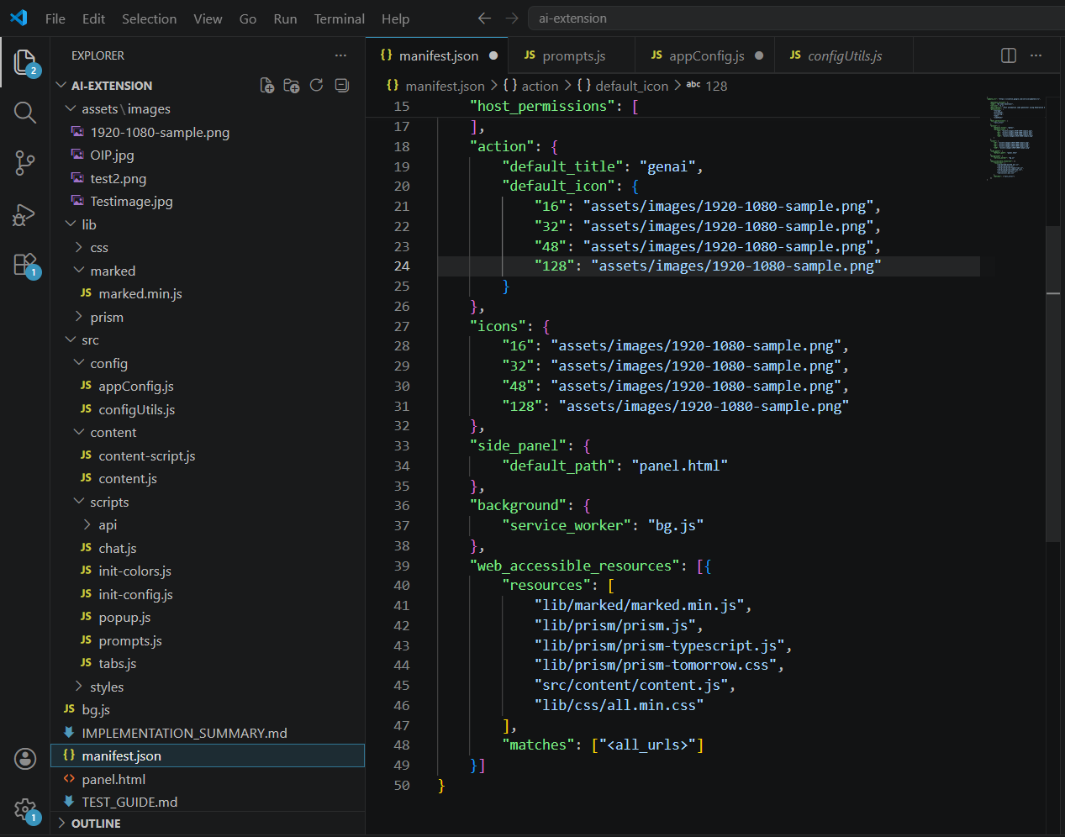

MD file:
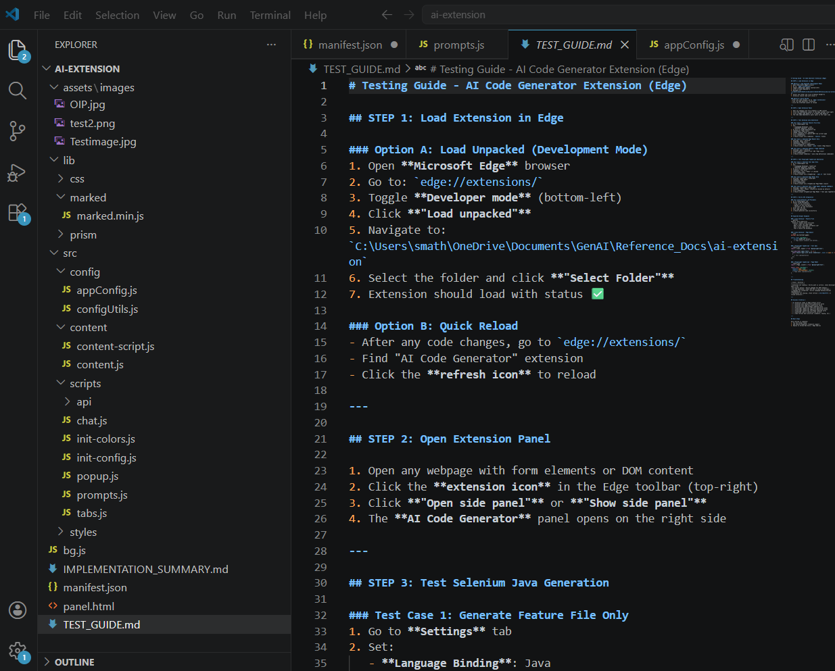
Prompt :
Analyze my entire code base for selenium java (Feature file,Page class,Fature+ Page class)

GO STEP BY STEP .ONCE UP ON MY APPROVAL PROCEED WITH NEXT STEP

--Give me the files in which implemenation is done
--Proceed with Playwright Typescript implementation

Prompt.js
/**
* Collection of default prompts for different use cases (ICE POT Format)
*/
export const DEFAULT_PROMPTS = {

/**
* Selenium Java Page Object Prompt (No Test Class)
*/
SELENIUM_JAVA_PAGE_ONLY: `
Instructions:
- Generate ONLY a Selenium Java Page Object Class (no test code).
- Add JavaDoc for methods & class.
- Use Selenium 2.30+ compatible imports.
- Use meaningful method names.
- Do NOT include explanations or test code.

Context:
DOM:
\`\`\`html
\${domContent}
\`\`\`

Example:
\`\`\`java
package com.testleaf.pages;

/**
* Page Object for Component Page
*/
public class ComponentPage {
// Add methods as per the DOM
}
\`\`\`

Persona:
- Audience: Automation engineer focusing on maintainable POM structure.

Output Format:
- A single Java class inside a \`\`\`java\`\`\` block.

Tone:
- Clean, maintainable, enterprise-ready.
`,

/**
* Cucumber Feature File Only Prompt
*/
CUCUMBER_ONLY: `
Instructions:
- Generate ONLY a Cucumber (.feature) file.
- Use Scenario Outline with Examples table.
- Make sure every step is relevant to the provided DOM.
- Do not combine multiple actions into one step.
- Use South India realistic dataset (names, addresses, pin codes, mobile numbers).
- Use dropdown values only from provided DOM.
- Generate multiple scenarios if applicable.

Context:
DOM:
\`\`\`html
\${domContent}
\`\`\`

Example:
\`\`\`gherkin
Feature: Login to OpenTaps

Scenario Outline: Successful login with valid credentials
Given I open the login page
When I type "<username>" into the Username field
And I type "<password>" into the Password field
And I click the Login button
Then I should be logged in successfully

Examples:
| username | password |
| "testuser" | "testpass"|
| "admin" | "admin123"|
\`\`\`

Persona:
- Audience: BDD testers who only need feature files.

Output Format:
- Only valid Gherkin in a \`\`\`gherkin\`\`\` block.

Tone:
- Clear, structured, executable.
`,

/**
* Cucumber with Step Definitions
*/
CUCUMBER_WITH_SELENIUM_JAVA_STEPS: `
Instructions:
- Generate BOTH:
1. A Cucumber .feature file.
2. A Java step definition class for selenium.
- Do NOT include Page Object code.
- Step defs must include WebDriver setup, explicit waits, and actual Selenium code.
- Use Scenario Outline with Examples table (South India realistic data).

Context:
DOM:
\`\`\`html
\${domContent}
\`\`\`
URL: \${pageUrl}

Example:
\`\`\`gherkin
Feature: Login to OpenTaps

Scenario Outline: Successful login with valid credentials
Given I open the login page
When I type "<username>" into the Username field
And I type "<password>" into the Password field
And I click the Login button
Then I should be logged in successfully

Examples:
| username | password |
\ | "admin" | "admin123"|
\`\`\`

\`\`\`java
package com.leaftaps.stepdefs;

import io.cucumber.java.en.*;
import org.openqa.selenium.*;
import org.openqa.selenium.chrome.ChromeDriver;
import org.openqa.selenium.support.ui.*;

public class LoginStepDefinitions {
private WebDriver driver;
private WebDriverWait wait;

@io.cucumber.java.Before
public void setUp() {
driver = new ChromeDriver();
wait = new WebDriverWait(driver, Duration.ofSeconds(10));
driver.manage().window().maximize();
}

@io.cucumber.java.After
public void tearDown() {
if (driver != null) driver.quit();
}

@Given("I open the login page")
public void openLoginPage() {
driver.get("\${pageUrl}");
}

@When("I type {string} into the Username field")
public void enterUsername(String username) {
WebElement el = wait.until(ExpectedConditions.elementToBeClickable(By.id("username")));
el.sendKeys(username);
}

@When("I type {string} into the Password field")
public void enterPassword(String password) {
WebElement el = wait.until(ExpectedConditions.elementToBeClickable(By.id("password")));
el.sendKeys(password);
}

@When("I click the Login button")
public void clickLogin() {
driver.findElement(By.xpath("//button[contains(text(),'Login')]")).click();
}

@Then("I should be logged in successfully")
public void verifyLogin() {
WebElement success = wait.until(ExpectedConditions.visibilityOfElementLocated(By.className("success")));
assert success.isDisplayed();
}
}
\`\`\`

Persona:
- Audience: QA engineers working with Cucumber & Selenium.

Output Format:
- Gherkin in \`\`\`gherkin\`\`\` block + Java code in \`\`\`java\`\`\` block.

Tone:
- Professional, executable, structured.
`,

/**
* Playwright TypeScript Page Model Prompt (No Test Class)
*/
PLAYWRIGHT_TYPESCRIPT_PAGE_ONLY: `
Instructions:
- Generate ONLY a Playwright TypeScript Page Model class (no test code).
- Add JSDoc comments for all methods and class.
- Use Playwright best practices (page.locator, expect, etc.).
- Use meaningful method names with clear intent.
- Use TypeScript interfaces and strong typing.
- Do NOT include test implementations or explanations.

Context:
DOM:
\`\`\`html
\${domContent}
\`\`\`
Page URL: \${pageUrl}

Example:
\`\`\`typescript
import { Page, Locator } from '@playwright/test';

/**
* Page Object Model for Dashboard
*/
export class DashboardPage {
readonly page: Page;
readonly welcomeHeader: Locator;
readonly logoutButton: Locator;

constructor(page: Page) {
this.page = page;
this.welcomeHeader = page.locator('h1:has-text("Welcome")');
this.logoutButton = page.locator('button[id="logout"]');
}

/**
* Navigate to dashboard page
*/
async goto(): Promise<void> {
await this.page.goto('/dashboard');
}

/**
* Logout from dashboard
*/
async logout(): Promise<void> {
await this.logoutButton.click();
}
}
\`\`\`

Persona:
- Audience: Automation engineers using Playwright with TypeScript.

Output Format:
- A single TypeScript class inside a \`\`\`typescript\`\`\` block.

Tone:
- Modern, type-safe, production-ready.
`,

/**
* Playwright TypeScript Test Spec Only Prompt
*/
PLAYWRIGHT_TYPESCRIPT_TEST_ONLY: `
Instructions:
- Generate ONLY Playwright TypeScript test spec file (.spec.ts).
- Use describe/test blocks with meaningful test names.
- Use South India realistic test data (names, addresses, pin codes).
- Add clear assertions using expect().
- Use page.locator() for element selection.
- Include proper setup (beforeEach) and teardown (afterEach).
- Do NOT include Page Object Model code.

Context:
DOM:
\`\`\`html
\${domContent}
\`\`\`
URL: \${pageUrl}

Example:
\`\`\`typescript
import { test, expect, Page } from '@playwright/test';

test.describe('Dashboard Tests', () => {
let page: Page;

test.beforeEach(async ({ browser }) => {
page = await browser.newPage();
await page.goto('\${pageUrl}');
});

test.afterEach(async () => {
await page.close();
});

test('should display welcome message', async () => {
const header = page.locator('h1:has-text("Welcome")');
await expect(header).toBeVisible();
});

test('should logout successfully', async () => {
await page.locator('button[id="logout"]').click();
await expect(page).toHaveURL(/login/);
});
});
\`\`\`

Persona:
- Audience: QA engineers who prefer standalone test specs.

Output Format:
- Valid TypeScript test spec in \`\`\`typescript\`\`\` block.

Tone:
- Clear, organized, immediately executable.
`,

/**
* Playwright TypeScript with Page Model and Tests
*/
PLAYWRIGHT_WITH_TYPESCRIPT_TESTS: `
Instructions:
- Generate BOTH:
1. A Playwright TypeScript Page Model class.
2. A Playwright TypeScript test spec file (.spec.ts) using the page model.
- Page model must have clear, reusable methods.
- Test spec must import and use the page model.
- Use South India realistic test data.
- Include proper setup/teardown hooks.
- Add JSDoc comments for clarity.

Context:
DOM:
\`\`\`html
\${domContent}
\`\`\`
Page URL: \${pageUrl}

Example:

Page Model:
\`\`\`typescript
import { Page, Locator } from '@playwright/test';

/**
* Login Page Object Model
*/
export class LoginPage {
readonly page: Page;
readonly usernameInput: Locator;
readonly passwordInput: Locator;
readonly loginButton: Locator;

constructor(page: Page) {
this.page = page;
this.usernameInput = page.locator('input[id="username"]');
this.passwordInput = page.locator('input[id="password"]');
this.loginButton = page.locator('button[type="submit"]');
}

/**
* Navigate to login page
*/
async goto(): Promise<void> {
await this.page.goto('\${pageUrl}');
}

/**
* Perform login with credentials
*/
async login(username: string, password: string): Promise<void> {
await this.usernameInput.fill(username);
await this.passwordInput.fill(password);
await this.loginButton.click();
}
}
\`\`\`

Test Spec:
\`\`\`typescript
import { test, expect, Page } from '@playwright/test';
import { LoginPage } from './pages/LoginPage';

test.describe('Login Tests', () => {
let page: Page;
let loginPage: LoginPage;

test.beforeEach(async ({ browser }) => {
page = await browser.newPage();
loginPage = new LoginPage(page);
await loginPage.goto();
});

test.afterEach(async () => {
await page.close();
});

test('should login with valid credentials', async () => {
await loginPage.login('rajesh.kumar@testleaf.in', 'password123');
await expect(page).toHaveURL(/dashboard/);
});

test('should display error with invalid credentials', async () => {
await loginPage.login('invalid@user.com', 'wrongpass');
await expect(page.locator('.error-message')).toBeVisible();
});
});
\`\`\`

Persona:
- Audience: Senior QA engineers using Playwright + TypeScript for production tests.

Output Format:
- Page model in first \`\`\`typescript\`\`\` block + test spec in second \`\`\`typescript\`\`\` block.

Tone:
- Professional, scalable, production-grade.
`,

/**
* Cypress JavaScript Page Object Prompt (No Test Class)
*/
CYPRESS_JAVASCRIPT_PAGE_ONLY: `
Instructions:
- Generate ONLY a Cypress JavaScript Page Object class (no test code).
- Add JSDoc comments for all methods and class.
- Use Cypress best practices (cy.get, cy.contains, etc.).
- Use meaningful method names with clear intent.
- Use CommonJS or ES6 modules as appropriate.
- Do NOT include test implementations or explanations.

Context:
DOM:
\`\`\`html
\${domContent}
\`\`\`
Page URL: \${pageUrl}

Example:
\`\`\`javascript
/**
* Dashboard Page Object for Cypress
*/
class DashboardPage {
/**
* Navigate to dashboard
*/
visitDashboard() {
cy.visit('/dashboard');
}

/**
* Get welcome header element
*/
getWelcomeHeader() {
return cy.get('h1:contains("Welcome")');
}

/**
* Click logout button and verify redirect
*/
logout() {
cy.get('button[id="logout"]').click();
cy.url().should('include', '/login');
}
}

module.exports = DashboardPage;
\`\`\`

Persona:
- Audience: QA engineers using Cypress with JavaScript.

Output Format:
- A single JavaScript class in a \`\`\`javascript\`\`\` block.

Tone:
- Clear, maintainable, Cypress idiomatic.
`,

/**
* Cypress JavaScript Test Spec Only Prompt
*/
CYPRESS_JAVASCRIPT_TEST_ONLY: `
Instructions:
- Generate ONLY Cypress JavaScript test spec file (.spec.js).
- Use describe/it blocks with meaningful test names.
- Use cy.visit(), cy.get(), cy.contains() for interactions.
- Use South India realistic test data.
- Add clear assertions using cy.should().
- Use proper Cypress hooks (beforeEach, afterEach).
- Do NOT include Page Object code.

Context:
DOM:
\`\`\`html
\${domContent}
\`\`\`
URL: \${pageUrl}

Example:
\`\`\`javascript
describe('Dashboard Tests', () => {
beforeEach(() => {
cy.visit('\${pageUrl}');
});

it('should display welcome message', () => {
cy.get('h1:contains("Welcome")').should('be.visible');
});

it('should logout successfully', () => {
cy.get('button[id="logout"]').click();
cy.url().should('include', '/login');
});

it('should display user profile', () => {
cy.get('[data-testid="user-profile"]').should('exist');
});
});
\`\`\`

Persona:
- Audience: QA engineers who prefer standalone Cypress test specs.

Output Format:
- Valid Cypress test spec in \`\`\`javascript\`\`\` block.

Tone:
- Clear, organized, immediately executable.
`,

/**
* Cypress JavaScript with Page Object and Tests
*/
CYPRESS_WITH_JAVASCRIPT_TESTS: `
Instructions:
- Generate BOTH:
1. A Cypress JavaScript Page Object class.
2. A Cypress JavaScript test spec file (.spec.js) using the page object.
- Page object must have clear, reusable methods.
- Test spec must import and use the page object.
- Use South India realistic test data.
- Add JSDoc comments for clarity.

Context:
DOM:
\`\`\`html
\${domContent}
\`\`\`
Page URL: \${pageUrl}

Example:

Page Object:
\`\`\`javascript
/**
* Login Page Object for Cypress
*/
class LoginPage {
/**
* Visit the login page
*/
visitLoginPage() {
cy.visit('\${pageUrl}');
}

/**
* Enter username in login form
*/
enterUsername(username) {
cy.get('input[id="username"]').type(username);
}

/**
* Enter password in login form
*/
enterPassword(password) {
cy.get('input[id="password"]').type(password);
}

/**
* Click login button
*/
clickLogin() {
cy.get('button[type="submit"]').click();
}

/**
* Verify successful login
*/
verifyLoginSuccess() {
cy.url().should('include', '/dashboard');
}
}

module.exports = LoginPage;
\`\`\`

Test Spec:
\`\`\`javascript
const LoginPage = require('./pages/LoginPage');

describe('Login Tests', () => {
let loginPage;

beforeEach(() => {
loginPage = new LoginPage();
loginPage.visitLoginPage();
});

it('should login with valid credentials', () => {
loginPage.enterUsername('rajesh.kumar@testleaf.in');
loginPage.enterPassword('password123');
loginPage.clickLogin();
loginPage.verifyLoginSuccess();
});

it('should display error with invalid credentials', () => {
loginPage.enterUsername('invalid@user.com');
loginPage.enterPassword('wrongpass');
loginPage.clickLogin();
cy.get('.error-message').should('be.visible');
});

it('should validate empty username field', () => {
loginPage.clickLogin();
cy.get('.error-message').should('contain', 'Username required');
});
});
\`\`\`

Persona:
- Audience: QA engineers using Cypress with Page Object Pattern.

Output Format:
- Page object in first \`\`\`javascript\`\`\` block + test spec in second \`\`\`javascript\`\`\` block.

Tone:
- Professional, maintainable, immediately executable.
`,

/**
* Puppeteer JavaScript Page Model Prompt
*/
PUPPETEER_JAVASCRIPT_PAGE_ONLY: `
Instructions:
- Generate ONLY a Puppeteer JavaScript Page Model class (no test code).
- Add JSDoc comments for all methods and class.
- Use Puppeteer best practices (page.$, page.$$, page.click, etc.).
- Use meaningful method names with clear intent.
- Use async/await pattern throughout.
- Do NOT include test implementations or explanations.

Context:
DOM:
\`\`\`html
\${domContent}
\`\`\`
Page URL: \${pageUrl}

Example:
\`\`\`javascript
/**
* Dashboard Page Model for Puppeteer
*/
class DashboardPage {
/**
* @param {Page} page - Puppeteer page instance
*/
constructor(page) {
this.page = page;
}

/**
* Navigate to dashboard
*/
async goto() {
await this.page.goto('/dashboard', { waitUntil: 'networkidle2' });
}

/**
* Get welcome header text
*/
async getWelcomeText() {
return await this.page.$eval('h1', el => el.textContent);
}

/**
* Click logout button
*/
async logout() {
await this.page.click('button[id="logout"]');
await this.page.waitForNavigation();
}
}

module.exports = DashboardPage;
\`\`\`

Persona:
- Audience: QA engineers using Puppeteer for browser automation.

Output Format:
- A single JavaScript class in a \`\`\`javascript\`\`\` block.

Tone:
- Production-ready, async-first, headless-focused.
`,

/**
* Puppeteer JavaScript Test Spec Only Prompt
*/
PUPPETEER_JAVASCRIPT_TEST_ONLY: `
Instructions:
- Generate ONLY Puppeteer JavaScript test spec file (.spec.js).
- Use Jest or Mocha test framework (as applicable).
- Use async/await for all async operations.
- Use South India realistic test data.
- Include proper setup (beforeEach/beforeAll) and teardown (afterEach/afterAll).
- Use puppeteer API directly (page.$, page.evaluate, etc.).
- Do NOT include Page Object code.

Context:
DOM:
\`\`\`html
\${domContent}
\`\`\`
URL: \${pageUrl}

Example:
\`\`\`javascript
const puppeteer = require('puppeteer');

describe('Dashboard Tests', () => {
let browser;
let page;

beforeAll(async () => {
browser = await puppeteer.launch({ headless: true });
page = await browser.newPage();
});

afterAll(async () => {
await browser.close();
});

beforeEach(async () => {
await page.goto('\${pageUrl}', { waitUntil: 'networkidle2' });
});

test('should display welcome message', async () => {
const heading = await page.$('h1:contains("Welcome")');
expect(heading).not.toBeNull();
});

test('should click logout button', async () => {
await page.click('button[id="logout"]');
await page.waitForNavigation();
expect(page.url()).toContain('/login');
});
});
\`\`\`

Persona:
- Audience: Automation engineers using Puppeteer for headless testing.

Output Format:
- Valid Puppeteer test spec in \`\`\`javascript\`\`\` block.

Tone:
- Technical, async-focused, production-grade.
`,

/**
* Puppeteer JavaScript with Page Model and Tests
*/
PUPPETEER_WITH_JAVASCRIPT_TESTS: `
Instructions:
- Generate BOTH:
1. A Puppeteer JavaScript Page Model class.
2. A Puppeteer JavaScript test spec file (.spec.js) using the page model.
- Page model must have clear, reusable async methods.
- Test spec must use Jest/Mocha and import the page model.
- Use South India realistic test data.
- Include proper async/await patterns throughout.
- Add JSDoc comments.

Context:
DOM:
\`\`\`html
\${domContent}
\`\`\`
Page URL: \${pageUrl}

Example:

Page Model:
\`\`\`javascript
/**
* Login Page Model for Puppeteer
*/
class LoginPage {
/**
* @param {Page} page - Puppeteer page instance
*/
constructor(page) {
this.page = page;
this.usernameSelector = 'input[id="username"]';
this.passwordSelector = 'input[id="password"]';
this.submitSelector = 'button[type="submit"]';
}

/**
* Navigate to login page
*/
async goto() {
await this.page.goto('\${pageUrl}', { waitUntil: 'networkidle2' });
}

/**
* Enter username
*/
async enterUsername(username) {
await this.page.type(this.usernameSelector, username);
}

/**
* Enter password
*/
async enterPassword(password) {
await this.page.type(this.passwordSelector, password);
}

/**
* Submit login form
*/
async submitLogin() {
await this.page.click(this.submitSelector);
await this.page.waitForNavigation();
}

/**
* Verify login success
*/
async verifyDashboard() {
return await this.page.url().includes('/dashboard');
}
}

module.exports = LoginPage;
\`\`\`

Test Spec:
\`\`\`javascript
const puppeteer = require('puppeteer');
const LoginPage = require('./pages/LoginPage');

describe('Login Tests with Puppeteer', () => {
let browser;
let page;
let loginPage;

beforeAll(async () => {
browser = await puppeteer.launch({ headless: true });
page = await browser.newPage();
loginPage = new LoginPage(page);
});

afterAll(async () => {
await browser.close();
});

beforeEach(async () => {
await loginPage.goto();
});

test('should login with valid credentials', async () => {
await loginPage.enterUsername('rajesh.kumar@testleaf.in');
await loginPage.enterPassword('password123');
await loginPage.submitLogin();
const isLoggedIn = await loginPage.verifyDashboard();
expect(isLoggedIn).toBe(true);
});

test('should display error with invalid credentials', async () => {
await loginPage.enterUsername('invalid@user.com');
await loginPage.enterPassword('wrongpass');
await loginPage.submitLogin();
const errorMsg = await page.$('.error-message');
expect(errorMsg).not.toBeNull();
});
});
\`\`\`

Persona:
- Audience: Senior automation engineers using Puppeteer for scalable headless testing.

Output Format:
- Page model in first \`\`\`javascript\`\`\` block + test spec in second \`\`\`javascript\`\`\` block.

Tone:
- Professional, performant, production-ready.
`
};

/**
* Helper function to escape code blocks in prompts
*/
function escapeCodeBlocks(text) {
return text.replace(/```/g, '\\`\\`\\`');
}

/**
* Function to fill template variables in a prompt
*/
export function getPrompt(promptKey, variables = {}) {
let prompt = DEFAULT_PROMPTS[promptKey];
if (!prompt) {
throw new Error(`Prompt not found: ${promptKey}`);
}

Object.entries(variables).forEach(([k, v]) => {
const regex = new RegExp(`\\$\\{${k}\\}`, 'g');
prompt = prompt.replace(regex, v);
});

return prompt.trim();
}

export const CODE_GENERATOR_TYPES = {
SELENIUM_JAVA_PAGE_ONLY: 'Selenium-Java-Page-Only',
CUCUMBER_ONLY: 'Cucumber-Only',
CUCUMBER_WITH_SELENIUM_JAVA_STEPS: 'Cucumber-With-Selenium-Java-Steps',
PLAYWRIGHT_TYPESCRIPT_PAGE_ONLY: 'Playwright-TypeScript-Page-Only',
PLAYWRIGHT_TYPESCRIPT_TEST_ONLY: 'Playwright-TypeScript-Test-Only',
PLAYWRIGHT_WITH_TYPESCRIPT_TESTS: 'Playwright-With-TypeScript-Tests',
CYPRESS_JAVASCRIPT_PAGE_ONLY: 'Cypress-JavaScript-Page-Only',
CYPRESS_JAVASCRIPT_TEST_ONLY: 'Cypress-JavaScript-Test-Only',
CYPRESS_WITH_JAVASCRIPT_TESTS: 'Cypress-With-JavaScript-Tests',
PUPPETEER_JAVASCRIPT_PAGE_ONLY: 'Puppeteer-JavaScript-Page-Only',
PUPPETEER_JAVASCRIPT_TEST_ONLY: 'Puppeteer-JavaScript-Test-Only',
PUPPETEER_WITH_JAVASCRIPT_TESTS: 'Puppeteer-With-JavaScript-Tests',
};

