1) 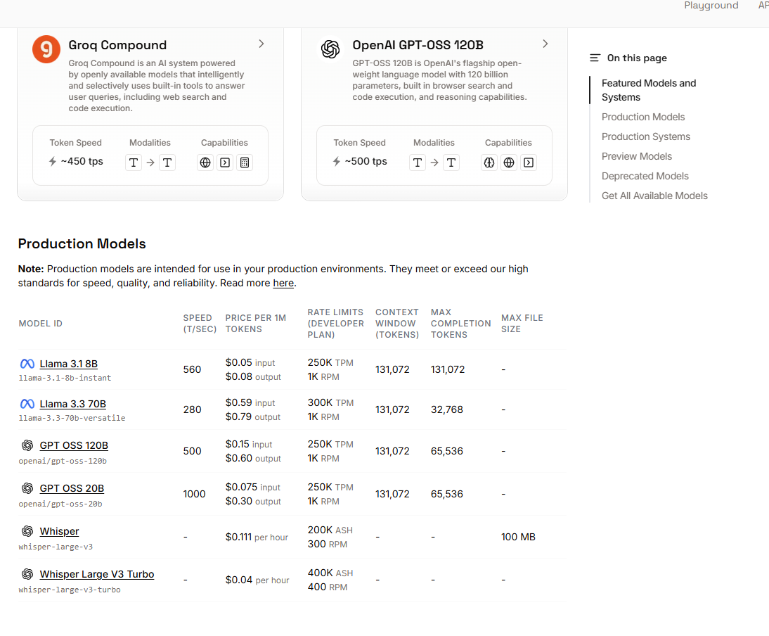

2)



3 )
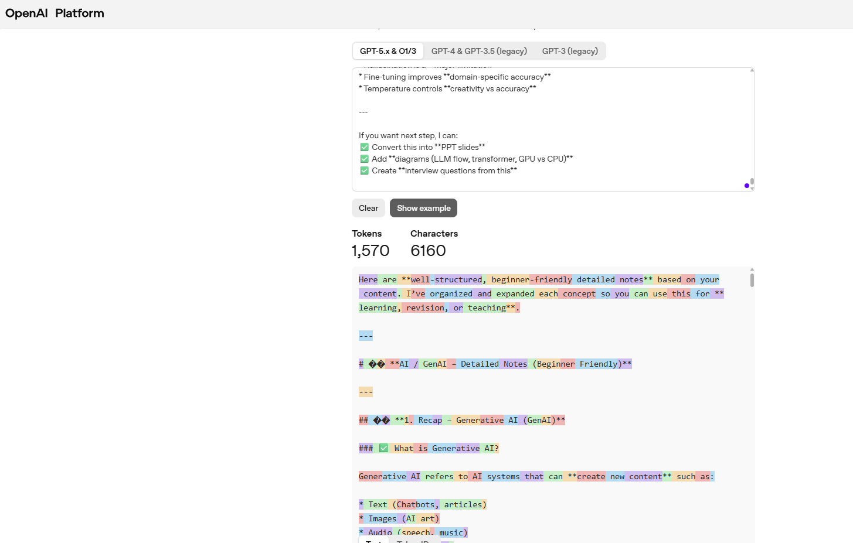A helpful rule of thumb is that one token generally corresponds to ~4 characters of text for common English text. This translates to roughly ¾ of a word (so 100 tokens ~= 75 words).
If you need a programmatic interface for tokenizing text, check out our tiktoken package for Python. For JavaScript, the community-supported @dbdq/tiktoken package works with most GPT models.

