Test Case 1 :Generator Langflow – Creating a test case for funds transfer flow for banking domain

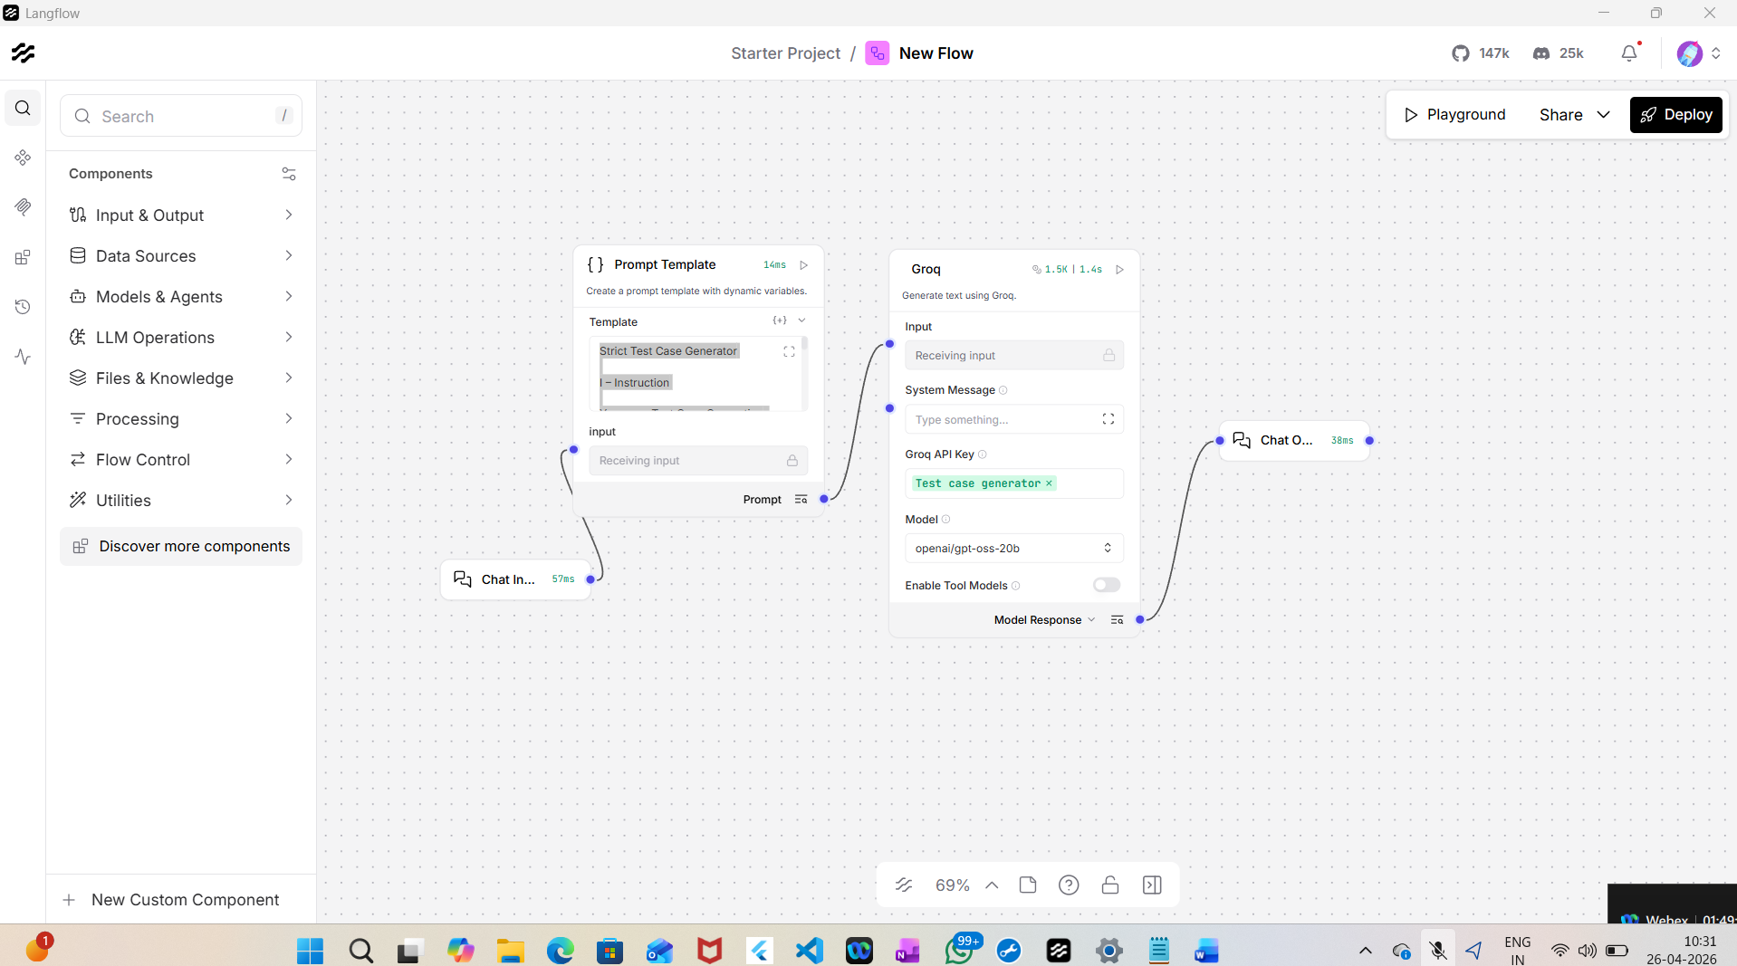

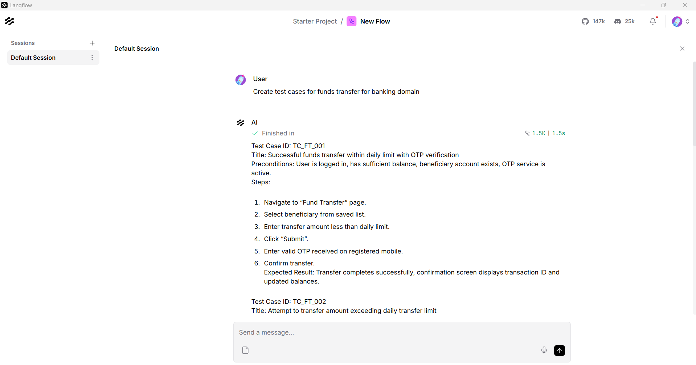

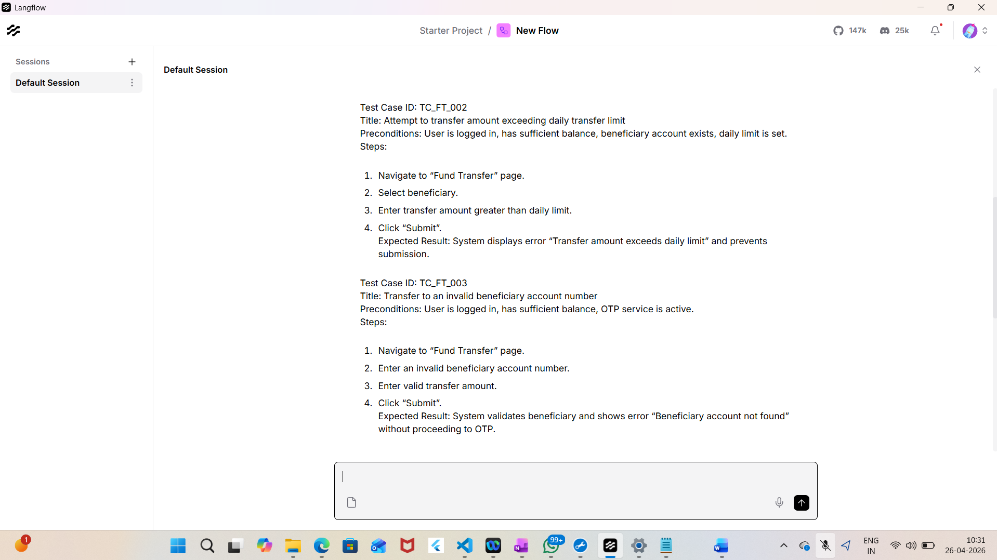
User
Pls create the test cases for funds transfer module in banking application
AI
Finished in1.4K|1.1s
Test Case ID: TC_FT_001
Title: Successful funds transfer within daily limit with OTP verification
Preconditions: User is logged in, has sufficient balance, daily transfer limit not exceeded, beneficiary account exists and is active.
Steps:
- Navigate to Funds Transfer screen.
- Enter beneficiary account number.
- Enter transfer amount within daily limit.
- Click “Submit”.
- Receive OTP on registered mobile.
- Enter OTP and confirm transfer.
Expected Result: Transfer completes successfully, confirmation message displayed, transaction recorded in account statement.
Test Case ID: TC_FT_002
Title: Attempt to transfer amount exceeding daily transfer limit
Preconditions: User is logged in, has sufficient balance, daily transfer limit is set.
Steps:
- Navigate to Funds Transfer screen.
- Enter beneficiary account number.
- Enter transfer amount that exceeds the daily limit.
- Click “Submit”.
- Observe system response.
Expected Result: System displays error “Transfer amount exceeds daily limit” and prevents submission.
Test Case ID: TC_FT_003
Title: Transfer to an invalid beneficiary account number
Preconditions: User is logged in, has sufficient balance, daily transfer limit not exceeded.
Steps:
- Navigate to Funds Transfer screen.
- Enter an invalid beneficiary account number (e.g., non-existent or incorrect format).
- Enter a valid transfer amount.
- Click “Submit”.
- Observe system response.
Expected Result: System validates account number, displays error “Beneficiary account not found” and aborts transfer.
Test Case ID: TC_FT_004
Title: Transfer with insufficient account balance
Preconditions: User is logged in, account balance is less than the transfer amount, daily transfer limit not exceeded.
Steps:
- Navigate to Funds Transfer screen.
- Enter beneficiary account number.
- Enter transfer amount greater than available balance.
- Click “Submit”.
- Observe system response.
Expected Result: System displays error “Insufficient balance” and prevents transfer.
Test Case ID: TC_FT_005
Title: Transfer failure due to network timeout during OTP verification
Preconditions: User is logged in, has sufficient balance, daily transfer limit not exceeded, beneficiary account exists.
Steps:
- Navigate to Funds Transfer screen.
- Enter beneficiary account number.
- Enter transfer amount within daily limit.
- Click “Submit”.
- System sends OTP; simulate network timeout before OTP is received.
- Attempt to enter OTP and confirm transfer.
Expected Result: System displays error “OTP verification failed due to network issue”, transaction is not processed, and user can retry.

Test case 2: Improvised version: TC_FT_003 is taken as a test case to be reviewed for improvement
Test Case Chat input :
Test Case ID: TC_FT_003 Title: Transfer to an invalid beneficiary account number Preconditions: User is logged in, has sufficient balance, daily transfer limit not exceeded. Steps: 1. Navigate to Funds Transfer screen. 2. Enter an invalid beneficiary account number (e.g., non existent or incorrect format). 3. Enter a valid transfer amount. 4. Click “Submit”. 5. Observe system response. Expected Result: System validates account number, displays error “Beneficiary account not found” and aborts transfer.

List of issues
1. Step 5 is vague – does not specify verification of error message or that no funds are deducted. (Severity: High)
2. Preconditions do not state that the beneficiary account number used is guaranteed to be invalid or non‑existent. (Severity: Medium)
3. Test case omits OTP/authentication flow, which may be required for fund transfer. (Severity: Medium)
4. Expected Result does not confirm that the source account balance remains unchanged. (Severity: Low)
5. No post‑condition to verify that the transaction is absent from the user’s history. (Severity: Low)
6. The test does not distinguish between an invalid format and a non‑existent account; these should be separate scenarios. (Severity: Medium)
7. Error message content and UI element are not explicitly identified. (Severity: Low)
8. Audit trail or logging verification is missing. (Severity: Low)

Suggestions for improvement
- Must fix: Clarify step 5 to include explicit verification of the error message and that no balance change occurs.
- Must fix: Add a precondition that the beneficiary account number is known to be invalid or non‑existent.
- Must fix: Include OTP entry step if OTP is required for fund transfer.
- Must fix: Separate test cases for “invalid format” and “non‑existent account” scenarios.
- Optional: Verify the exact error message text and UI element.
- Optional: Check audit log for failed transfer attempt.

Improved version of the test case
Test Case ID: TC_FT_003
Title: Verify system rejects transfer to an invalid beneficiary account number
Preconditions:
- User is logged in to the banking application.
- User has an active source account with sufficient balance.
- Daily transfer limit has not been reached.
- The beneficiary account number entered in the test is guaranteed to be invalid (either non‑existent or in incorrect format).
- OTP is enabled for fund transfer (if applicable).

Steps:
1. From the home dashboard, tap “Funds Transfer”.
2. In the “Beneficiary Account Number” field, enter an invalid account number (e.g., “12345ABC” or a 12‑digit number that does not exist).
3. Enter a valid transfer amount that is within the user’s balance and daily limit.
4. Tap the “Submit” button.
5. If prompted, enter the OTP and confirm the transaction.
6. Observe the system response.

Expected Result:
- The system validates the beneficiary account number and displays the error message “Beneficiary account not found” (or “Invalid account number format” as appropriate).
- The transfer is aborted and no deduction is made from the source account.
- The transaction does not appear in the user’s transaction history.
- An audit log entry is created indicating the failed transfer attempt.

Test case 3: Extracting the ‘issue date’, ‘sub total’ and ‘Due amount’ from a PDF
