embedUR
Advanced C programming Assingment - 1

Name: Saravanan D
Collage: VIT University

1.
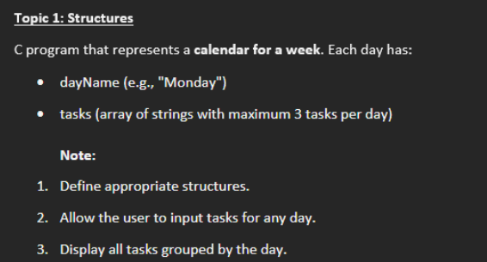

#include <stdio.h>
#include <string.h>
struct Day {
char dayName[20];
char tasks[3][100];
};
int main() {
struct Day week[7] = {
{"Monday"}, {"Tuesday"}, {"Wednesday"},
{"Thursday"}, {"Friday"}, {"Saturday"}, {"Sunday"}
};
int i, j;
for(i = 0; i < 7; i++) {
printf("\nEnter 3 tasks for %s:\n", week[i].dayName);
for(j = 0; j < 3; j++) {
printf("Task %d: ", j + 1);
scanf(" %[^\n]", week[i].tasks[j]);
}
}
printf("\n----- Weekly Calendar -----\n");
for(i = 0; i < 7; i++) {
printf("\n%s:\n", week[i].dayName);

for(j = 0; j < 3; j++) {
printf(" - %s\n", week[i].tasks[j]);
}
}
return 0;
}

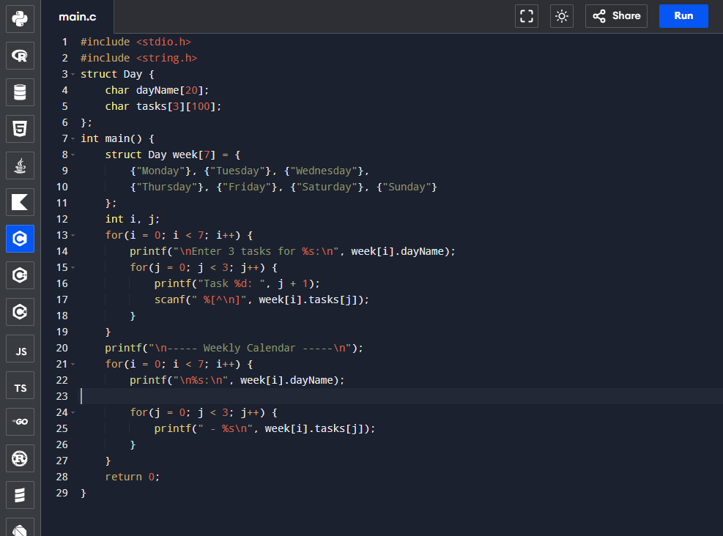
Execution :
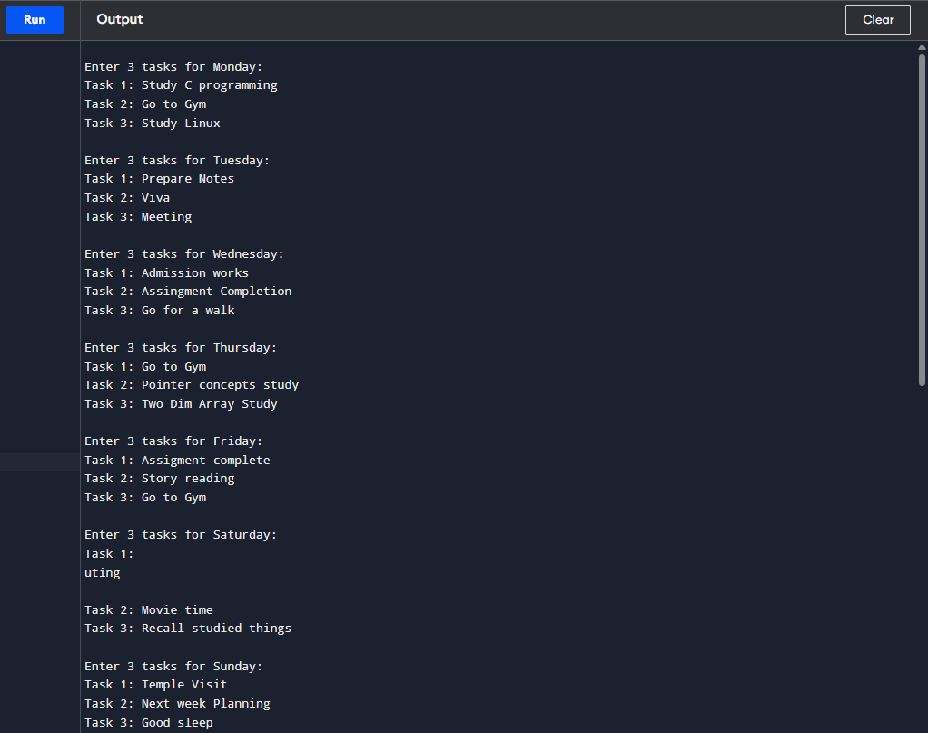
Inputs:

Output:

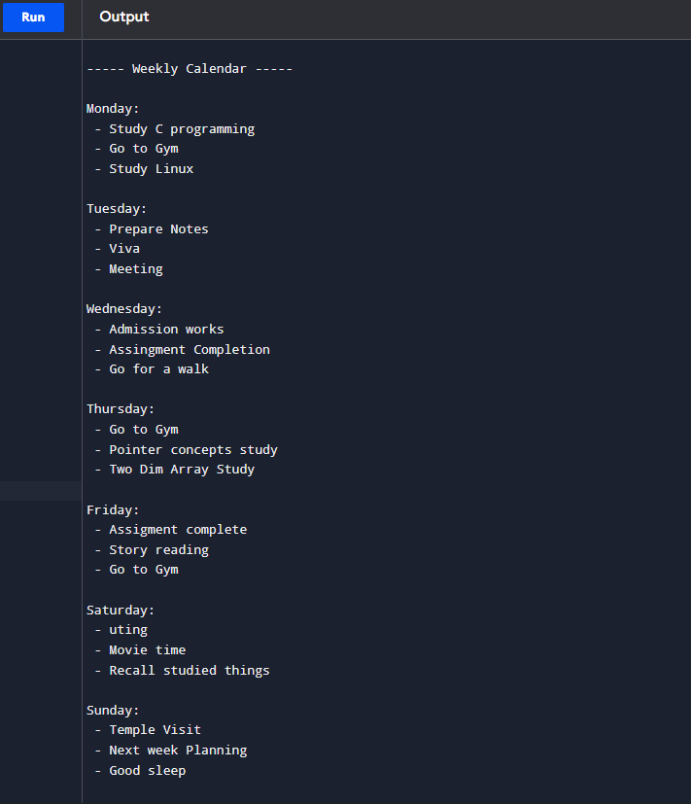

2.
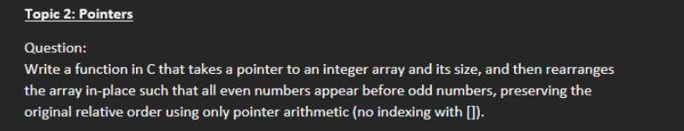

#include <stdio.h>
void rearrange(int *arr, int n)
{
int temp[n];
int *p = arr;
int *t = temp;
int i;
for(i = 0; i < n; i++)
{
if(*(p + i) % 2 == 0)
{
*t = *(p + i);
t++;
}
}
for(i = 0; i < n; i++)
{
if(*(p + i) % 2 != 0)
{
*t = *(p + i);
t++;
}
}
for(i = 0; i < n; i++)
{
*(arr + i) = temp[i];
}
}
int main()
{
int n, i;

printf("Enter size of array: ");
scanf("%d", &n);

int arr[n];

printf("Enter %d elements:\n", n);

for(i = 0; i < n; i++)
{
scanf("%d", &arr[i]);
}
rearrange(arr, n);

printf("Array after rearranging:\n");

for(i = 0; i < n; i++)
{
printf("%d ", arr[i]);
}
return 0;
}

Execution:
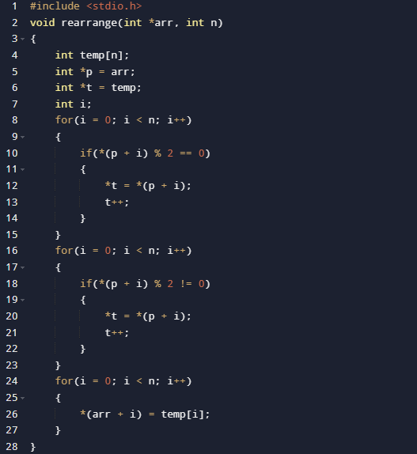

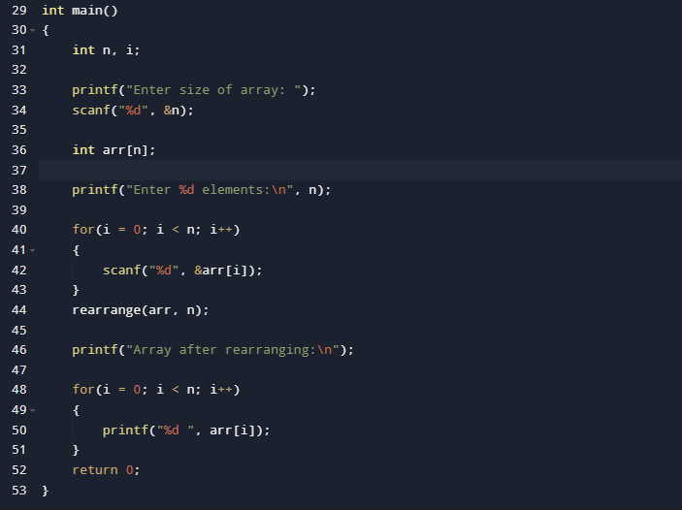

Output:
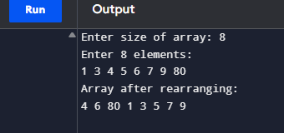

3.
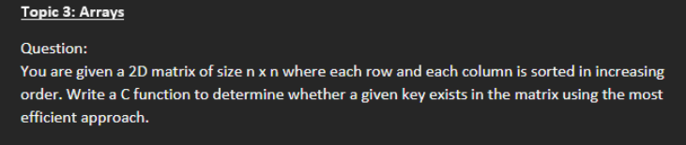

#include <stdio.h>

int main()
{
int n, key;

printf("Enter the order of matrix: ");
scanf("%d", &n);

int mat[n][n];

printf("Enter the matrix elements:\n");
for(int i = 0; i < n; i++)
{
for(int j = 0; j < n; j++)
{
scanf("%d", &mat[i][j]);
}
}

printf("Enter the key to search: ");
scanf("%d", &key);

int row = 0;
int col = n - 1;
int found = 0;

while(row < n && col >= 0)
{
if(mat[row][col] == key)
{
found = 1;
break;
}
else if(mat[row][col] > key)
{
col--;
}
else
{
row++;
}
}

if(found)
printf("Key %d found in the matrix.\n", key);
else
printf("Key %d not found in the matrix.\n", key);

return 0;
}

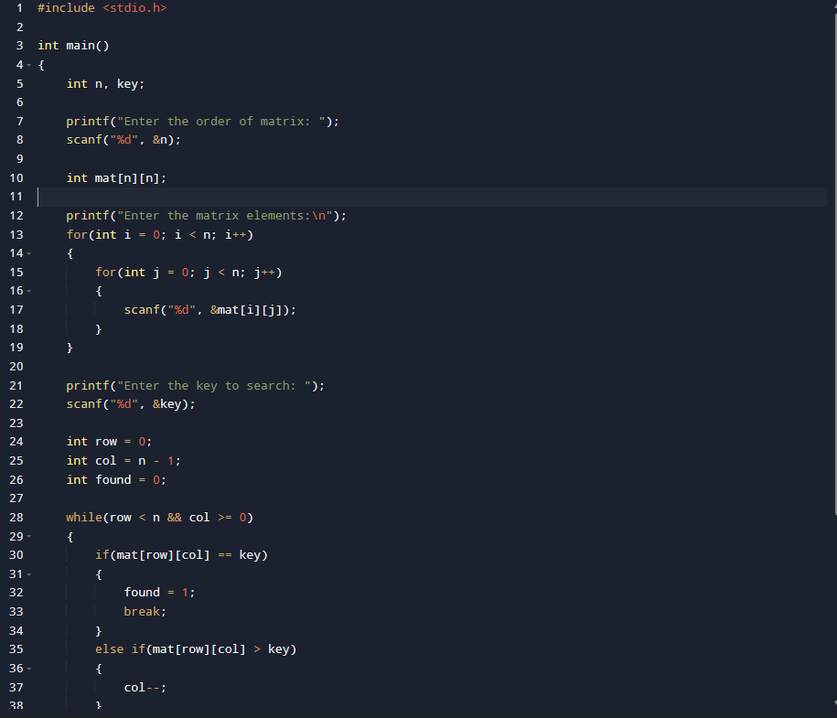

Output:
