embedUR
Advanced C programming Assingment - 2

Name: Saravanan D
Collage: VIT University

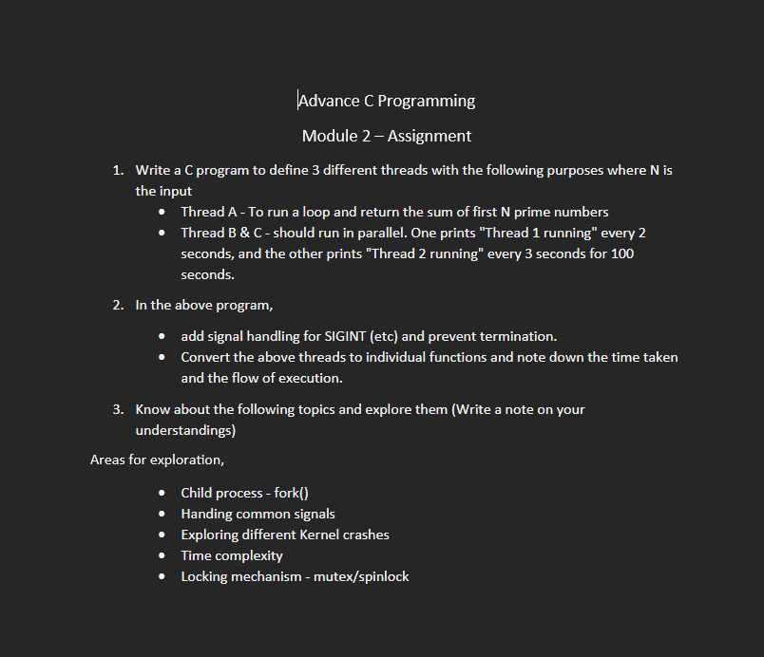

1.

#include <stdio.h>
#include <pthread.h>
#include <unistd.h>

int N;

int isPrime(int n)
{
if(n < 2) return 0;

for(int i = 2; i * i <= n; i++)
{
if(n % i == 0)
return 0;
}
return 1;
}

void *threadA(void *arg)
{
int count = 0, num = 2;
long sum = 0;

while(count < N)
{
if(isPrime(num))
{
sum += num;
count++;
}
num++;
}

printf("Sum of first %d prime numbers = %ld\n", N, sum);
return NULL;
}

void *threadB(void *arg)
{
for(int i = 0; i < 50; i++)
{
printf("Thread 1 running\n");
sleep(2);
}
return NULL;
}

void *threadC(void *arg)
{
for(int i = 0; i < 34; i++)
{
printf("Thread 2 running\n");
sleep(3);
}
return NULL;
}

int main()
{
pthread_t t1, t2, t3;

printf("Enter N: ");
scanf("%d", &N);

pthread_create(&t1, NULL, threadA, NULL);
pthread_create(&t2, NULL, threadB, NULL);
pthread_create(&t3, NULL, threadC, NULL);

pthread_join(t1, NULL);
pthread_join(t2, NULL);
pthread_join(t3, NULL);

return 0;
}

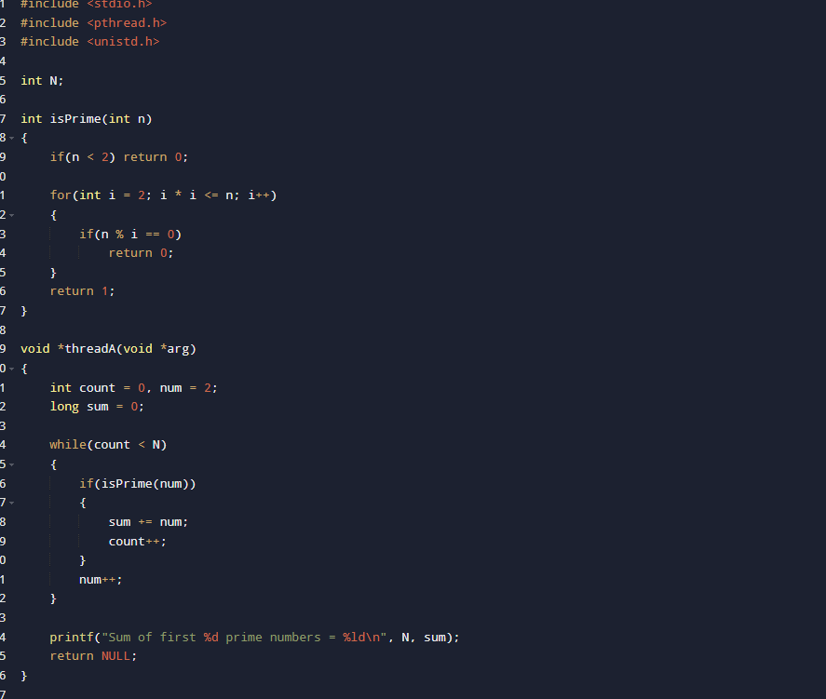

Output:
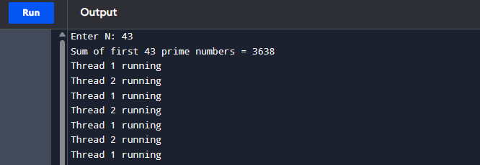

2.
#include <stdio.h>
#include <signal.h>
#include <unistd.h>
void sigint_handler(int sig)
{
printf("\nSIGINT received. Program termination prevented.\n");
}
int main()
{
signal(SIGINT, sigint_handler);
printf("Press Ctrl+C to test SIGINT\n");
while(1)
{
sleep(1);
}
return 0;
}

3.
1. Child Process – fork()
fork() is a system call used to create a new process called a child process. After fork(), both parent and child processes execute independently. It is widely used in Linux and Unix operating systems for multitasking and process management.
2. Handling Common Signals
Signals are software interrupts sent to a process to notify it of an event.
Common signals:
- SIGINT – Generated by Ctrl+C.
- SIGTERM – Requests process termination.
- SIGKILL – Forcefully terminates a process.
- SIGSTOP – Stops a process.
- SIGCONT – Resumes a stopped process.
- SIGSEGV – Invalid memory access.
3. Exploring Different Kernel Crashes
A kernel crash occurs when the operating system kernel encounters a fatal error and can no longer continue safely.
Common causes:
- Null pointer dereference
- Invalid memory access
- Driver bugs
- Stack overflow
- Memory corruption
Effects include system freeze, reboot, or data loss. Proper testing and memory management help prevent kernel crashes.

4. Time Complexity
Time complexity measures how the execution time of an algorithm grows as the input size increases.
Common complexities:
Complexity | Example
O(1) | Array access
O(log n) | Binary Search
O(n) | Linear Search
O(n log n) | Merge Sort
O(n²) | Bubble Sort
Locking Mechanism – Mutex and Spinlock
Mutex
A mutex (Mutual Exclusion) allows only one thread at a time to access a shared resource.
Spinlock
A spinlock repeatedly checks until the lock becomes available.
Difference
Mutex | Spinlock
Thread sleeps while waiting | Thread keeps checking
Low CPU usage | High CPU usage
Suitable for long waits | Suitable for short waits

Both mutexes and spinlocks are synchronization mechanisms used to prevent race conditions in multithreaded programs.

