embedUR
Networking Assingment-2

Name:Saravanan D
Collage: VIT University

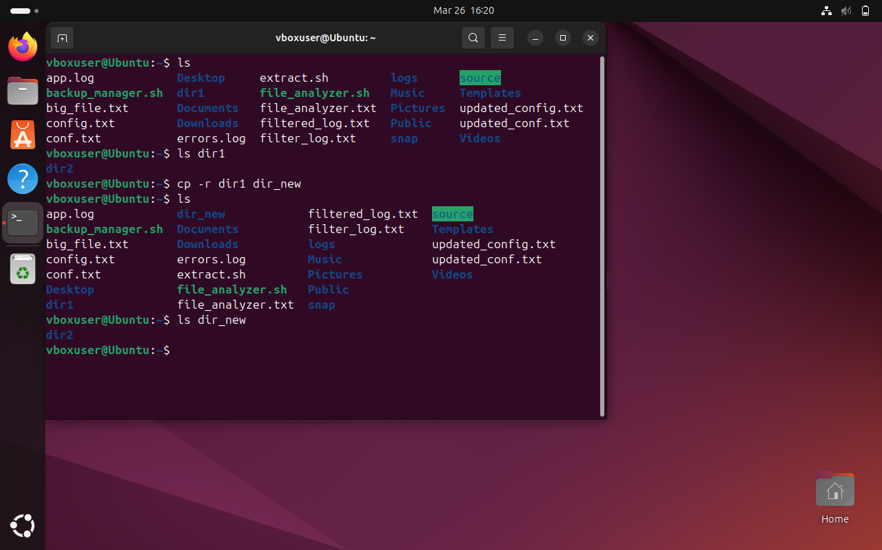
- Consider a case, a folder has multiple files and how would copy it to destination machine path (Try using SCP, cp options in Linux)
Using cp:
Commands:
ls
ls dir1
cp -r dir1 dir_new
ls dir_new

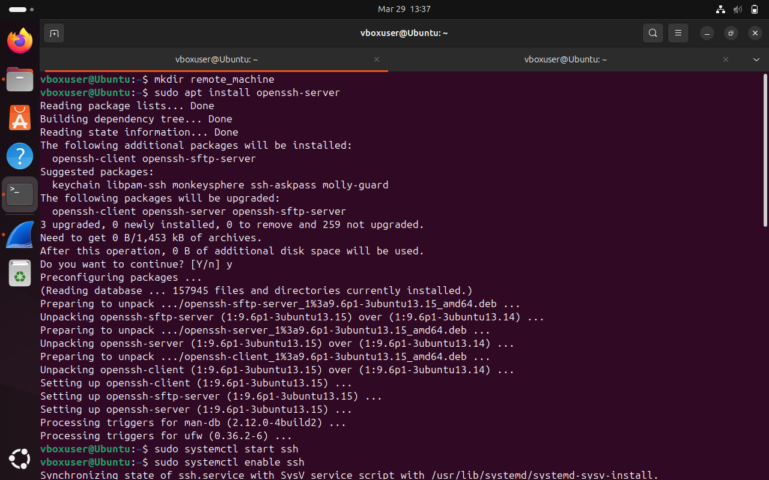
Using scp:
Commands:
mkdir remote_machine
sudo apt install openssh-server
sudo systemctl start ssh
sudo systemctl enable ssh
scp -r dir1 vboxuser@localhost:/home/vboxuser/remote_machine
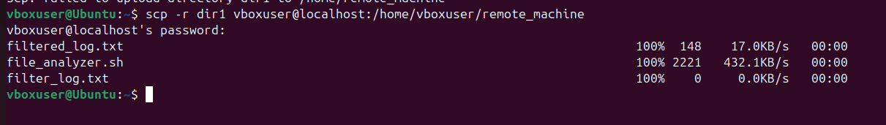
- Host a FTP and SFTP server and try PUT and GET operations.
Commands:
sudo apt install vsftpd
sudo systemctl start vsftpd
sudo systemctl status vsftpd
ftp localhost
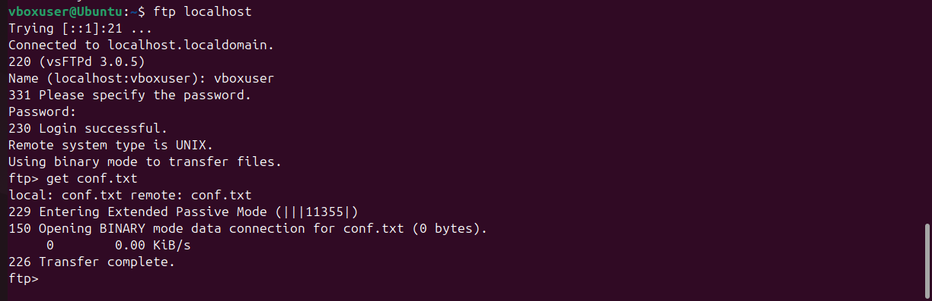
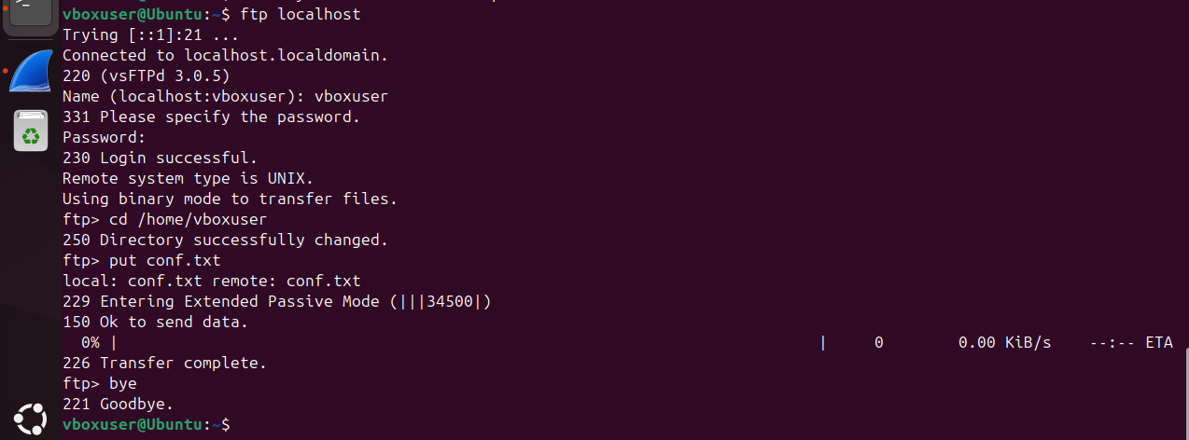
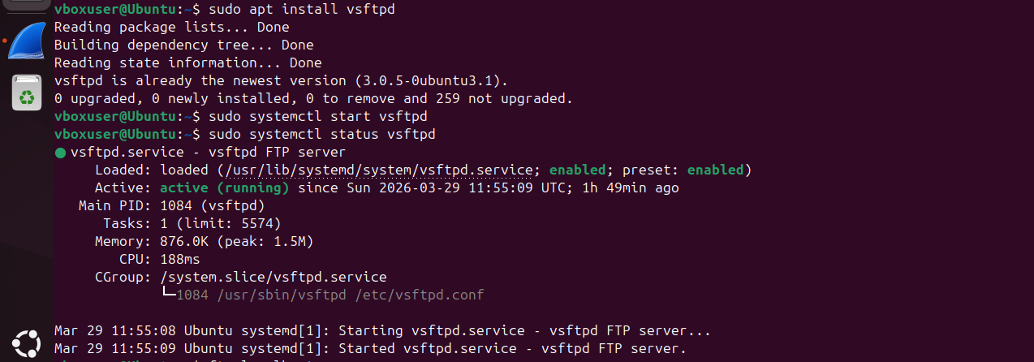
put conf.txt
get conf.txt
- Explore with Wireshark/TCP-dump/cisco packet tracer tools and learn about packets filters.
Commands:
tcpdump --version
sudo tcpdump -i enp0s3

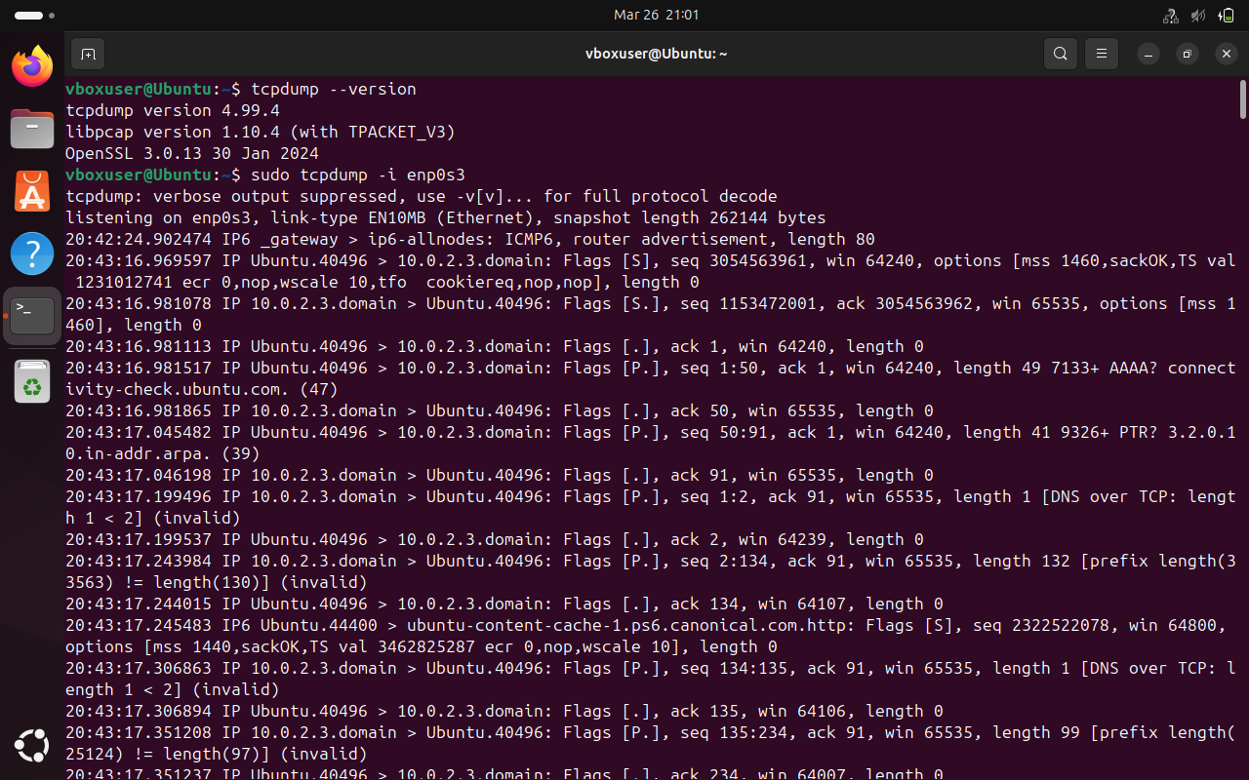

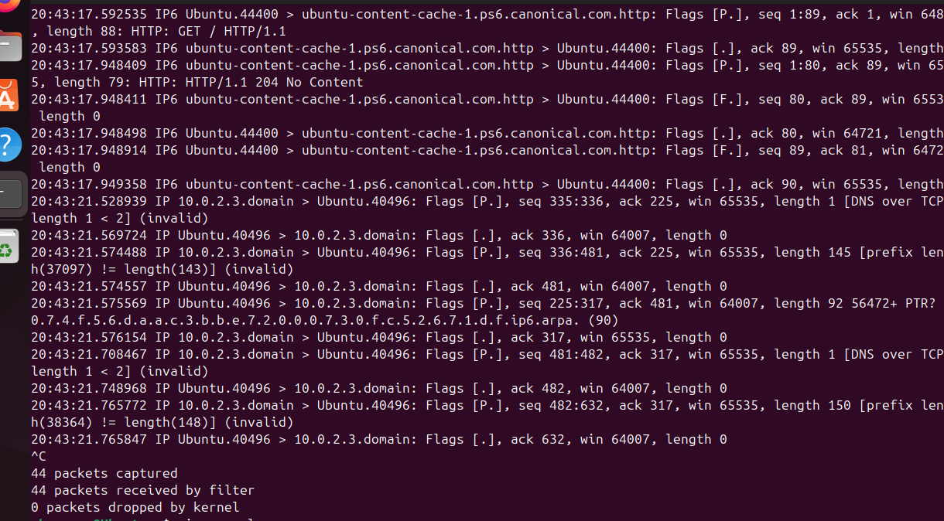

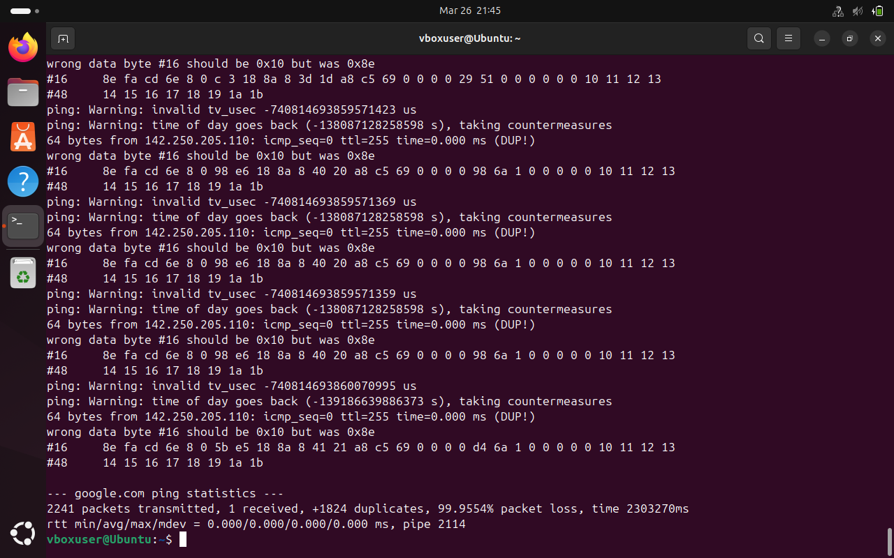
4.Understand linux utility commands like - ping, arp (Understand each params from ifconfig output)
Commands:
ping 8.8.8.8
arp -a
ifconfig
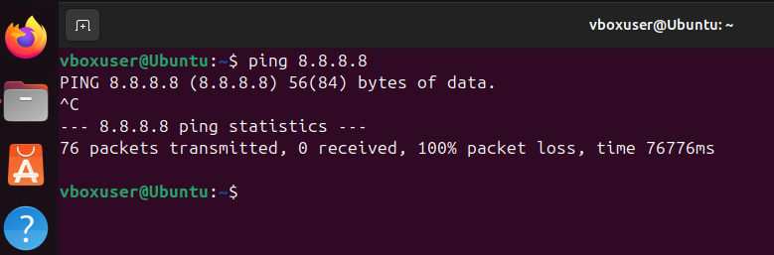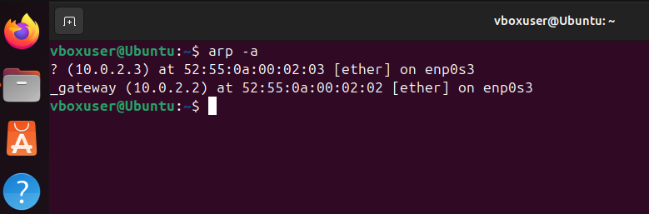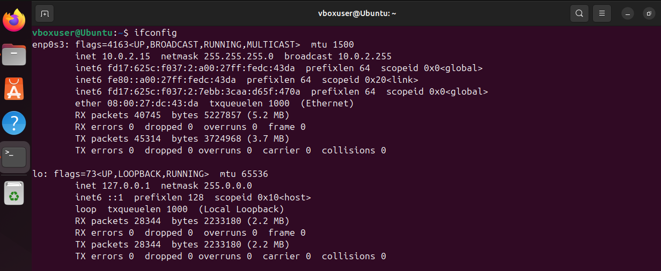

5.Understand what happens when duplicate IPs configured in a network.

When duplicate IP addresses are configured in a network, it causes an IP conflict because two devices share the same identity. This leads to communication problems, where data may be sent to the wrong device or not delivered at all. Devices may experience unstable or intermittent network connectivity. The ARP process gets confused, causing increased network traffic and reduced performance.To avoid this issue, each device must have a unique IP address, usually assigned using DHCP or proper manual configuration.
6.Understand how to access remote system using (VNC viewer, Anydesk, teamviewer and remote desktop connections)
Remote access allows a user to control another computer over a network using tools like VNC Viewer, AnyDesk, TeamViewer, and Remote Desktop Connection.
These applications work by sharing the remote system’s screen and allowing keyboard and mouse control.
The user connects using an IP address, ID, or hostname along with authentication (password or access code).
They are commonly used for technical support, remote work, and accessing files from distant locations.
A stable internet connection and proper permissions are required for secure and successful remote access
7.How to check your default gateway is reachable or not and understand about default gateway.
The default gateway is the network device (usually a router) that connects a local network to other networks, including the internet. To check if the default gateway is reachable, we can use the ping command followed by the gateway IP address (e.g., ping 192.168.1.1). If replies are received, it means the gateway is reachable and functioning properly. If there is no response, it may indicate network issues or that the gateway is down. Understanding the default gateway is important because it acts as the main path for data to leave the local network.
Commands:
ip route
ping 10.0.2.2
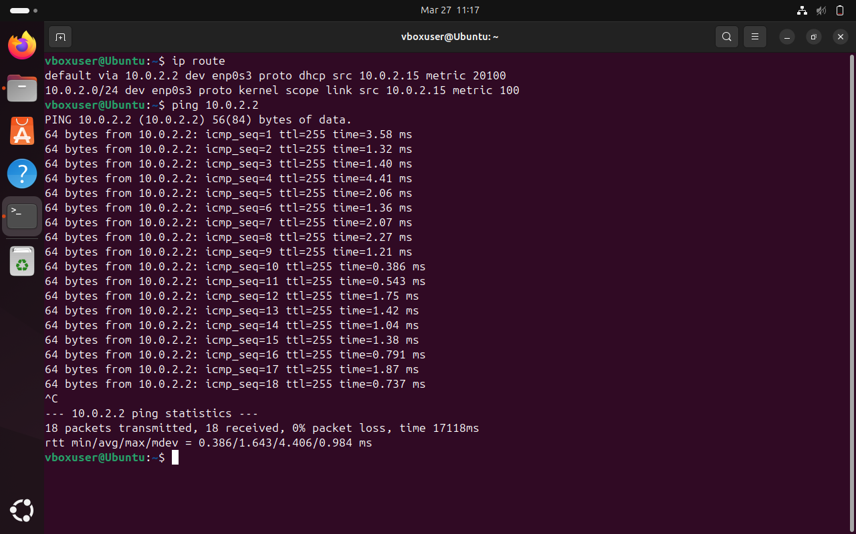
8.Check iwconfig/ifconfig to understand in detail about network interfaces (check about interface speed, MTU and other parameters)
ifconfig and iwconfig are Linux commands used to view and configure network interfaces. Using ifconfig, we can check details like IP address, MAC address, MTU (Maximum Transmission Unit), and interface status. The MTU defines the maximum packet size that can be transmitted over the network. iwconfig is specifically used for wireless interfaces and provides information such as SSID, frequency, signal strength, and transmission speed. Together, these commands help in understanding and troubleshooting both wired and wireless network configurations.
Commands:
ifconfig
iwconfig

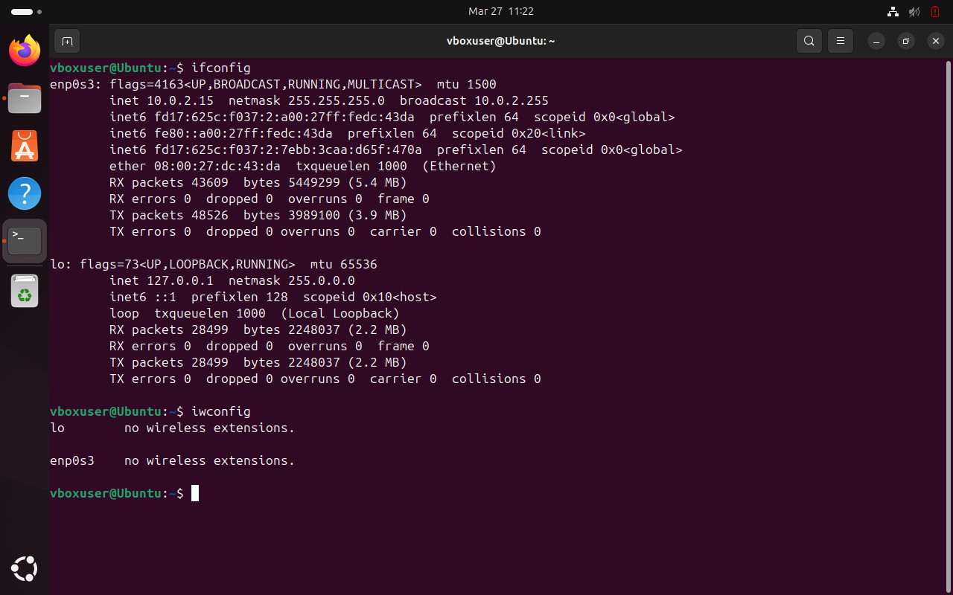
9.Log in to your home router’s web interface (usually at 192.168.1.1 or 192.168.0.1) and check the connected devices list.
I logged into my home router by entering the IP address like 192.168.1.1 in the web browser. Then it asked for the username and password, which I entered using the details given on the router. After logging in, I checked the “Connected Devices” section. It showed all the devices connected to my network along with their IP and MAC addresses. This helped me understand how many devices are using the network and identify any unknown devices.
10.Explain how a DHCP server assigns IP addresses to devices in your network.
A DHCP server automatically assigns IP addresses to devices in a network so that manual configuration is not required. When a device connects to the network, it sends a request asking for an IP address. The DHCP server responds by offering an available IP address along with other details like subnet mask and default gateway. The device then accepts the offer, and the server confirms the assignment for a specific time called a lease period. This process makes network management easier and avoids IP address conflicts.
11.Using a terminal, connect to a remote machine via SSH and telnet
SSH:
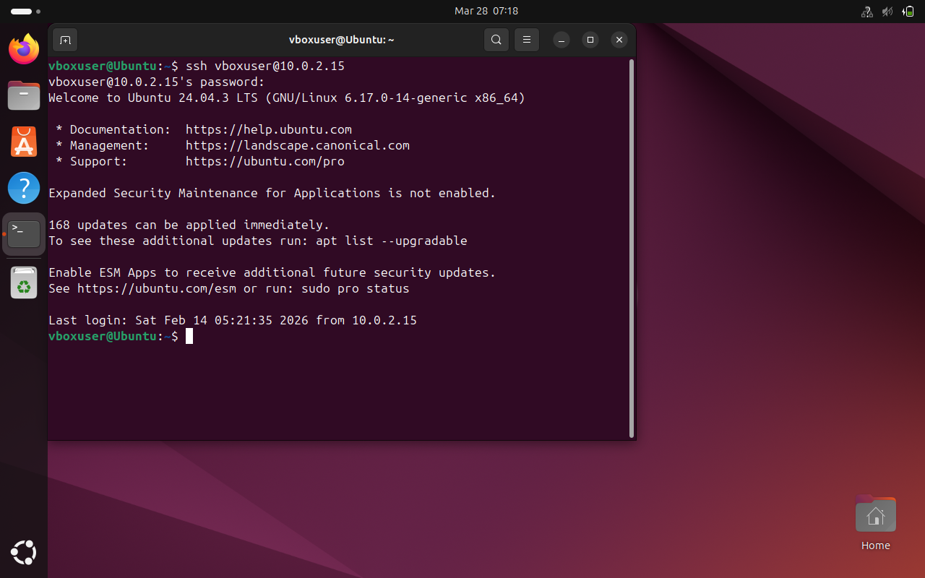
Telnet:
Telnet is a network protocol used to connect to a remote computer over a TCP/IP network using a command-line interface. It allows users to log in to another system and execute commands as if they were working directly on that machine. Telnet operates on port 23 and transmits data in plain text, which makes it less secure compared to SSH. Because of this lack of encryption, Telnet is mainly used for testing, troubleshooting, or in secure internal networks. Despite its limitations, it helps in understanding basic remote communication between systems.

