embedUR
Networking Assingment-2

Name:Saravanan D
Collage: VIT University
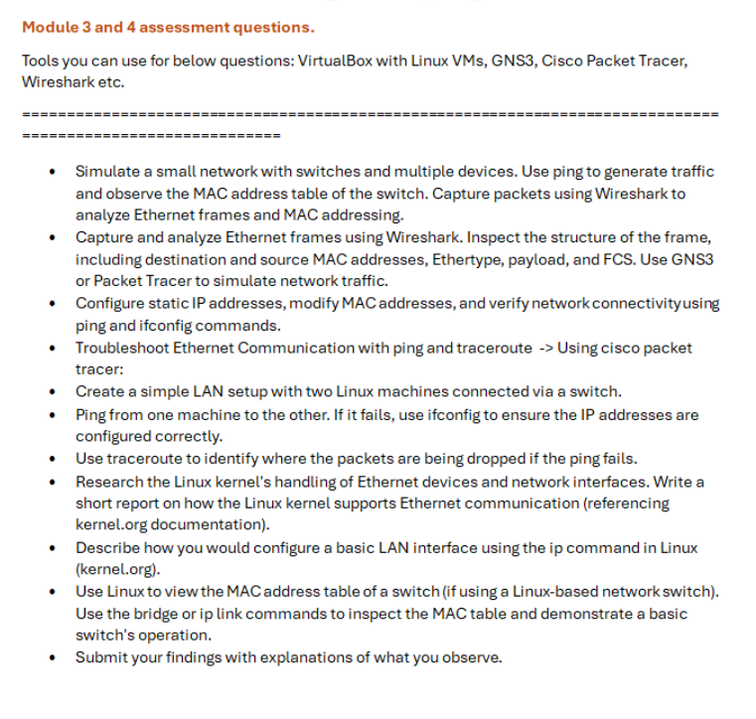
ip link
In VM1
Checking the network connectivity for internal network and NAT
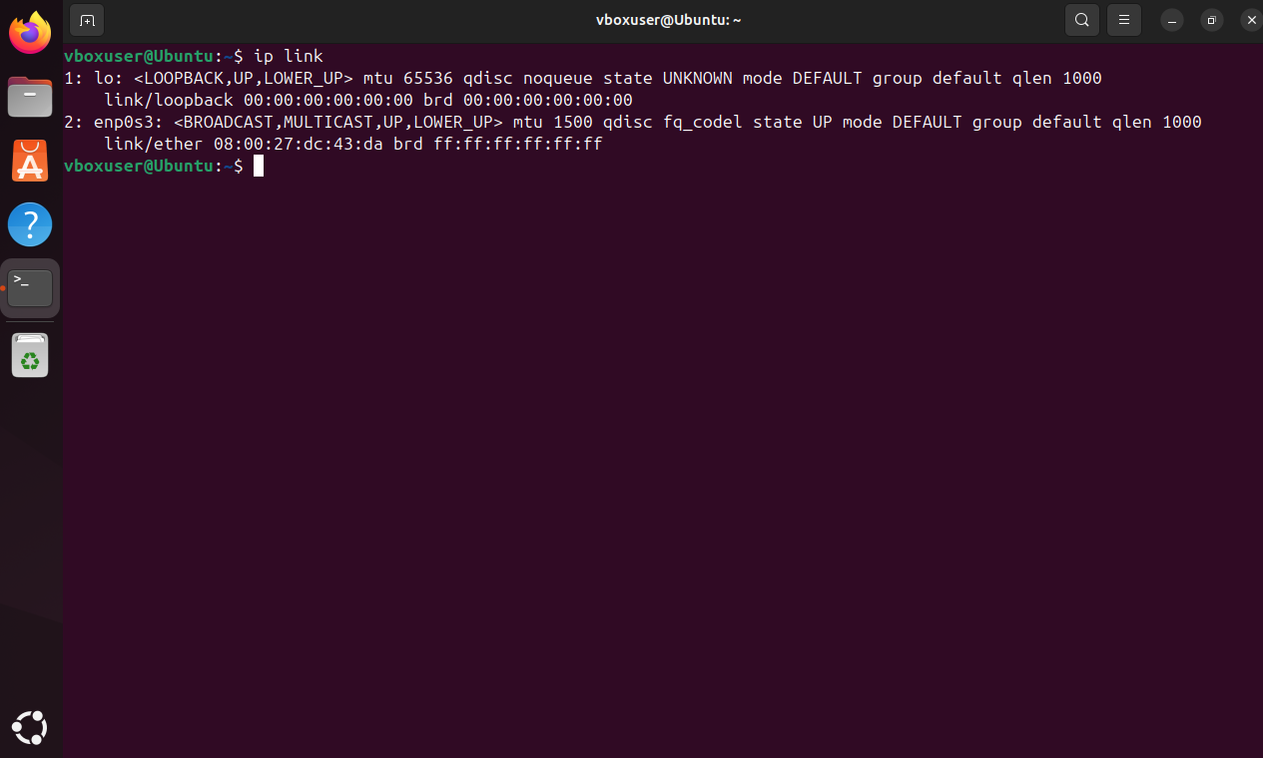

In VM2
Checking the network connectivity for internal network and NAT
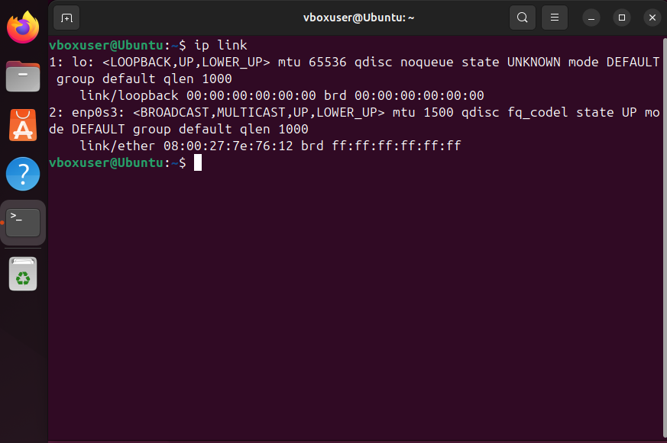

Configuration of ip addr
VM1
sudo ip addr add 192.168.1.10/24 dev enp0s3
sudo ip link set enp0s3 up
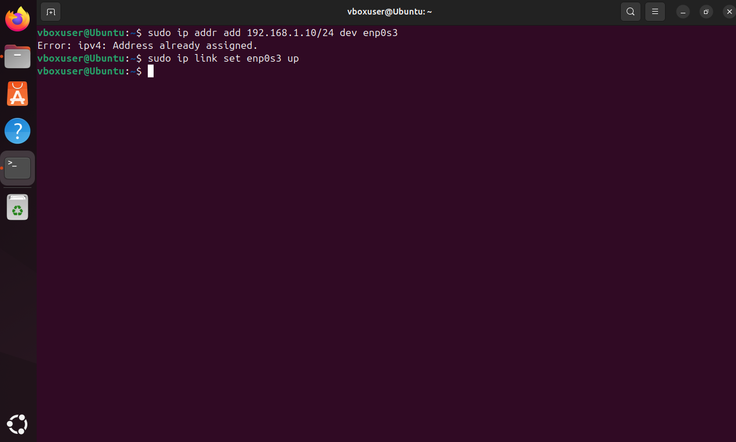
VM2
sudo ip addr add 192.168.1.20/24 dev enp0s3
sudo ip link set enp0s3 up
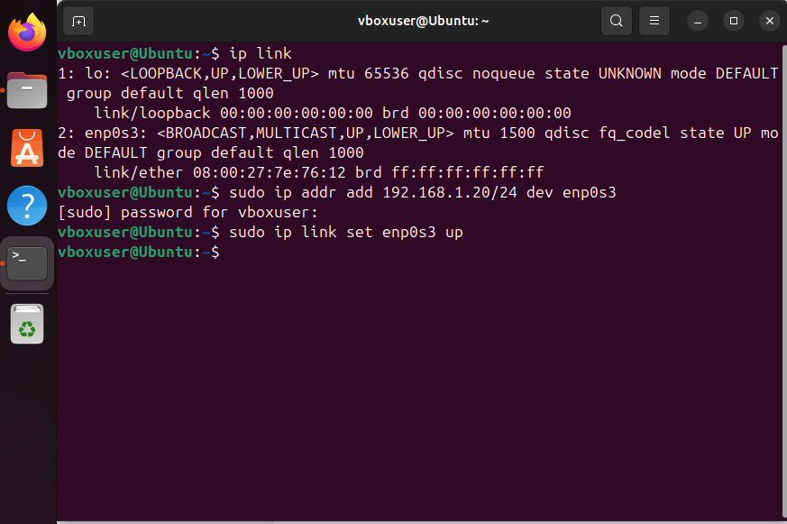
Checking the configured ip in ipnet

VM1
ip addr
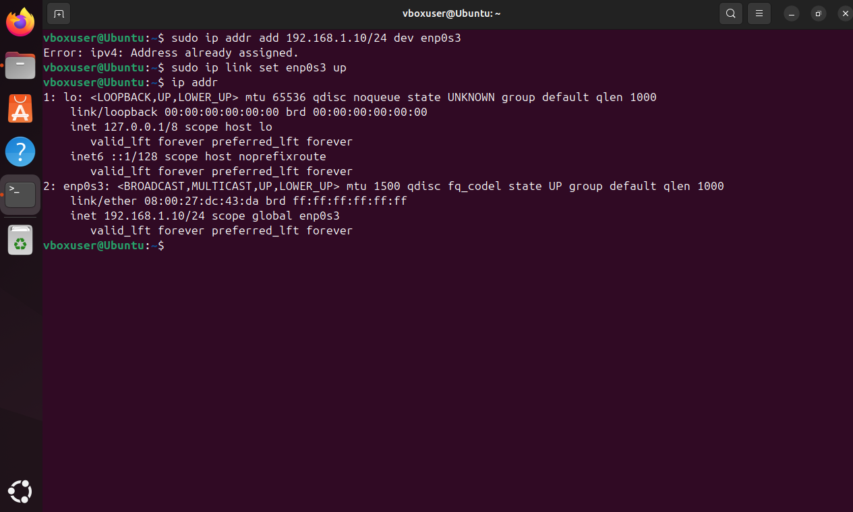
VM2
ip addr
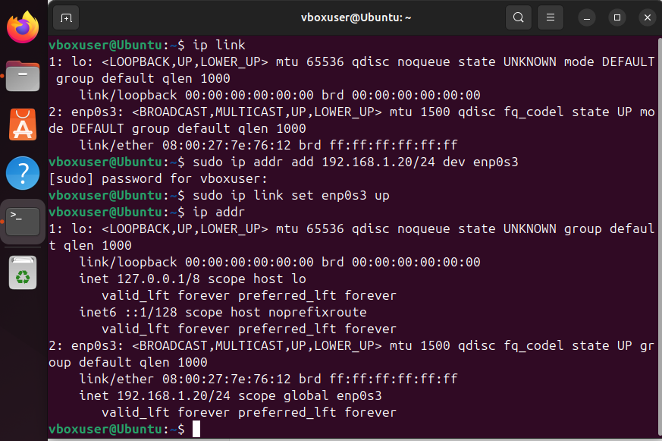

Pinging VM1 from VM2 and VM2 from VM1 to check the connectivity
VM1
ping 192.168.1.20
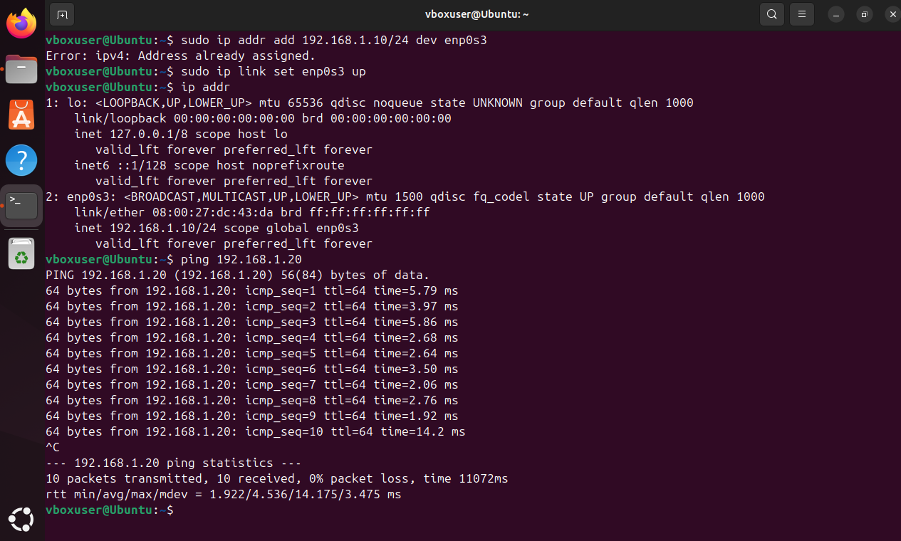
VM2
ping 192.168.1.10
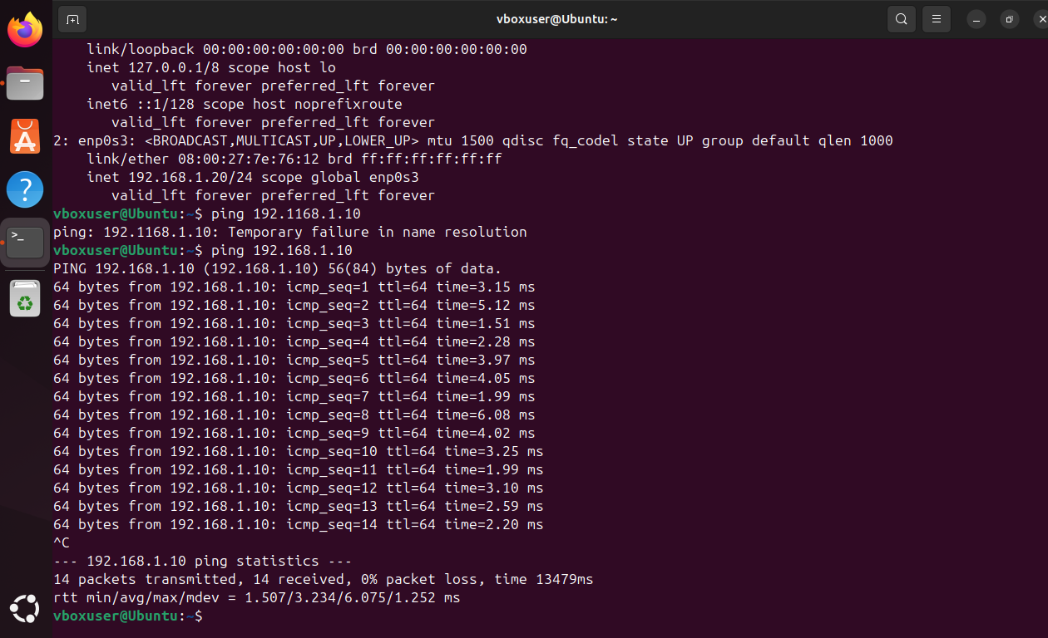
Install wireshark in both virtual machines to analyze the packets

After Installation VM2 sends packets to VM1
Wireshark observations:
In VM1
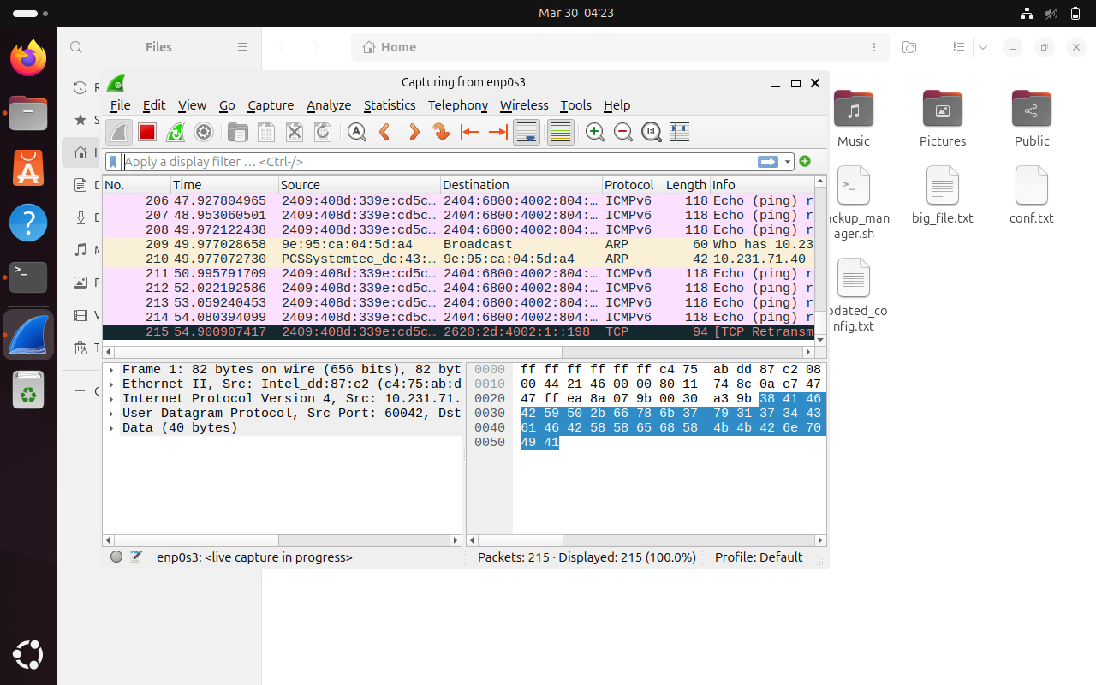
By clicking a packet we will se source,destination and path
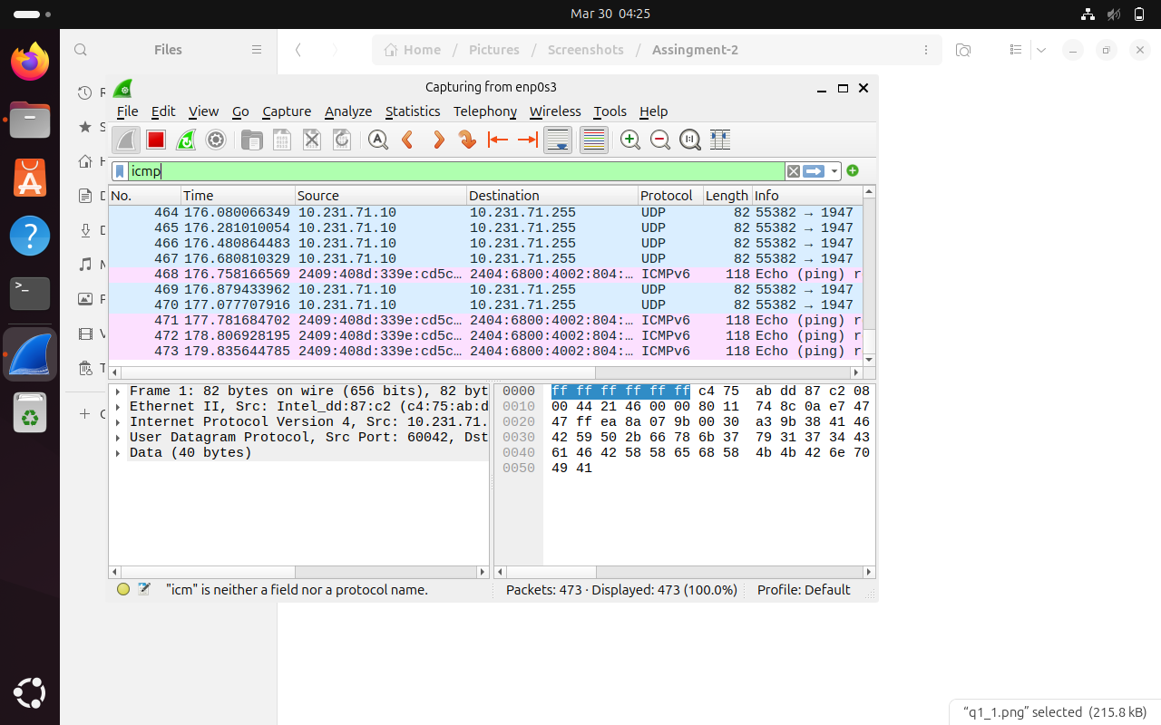
Applying icmp filter

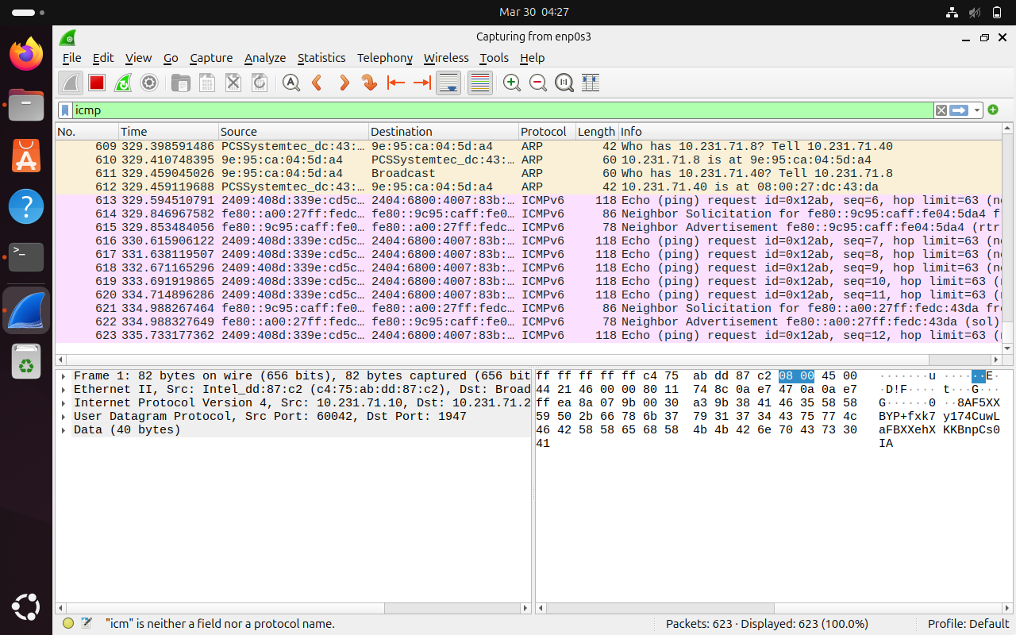
View MAC address
VM1:
ip link
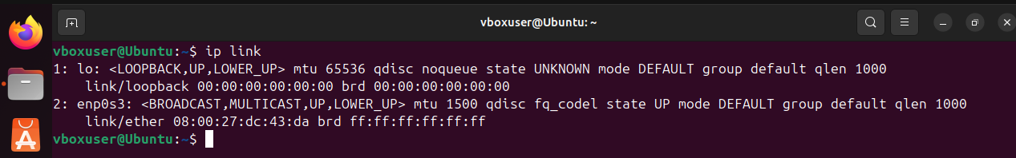
VM2:
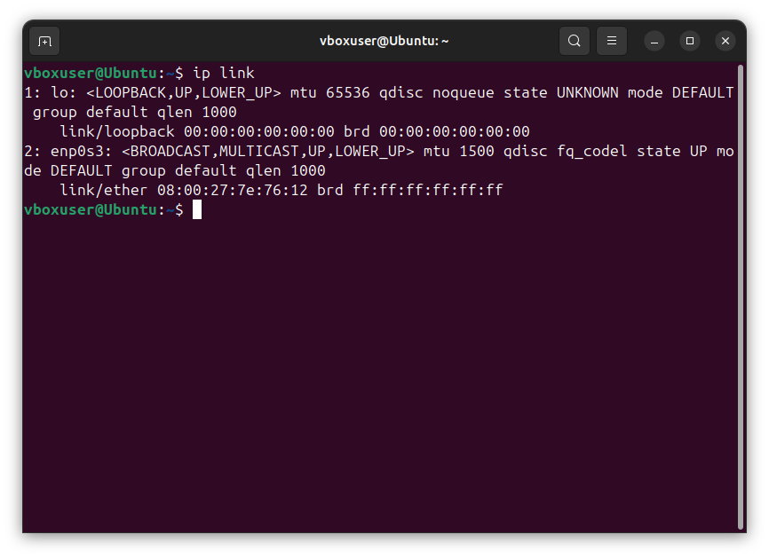

MAC address modifications:
In VM2:

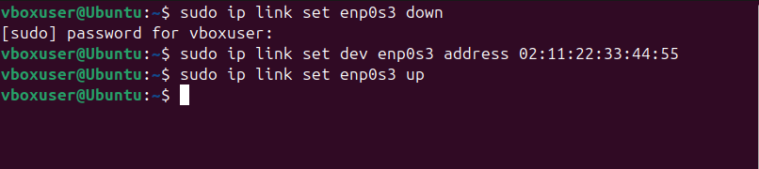

Verification after changing the MAC address
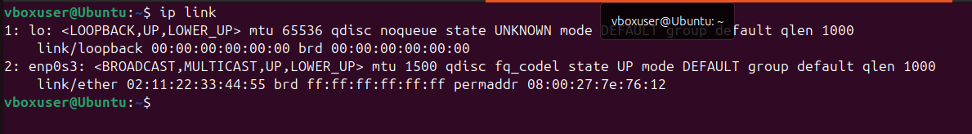

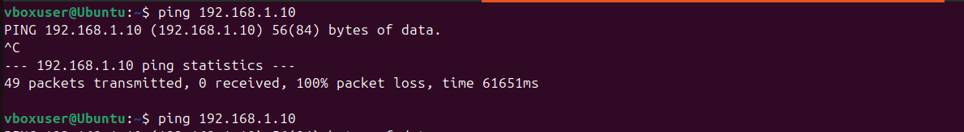

Host is not reachable due to change in MAC address
Reassign the ip addresses in both virtual machine and check the connection

Install Traceroute in both virtual mahines
traceroute google.com
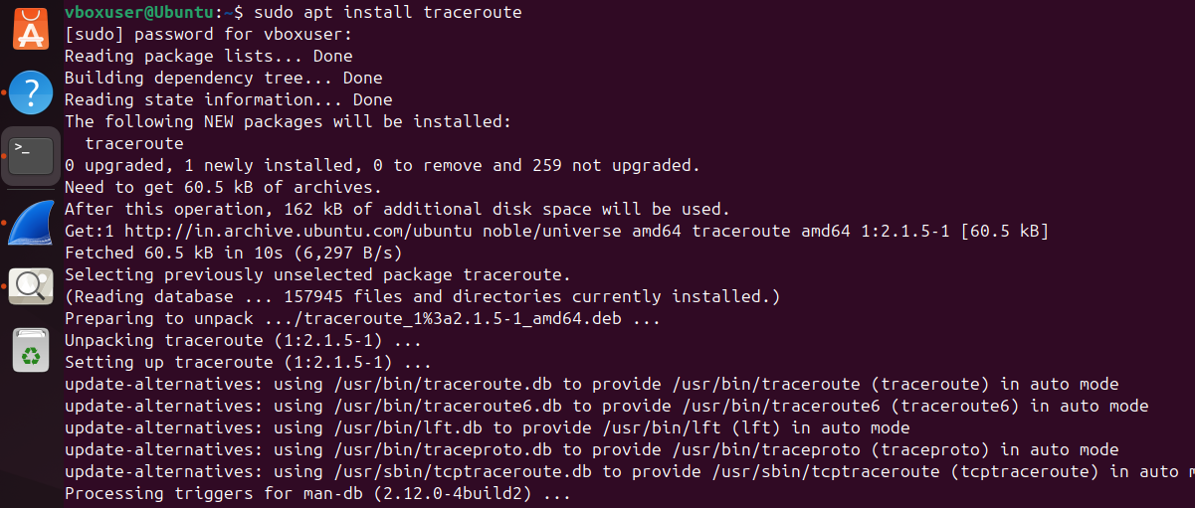

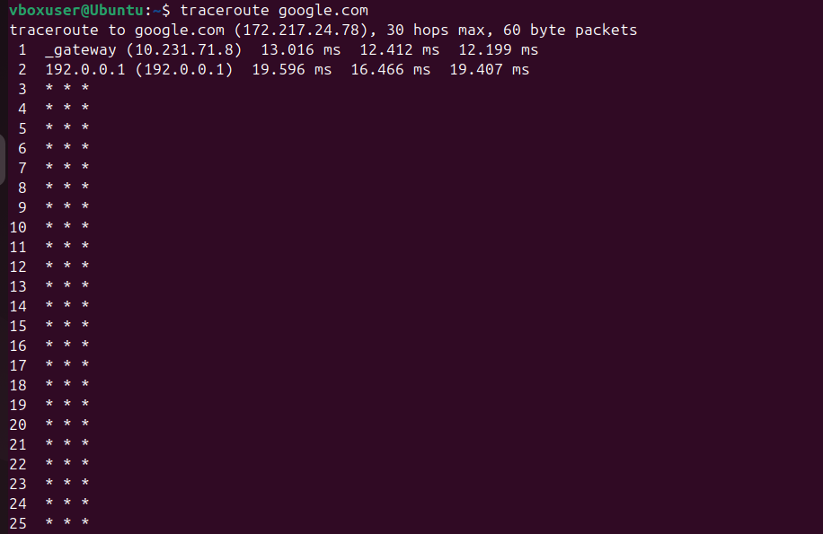

MAC address Table:
bridge fdb show

