embedUR
Networking Assingment-3

Name:Saravanan D
Collage: VIT University

1.Capture and analyze ARP packets using Wireshark. Inspect the ARP request and reply frames, and discuss the role of the sender's IP and MAC address in these packets.

Commands:
sudo wireshark
ping google.com
arp
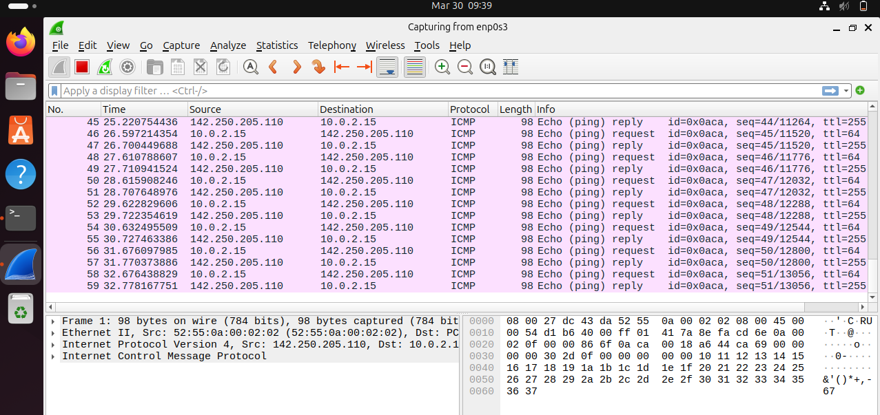
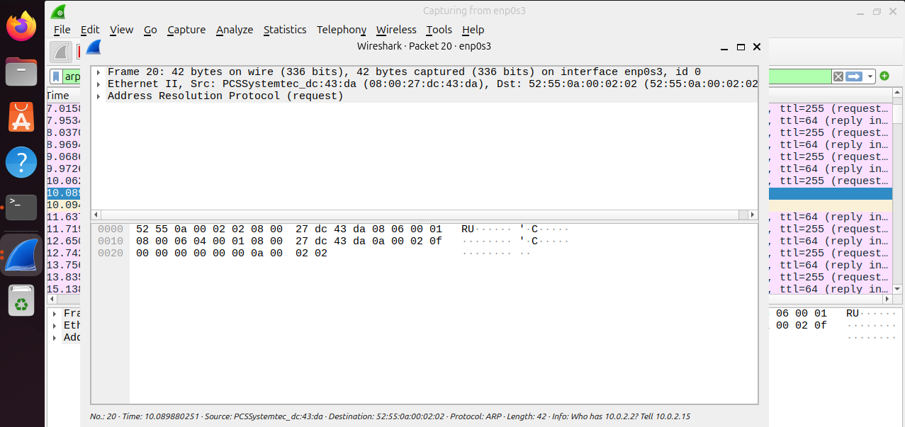
After installing wireshark to capture packets opened a new terminal to hop packets to capture
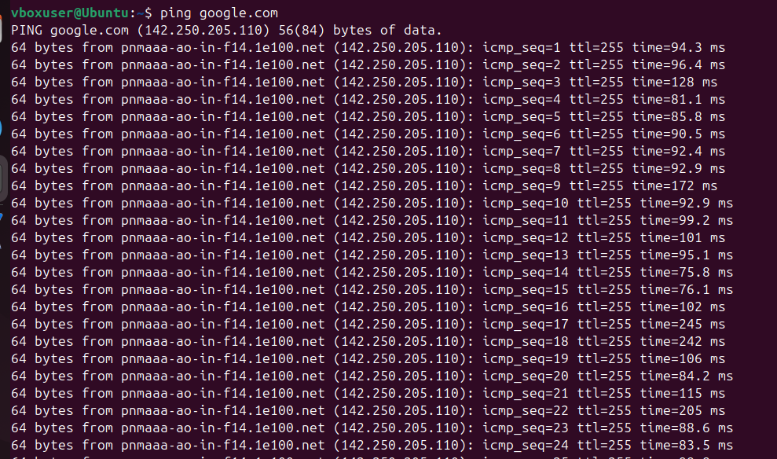

In an ARP packet, the sender’s IP address and MAC address help identify the device that is sending the request. The sender’s IP address shows which device on the network is asking for the MAC address of another device. The sender’s MAC address represents the physical address of that device’s network interface. When another device receives the ARP request, it can see both the sender’s IP and MAC address and know exactly where to send the ARP reply. This process helps devices in the same local network find each other and communicate correctly.
2.Using Packet Tracer, simulate an ARP spoofing attack. Analyze the behavior of devices on the network when they receive a malicious ARP response.
SETUP:
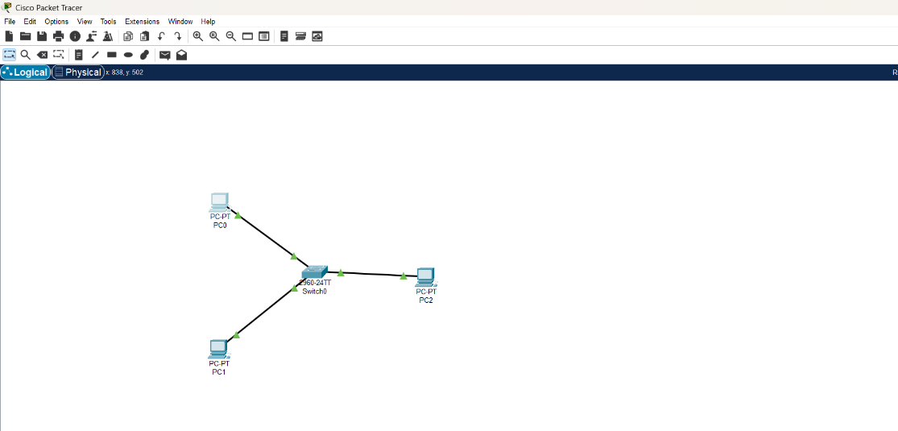
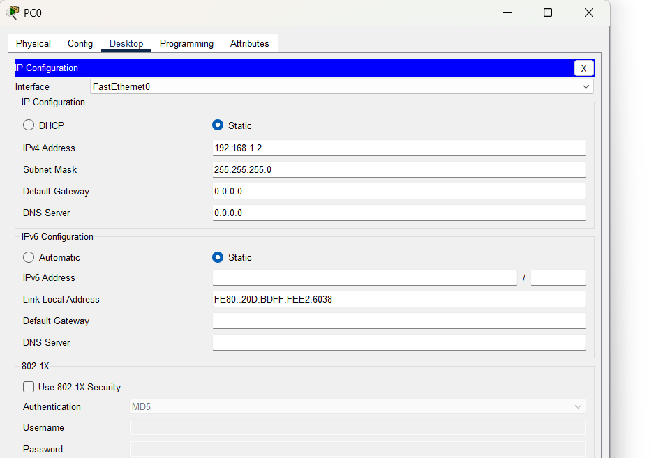
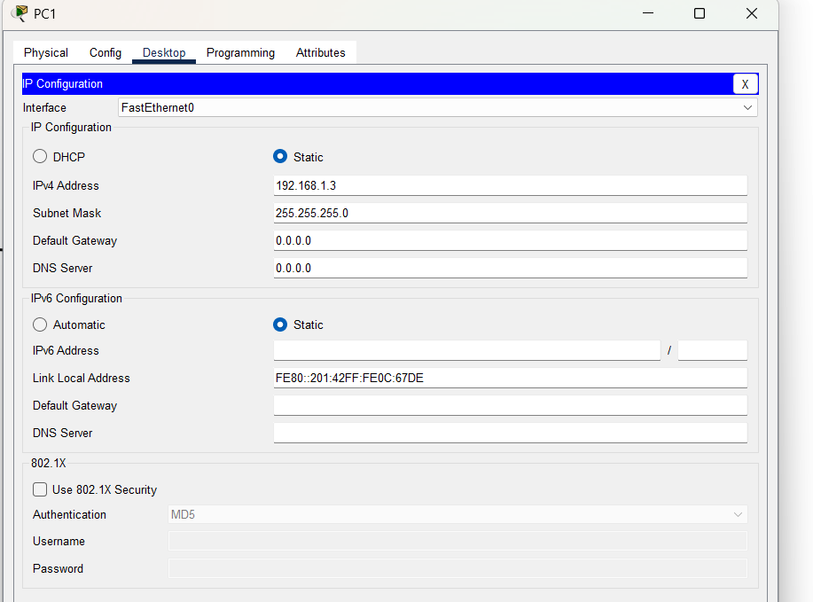

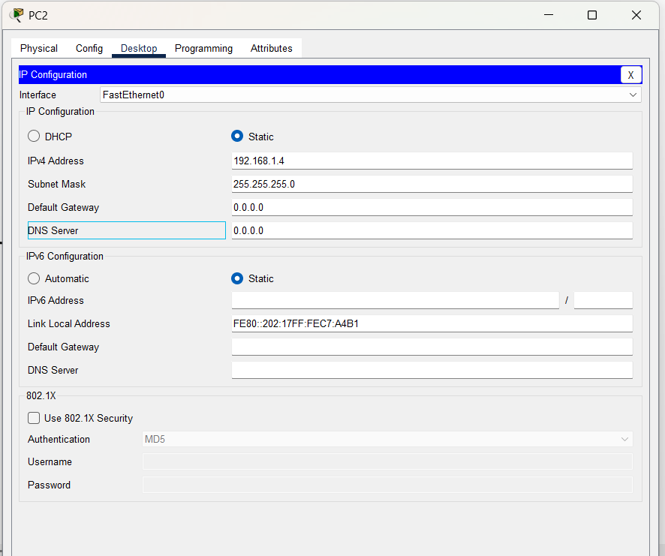
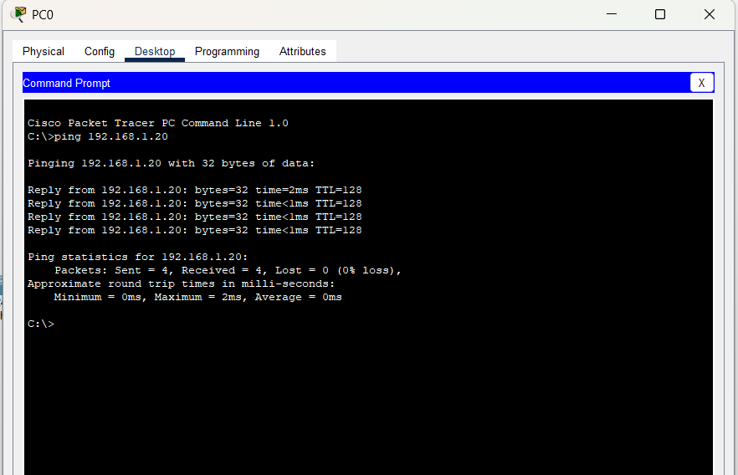
ARP spoofing is a type of network attack where an attacker sends fake ARP messages to a network. The attacker associates their MAC address with the IP address of another device, such as a router or another computer. Because of this, other devices send their data to the attacker instead of the real device. This allows the attacker to intercept or monitor the communication between devices.
3.Manually configure static IPs on the client devices (like Pc or your mobile phone) and verify connectivity using ping.
Commands
ip a
sudo ifconfig enp0s3 10.0.2.20 netmask 255.255.255.0
sudo route add default gw 10.0.2.2
ip a
ping 8.8.8.8
ip a (shows all the ip in the network)
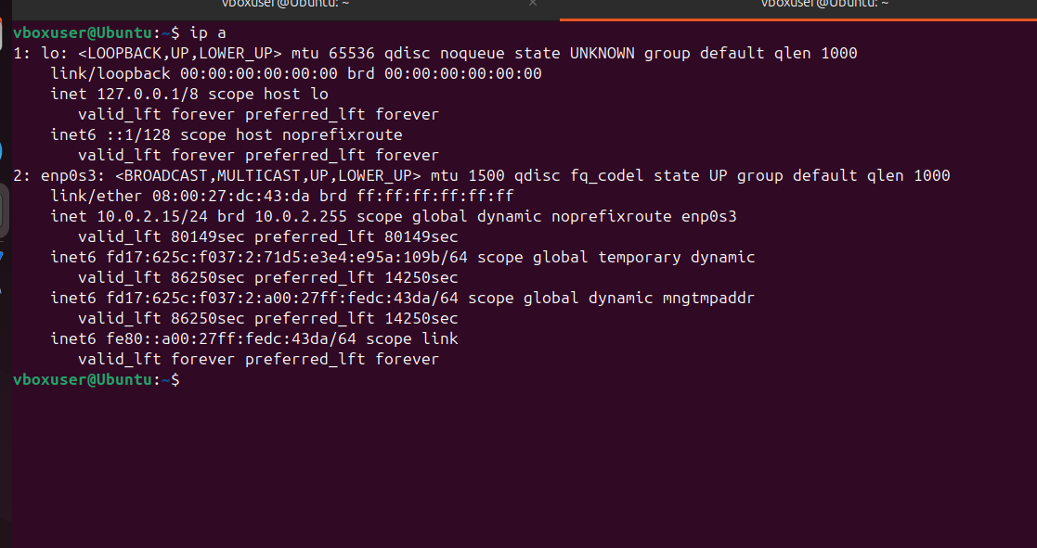

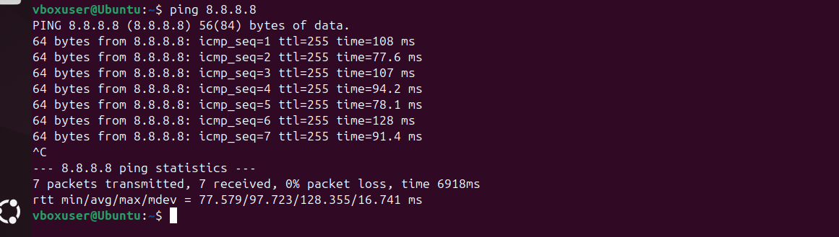

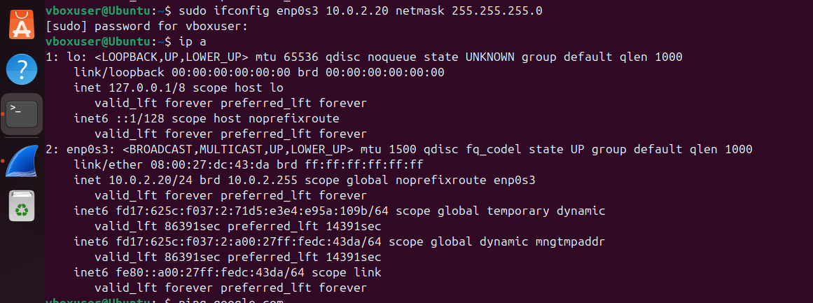
4.Use Wireshark to capture DHCP Discover, Offer, Request, and Acknowledge messages and explain the process
Commands:
sudo wireshark
sudo apt update
sudo apt install isc-dhcp-client
sudo dhclient -v enp0s3

Wireshark Filter
dhcp
Open enp0s3 in wireshark

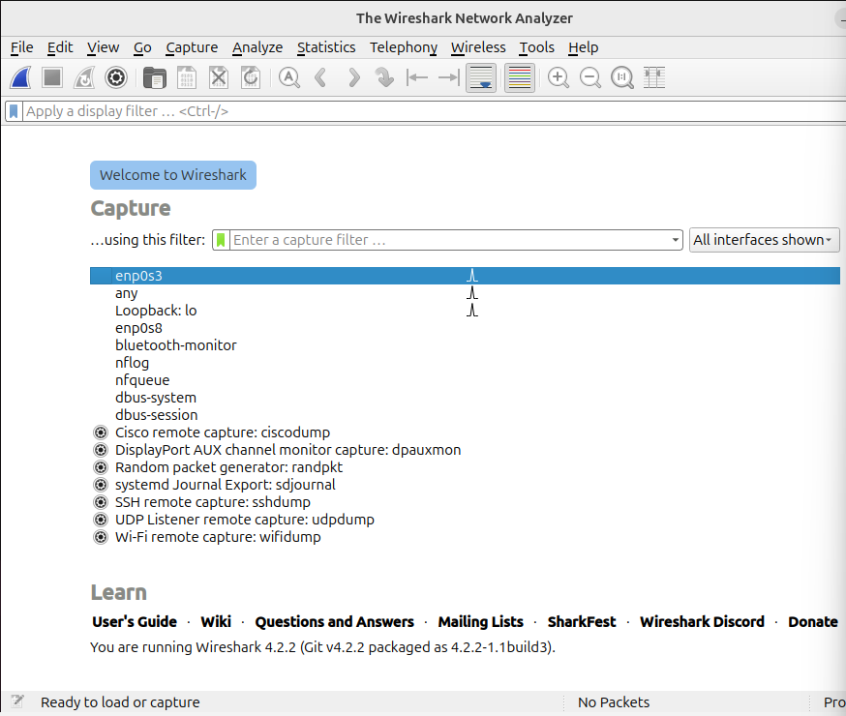

Apply dhcp filter in the top in the display filter

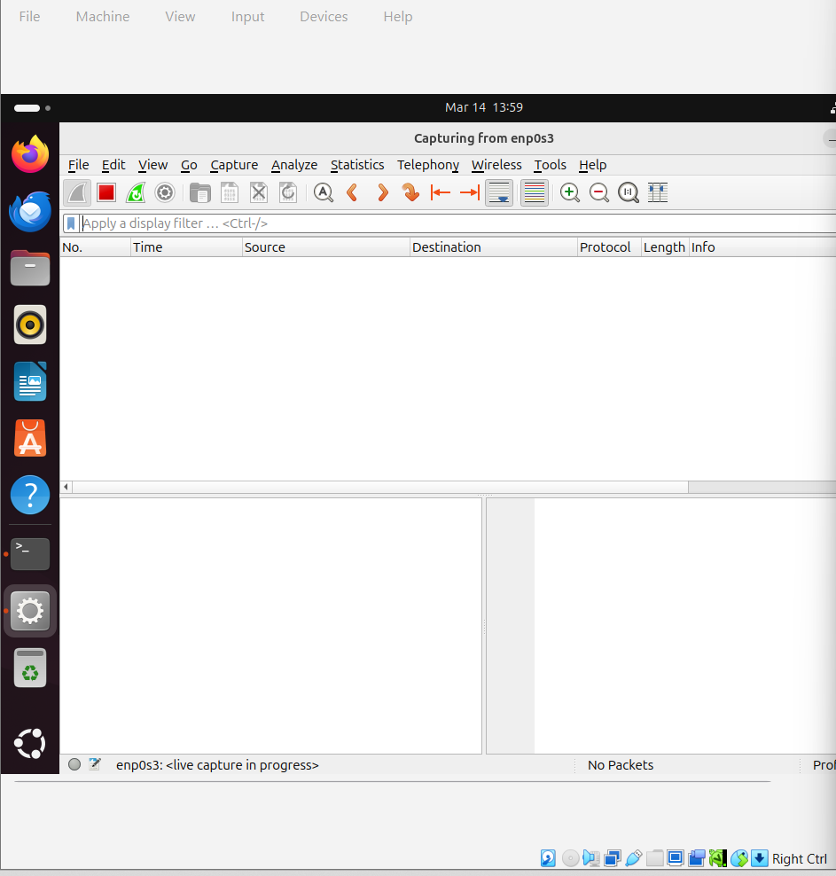
Applying
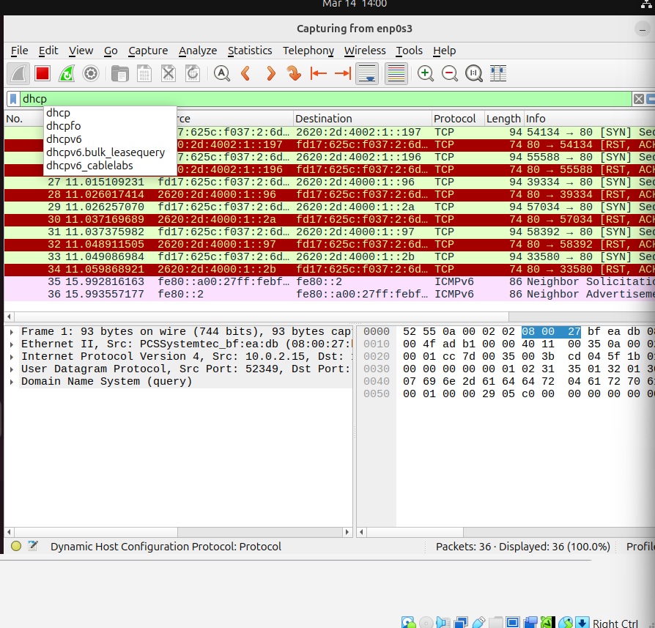

Dhcp packets
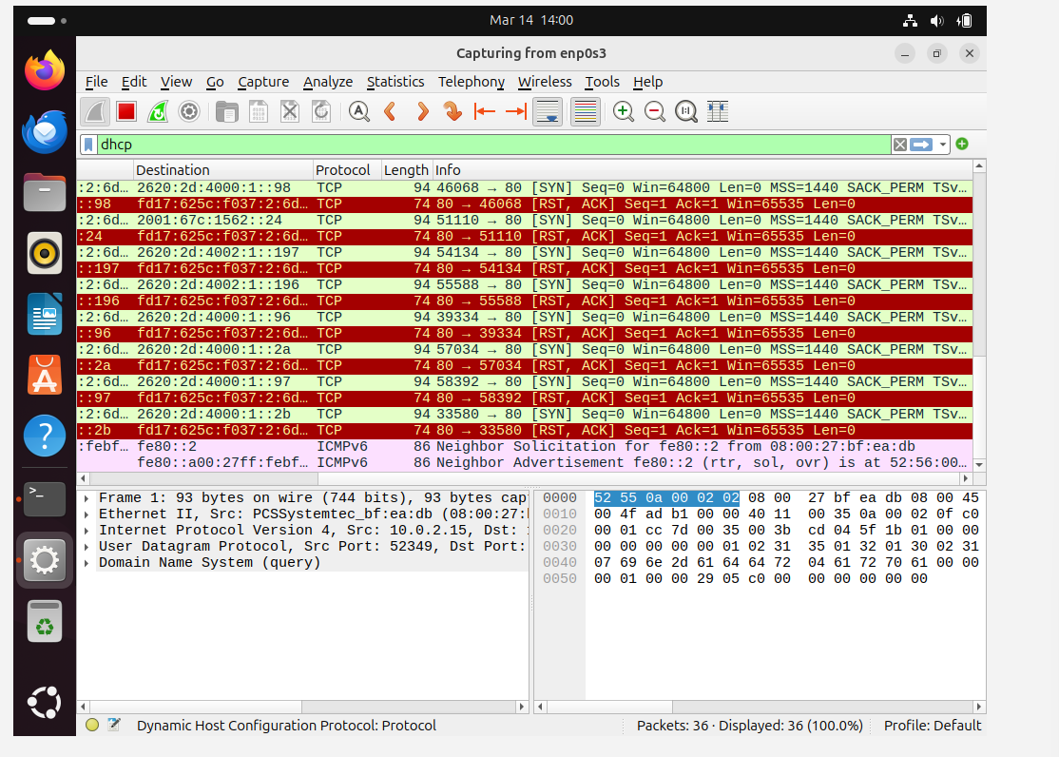
Assign a new ip
Using command sudo dhclient -v enp0s3

DHCP is used to automatically assign IP addresses to devices in a network. The DHCP process consists of four steps known as the DORA process: Discover, Offer, Request, and Acknowledge. In the experiment, Wireshark was used to capture DHCP packets generated when the client requested an IP address from the DHCP server.
5.Given an IP address range of 192.168.1.0/24, divide the network into 4 subnets.

Subnetting Calculation
The given network address is 192.168.1.0/24. The /24 indicates that the subnet mask is 255.255.255.0, which means the first 24 bits are used for the network and the remaining bits are used for hosts.
The task is to divide this network into 4 smaller subnets. To create 4 subnets, we need to borrow bits from the host portion. The formula used is:
2ⁿ ≥ number of required subnets
Since we need 4 subnets, we borrow 2 bits because:
2² = 4
After borrowing 2 bits from the host portion, the new prefix becomes:
/24 + 2 = /26
So the new subnet mask becomes 255.255.255.192.
Next, the block size is calculated using the formula:
Block Size = 256 − Subnet Mask value
256 − 192 = 64
This means each subnet increases by 64 addresses. Using this block size, the four subnets are:
- 192.168.1.0/26
Host range: 192.168.1.1 – 192.168.1.62
Broadcast: 192.168.1.63
- 192.168.1.64/26
Host range: 192.168.1.65 – 192.168.1.126
Broadcast: 192.168.1.127
- 192.168.1.128/26
Host range: 192.168.1.129 – 192.168.1.190
Broadcast: 192.168.1.191
- 192.168.1.192/26
Host range: 192.168.1.193 – 192.168.1.254
Broadcast: 192.168.1.255
Thus, the network 192.168.1.0/24 was successfully divided into 4 smaller subnets, each with 62 usable host addresses.

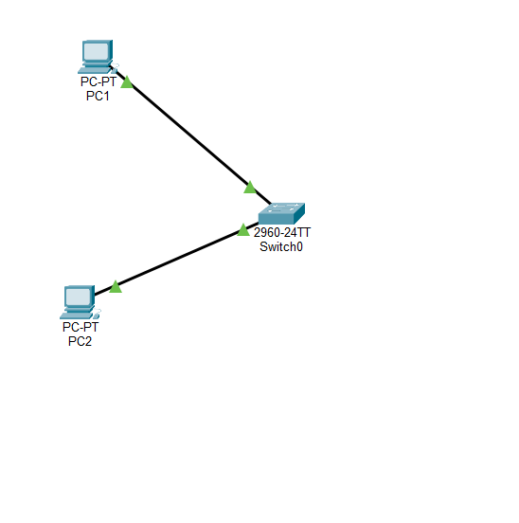
Pinging pc2 from pc1 command prompt
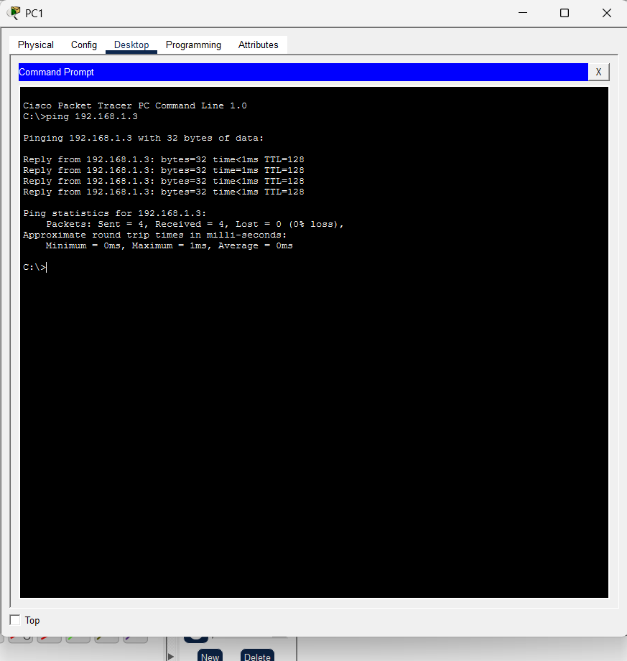

6)You are given three IP addresses: 10.1.1.1, 172.16.5.10, and 192.168.1.5.

Task: Identify the class of each IP address (Class A, B, or C). What is the default subnet mask for each class?

IP addresses are divided into different classes based on the value of the first number (first octet) of the address. This range was defined in the original IP addressing system to organize networks of different sizes.
If the first number of the IP address is between 1 and 126, it belongs to Class A, and its default subnet mask is 255.0.0.0. Class A networks are designed for very large networks because they support a large number of hosts.
If the first number is between 128 and 191, it belongs to Class B, with a default subnet mask of 255.255.0.0. Class B networks are meant for medium-sized networks.
If the first number falls between 192 and 223, it belongs to Class C, and its default subnet mask is 255.255.255.0. Class C networks are typically used for smaller networks with fewer devices.
By checking the first number of each IP address, we can easily determine which class it belongs to and identify its default subnet mask.
IP Address | Class | Default Subnet Mask | Range
10.1.1.1 | Class A | 255.0.0.0 | 1.0.0.0 – 126.255.255.255
172.16.5.10 | Class B | 255.255.0.0 | 128.0.0.0 – 191.255.255.255
192.168.1.5 | Class C | 255.255.255.0 | 192.0.0.0 – 223.255.255.255

7)Provide the range of IP addresses for each class.v7) In Cisco Packet Tracer, create a small network with multiple devices (e.g., 2 PCs and a router). Use private IP addresses (e.g., 192.168.1.x) on the PCs and configure the router to perform NAT to allow the PCs to access the internet.

Task: Test the NAT configuration by pinging an external IP address from the PCs and capture the traffic using Wireshark.

What is the source IP address before and after NAT?

Commands:
enable
configure terminal
interface g0/0
ip address 192.168.1.1 255.255.255.0
no shutdown
exit
interface g0/0
ip nat inside
exit
interface g0/1
ip nat outside
exit
access-list 1 permit 192.168.1.0 0.0.0.255
ip nat inside source list 1 interface g0/1 overload
Network
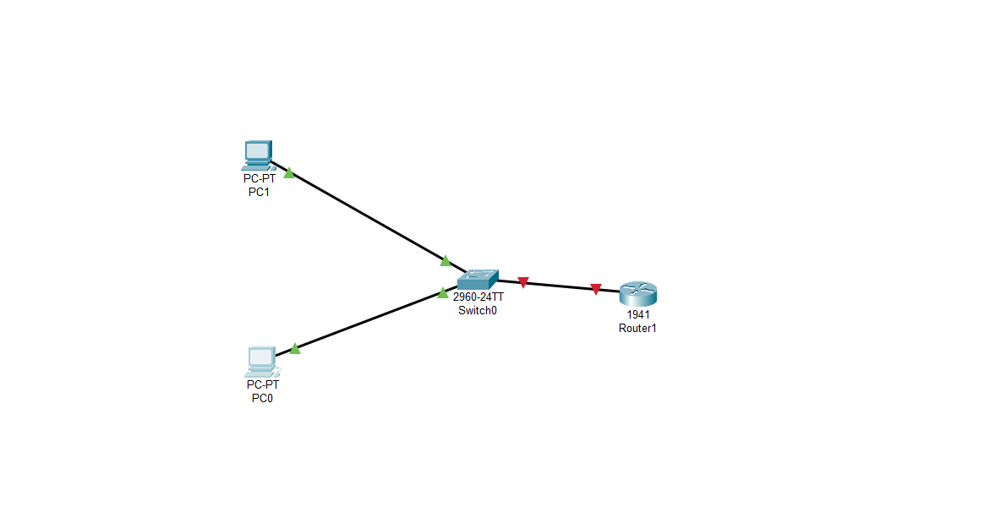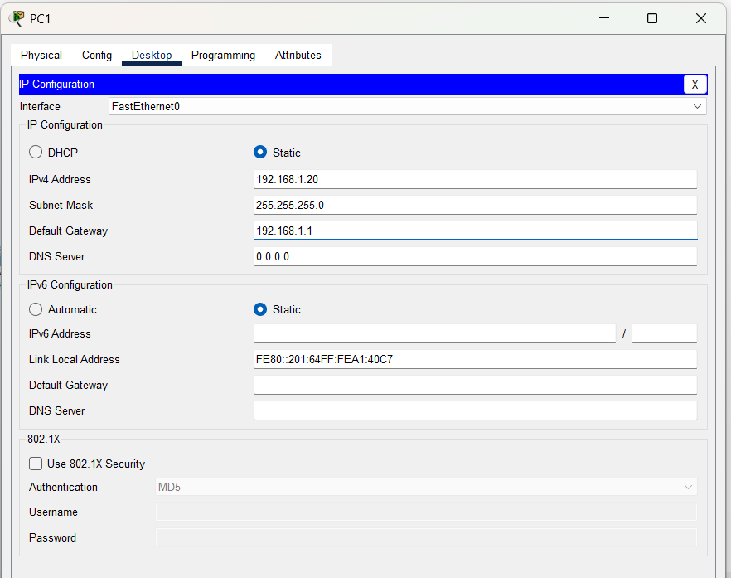
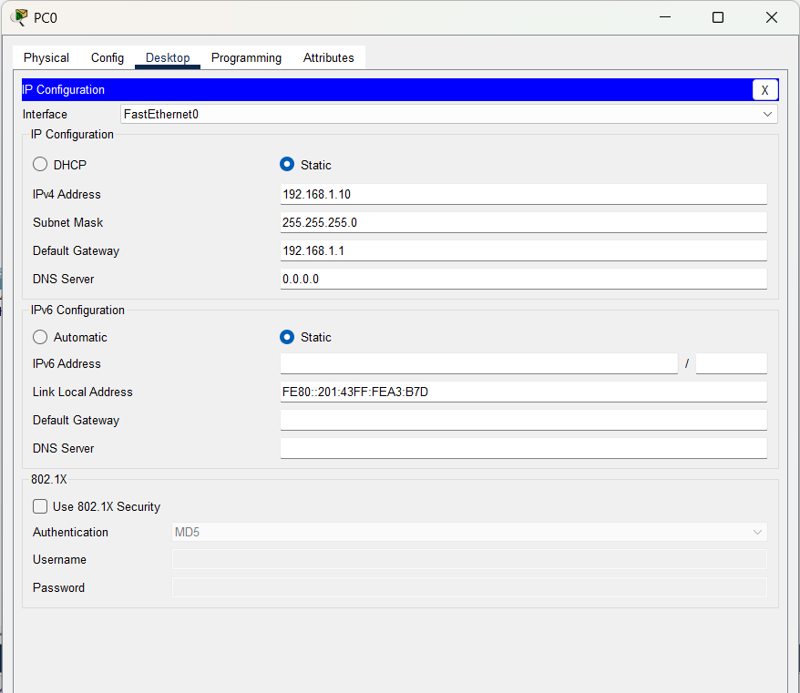
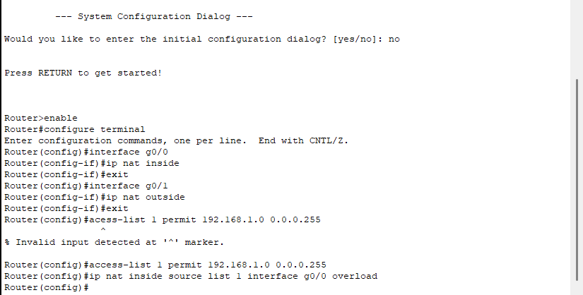
In this experiment, NAT was configured on a router to allow devices with private IP addresses to communicate with external networks. The router translated the internal private addresses into a public address, enabling multiple devices in the network to share a single public IP. This demonstrates how NAT helps conserve IP addresses and enables communication between internal networks and the internet.

