embedUR
Networking Assingment-3

Name:Saravanan D
Collage: VIT University
1))
arp -a
This command shows the ARP table stored in your system.
sudo ip neigh flush all
It clears all ARP entries from the ARP table.
Meaning the system forgets all MAC addresses.
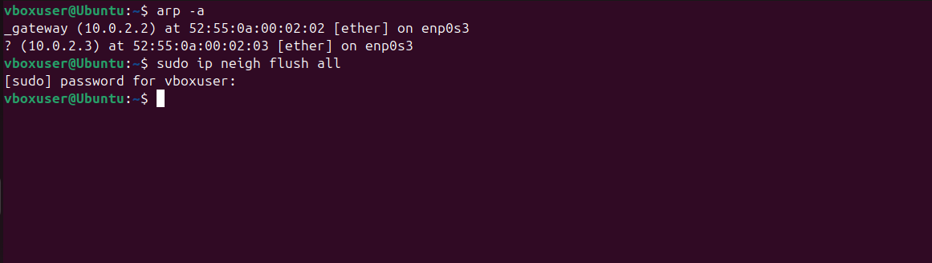

Open wireshark
sudo wireshark
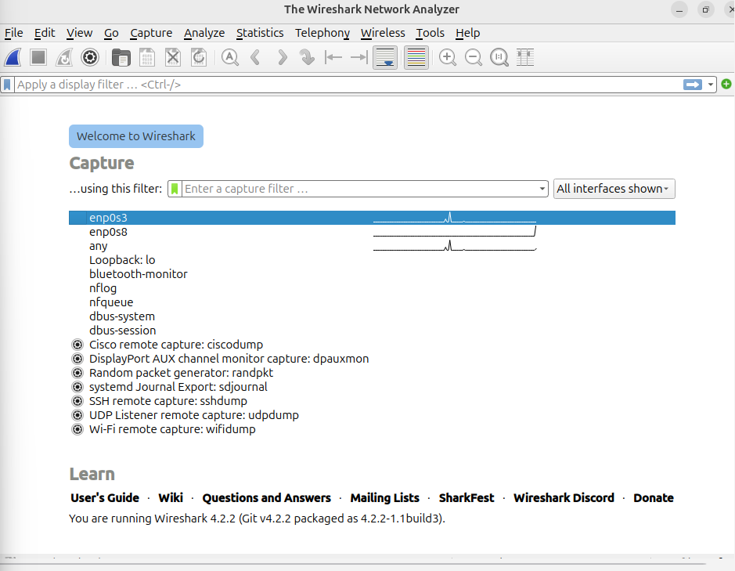
Select interface enp0s3
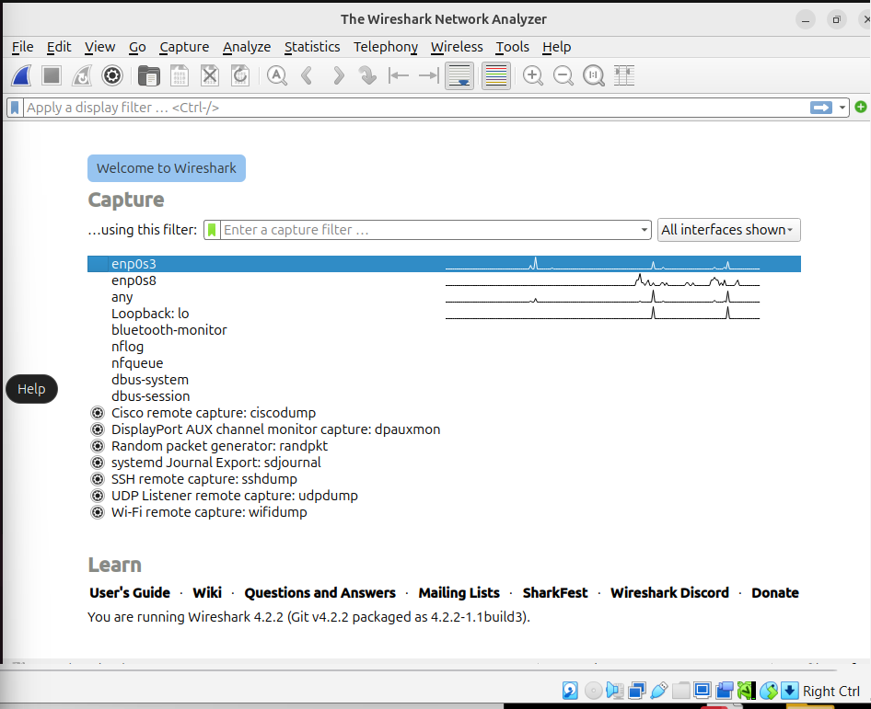
Apply arp filter in the display
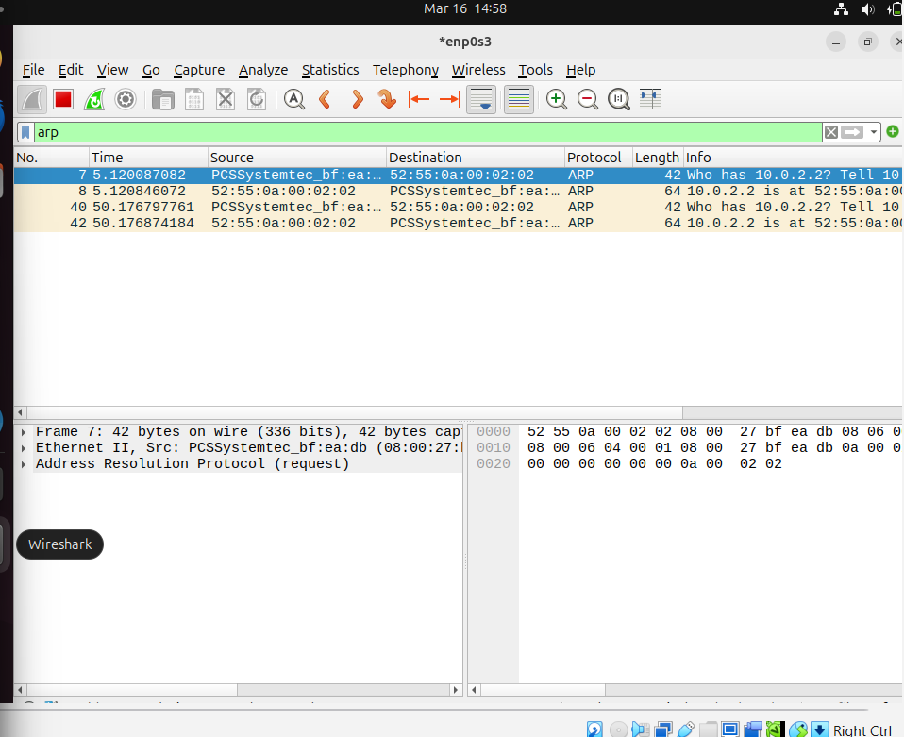

Ping google.com in a new terminal to verify the arp request to the router to connect internet to ping google.com
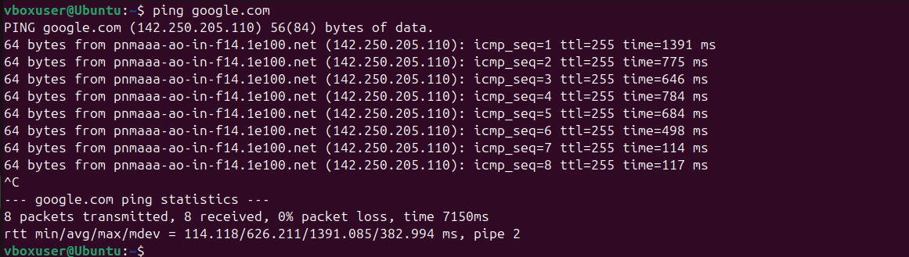
arp
The router replies:
"I am 10.0.2.2 and my MAC address is 52:55:0a:00:02:02"
This is an ARP Reply.
Now your PC knows the router MAC.

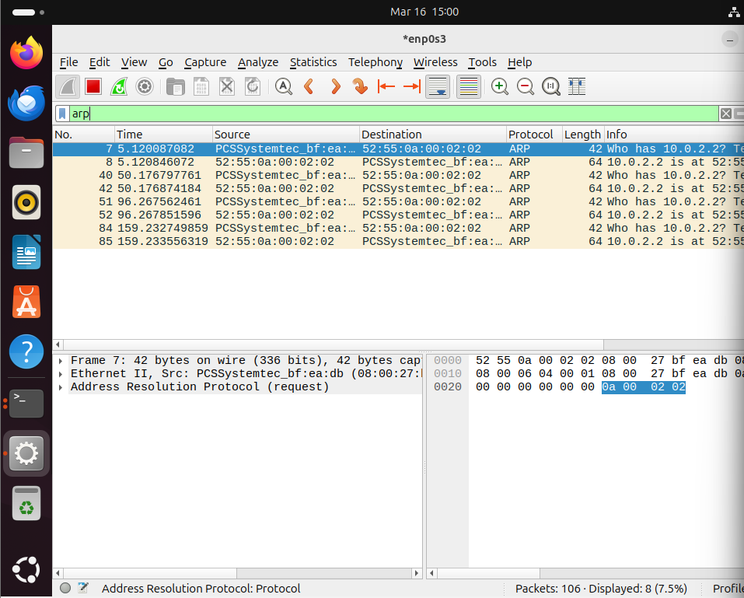
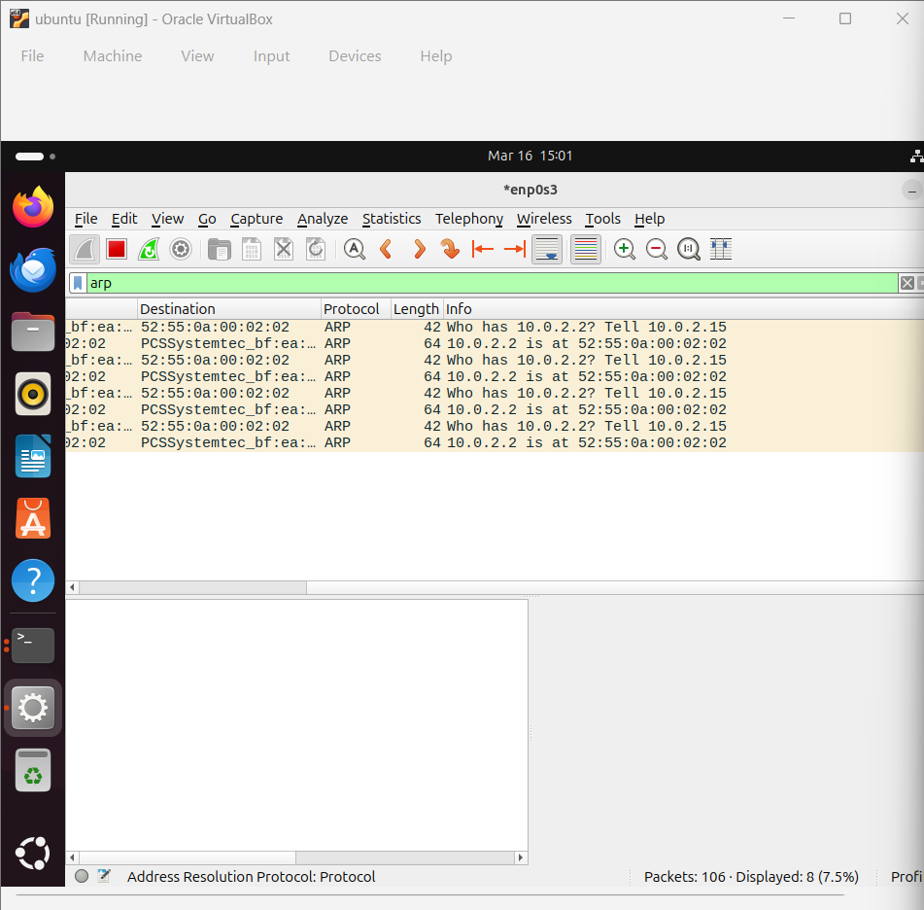
2))
Ip route

Part | Meaning
default | default gateway
via 10.0.2.2 | router address
dev enp0s3 | network interface
src 10.0.2.15 | your IP

Add a Static Route
Command:
sudo ip route add 192.168.2.0/24 via 10.0.2.2
:
Destination network → 192.168.2.0
Subnet mask → /24
Next hop router → 10.0.2.2

Checking the ip route added :
Command:
Ip route
:
Here 192.168.2.0/24
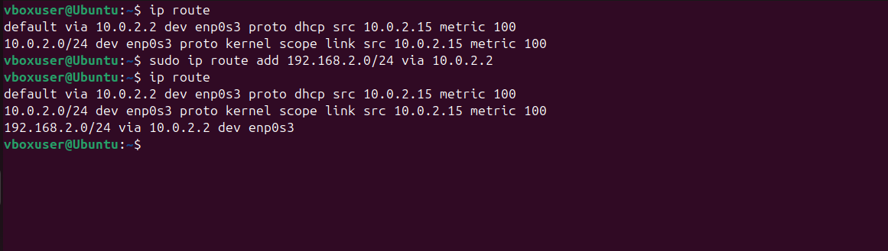
Traceroute of the packets having the destination 192.168.2.0/24

Max 30 hops
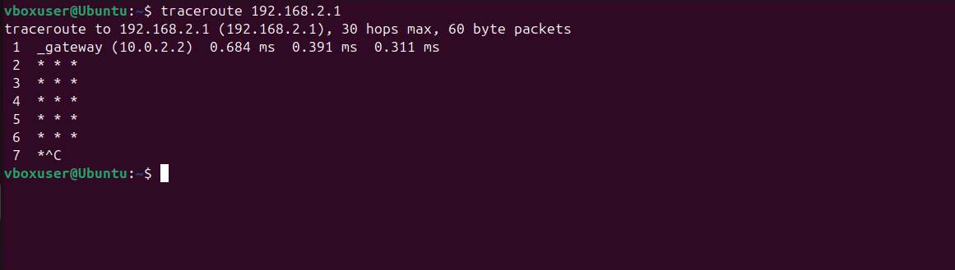

3))
The given network address is 10.0.0.0/24. The /24 indicates that the first 24 bits represent the network portion, while the remaining 8 bits represent the host portion of the IP address. The subnet mask corresponding to /24 is 255.255.255.0.
A /24 network contains a total of 256 IP addresses (from 10.0.0.0 to 10.0.0.255). Out of these, the first address is the network address and the last address is the broadcast address, leaving 254 usable host addresses.
The question requires dividing this network into 4 equal subnets. To achieve this, we need to borrow some bits from the host portion of the address. The number of subnets created depends on the formula:
Number of subnets = 2^n
where n is the number of borrowed bits.
Since we need 4 subnets, we determine the value of n as follows:
2^2 = 4
Therefore, we borrow 2 bits from the host portion.
Originally, the network had a prefix of /24. After borrowing 2 bits, the new prefix becomes:
/26
The subnet mask for /26 is:
255.255.255.192
This means each subnet will contain 64 IP addresses. This value can also be calculated using the block size formula:
Block Size = 256 − 192 = 64
Therefore, the subnet ranges increase in increments of 64.
Starting from 10.0.0.0, the four subnets are determined as follows:

Subnet 1
Network Address: 10.0.0.0/26
Usable Host Range: 10.0.0.1 – 10.0.0.62
Broadcast Address: 10.0.0.63

Subnet 2
Network Address: 10.0.0.64/26
Usable Host Range: 10.0.0.65 – 10.0.0.126
Broadcast Address: 10.0.0.127

Subnet 3
Network Address: 10.0.0.128/26
Usable Host Range: 10.0.0.129 – 10.0.0.190
Broadcast Address: 10.0.0.191

Subnet 4
Network Address: 10.0.0.192/26
Usable Host Range: 10.0.0.193 – 10.0.0.254
Broadcast Address: 10.0.0.255

In conclusion, the network 10.0.0.0/24 has been successfully divided into four equal subnets using a /26 subnet mask. Each subnet contains 64 addresses (62 usable hosts) and can be used to assign IP addresses to devices in different network segments.
This subnetting process helps in organizing networks efficiently, reducing broadcast traffic, and improving network management.

3)) practical part
network
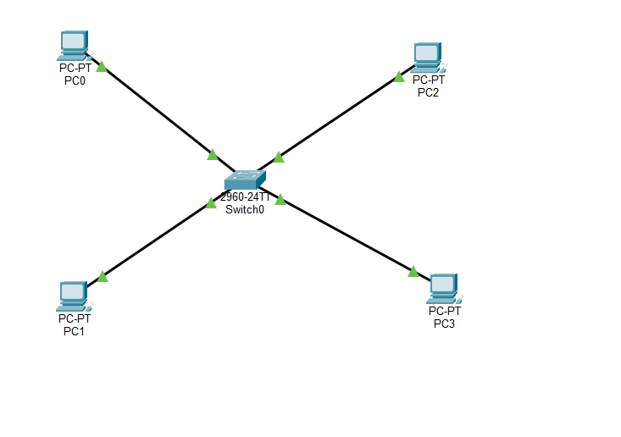
Pc0
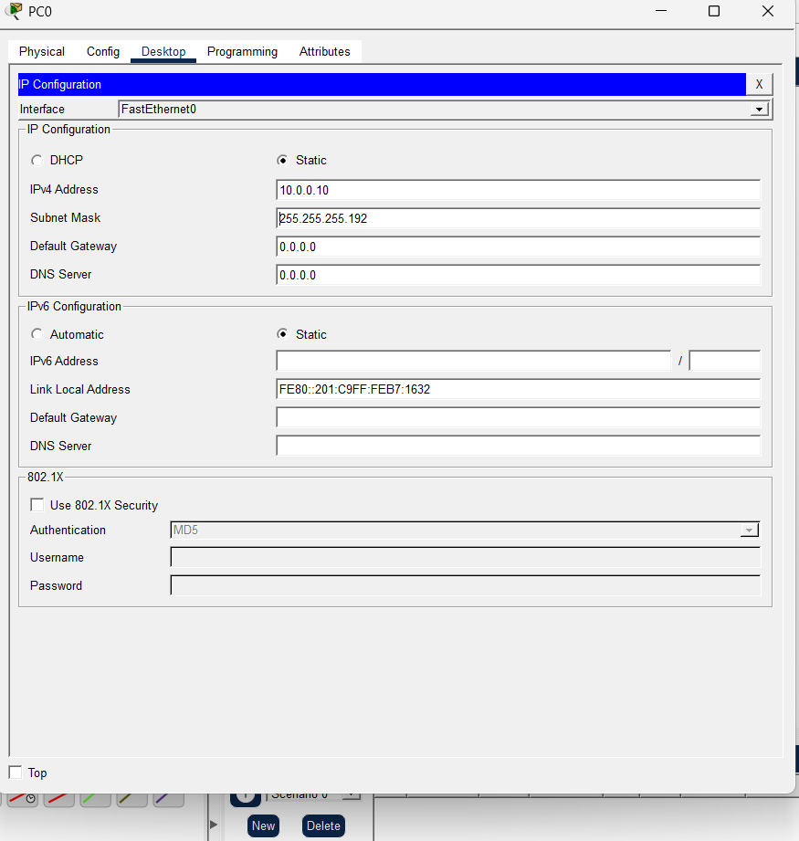

Pc1
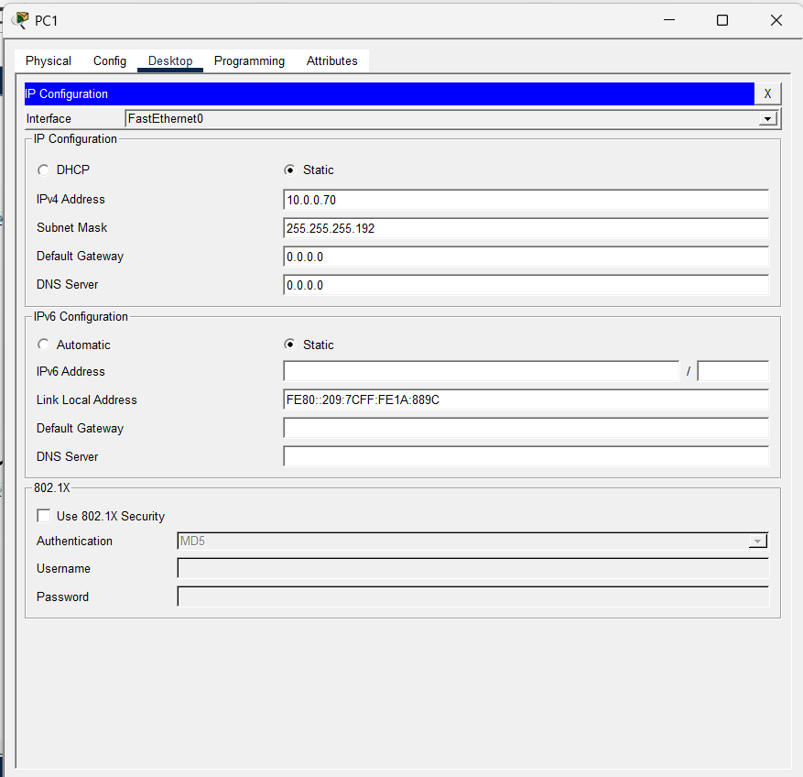
Pc2
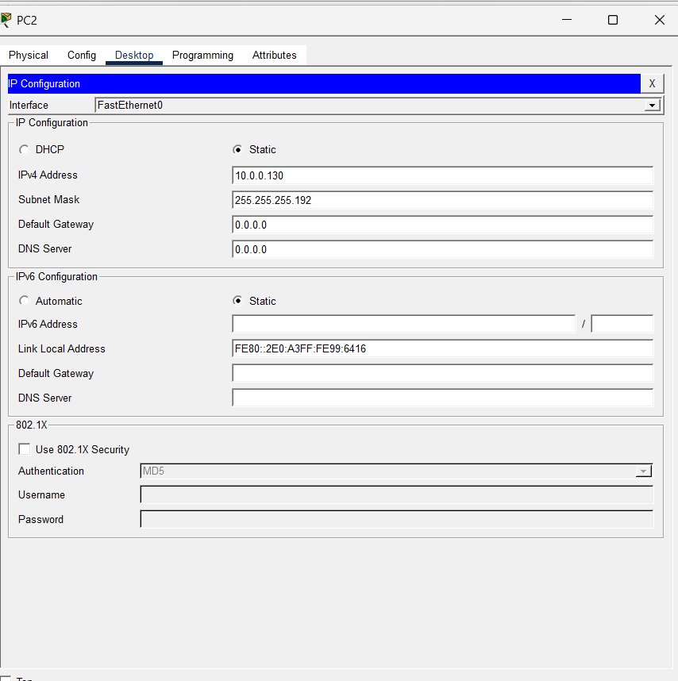
Pc3
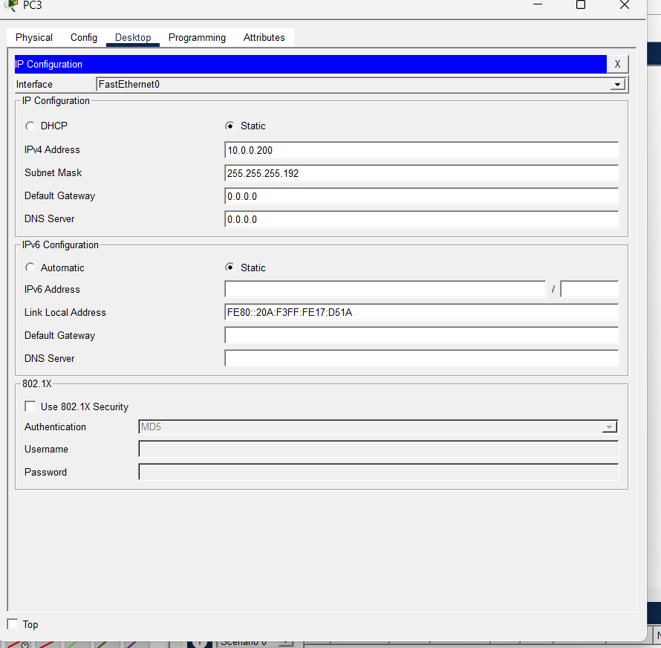
Test connectivity
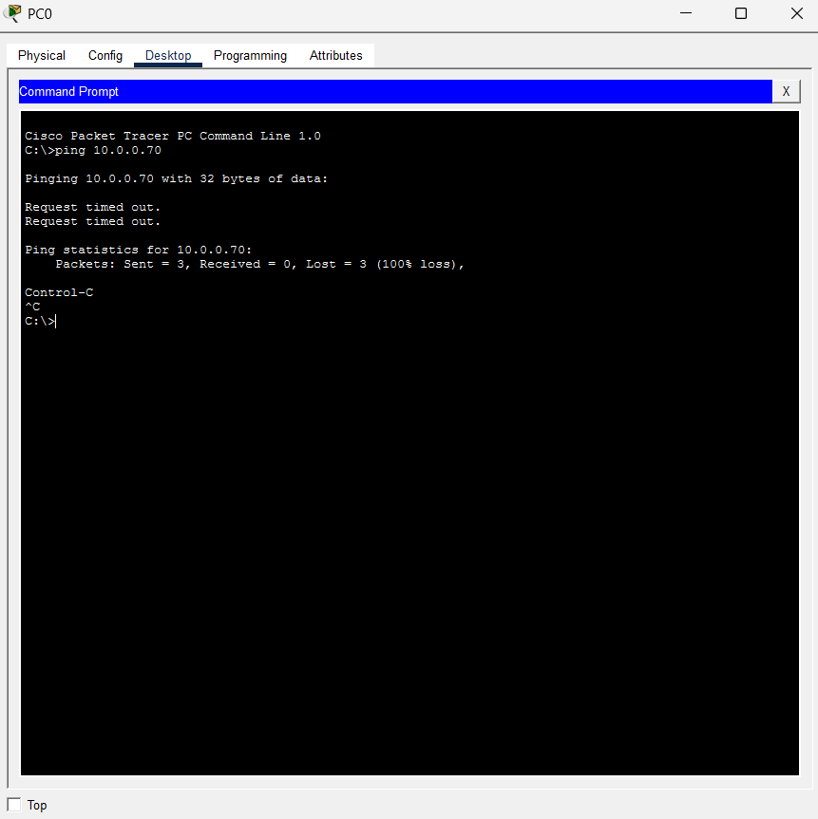

During the practical experiment, IP addresses from different subnets were assigned to multiple PCs. All PCs were connected through a switch. When a ping test was performed between devices belonging to different subnets, the packets were not delivered successfully. This occurred because a switch operates at Layer 2 and cannot route packets between different subnets. A router is required to enable communication between separate subnetworks.

4))
Three IP addresses are given: 192.168.10.5, 172.20.15.1, and 8.8.8.8. For each address, we need to identify its IP class, determine whether it is private or public, and explain how NAT works when private IP addresses access the internet.

1. IP Address: 192.168.10.5
The first octet of this IP address is 192. According to IPv4 classification, addresses whose first octet lies between 192 and 223 belong to Class C. Therefore, 192.168.10.5 is a Class C IP address.
Next, we check whether it is a private or public IP. The range 192.168.0.0 to 192.168.255.255 is reserved for private networks. Since 192.168.10.5 falls within this range, it is considered a private IP address.

2. IP Address: 172.20.15.1
The first octet of this IP address is 172. IP addresses with the first octet between 128 and 191 belong to Class B. Therefore, 172.20.15.1 is a Class B IP address.
For private address ranges, 172.16.0.0 to 172.31.255.255 is reserved for private networks. Since 172.20.15.1 lies within this range, it is also a private IP address.

3. IP Address: 8.8.8.8
The first octet of this IP address is 8. IP addresses with the first octet between 1 and 126 belong to Class A. Therefore, 8.8.8.8 is a Class A IP address.
Next, we check if it belongs to any private IP range. The private range for Class A is 10.0.0.0 to 10.255.255.255, and since 8.8.8.8 does not fall within this range, it is a public IP address. In fact, 8.8.8.8 is a well-known public DNS server provided by Google.

NAT Explanation
Private IP addresses cannot communicate directly with the internet. To enable communication between private networks and the public internet, routers use a technique called Network Address Translation (NAT).
When a device inside a private network sends a request to the internet, the router replaces the device’s private IP address with its own public IP address. The request is then sent to the internet using the public IP. When the response comes back, the router translates the public IP back to the original private IP and forwards the data to the correct device inside the network.
In this way, NAT allows multiple devices in a private network to access the internet using a single public IP address while also improving network security.

5))
Network
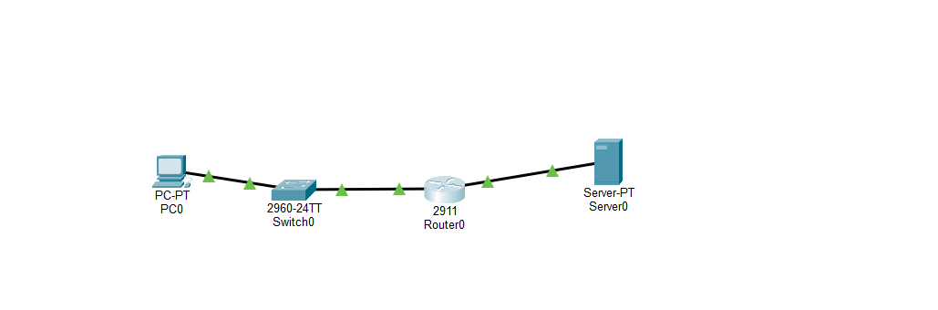
Pc0
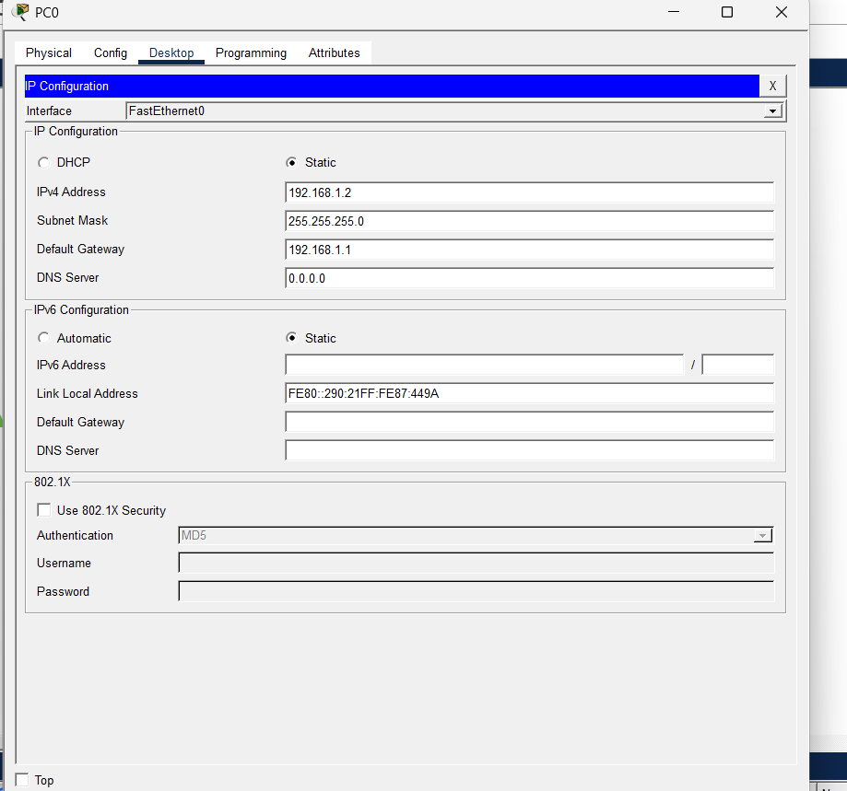
Server
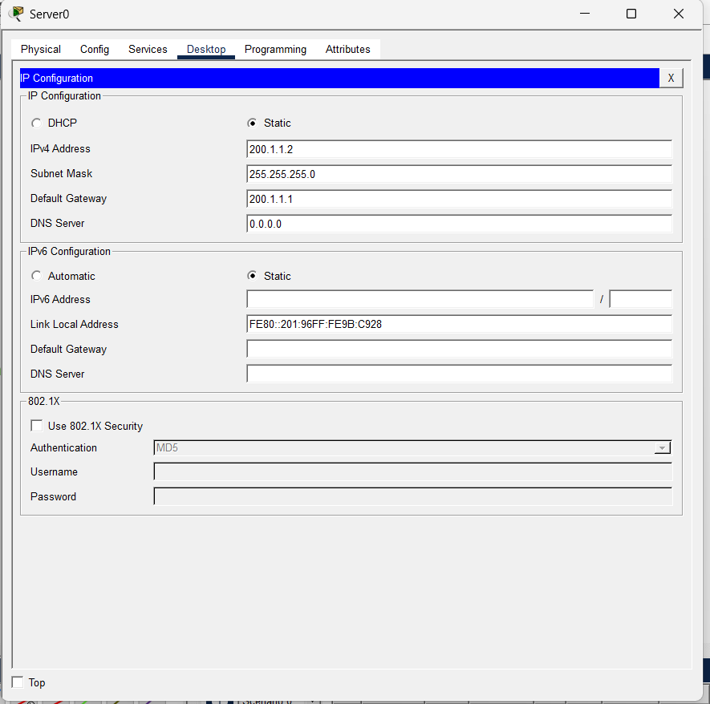

Router

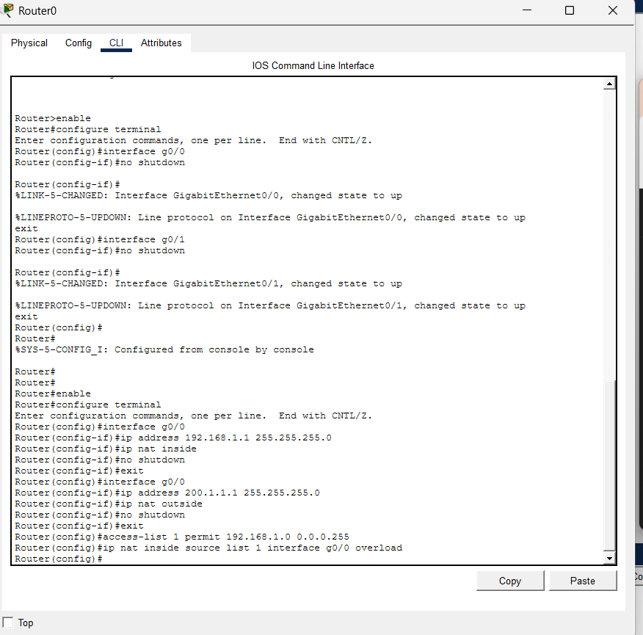

Router
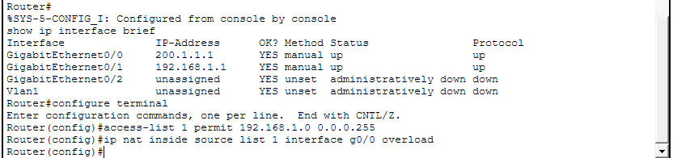
Test nat

