EXPT NO:1 | Implementation of data charts
DATE: 12.01.2026 | Implementation of data charts

PRE-LAB QUESTIONS (PROVIDE BRIEF ANSWERS TO THE FOLLOWING QUESTIONS)

- How can visualization help an academic institution improve student outcomes?
Visualization helps identify weak subjects and low-performing students easily.
It shows performance patterns and learning gaps clearly.This helps institutions plan timely academic support and improve teaching methods.

- Which chart types are suitable for comparing subject-wise performance?
Bar charts clearly compare average marks across different subjects. Box plots show the spread, median, and outliers in subject scores. Both help in understanding differences in performance effectively.

- What type of data scale is used for student marks?
Student marks use the ratio scale of measurement. It has equal intervals between values and a true zero point. This allows meaningful comparison and mathematical operations.

- Why should raw academic data be cleaned before visualization?
Raw data may contain missing values, duplicates, or incorrect entries. These errors can distort charts and lead to wrong conclusions. Cleaning ensures accurate and reliable visual analysis.

- How does visualization support evidence-based decision making?
Visualization presents data in a clear and understandable graphical form.
It helps decision-makers observe trends, patterns, and problem areas quickly. This enables objective decisions based on facts rather than assumptions.

IN-LAB EXERCISE:

OBJECTIVE:
To design appropriate data charts to analyze and compare academic performance indicators.

SCENARIO:
An autonomous engineering college wants to analyze internal assessment performance of first-year students across five subjects to identify difficult courses and improve teaching strategies.

IN-LAB TASKS (Using R Language)
- Load required R libraries (ggplot2, dplyr)
- Import dataset using read.csv()
- Perform basic data preprocessing
- Create bar chart for subject-wise average marks
- Generate line chart for performance trend across tests
- Plot pie chart for grade distribution

CODE:

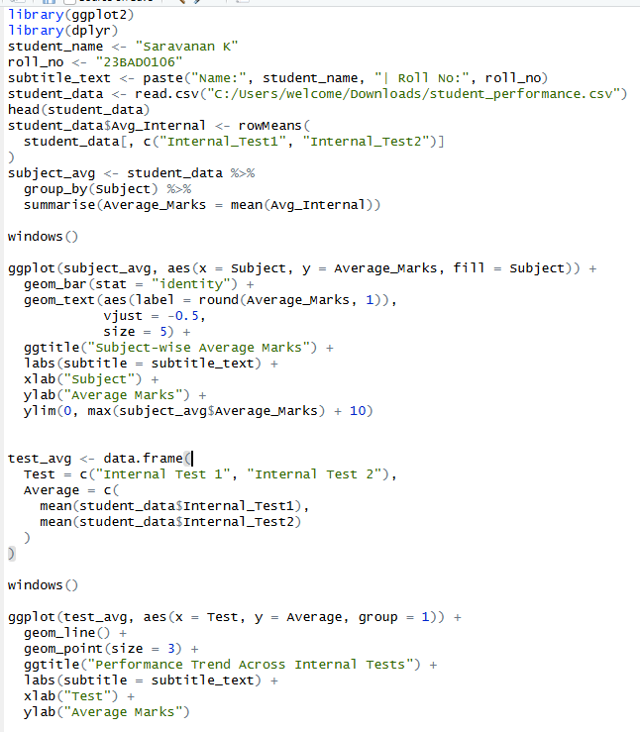

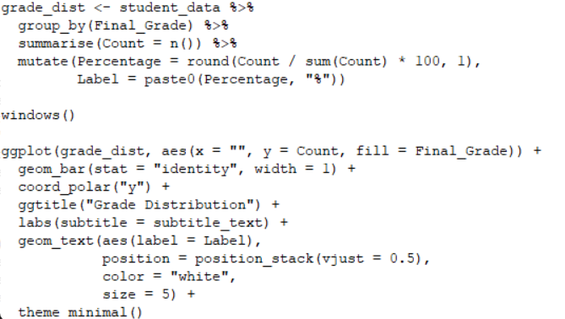

OUTPUT:

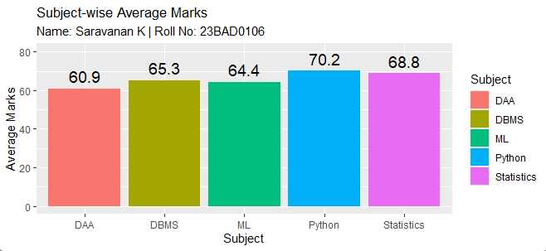

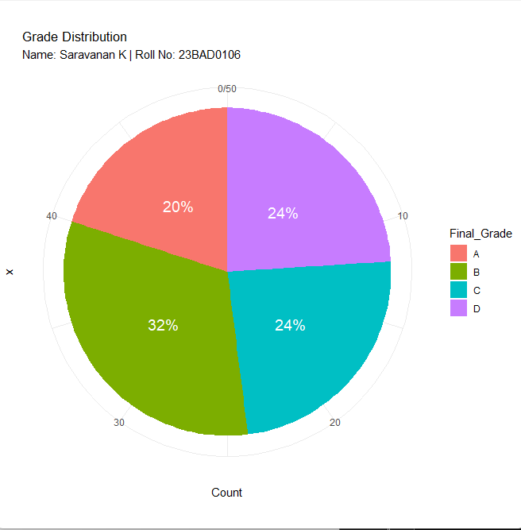

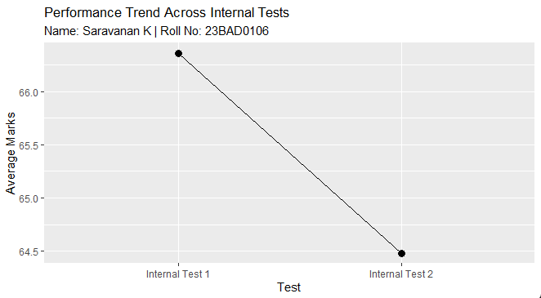

POST-LAB QUESTIONS (PROVIDE BRIEF ANSWERS TO THE FOLLOWING QUESTIONS)

- Which subject shows consistently low performance and why?
From the subject-wise average marks bar chart, DAA has the lowest average marks (around 61) compared to other subjects. This indicates that students find DAA more difficult than DBMS, ML, Python, and Statistics. The subject involves complex algorithms, logical thinking, and mathematical analysis. These factors may contribute to lower performance and the need for additional academic support.

- Why is a line chart suitable for trend analysis?
The line chart clearly shows the change in average marks from Internal Test 1 to Internal Test 2. It helps visualize whether performance is improving or declining over time. In the chart, there is a slight decrease in average marks in the second test. This makes line charts ideal for tracking progress and identifying performance patterns.

- What limitations does a pie chart have in analytics?
A pie chart makes it difficult to accurately compare small differences between categories. It cannot show trends or changes over time. It becomes confusing and less effective when there are many categories or similar values.

- How can this analysis help curriculum planning?
The analysis highlights DAA as a weak subject that needs improvement. Faculty can revise the syllabus structure and teaching methodology for such subjects. Extra tutorial sessions and practical problem-solving classes can be introduced. This helps improve student understanding and overall academic performance.

- How can such visualizations be integrated into AI-driven academic analytics?
The charts provide structured performance data that can be used as input for AI systems. AI models can detect patterns such as declining test scores or weak subjects automatically. They can predict students who are at risk of failing and suggest early interventions. This enables personalized learning plans and smarter academic decision-making.

ASSESSMENT
Description | Max Marks | Marks Awarded
Pre Lab Exercise | 5
In Lab Exercise | 10
Post Lab Exercise | 5
Viva | 10
Total | 30
Faculty Signature

