EXPT NO:3 | Designing Multivariate Patterns
DATE: 24.01.2026 | Designing Multivariate Patterns

PRE-LAB QUESTIONS (PROVIDE BRIEF ANSWERS TO THE FOLLOWING QUESTIONS)
- Why is multivariate analysis essential in real-world AI problems?
Real-world AI problems involve many variables affecting the outcome simultaneously. Multivariate analysis helps understand relationships between these variables. It captures complex interactions that single-variable analysis cannot show.
This improves prediction accuracy and decision-making in AI systems.
- What challenges arise when visualizing high-dimensional data?
High-dimensional data is difficult to display clearly in 2D or 3D graphs. Visualizations often become cluttered and hard to interpret. Important patterns may be hidden due to overlapping data points. This can lead to misunderstanding or loss of useful information.
- How does correlation analysis support feature selection?
Correlation analysis identifies relationships between different variables. Highly correlated features may provide redundant information. Removing such features simplifies the AI model. This improves model efficiency and reduces overfitting.
- What are ethical concerns in healthcare data visualization?
Patient privacy and data confidentiality must be protected. Incorrect visualizations can lead to wrong medical decisions. Biased data can produce misleading conclusions about certain groups. Ethical handling ensures trust and responsible use of healthcare data.
- Give examples of multivariate data in AI systems.
Healthcare systems use age, BMI, glucose, and blood pressure together. E-commerce platforms analyse user age, income, and purchase history. Autonomous vehicles process speed, distance, weather, and traffic data. Financial AI systems use income, expenses, credit score, and loan history.
IN-LAB EXERCISE:

OBJECTIVE:
To discover relationships among multiple variables using multivariate visualization.

SCENARIO:
A hospital analytics team studies patient health records to identify relationships between age, BMI, glucose levels, and blood pressure for early disease prediction.

IN-LAB TASKS (Using R Language)
- Generate scatter plot matrix
- Apply colour encoding for age groups
- Identify correlated health indicators
CODE:

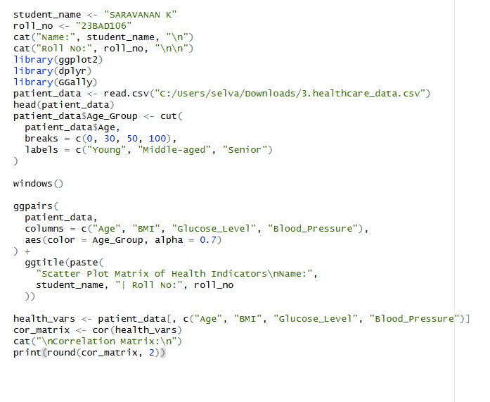

OUTPUT:
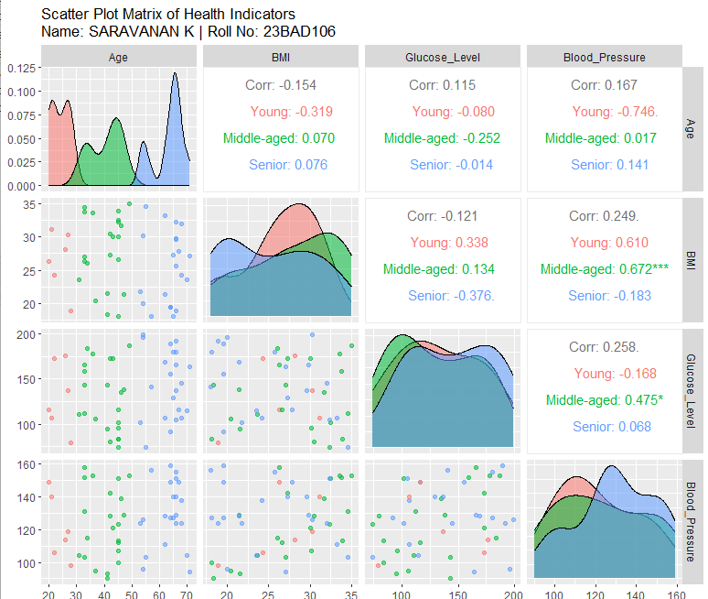

POST-LAB QUESTIONS (PROVIDE BRIEF ANSWERS TO THE FOLLOWING QUESTIONS)

- Which health parameters show strong correlation?
Body Mass Index (BMI) and Blood Pressure show a strong positive correlation. As BMI increases, blood pressure levels also tend to increase. Age also shows moderate correlation with blood pressure and glucose levels. These relationships indicate important health risk factors.
- Why correlation does not imply causation in medical data?
Correlation only shows that two variables change together. It does not prove that one variable causes the other. Other hidden factors may influence both variables. Medical conclusions require clinical validation and experiments.
- How can these patterns assist predictive healthcare AI?
Correlated features help AI models identify important health indicators. They improve early detection of disease risks. AI systems can prioritize critical variables for prediction. This leads to more accurate and timely medical decisions.
- What visualization limitations exist for high-dimensional data?
High-dimensional data is difficult to represent clearly on simple charts. Visualizations become cluttered with overlapping points. Important trends may be hidden or misinterpreted. This reduces readability and analytical accuracy.
- How can dimensionality reduction improve visualization?
It reduces many variables into fewer meaningful components. This makes complex data easier to visualize in 2D or 3D. Patterns and clusters become more visible. It improves understanding and interpretation of data.

ASSESSMENT
Description | Max Marks | Marks Awarded
Pre Lab Exercise | 5
In Lab Exercise | 10
Post Lab Exercise | 5
Viva | 10
Total | 30
Faculty Signature

