EXPT NO:2 | Implementation of data visualization techniques
DATE: 12.01.2026 | Implementation of data visualization techniques

PRE-LAB QUESTIONS (PROVIDE BRIEF ANSWERS TO THE FOLLOWING QUESTIONS)
- Why is exploratory data analysis critical before model building?
EDA helps in understanding the structure and quality of data. It identifies missing values, outliers, and important patterns. This ensures proper data cleaning and selection of suitable machine learning models. As a result, model accuracy and reliability are improved.
- How do distributions influence algorithm selection in ML?
Different algorithms work better with specific data distributions. Some models assume normally distributed data, while others handle skewed or complex data better. Understanding distribution helps choose the most effective algorithm. It also reduces prediction errors.
- What insights can outliers provide in business data?
Outliers may indicate fraud, rare events, or high-value customers. They can also highlight data entry mistakes. Analyzing them helps businesses take corrective or strategic actions. This improves risk management and decision-making.
- Why are visual summaries preferred over raw tables?
Visual summaries present data in an easy-to-understand format. They quickly show trends, patterns, and anomalies. Large tables are difficult to interpret manually. Visualization saves time and improves clarity.
- How does visualization improve business intelligence?
Visualization converts complex datasets into meaningful graphical insights. It helps managers identify trends and performance issues easily. This supports faster and more accurate decisions. Overall, it enhances strategic planning.
IN-LAB EXERCISE:
OBJECTIVE:
To explore data distribution and variability using advanced visualization techniques.

SCENARIO:
A startup analyzes e-commerce transaction data to understand customer spending behavior and detect abnormal purchase patterns.

IN-LAB TASKS (Using R Language)
- Plot histogram of transaction amounts
- Use boxplot to detect outliers
- Create heatmap of monthly sales intensity
CODE:

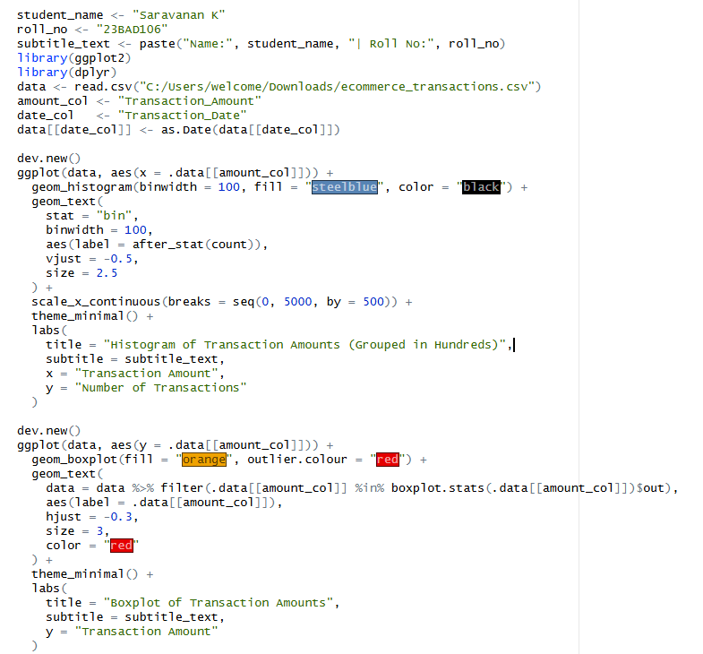
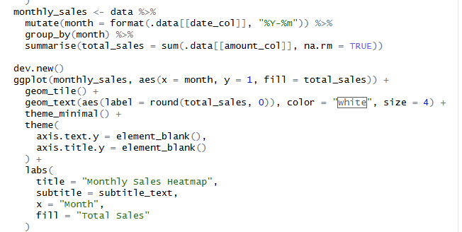

OUTPUT:

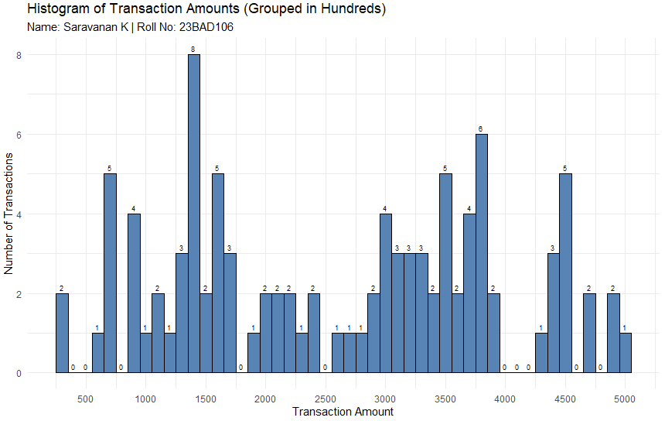

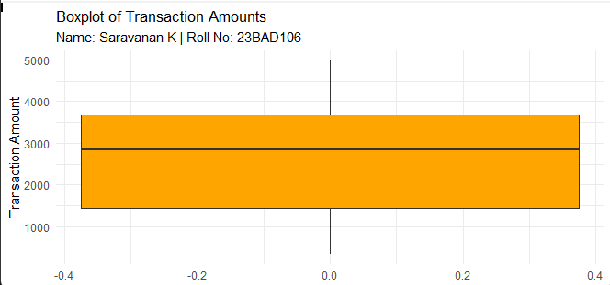

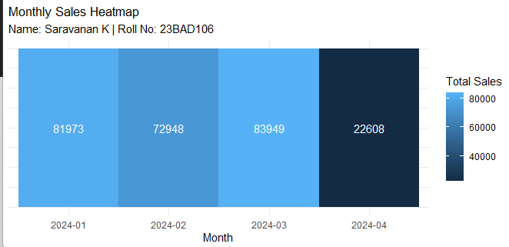

POST-LAB QUESTIONS (PROVIDE BRIEF ANSWERS TO THE FOLLOWING QUESTIONS)

- What does right-skewed distribution indicate about customer behavior?

It shows that most customers spend smaller amounts. Only a few customers make very large purchases. This pattern is common in e-commerce businesses. It helps identify high-value customers.

- How can detected outliers impact business decisions?

Outliers can reveal fraud, unusual activity, or premium customers. They help in improving security and marketing strategies. Businesses can also correct system or pricing errors. This leads to better operational control.

- Which visualization best supports anomaly detection?

Boxplots are best for detecting anomalies. They clearly show values outside the normal range. Outliers are visually highlighted. This makes unusual data easy to identify.

- How does EDA improve AI model accuracy?

EDA removes noise and incorrect data before training. It helps select relevant features. This improves data quality and reduces model errors. As a result, predictions become more reliable.

- How can visualization guide feature engineering?

Visualization shows relationships between variables. It helps detect important trends and correlations. New useful features can be created from these patterns. This improves model performance.

ASSESSMENT
Description | Max Marks | Marks Awarded
Pre Lab Exercise | 5
In Lab Exercise | 10
Post Lab Exercise | 5
Viva | 10
Total | 30
Faculty Signature

