EXPT NO:4 | Visual encoding of data
DATE: 26.01.2026 | Visual encoding of data

PRE-LAB QUESTIONS
- How does the human visual system process visual variables?
The human brain quickly interprets colour, size, shape, and position. These variables help distinguish patterns and differences in data. Colour is noticed first, followed by size and shape. This enables fast understanding of complex information.
- Why is improper encoding misleading in analytics?
Incorrect encoding can exaggerate or hide important data patterns. It may lead users to wrong conclusions. Poor visuals distort real relationships in data. This affects trust and decision quality.
- What are perceptual limitations in visualization?
Humans cannot easily compare many colours or shapes accurately. Small differences may go unnoticed. Overcrowded charts reduce clarity. This limits correct interpretation.
- How does colour choice affect interpretation?
Colores influence attention and emotional response. Red often indicates danger, green indicates safety. Wrong colours may confuse users. Good colour choice improves clarity.
- Why should AI dashboards be perceptually optimized?
AI outputs must be easily understood by humans. Clear visuals increase trust in predictions. They reduce misinterpretation of results. This supports better decisions.

OBJECTIVE:
To apply effective visual encoding principles for meaningful data communication.

SCENARIO:
A city traffic department analyzes accident data to identify high-risk zones and accident severity patterns.

IN-LAB TASKS (Using R Language)
• Encode severity using color gradients
• Represent accident frequency using size • Use shape to indicate accident type

CODE:

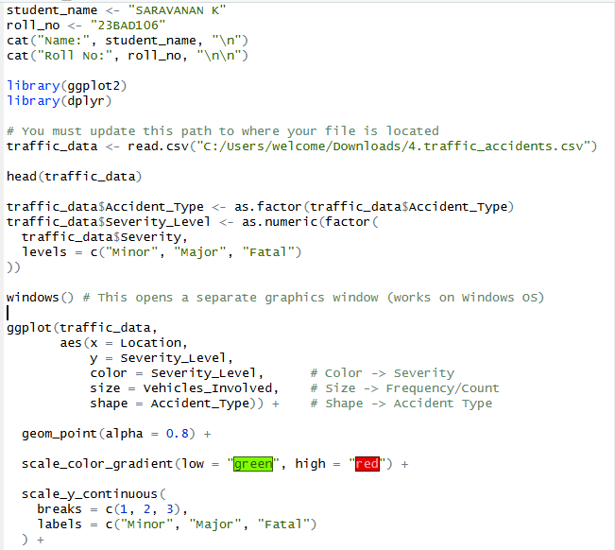

OUTPUT:

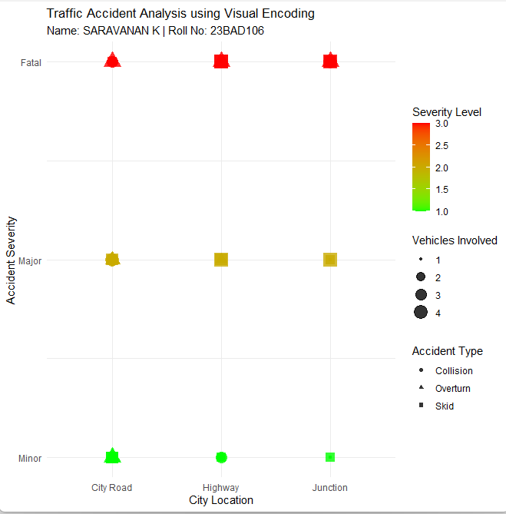

POST-LAB QUESTIONS
- Which visual variable best conveys severity and why?
Colour best represents severity. Humans detect colour differences instantly. Gradient colours show low to high risk clearly. This makes severity easy to understand.
- How can poor encoding mislead policy decisions?
It can hide high-risk zones. Officials may allocate resources wrongly. Serious problems may be underestimated. This affects public safety planning.
- What precautions should be taken for colour-blind users?
Use colour-blind friendly palettes. Avoid red-green combinations. Add shapes or labels as alternatives. Ensure readability for all users.
- How does visual encoding affect AI explainability?
Clear encoding makes AI results understandable. Users can see why predictions occur. It improves transparency. This increases trust in AI systems.
- Suggest improvements for large-scale public dashboards.
Use simple and consistent colour schemes. Avoid overcrowding charts. Include filters and zoom options. Ensure mobile and accessibility support.

LEARNING OUTCOME: Students learn perceptually effective visual communication for AI systems.

ASSESSMENT
Description | Max Marks | Marks Awarded
Pre Lab Exercise | 5
In Lab Exercise | 10
Post Lab Exercise | 5
Viva | 10
Total | 30
Faculty Signature

