**Technologies covered:**

Frontend - Angular, ReactJS, React + TypeScript

Backend - Spring Boot

**Versions of Technologies:**

Angular: 16.0.5

React: 18.2.0

Spring Boot: 3.0.5

**Integrated Development Environment (IDE):**

Angular : Visual Studio Code (1.80)

React : Visual Studio Code (1.80)

Spring Boot : Spring Tool Suite (4.15.1)

**Let’s go to the installation process:**

**Let’s start with Angular:**

Please follow the steps of the below image to Angular Environment Setup.

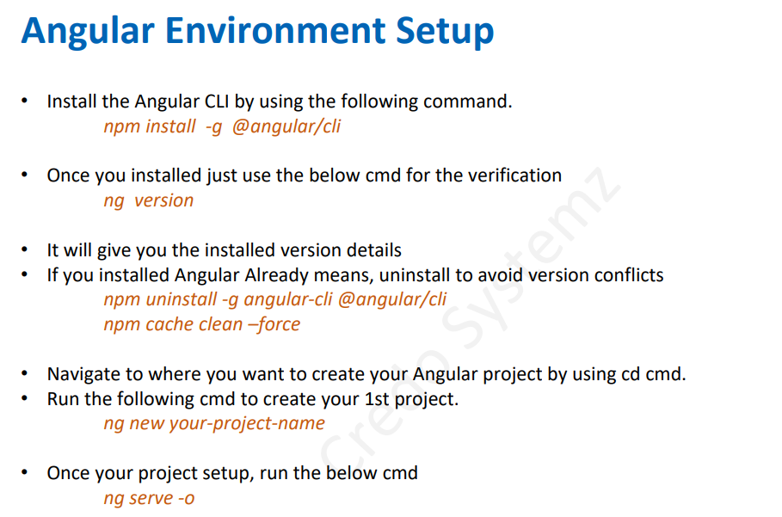

Once you have done all the steps please install Nodejs for using the npm package from Nodejs library.

Click the below link to install the Nodejs:

https://nodejs.org/en/download

There is only one more setup which is typescript:

Please follow the steps of the below image to install the typescript.



Now we have completed the installation process of Angular.

**Let’s go to React:**

For React is very simple. We can use create-react-app which is from npm package. We have already install npm. So You just type in your terminal.

**npx-create-react-app you project name**

**Then you can get your react app.**

Now we have completed the installation process of React.

**Let’s go to Spring Boot:**

Click the link to download STS:

[**https://spring.io/tools**](https://spring.io/tools)

**For environment setup and crate project click the link to learn to create project spring boot project in sts.**

[**https://www.youtube.com/watch?v=19lZkM7Dr-c**](https://www.youtube.com/watch?v=19lZkM7Dr-c)

**Final step is to download and install the oracle database:**

**Watch the video to download oracle 10g express edition and the all setups:**

**https://www.youtube.com/watch?v=s53IDbGBbbc&t=45s**

Now we have completed all the installation processes of frontend and backend.

**Let’s discuss the projects:**

**I have completed my create, read, update, and delete (crud) operations and I have created REST API in the backend.**

**Please go through my projects.**

**Note: Thymeleaf is not frontend it’s a server side java templete engine**

**PLEASE REFER ALL THE PROJECT DOCUMENTS TO LEARN FRONEND AND BACKEND**