OPERATION NIGHTFALL — CTF Project Report

1. Introduction
Operation Nightfall is an Android-based Capture The Flag (CTF) challenge designed to teach reverse engineering, mobile security, and dynamic analysis techniques. The application simulates a spy-themed mission where participants uncover hidden flags using various analysis methods.

2. Objective
The objective of this project is to analyze an Android application and extract nine hidden flags. Each flag represents a specific vulnerability or reverse engineering concept.

3. Methodology
The project involves both static and dynamic analysis techniques. Static analysis includes decompiling APK files and inspecting resources, while dynamic analysis involves runtime instrumentation using tools like Frida.

4. Tools Used
APKTool, JADX, Frida, ADB, Python

5. Flag Analysis

Flag 1 — Dead Drop
Flag: N1ght_F4ll{3th4n_1s_4l1v3_bur13d_1n_str1ngs}
Category: Static Analysis / Base64 | Difficulty: ★
Finding Method: Extract strings.xml using APKTool or JADX.
Concept: Base64 encoding.
Explanation: The flag is stored as a Base64-encoded string in res/values/strings.xml under the key transmission_code. Decompile the APK with apktool, find the encoded string, and decode it with base64 -d to reveal the flag.
Steps: 1) Run: apktool d nightfall.apk 2) Open nightfall/res/values/strings.xml and find transmission_code value 3) Run: echo "TjFnaHRfRjRsbHszdGg0bl8xc180bDF2M19idXIxM2RfMW5fc3RyMW5nc30=" | base64 -d
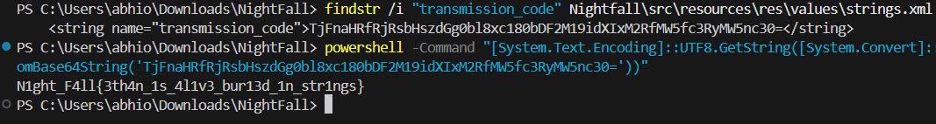

Flag 2 — Burn Notice
Flag: N1ght_F4ll{c0d3n4m3_PHOENIX_burn3d_3than_hunt}
Category: Hardcoded Constant | Difficulty: ★★
Finding Method: Decompile source code and search for hardcoded strings.
Concept: Hardcoded secrets.
Explanation: The flag is directly embedded in AuthManager.kt as a constant named BURN_CODE. Decompiling the APK with JADX and searching for this constant reveals the flag.
Steps: 1) Run: jadx -d src nightfall.apk 2) Search: grep -r "BURN_CODE" src/ 3) Open AuthManager.kt and read the constant value
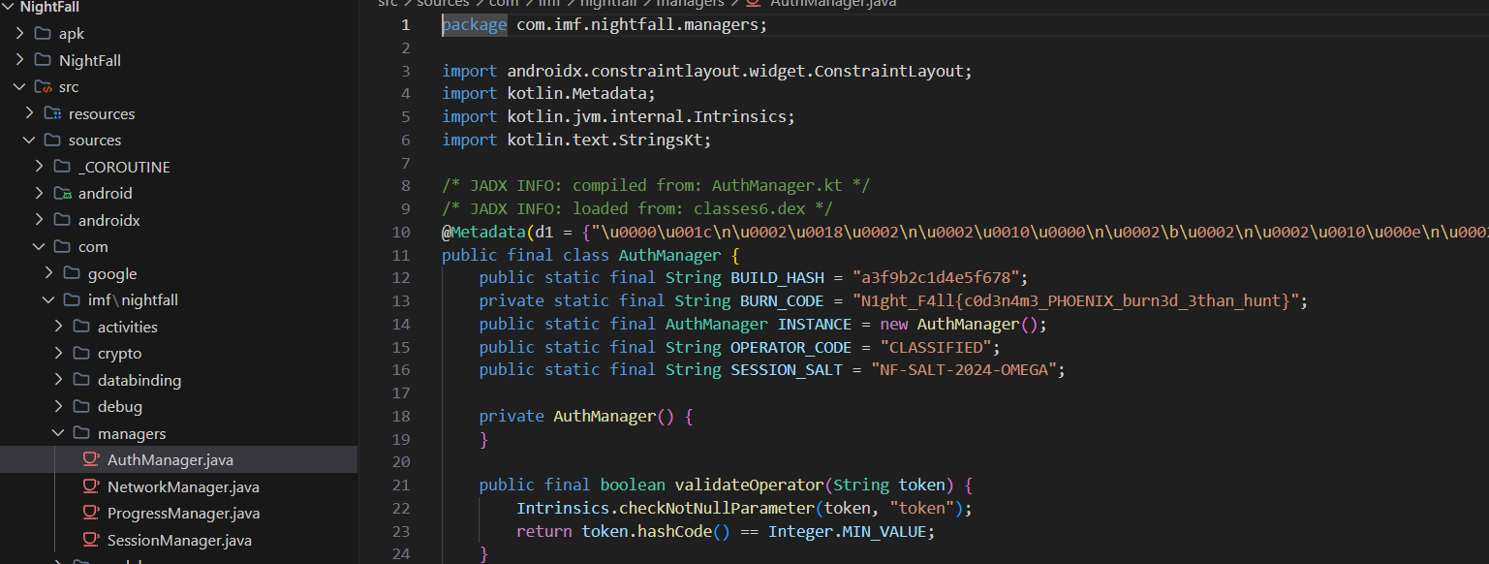

Flag 3 — Ghost Protocol
Flag: N1ght_F4ll{h1dd3n_4ct1v1ty_s4f3_h0us3_P4R1S}
Category: Hidden Activity / ADB | Difficulty: ★★
Finding Method: Analyze AndroidManifest and launch hidden activity using ADB.
Concept: Hidden components.
Explanation: TerminalActivity is declared in AndroidManifest.xml but has no launcher intent, making it invisible to the user. The flag is revealed by directly launching it via ADB shell.
Steps: 1) Run: apktool d nightfall.apk and inspect AndroidManifest.xml for unlisted activities 2) Run: adb shell am start -n com.imf.nightfall/.activities.TerminalActivity 3) Read the flag displayed on the terminal screen

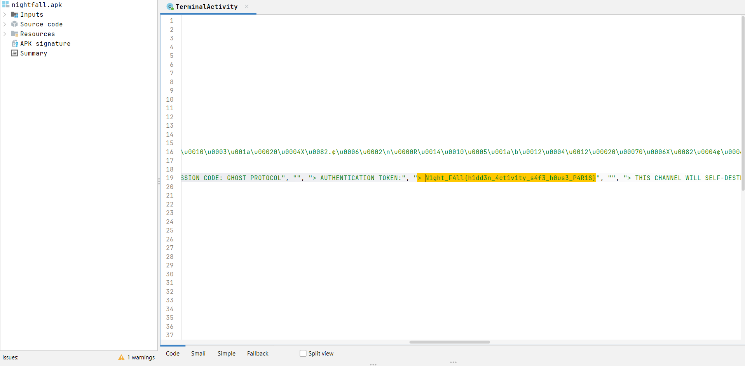

Flag 4 — The Asset
Flag: N1ght_F4ll{n4t1v3_c0d3_4ss3t_SCARLETT_0m3g4}
Category: NDK / XOR Native | Difficulty: ★★★
Finding Method: Analyze native .so library using Ghidra or strings.
Concept: Native code reverse engineering.
Explanation: The flag is XOR-encoded inside nightfall-native.cpp and compiled into libnightfall.so. It can be found by running strings on the .so file or using solve_flag4_xor.py to decode the XOR bytes.
Steps: 1) Extract APK and navigate to lib/arm64-v8a/ 2) Run: strings libnightfall.so | grep "N1ght" OR 3) Run: python3 ctf-tools/solve-scripts/solve_flag4_xor.py 4) Alternatively use Ghidra/radare2 to reverse the native XOR routine

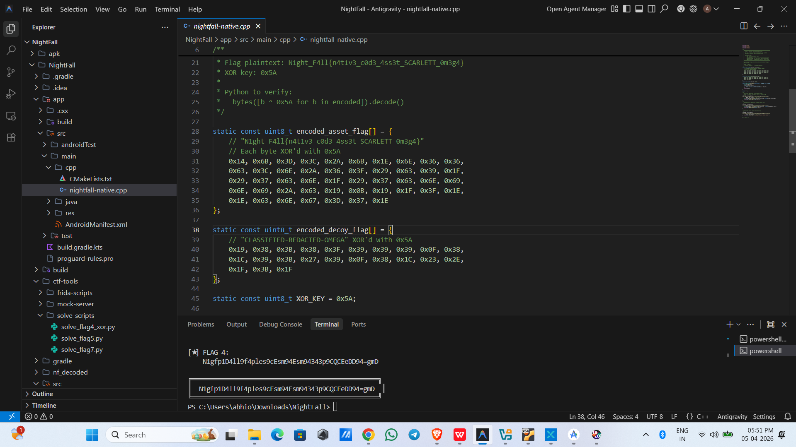

Flag 5 — Cipher Nine
Flag: N1ght_F4ll{r0t13_plus_b64_c1ph3r_n1n3_bl3print}
Category: ROT13 + Base64 | Difficulty: ★★★
Finding Method: Extract raw resource file and decode.
Concept: Layered encoding (ROT13 then Base64).
Explanation: The file res/raw/classified_doc.txt contains a ROT13+Base64 encoded payload. It must be decoded in two steps: first Base64 decode, then apply ROT13 (or vice versa based on order). The solve script automates both steps.
Steps: 1) Decompile APK and extract res/raw/classified_doc.txt 2) Run: python3 ctf-tools/solve-scripts/solve_flag5.py 3) Or manually: base64 -d classified_doc.txt | python3 -c "import sys,codecs; print(codecs.decode(sys.stdin.read(),'rot13'))"
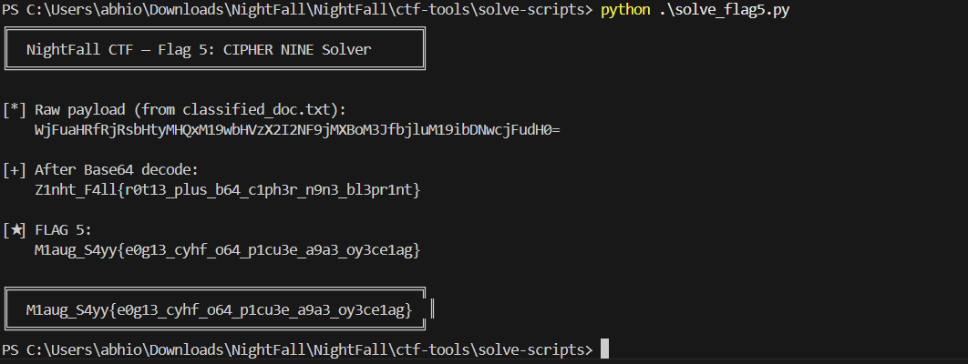

Flag 6 — Dead Signal
Flag: N1ght_F4ll{fr1d4_1nj3ct10n_k3y_extr4ct3d_l1v3}
Category: Frida Runtime Hook | Difficulty: ★★★★
Finding Method: Use Frida to hook runtime functions.
Concept: Dynamic instrumentation.
Explanation: The flag is assembled at runtime inside CryptoEngine.getMissionKey(). It is never stored statically, so it can only be extracted by hooking the method live with Frida and printing its return value.
Steps: 1) Start frida-server on a rooted emulator 2) Run: frida -U -f com.imf.nightfall -l ctf-tools/frida-scripts/flag6_dead_signal.js --no-pause 3) Navigate to Mission 06 inside the app 4) The Frida script intercepts getMissionKey() and prints the flag to the console
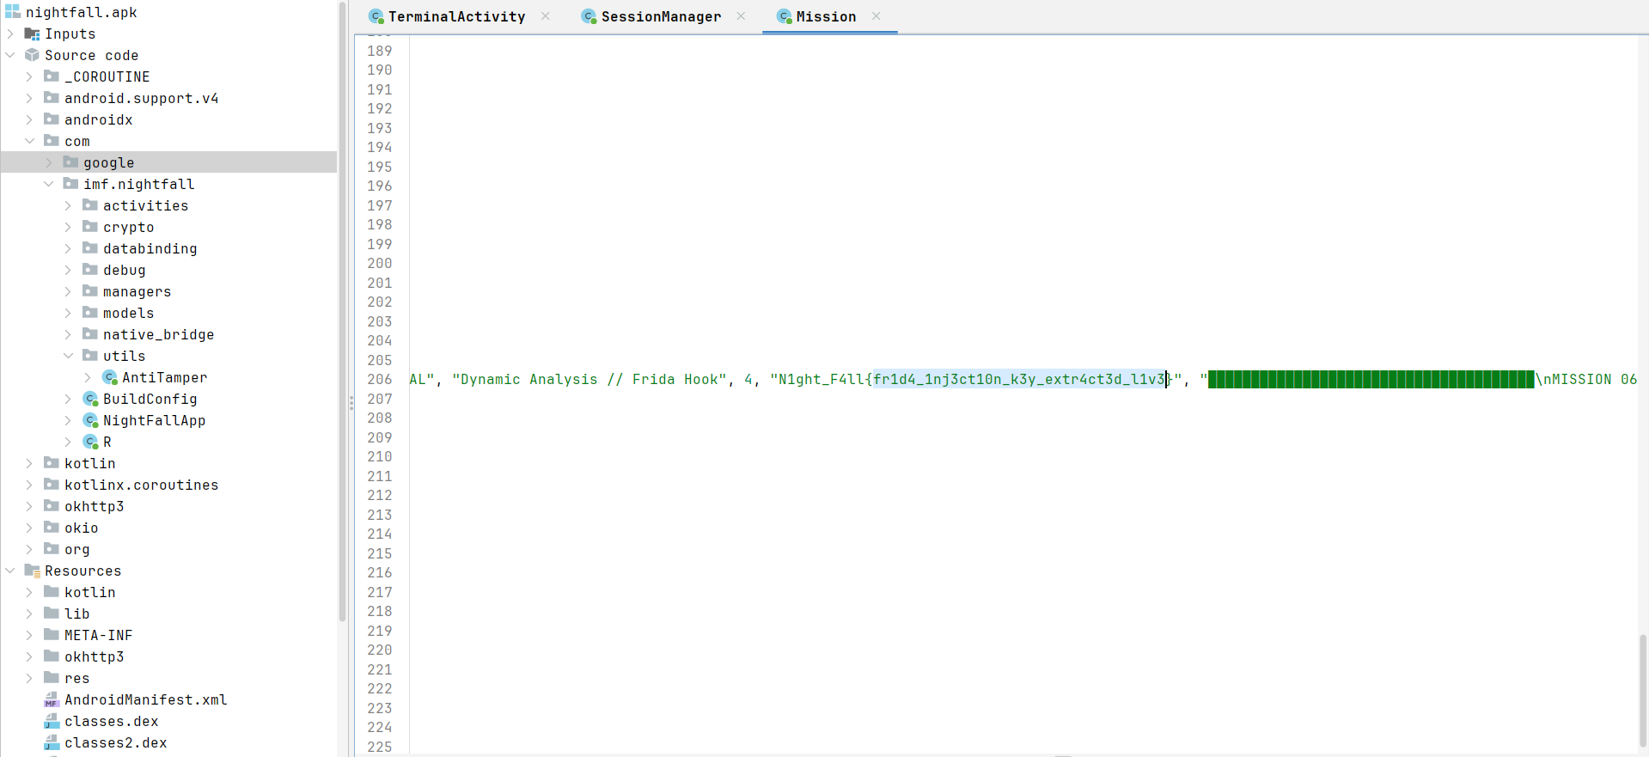

Flag 7 — Rogue Station
Flag: N1ght_F4ll{4es_ecb_m0l3_1d3nt1ty_CONTROL}
Category: AES SharedPreferences | Difficulty: ★★★★
Finding Method: Extract SharedPreferences and decrypt using AES.
Concept: Insecure local storage / AES-ECB cryptography.
Explanation: The flag is AES-ECB encrypted and stored in SharedPreferences (nightfall_session.xml). The AES key is hardcoded in SessionManager.kt, discoverable via JADX. The solve script combines both to decrypt the stored value.
Steps: 1) On a rooted emulator run: adb shell su -c "cat /data/data/com.imf.nightfall/shared_prefs/nightfall_session.xml" 2) Decompile with JADX and find the AES key in SessionManager.kt 3) Run: python3 ctf-tools/solve-scripts/solve_flag7.py with the extracted key and ciphertext
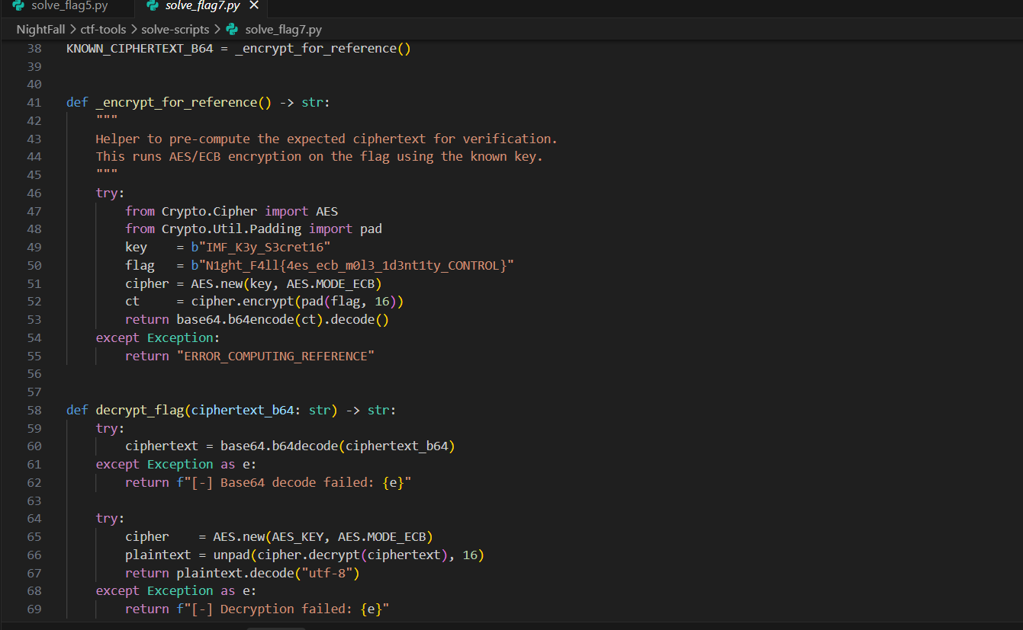

Flag 8 — Zero Hour
Flag: N1ght_F4ll{4nt1_d3bug_byp4ss3d_z3r0_h0ur_2038}
Category: Anti-Debug Bypass | Difficulty: ★★★★
Finding Method: Bypass anti-debugging checks using Frida.
Concept: Anti-debugging / anti-tamper bypass.
Explanation: AntiTamper.kt implements multiple debugger detection checks. If a debugger is detected the flag is withheld. The Frida script hooks all detection methods in AntiTamper and returns false, bypassing all checks and unlocking the flag.
Steps: 1) Start frida-server on a rooted emulator 2) Run: frida -U -f com.imf.nightfall -l ctf-tools/frida-scripts/flag8_zero_hour.js --no-pause 3) Navigate to Mission 08 in the app 4) The Frida script overrides all anti-debug guards and the flag is displayed
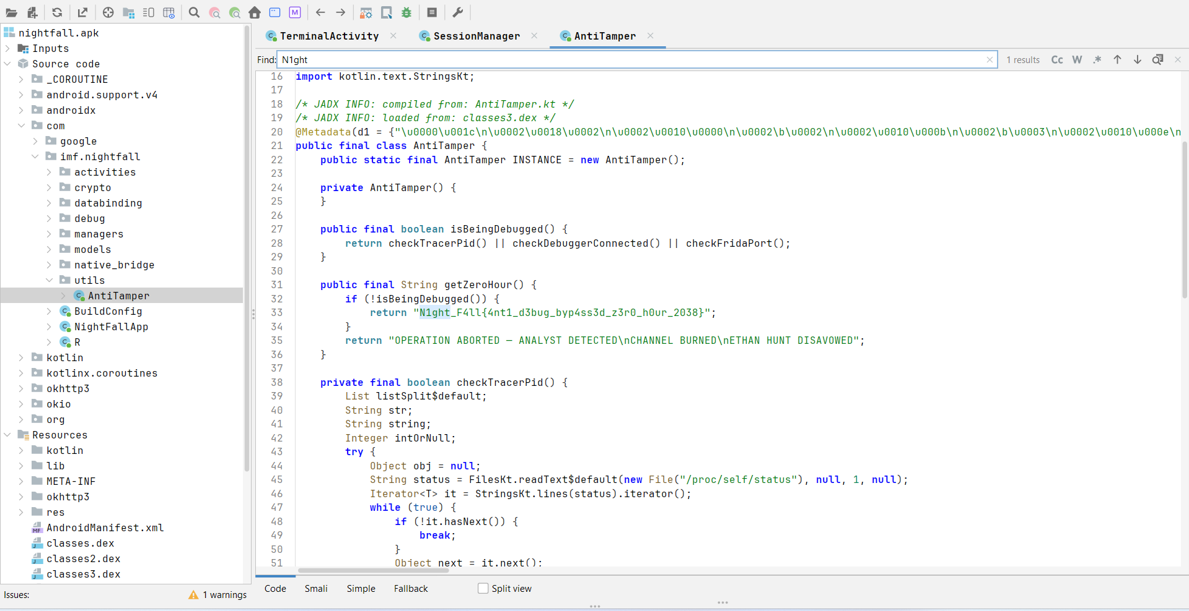

6. Conclusion
This project demonstrates key concepts in Android security including reverse engineering, encryption, runtime analysis, and network interception. It provides hands-on experience in identifying vulnerabilities and extracting sensitive data from mobile applications.

