**Steps to extend the existing file system in ec2 instance**

Step1: Take Snapshot of EBS Volume

Step 2: Increase EBS Volume Size in AWS Console.

Login to the console, choose **ELASTIC BLOCK STORE** --->**Volume** --->select the exact volume which is attached towards the ec2 instance --->**ACTIONS** --->**Modify Volume** ---> Alter the size value --->Click **MODIFY** to complete

By doing this step, the volume will be added in the exiting file system but not in the ec2 instance, so we need to extend in the file System level.

Step 3: **sudo lsblk** command to check the disk space allocated in the OS level.

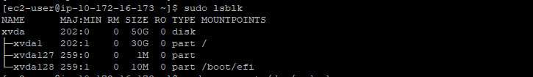

**sudo growpart /dev/xvda 1** to extend the partition size



Crossverify the partition details by using **sudo lsblk** now the space will get reflected for the mentioned partition.

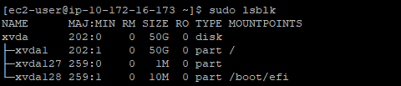

To make it to get reflected in the df –h executes this command **sudo xfs_growfs -d /**

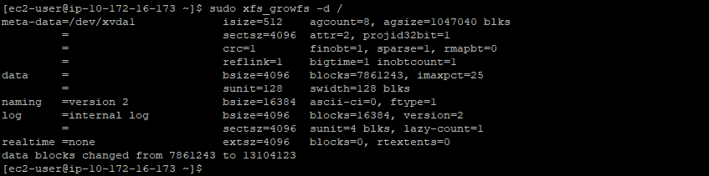

All the blocks will get updated, and it will also get it reflected in the df –h

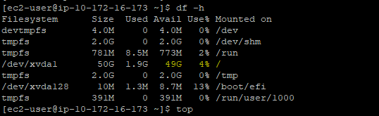

Now the disk which we increased will get reflected in the mount point.