Step 1 : https://github.com/kyndryl/migrations
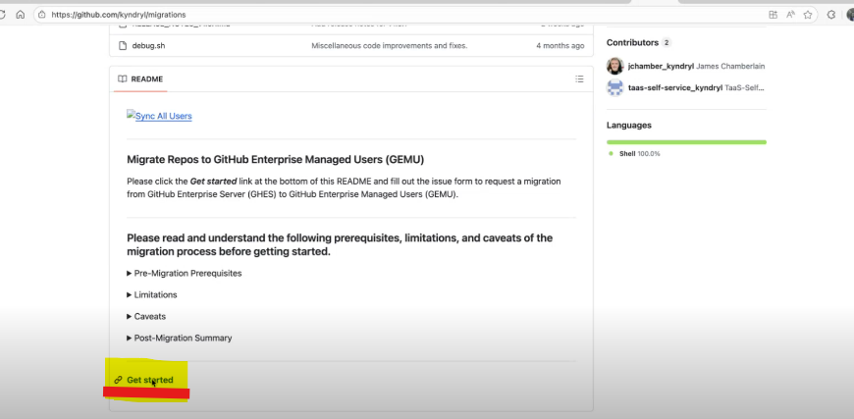
Step 2 :
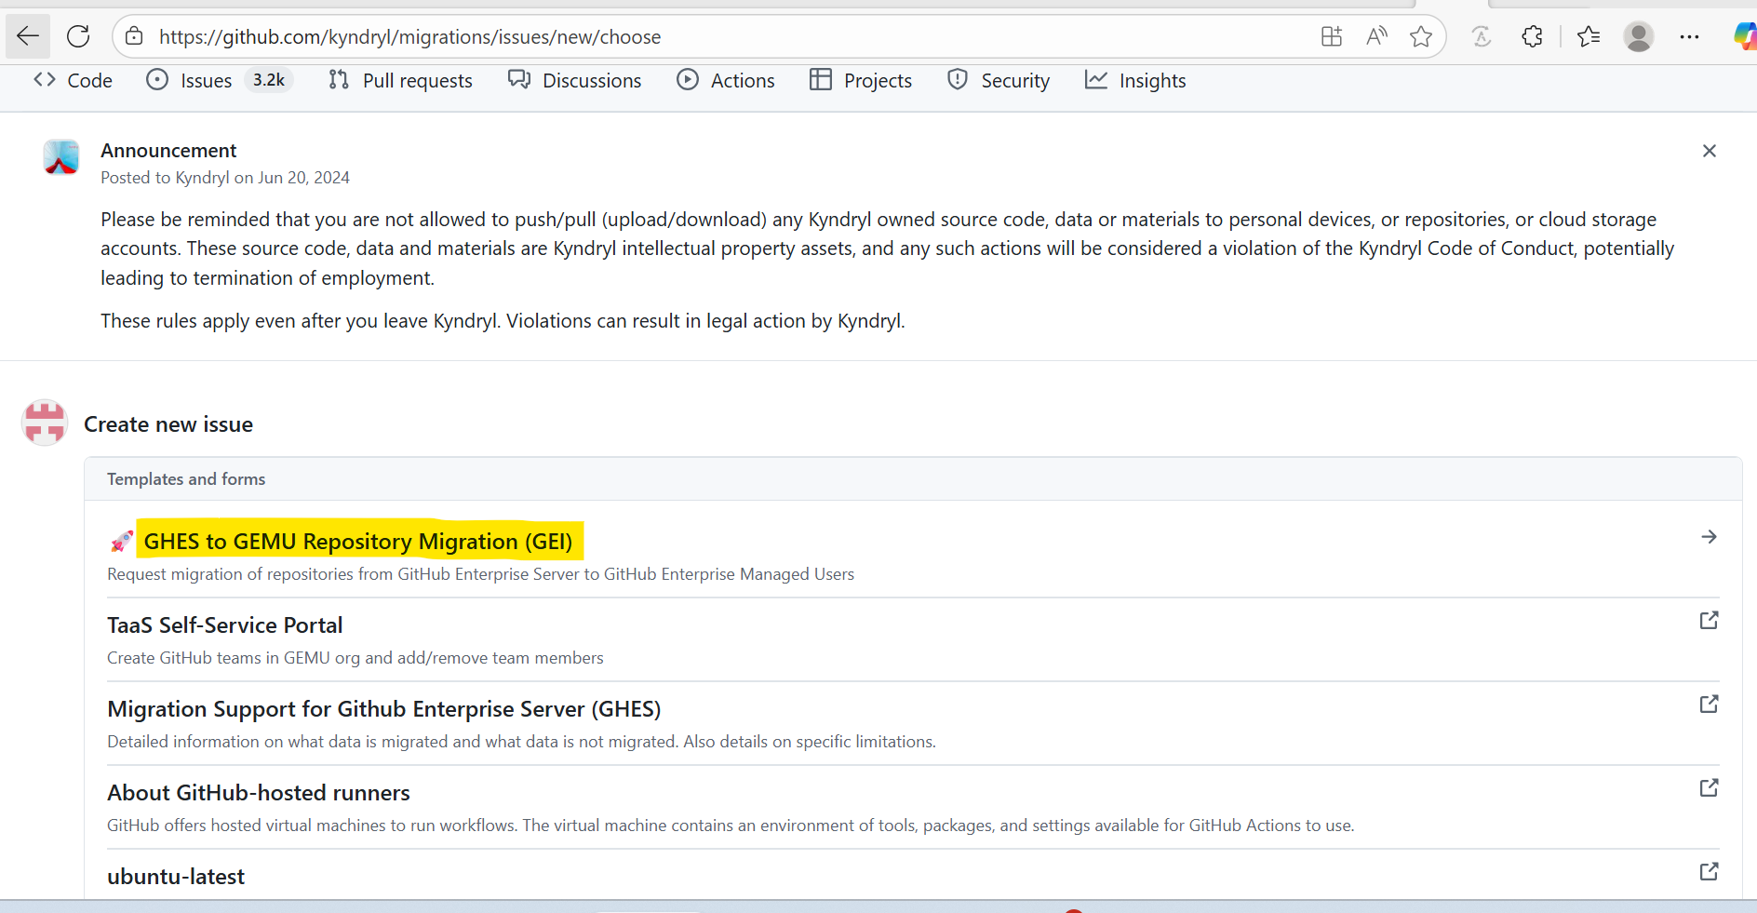

Step 3 :
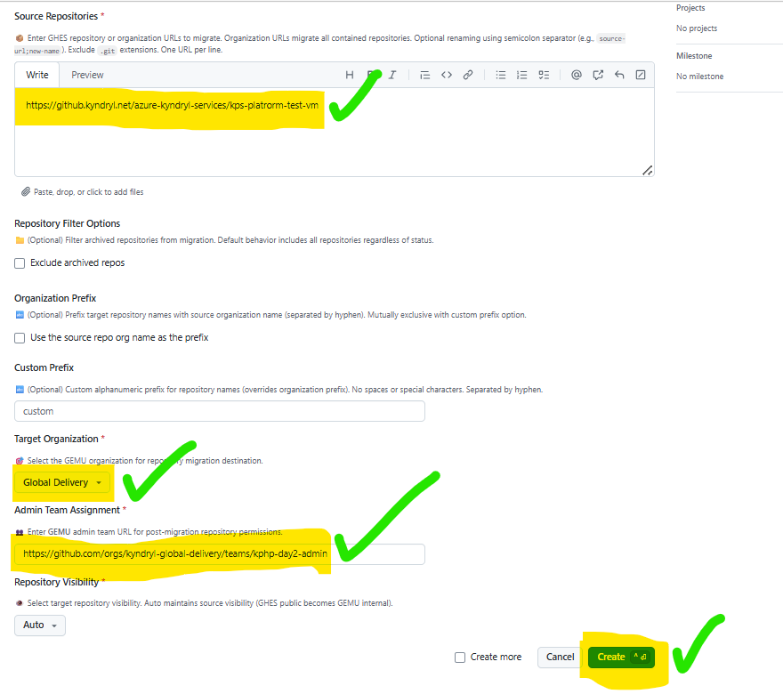

Team link : kphp-day2-admin · Global Delivery Team
Step 4: /run-dry-run-migration
Step 5: Go to the workflow(.yaml) For jwt token check the role name and login the Vault
For Mac:
export VAULT_ADDR=https://secrets.kyndryl.net
export VAULT_NAMESPACE=admin/KYNRL_PRACTICES/
vault login
For Windows:
set VAULT_ADDR=https://secrets.kyndryl.net
set VAULT_NAMESPACE= admin/KYNDRYL_PRACTICES/
vault login
vault list /auth/jwt/role For GHES
vault list /auth/jwt-ghe/role For GEMU
vault read /auth/jwt/role/ kp-common-role
vault write /auth/jwt-ghe/role/ kp-common-role @ demo-vmbuild.json

