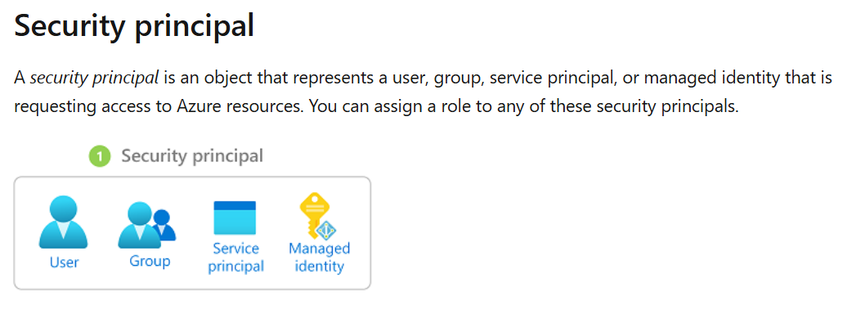

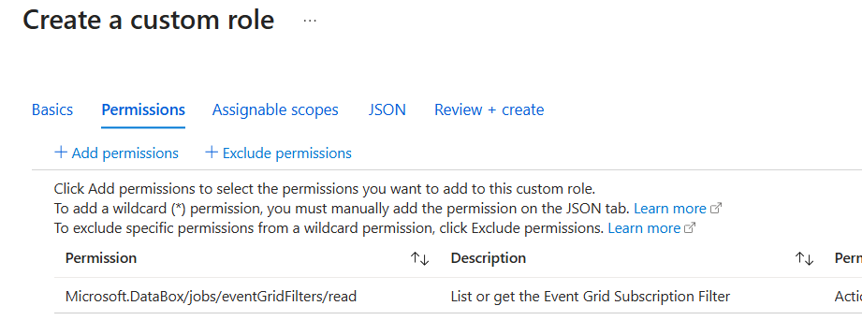

Add permissions
Action
Data Action
Exclude permissions
- Not Actions
- Not Data Actions

Actions - NotActions = Effective management permissions
DataActions - NotDataActions = Effective data permissions

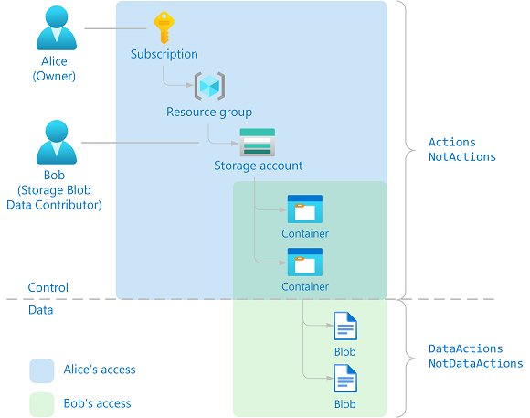

Storage Blob Data Contributor
Actions
Microsoft.Storage/storageAccounts/blobServices/containers/delete
Microsoft.Storage/storageAccounts/blobServices/containers/read
Microsoft.Storage/storageAccounts/blobServices/containers/write
Microsoft.Storage/storageAccounts/blobServices/generateUserDelegationKey/action
DataActions
Microsoft.Storage/storageAccounts/blobServices/containers/blobs/delete
Microsoft.Storage/storageAccounts/blobServices/containers/blobs/read
Microsoft.Storage/storageAccounts/blobServices/containers/blobs/write
Microsoft.Storage/storageAccounts/blobServices/containers/blobs/move/action
Microsoft.Storage/storageAccounts/blobServices/containers/blobs/add/action

\

📂 5. Types of Permissions in Role Definitions
Field | Controls What? | Example
actions | Control-plane operations | Start VM
notActions | Denied control-plane ops | Block VM delete
dataActions | Data access (e.g., read blob) | Read Key Vault secret
notDataActions | Denied data access | Deny blob write

⚠️ Important Notes
- notActions in a role does NOT deny access — it just means that role doesn’t include the action. If another role grants delete, the user still gets it.
- Only Deny Assignments (from Policy or Blueprint) truly block permissions.

🧠 Summary Answer for Interview:
“Since Azure RBAC is additive, I cannot deny delete access using roles alone. To block delete even for users with Contributor, I would use an Azure Policy with a deny effect targeting the delete operation — or implement a Deny Assignment via Azure Blueprints.”

